**TEXT MINING FOR SOCIAL SCIENCES**

**PROBLEM SET 3**

**Maria Fernández, Tim Kreienkamp, Joan Verdú**

*2) Consider the following multinomial mixture model for describing documents. First, each document d is allocated a latent topic zd € {0,…,K}, where Pr [ zd = k ] = ρk.*

*Then, each word in document d is generated by taking independent draws from βk, a probability vector with V elements (V is the number of distinct terms in the corpus). Let xdv be the count in document d of term v.*

*(a) In this model, what are the parameters, what are the latent variables, and what is*

*the observed data?*

Parameters are:

*ρk:* Probabilities of a document to belong to a topic (K+1 parameters)

*βk:* Vector (dimensions V) of probabilities of distinc terms, for each topic k. At the end there are (K+1)·V

Adding all, we have (K+1)(V+1) parameters

Latent variables are the topics of each document (zd), assuming that each document belongs just to one topic (simple model topic).

Observed data are documents (d, nd in total) and words (w, V unique ones) of each document

*(b) Write down the complete data log-likelihood function. Recall that this expresses the*

*log of the joint probability of the latent variables and the observed data.*

The likelihood is a factorization of probabilities of each document. We know the topic of each document is a summation, so the probability of the words of a document is the product of probabilities of each term to the power of counts, weighted by the probability of belonging to the assigned topic (z). That is

Then the log likelihood is just (transforming log of product to sums of log):

Where nd are the number of documents; is the probability of document i of belonging to topic zi; then is the probability of term j when topic is z; and finally recall is the count of term v in document d (so x is function of w and d).

*(c) Compute the expected value of the above log-likelihood function given fixed values*

*for the parameters. Recall this is the E-step in the EM algorithm. Denote this*

*function Q, and note that it will depend on the parameter values.*

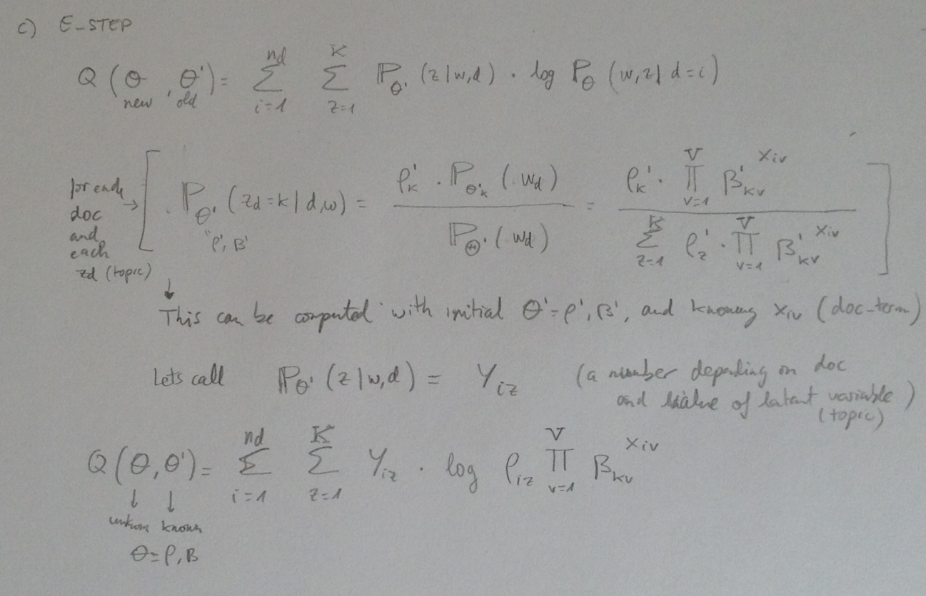

*(d) Maximize Q with respect to the parameter values. Show ALL steps. (Hint: this will*

*involve the setting up of a constrained maximization problem).*

The setup is

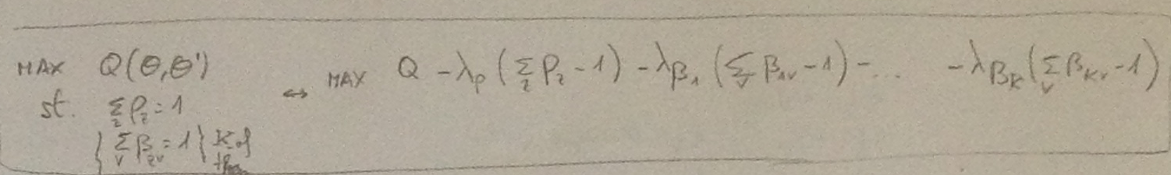

where we also have to consider all rhos>0 and all betas>0, since they are probabilities.

Maximizing the rhos we have:

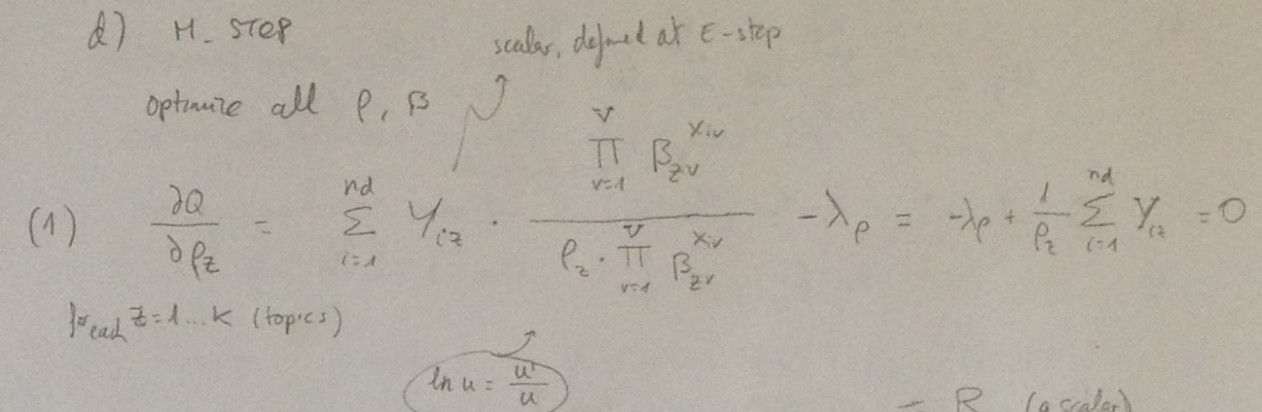

Max betas:

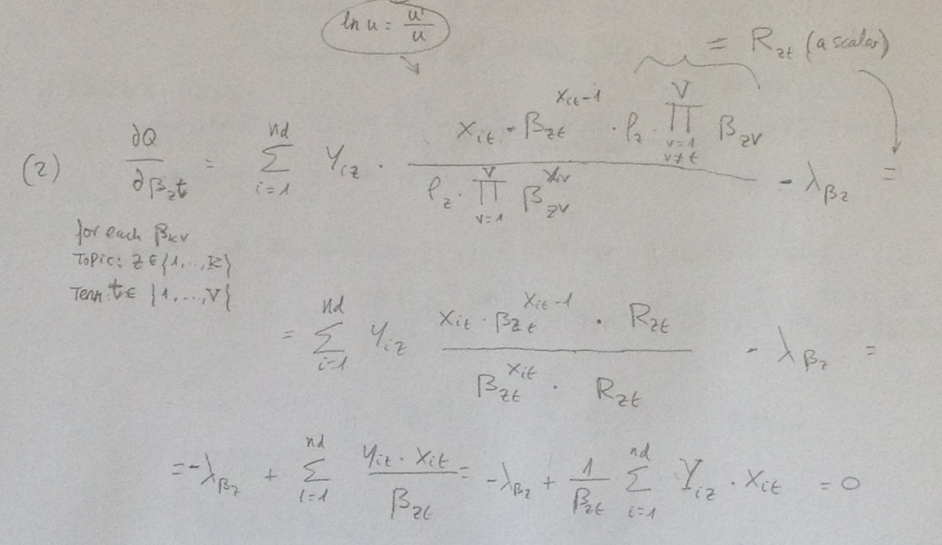

And max lambdas:

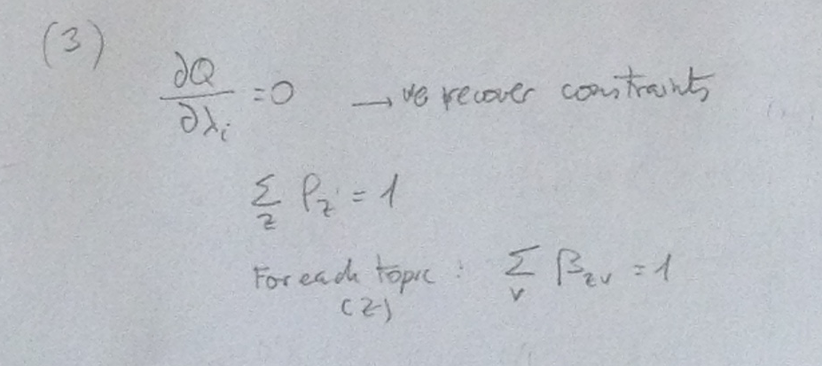

So we have a solvable system of linear equations.

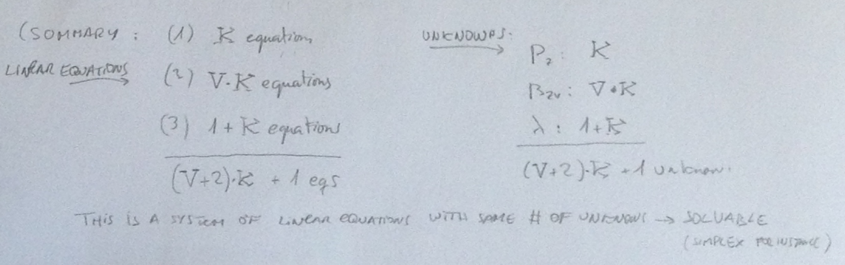

*(e) Use your answers to the above to write pseudo-code for implementing the EM algo-*

*rithm for multinomial mixture models.*

Basically to find a local optimum for the parameters rho and beta we have to do iteratively steps E and M of the EM algorithm until the variation of log L gets under a predefined threshold.

# Load/calculate data

Docs= load_docs()

Words= load_words()

Topics=load_topics()

Z= unique(topics)

D= unique(Docs)

W= unique(words)

K=length(Z)

Nd=length(D)

V=length(W)

X = count(docs,words) #matrix of Nd x V

# Initialize parameters and

Rho= random(K)

Beta= matrix(random(K*V),rows=K,cols=V)

Diff= 1

Delta= 0.001

P= matrix(NA,rows=Nd,cols=K)

# Iterate EM algorithm

Max_Iter=1000

Iter=0

While (abs(diff)>delta AND iter<Max_Iter) do

#E step

S=0

For (d in Docs)

Denominator= for (z in Z)

S=S+rho(z)*factorial(beta(row=z),Xdv)

For (z in Z)

P[d,z]=[rho(z)*factorial(beta(row=z),Xdv)]/ denominator

# we only need this to go for optimization, the other part of Q is fixed

#M step

Rho_old=rho

Beta_old=beta

Rho,Beta= solve (P,Rho_old,Beta_old,Xdv,) #solve linear equations to update rho, beta values

#Compute gain

Diff=1-[LogL(rho,beta,xdv)/LogL(rho_old,beta_old_xdv)]

Iter += 1

Since this is dependent on initial values of parameters, to be closer to the global optimum, we should repeat the procedure several times, and get the optimal solution than yields maximum value of log L.