LuminFlow
AI-Driven Client Audit Visibility & Sampling Transparency

Global Audit Hackathon 2026 — Challenge 2 Submission

Transforming Fragmented Audit Updates into a Dynamic, Insight-Driven Experience

An AI-enabled platform that consolidates, interprets, and communicates
audit status and sampling information to clients in real-time,
built on the COSO 2013 Internal Control Framework.

June 2026

1. Project Background & Challenge Response

1.1 The Challenge
Clients increasingly expect clear, timely, and meaningful visibility into how audit requests, data submissions, and sampling activities are linked to audit objectives and outcomes. This expectation reflects a fundamental shift from passive compliance to active partnership. The current audit communication experience, however, remains fragmented:
- Information is spread across multiple media and channels
- Updates arrive too late to prevent wider impact
- Limited transparency and context hinder understanding of progress and delays
- Clients lack a unified view connecting objectives, risks, controls, testing, and reporting

1.2 Our Solution — LuminFlow
LuminFlow addresses all six Challenge 2 priorities through integrated, AI-powered experiences for audit teams and clients.
- Integrated Visualization Framework: Connects all audit dimensions — risk assessment, controls, substantive testing, and reporting — to specific audit objectives through interactive visualizations that both engagement teams and clients can explore. This creates a shared understanding of audit scope and progress, replacing static status reports with dynamic, drillable views.
- Pre-Request Visibility: AI-powered SampleLens indicates sample size ranges (x-y) BEFORE selection, with document type predictions (POs, invoices, contracts) and methodology explanations.
- Comprehensive KPI Integration: Dashboard aggregates KPIs, risk heatmaps, status distributions, and activity timelines, giving clients an upfront view of anticipated requests across all audit objectives.
- Dual Progress Visualization: Tracks both auditor progress through the audit lifecycle AND client PBC submission progress, with overdue alerts and real-time status dashboards.
- Impact Analysis Engine: ImpactSimulator quantifies the ripple effect of audit changes or delays across the connected COSO framework, providing AI-recommended next steps and mitigation strategies. This enables engagement teams to proactively address client concerns rather than reactively explaining problems after they escalate.
- Role-Based Visibility Control: VisibilityPanel enables engagement teams to manage what is visible to each stakeholder (Partner, CFO, Auditor, Finance Clerk) with fine-grained data filtering.

2. Integrated Visualization Framework & AI Pipelines

2.1 Three-Phase Audit Workflow Architecture
LuminFlow organizes the audit lifecycle into three phases with purpose-built tools:

Phase 1 — Planning
- TraceMap: Interactive full-linkage map showing objective-to-procedure relationships.
- HeatLens: Risk heatmap with COSO five-dimension scoring, factor breakdown, and risk scoring.

Phase 2 — Execution
- SampleLens: AI sampling preview with size recommendations, document distribution charts, and methodology explanations.
- PBCView: PBC request tracking with auto-generation, overdue alerts, and email draft automation.

Phase 3 — Evaluation and Communication
- NarrativeLens: Audience-adapted narratives for Client, Internal Audit, and IT stakeholders.
- ImpactSimulator: BFS propagation model with force-directed visualization and before/after comparison tables.

2.2 Four AI Pipelines
LuminFlow's four AI engines use structured prompts with mock fallback:
- Risk Analyzer: COSO-based risk assessment with residual risk scoring across all five framework dimensions.
- Sample Recommender: AI-determined sample size ranges based on control frequency, characteristics, and risk levels.
- Impact Simulator: Models cascading consequences of delays, scope changes, or control deficiencies across the COSO dependency graph.
- Narrative Generator: Produces audience-adapted communications from unified audit data for CFOs, audit directors, and IT.

3. Key Capabilities Addressing Challenge 2 Deliverables

3.1 Objective-to-Evidence Traceability
ObjectivePage connects audit objectives to test procedures:
- AuditTreeD3: Interactive D3 tree connecting objectives, risks, controls, and test procedures with collapsible nodes.
- RadarChart: Multi-dimensional assessment comparing current vs. prior period vs. industry benchmark across COSO dimensions.
- DualProgress: Side-by-side tracking of audit procedures and client PBC submissions with gap warnings.

3.2 Sampling Transparency & Pre-Request Visibility
SampleLens provides pre-selection sampling transparency:
- AI-Generated Ranges: Sample size intervals with confidence levels from control frequency, operating type, and RMM.
- Document Predictions: AI-predicted document distribution with priority levels.
- Methodology: AILogicExplainer details statistical basis, factors, and recommendation logic in plain language.
- Visualizations: Sunburst chart and historical trend bars for intuitive data exploration.

3.3 Impact Simulation & Delay Analysis
ImpactSimulator provides real-time impact analysis:
- ForceGraphD3: Force-directed COSO dependency graph with draggable nodes and hover highlighting.
- ComparisonTable: Before/after impact comparison with delta calculations and mitigation strategies.
- AI Recommendations: Context-aware next steps based on event type, severity, and affected COSO dimensions.

3.4 Multi-Stakeholder Communication
NarrativeLens generates role-specific communications:
- CFO: Financial impact with quantitative analysis and business implications.
- Internal Audit: Control deficiencies with remediation recommendations and residual risk assessment.
- IT: System implications with technical dependency mapping and configuration impacts.
- Approval Workflow: Publish controls with engagement team oversight.

4. Design Assumptions & Business Rationale
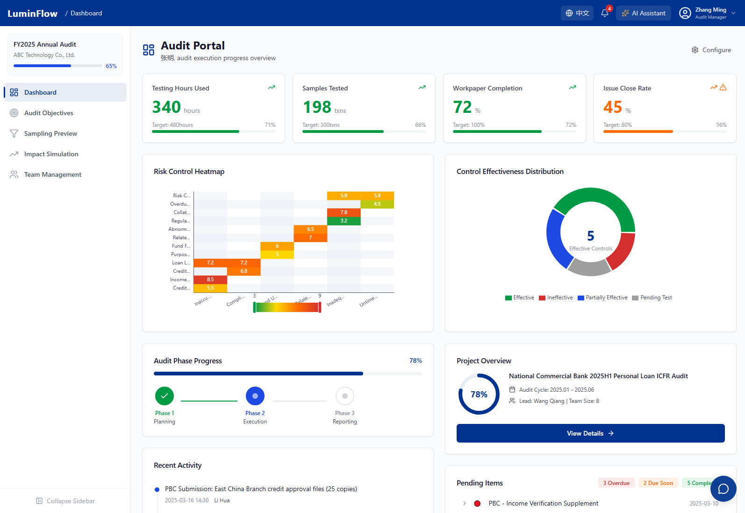
Figure 1: LuminFlow Dashboard — Integrated KPI Overview with Risk Heatmap and Activity Timeline

4.1 Foundational Assumptions
Five core assumptions about the evolving audit landscape:
- Transparency Demand is Structural: Clients expect real-time, contextual audit visibility driven by regulatory pressure and governance expectations.
- Fragmentation Erodes Trust: Disparate channels prevent coherent understanding, breeding anxiety and eroding confidence.
- Early Visibility Prevents Escalation: Surprises drive client-auditor conflict; pre-request visibility defuses tension before it escalates.
- Context Over Volume: Clients need context, not more data points. Methodology explanation creates understanding where raw numbers create confusion.
- Differentiated by Role: CFOs, audit directors, and IT managers have fundamentally different information needs requiring tailored communication.

4.2 Design Rationale — Why We Built LuminFlow This Way
Key design decisions and rationale:
- Three-Phase Architecture: Each phase serves distinct client needs — scope clarity (Planning), progress transparency (Execution), impact understanding (Communication).
- AI Sampling Preview: Exposes sampling logic upfront — sample ranges, document predictions, methodology — BEFORE selection, replacing post-hoc black-box decisions.
- Impact Simulation: Enables proactive scenario analysis, modeling cascading COSO effects before they occur rather than explaining after the fact.
- Role-Based Visibility: Different views for different stakeholders — information relevance varies dramatically by role, not because information is hidden.
- AI as Interpreter: AI translates technical findings into plain-language narratives with explained methodology — judgment stays with audit professionals.

4.3 Business Value — Why This Matters
LuminFlow creates measurable value at three levels, each addressing a distinct stakeholder concern:
- Transforms audit from black-box to transparent, collaborative partnership.
- AI automation frees teams from routine communication, focusing effort on high-judgment work.
- Transparency as competitive differentiator influencing client retention and fee negotiations.

4.4 Prototype Scope &amp; Validation
This prototype validates core assumptions through focused demonstration:
- Synthetic bank lending ICFR data, no real client info.
- Three objectives with full COSO 2013 mapping across all five dimensions.
- Four stakeholder personas with distinct visibility controls and AI-tailored outputs.
- Curated mock data enables full demonstration without API key or external service dependencies.

Appendix. Tools & Capabilities
Category | Technology | Purpose
Frontend Framework | React 18 + TypeScript + Vite | Component-based SPA with type safety
Styling | Tailwind CSS + shadcn/ui | Consistent design system
Visualization | D3.js, ECharts, Recharts | Interactive charts and force graphs
State Management | Zustand | Lightweight role/language/UI state
Data Fetching | TanStack React Query + Axios | Cached API calls with retry
Backend Framework | FastAPI + Uvicorn | Async REST API with OpenAPI docs
AI / LLM | DeepSeek API (deepseek-chat)  [Currently, can be changed to internally trained LLM through API] | Risk analysis, sampling, narrative, impact
Image Generation | Ark API (doubao-seedream-4.5) | Audit character reference images
Video Generation | Ark Seedance 2.0 API | Promotional video pipeline
Video Post-processing | ffmpeg / ffprobe | SRT subtitles, concat, BGM mixing
Streaming | SSE (Server-Sent Events) | Real-time AI chat responses
Data Validation | Pydantic v2 | Request/response schema enforcement
Prompt Templates | YAML-based (PyYAML) | Modular, version-controlled LLM prompts
Internationalization | Custom i18n + localStorage | Chinese/English bilingual support

— End of Submission —

