LuminFlow Audit Management System
Review Pack / Platform Demo
Functional review, interactive experience, and constructive feedback collection for team members

Item | Description
Platform Positioning | A transparent collaboration platform for the audit domain, enhancing audit visualization, collaboration efficiency, and result credibility.
Demo Scope | Dashboard, Audit Objectives, Sampling Preview, Impact Simulation, Team Management.
Screenshot Language | Main pages use English UI; language switch, role switch, and AI assistant use partial screenshots for illustration.
Supporting Deliverable | Standalone HTML interactive demo page: LuminFlow_Interactive_Demo.html.

1. Quick Tour
LuminFlow integrates audit objectives, control testing, smart sampling, impact simulation, AI-assisted explanations, and team collaboration into a single transparent workbench. Members can use this document to quickly understand each page's features, core operational workflows, and audit workflow value.
Page | Core Purpose | Review Focus
Dashboard | Project cockpit displaying progress, risks, PBCs, pending items, and activity. | Whether KPI definitions cover management and audit team needs.
Objective | Audit objectives, control points, deficiencies, and COSO relationship graph. | Whether node granularity, deficiency priorities, and evidence linkage are reasonable.
Sampling | Risk-oriented sampling recommendations with AI logic explanations. | Whether sampling rationale is auditable, defensible, and documentable.
Impact | Cascading impact simulation and mitigation recommendations for change events. | Whether impact chains and recommendations align with professional judgment.
Team | Multi-role collaboration, AI approval, client interaction, and evidence checking. | Whether permission boundaries and approval mechanisms meet quality control requirements.

2. Role & Permission Model
Role | Focus Areas | Typical Visible Capabilities
CFO / Client Management | Project status, risk summaries, PBC responses, client interactions. | Simplified dashboard, client interaction statistics, approved AI summaries.
Auditor / Audit Manager | Execution progress, control testing, sampling plans, evidence completeness. | Full workbench, sampling parameters, AI approval queue, evidence checker.
Partner / Engagement Partner | Quality review, significant matters, review comments, and risk judgments. | Review KPIs, approval queue, QC perspective, and high-risk items.

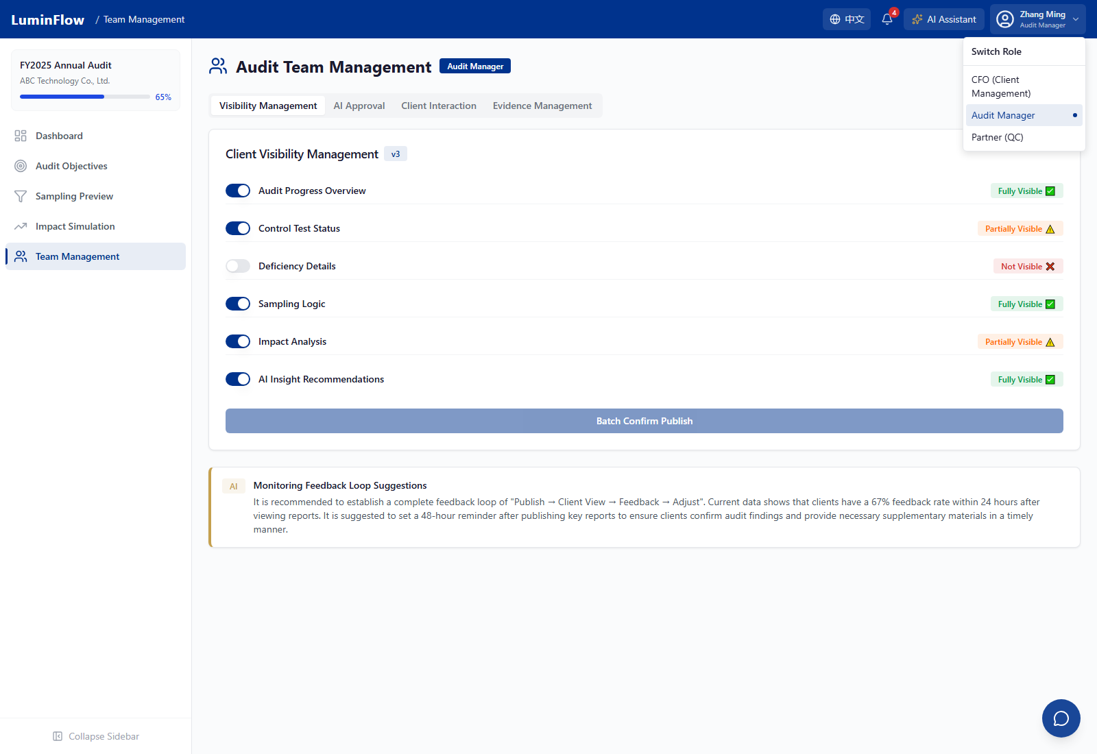
Role switcher partial screenshot: CFO, Audit Manager, Partner — three perspective entry points.

3. Global AI & Internationalization Capabilities
- Multi-language Support: Based on zustand state management and a custom useTranslation hook, default language is English, with toggle state persisted to localStorage.
- Full-stack i18n Coverage: Navigation, buttons, labels, table column names, mock data, AI-generated content, dynamic fields, and chart titles all support both English and Chinese.
- AI Assistant Mechanism: The frontend sends the current page route, user role, and conversation content as context to the backend, supporting page-relevant quick prompts and streaming responses.
- No-API-Key Fallback: When backend environment variables are not configured, a mock mode demonstrates AI capabilities and recommendation logic.
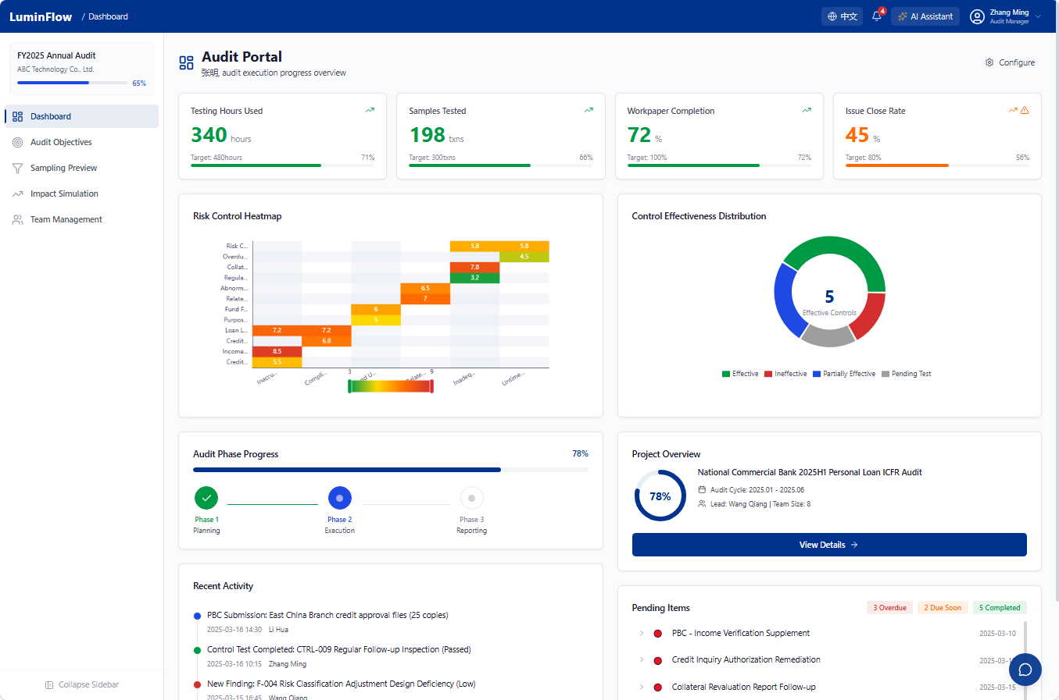
Language switch partial screenshot: English main interface with one-click Chinese toggle.
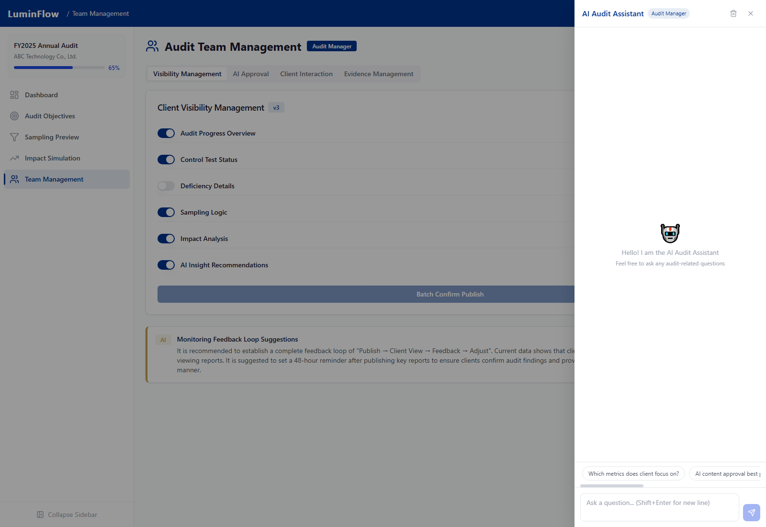
AI Assistant partial screenshot: drawer-style conversation, role context tags, quick prompts, and input field.

Dashboard
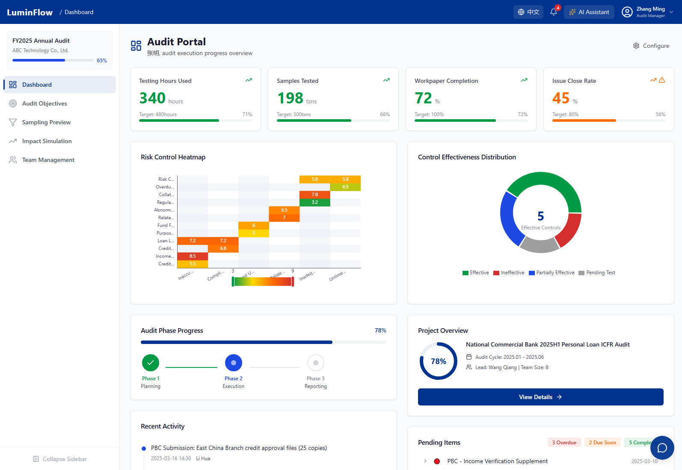
Dashboard main page screenshot

Page Objective
Serves as the audit project cockpit, centrally presenting project progress, key metrics, risk hotspots, control status, pending items, and activity timeline.

Core Modules
- KPI Cards: Filter by role to display overall audit progress, control coverage, PBC completion rate, deficiency count, and risk scores.
- Risk Heatmap: Renders risk-control hotspots based on the RCM matrix and RAWTC scores, helping quickly identify high-risk control points.
- Status Doughnut / Pending Items: Shows control test status distribution, overdue PBC items, and pending tasks.
- Activity Timeline: Records key deliverables, approvals, client responses, and review activities.

Core Workflow
1. Enter the Dashboard to review overall project health and key risk indicators.
2. Switch between CFO, Audit Manager, and Partner views to observe how the same project appears with different permission scopes.
3. Navigate from high-risk KPIs, overdue PBCs, or the risk heatmap into Objective, Sampling, or Team modules for deeper analysis.

Audit Workflow Value
The Dashboard enables management and project teams to communicate progress and risks on a shared factual basis, reducing information asymmetry in audit status reporting.

Feedback Suggestions
Members should assess whether KPI definitions cover the three core needs: project management, quality review, and client communication.

Audit Objectives
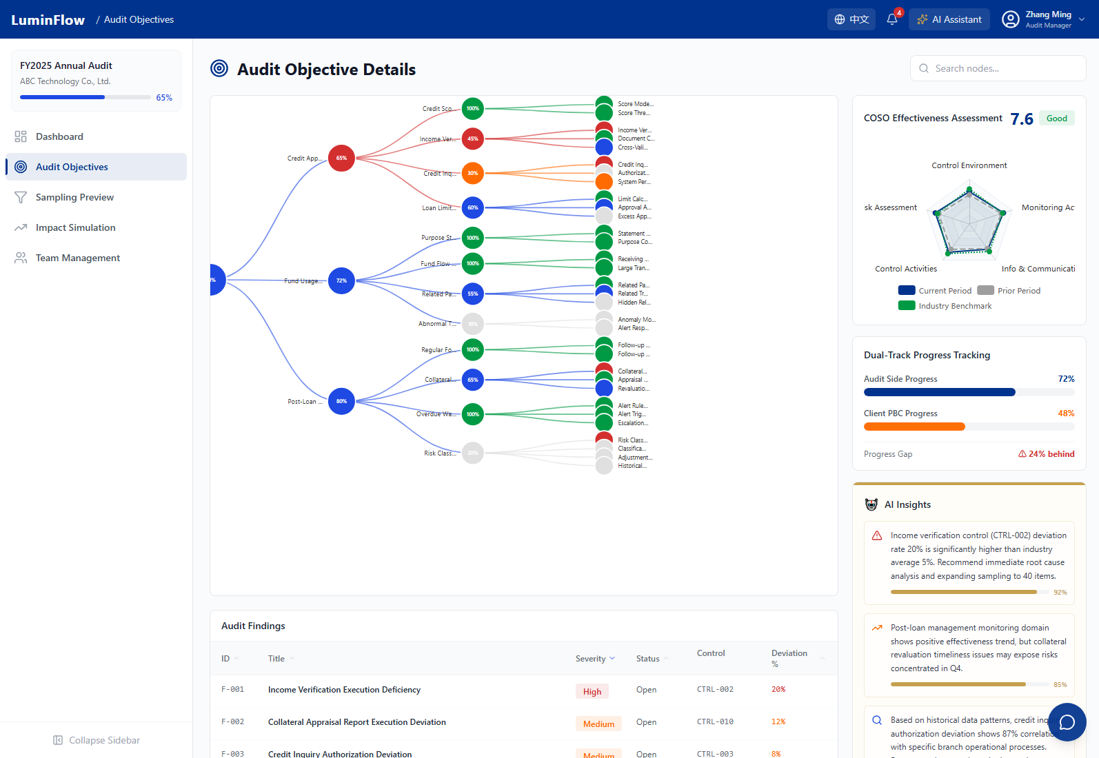
Audit Objectives main page screenshot

Page Objective
Visualizes relationships between audit objectives, risk areas, control points, test procedures, and findings using a tree diagram and linked cards.

Core Modules
- AuditTreeD3: Displays the audit objective hierarchy, control point statuses, deficiency nodes, and risk areas.
- Node Detail: Click a node to view control description, execution status, risk score, findings, and remediation suggestions.
- RadarChart / DualProgress: Shows COSO coverage, audit progress, and client-side response progress.
- FindingsTable / AIInsightPanel: Summarizes deficiency severity, deviation rates, impact assessments, and AI priority recommendations.

Core Workflow
1. Locate a control point or finding using the search box, e.g., CTRL-002 Income Proof Review.
2. Click a node to open details and inspect test procedures, COSO mapping, and deficiency evidence.
3. Combine the radar chart, dual progress bars, and findings table to determine the next review or remediation priority.

Audit Workflow Value
The Objectives page transforms the traditional audit matrix into an explorable graph, making it easier for Members to inspect test coverage completeness and control-deficiency propagation relationships.

Feedback Suggestions
Members should evaluate whether node granularity, COSO mapping, and deficiency priorities align with actual audit methodology.

Sampling Preview
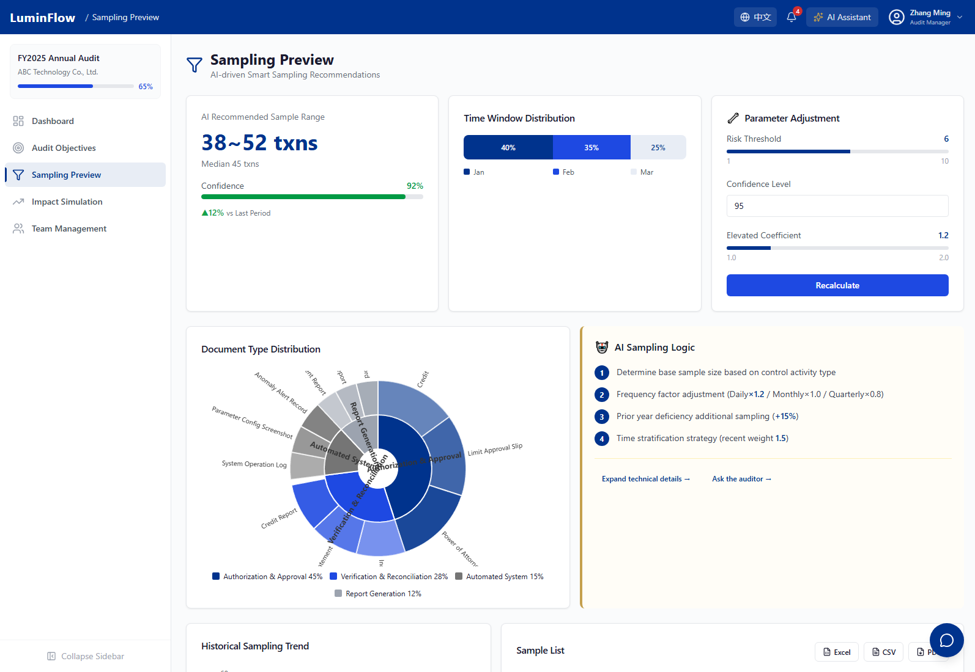
Sampling Preview main page screenshot

Page Objective
Generates explainable smart sampling plans based on population size, risk scores, confidence levels, prior-year deficiencies, and system changes.

Core Modules
- SampleSizeCard: Displays recommended sample range, population size, confidence level, and period.
- ParamAdjuster: Allows adjustment of risk threshold, confidence level, and high-risk control weighting factor.
- SunburstChart / TimeWindowCard: Shows document category distribution and time-window distribution.
- AILogicExplainer / SampleTable: Explains the sampling rationale and displays sample details.

Core Workflow
1. reviews the system-recommended sample range and document distribution.
2. Adjust confidence level or risk threshold, then recalculate sample size.
3. Review the AI explanation, historical trends, and sample details to determine whether the sampling plan is auditable and defensible under challenge.

Audit Workflow Value
Smart Sampling transforms sampling rationale from black-box experience into explainable, adjustable, and auditable risk-oriented plans.

Feedback Suggestions
Members should assess whether sampling parameters, sample distribution, and explanation text are sufficient to support workpaper documentation.

Impact Simulation
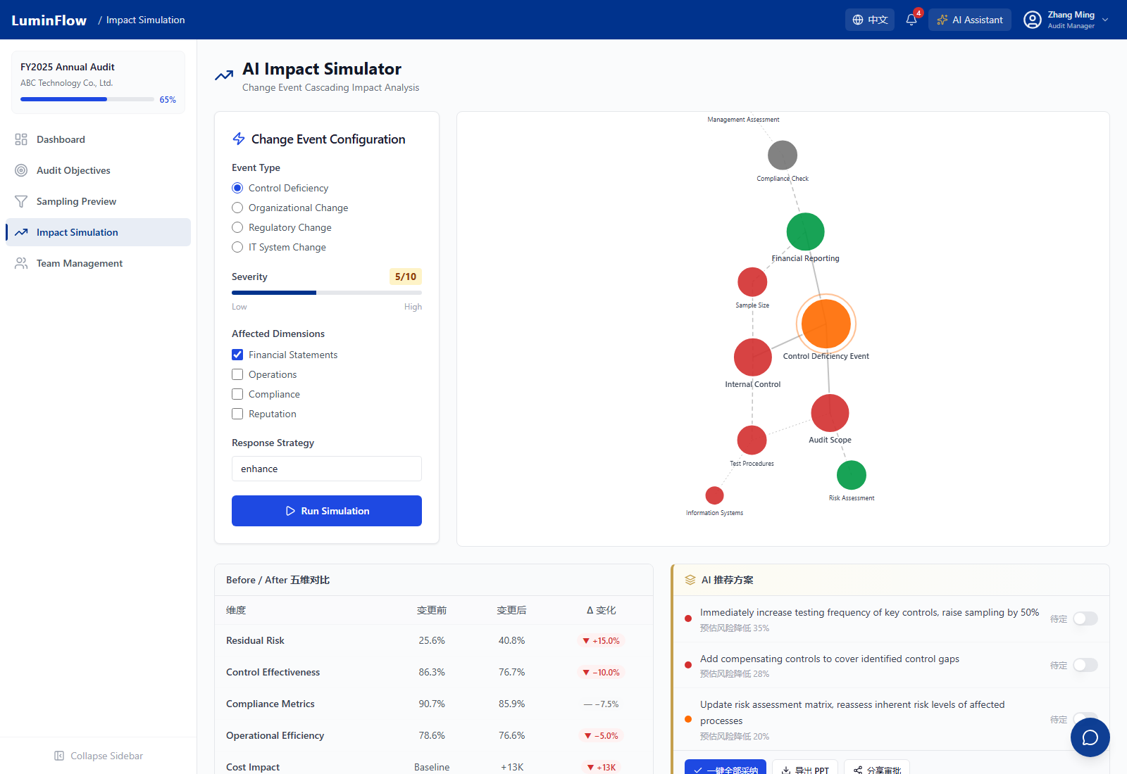
Impact Simulation main page screenshot

Page Objective
Simulates the cascading impact of control deficiencies, organizational changes, regulatory changes, or IT system changes on audit scope, sample size, timeline, and risk indicators.

Core Modules
- EventConfig: Configure event type, severity, impact dimensions, and response strategy.
- ForceGraphD3: Displays direct, indirect, and potential impact nodes as a network graph.
- ComparisonTable: Compares residual risk, control effectiveness, compliance indicators, operational efficiency, and cost impact before and after simulation.
- AIRecommendations: Generates mitigation suggestions, priorities, and risk reduction estimates based on simulation results.

Core Workflow
1. Select a change event and set severity, impact dimensions, and response strategy.
2. Click Run Simulation and wait for the network node propagation animation and computation to complete.
3. Review impact chains, indicator changes, and AI recommendations, then decide whether to adjust audit scope or add compensating controls.

Audit Workflow Value
Impact Simulation transforms risk events from static descriptions into dynamic decision-support evidence, enabling Members to proactively assess the impact of changes on audit plans.

Feedback Suggestions
Members should focus on verifying whether impact dimensions, propagation logic, and AI recommendations align with professional audit judgment.

Impact Simulation Supplementary Screenshots
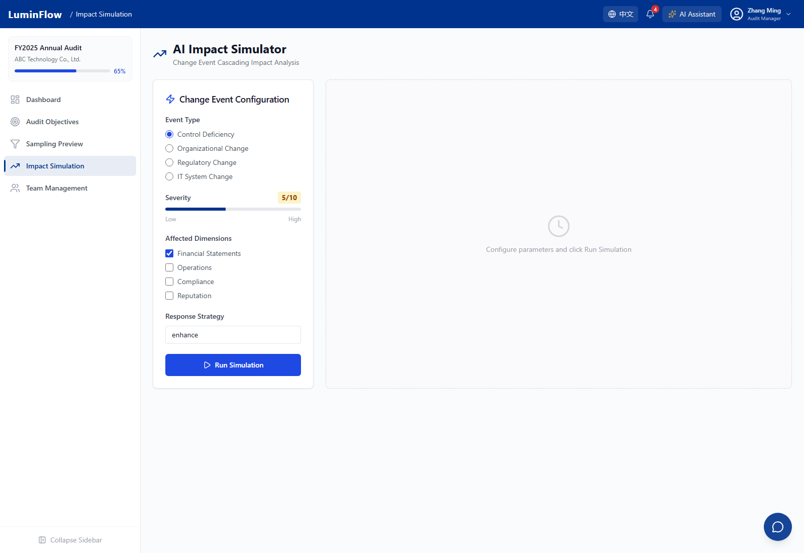
Impact simulation configuration state: selecting event type, severity, impact dimensions, and response strategy.
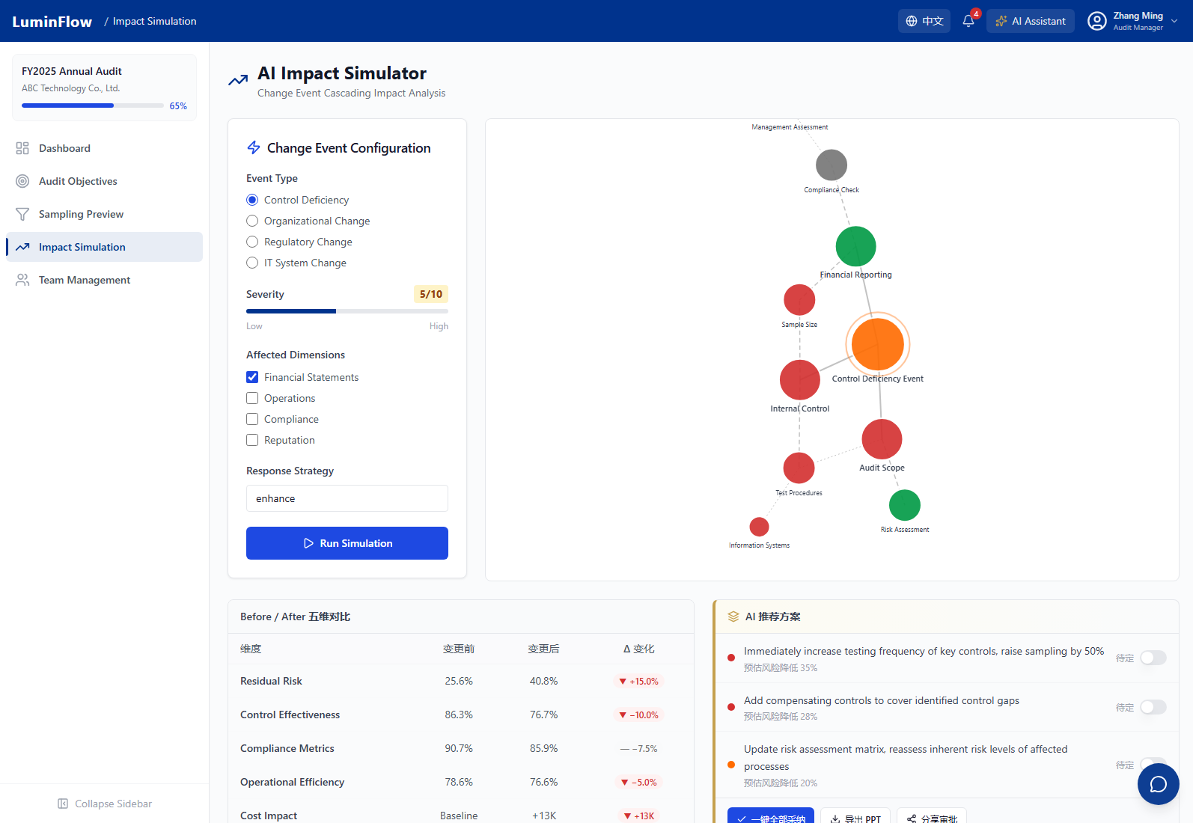
Impact simulation loading state: processing animation and network visualization during simulation execution.

Team Management
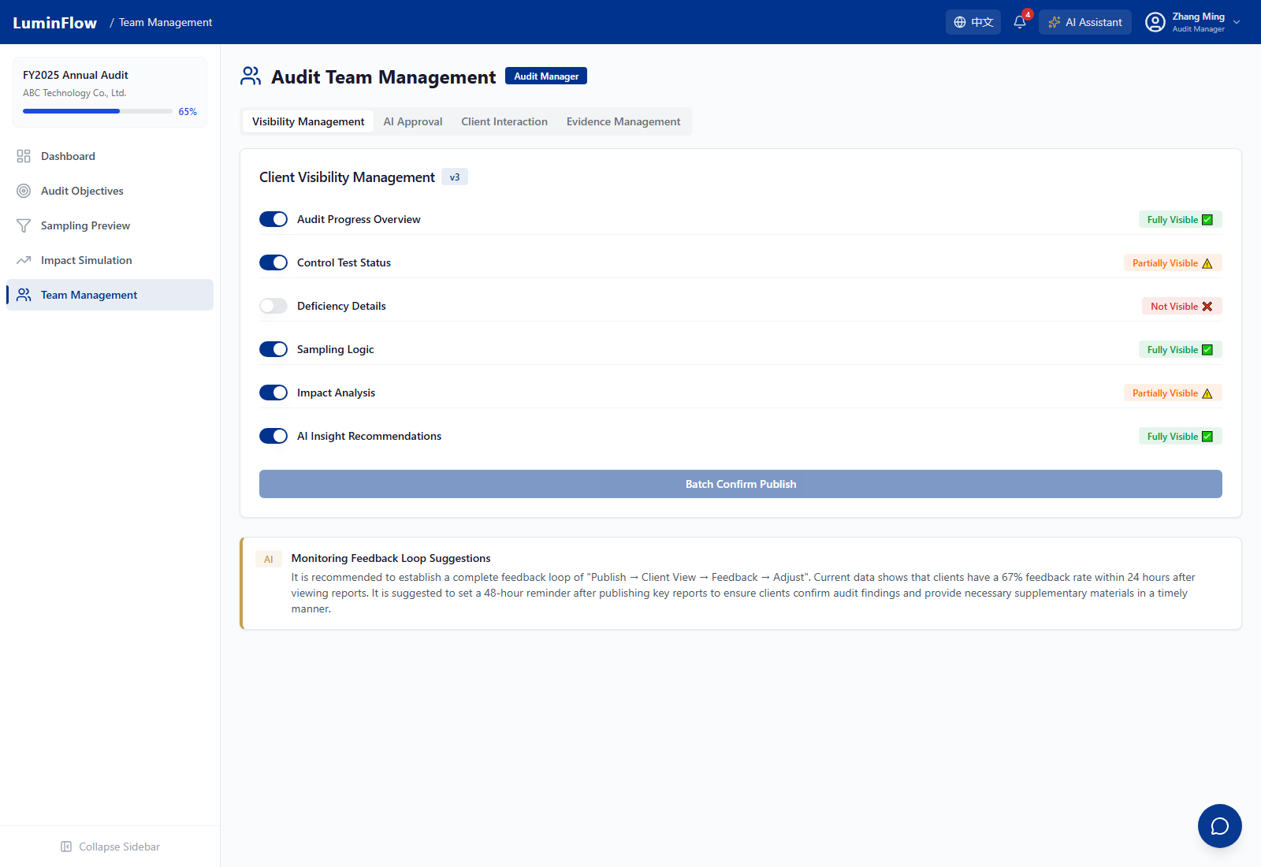
Team Management main page screenshot

Page Objective
Supports transparent collaboration among audit teams, clients, and partners through visibility management, AI approval workflows, client interaction statistics, and evidence checking.

Core Modules
- VisibilityPanel: Controls content boundaries for client-visible, team-internal, and partner-review views.
- ApprovalQueue: Routes AI-generated content through Audit Manager approval and Partner QC review, preventing unconfirmed information from being released externally.
- InteractionChart / HotQuestionsBar: Tracks client questions, hot topics, and response efficiency.
- EvidenceChecker: Checks critical evidence for missing, overdue, and review status.

Core Workflow
1. Audit Manager reviews team collaboration and visibility status.
2. Approve AI-generated summaries or client responses, escalating to Partner review when necessary.
3. Combine client interaction hotspots with evidence check results to drive PBC supplementation and deficiency closure.

Audit Workflow Value
The Team page increases transparency while preserving audit quality control and permission boundaries, reducing risks in client communication and AI output.

Feedback Suggestions
Members should evaluate whether approval granularity, evidence check rules, and client visibility boundaries meet project quality control requirements.

Feature Highlights Summary
Highlight | Innovation Value | Evaluation Question
Impact Simulation | Transforms control deficiencies and business changes into visual impact chains. | Does the propagation logic align with actual audit judgment?
Smart Sampling | Generates sample recommendations combining risk scores, confidence, deficiency history, and branch coverage. | Are sampling explanations sufficient for workpaper inclusion?
Audit Objective Graph | Places audit objectives, controls, tests, and findings into a single relationship network. | Does the node hierarchy align with project methodology?
AI Contextual Assistant | Generates explanations, recommendations, and communication summaries based on current page and role. | Does AI output need more citations and evidence constraints?
Multi-Role Transparent Collaboration | Establishes approval and visibility boundaries between client transparency and quality control. | Do permission boundaries meet independence and disclosure requirements?

Improvement Suggestions Collection Form
Feedback Dimension | Comments | Priority | Follow-up Actions
Business Value
Usability & Interaction
Data Credibility
AI Explainability
Role Permissions
Deliverable Fit

