Name: Gautham Radheepan

Student Name: 300072428

Email: gradh033@uottawa.ca

Test Case: 2001



Test Case: 2002

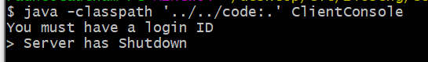

Test Case: 2003

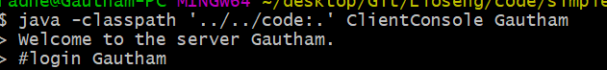

Test Case: 2004

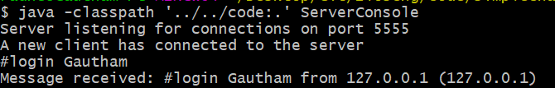

Test Case: 2005

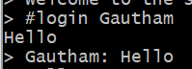



Test Case: 2006



Test Case: 2007

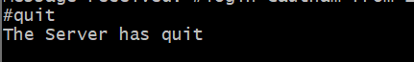

Test Case: 2008



Test Case: 2009



Test Case 2010:

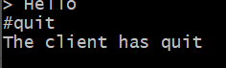

Test Case 2011:

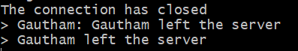

Test Case 2012:

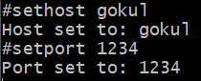

Test Case 2013:



Test Case 2014:

