Test 2001:



Test 2002:

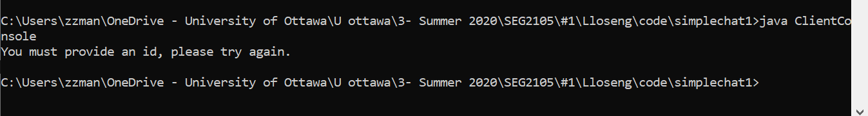

Test 2003:

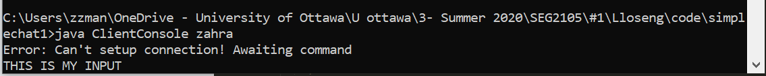

Test 2004:

Server side:

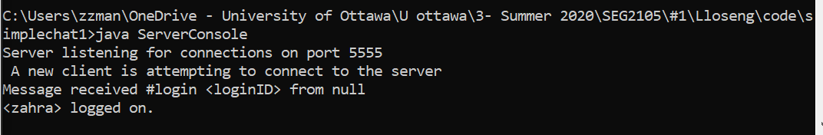

Client side:



Test 2005:

Server side:

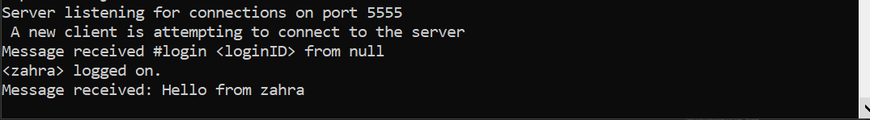

Client side:



Test 2006:

Server side:

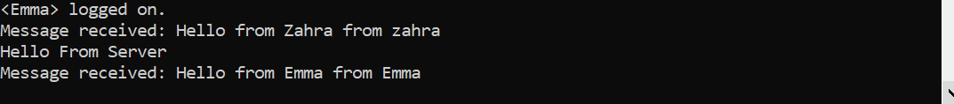

Client 1:

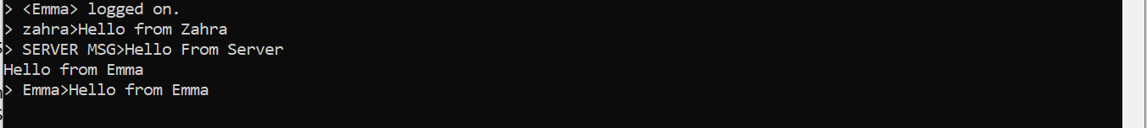

Client 2:

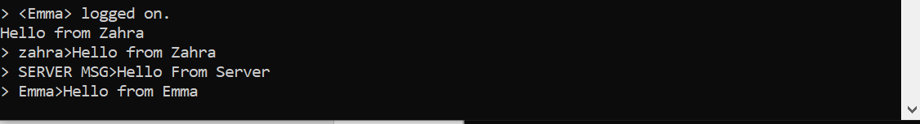

Test 2007:

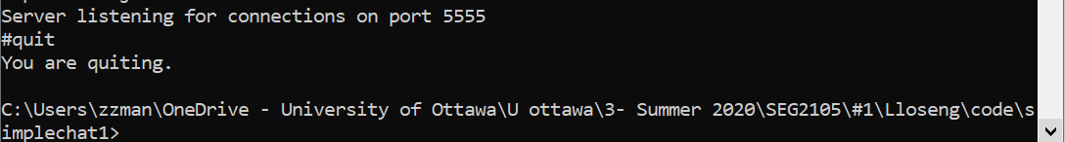

Test 2008:

Server side:

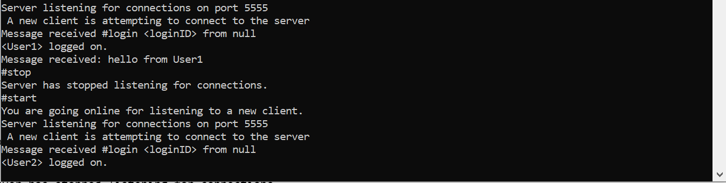

Client 1:

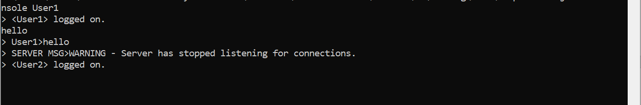

Client 2:



Test 2009:

Server side:

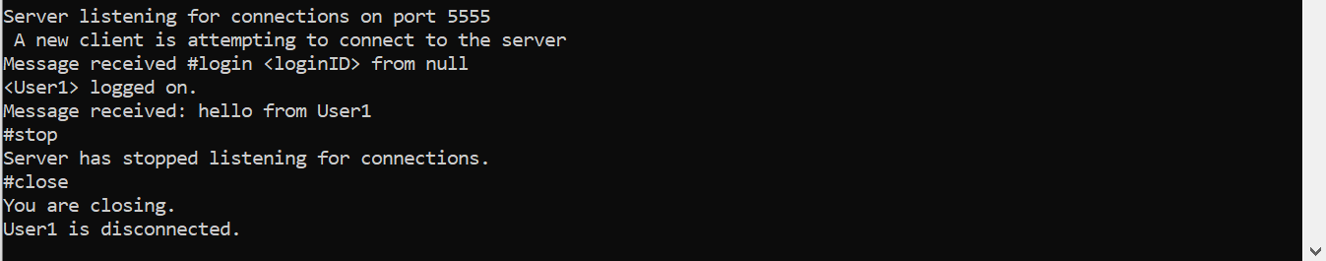

Client side:

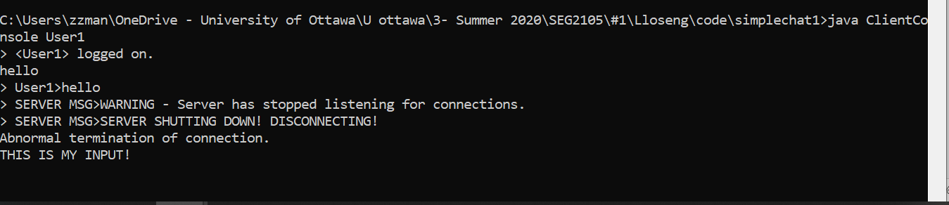

Test 2009: (Respectively, since there were two Test cases for #2009)

Server side:

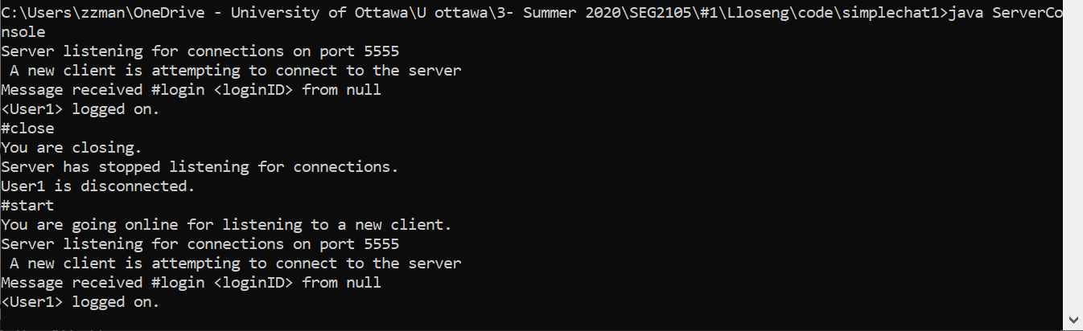

Client side:

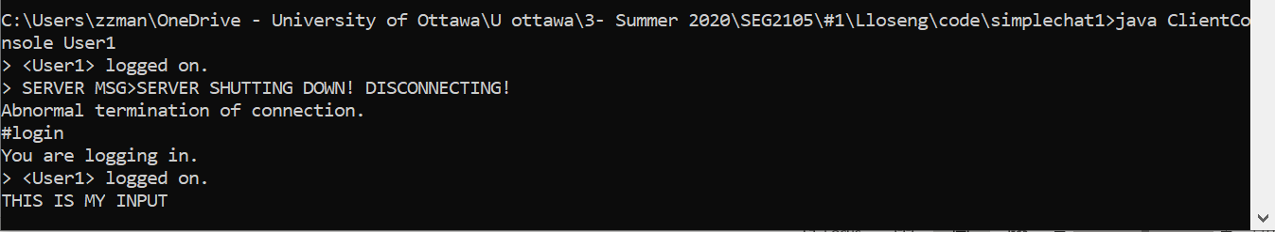

Test 2010:

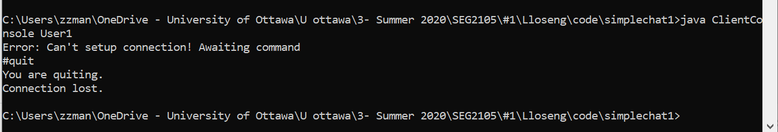

Test 2011:

Server side:

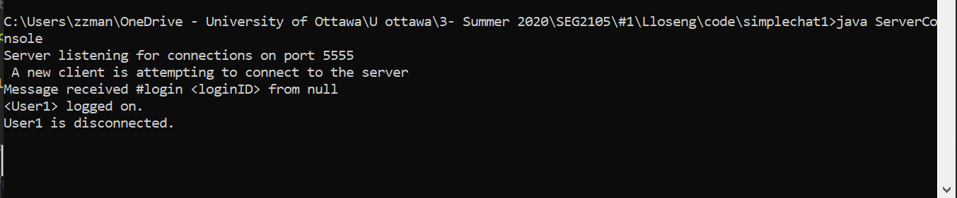

Client side:

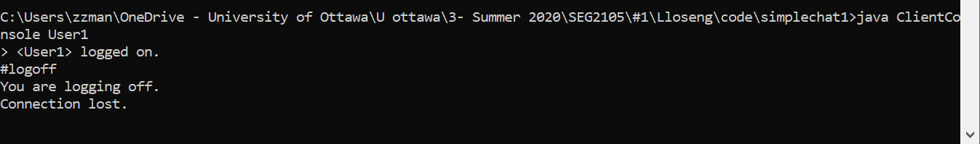

Test 2012:

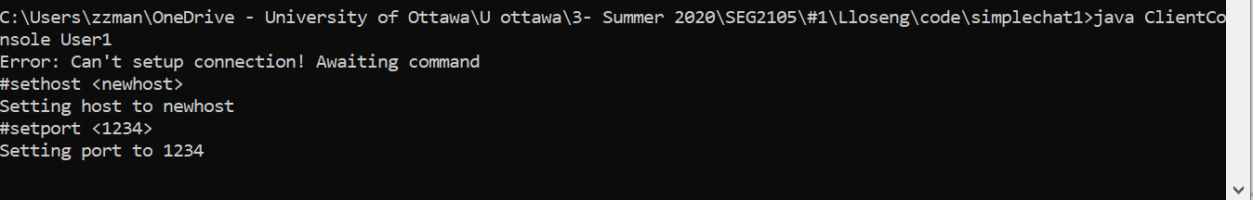

Test 2013:



Test 2014:

Server side:

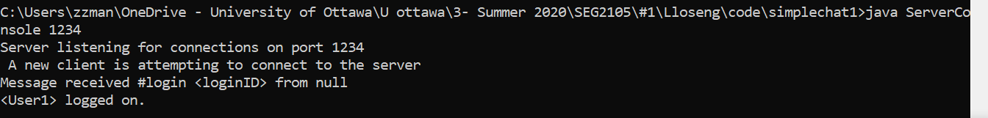

Client side:



Test 2015:

* I did not have two computers.

Test 2016:

* I did not have two computers.

Test 2017:

Server side:

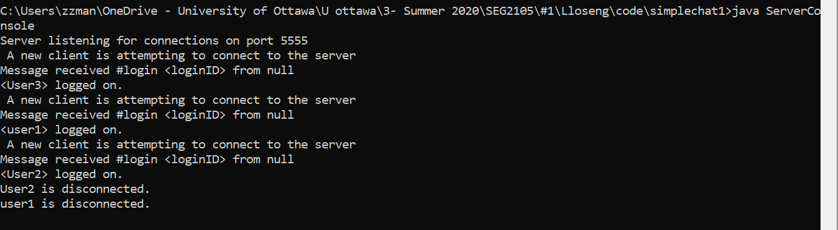

Client 1:

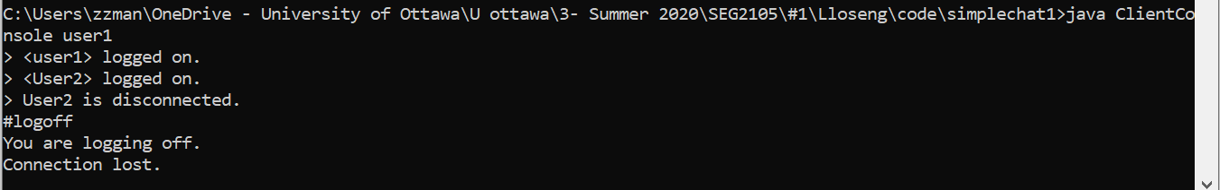

Client 2:

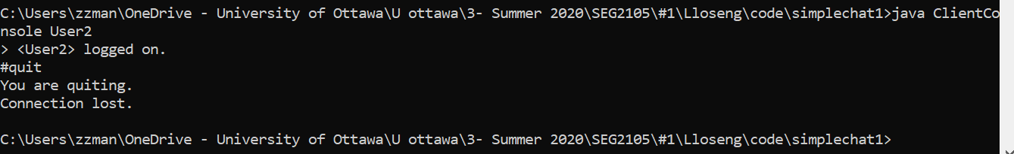

Client 3:

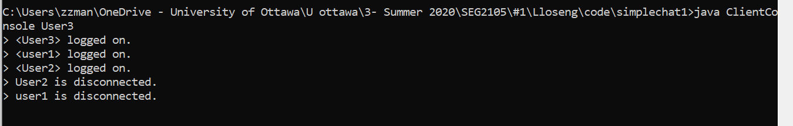

Test 2018:

* I did not have any access to other platforms.

Test 2019:

* I did not have any access to other platforms.

Test case 1001:



Test case 1002:

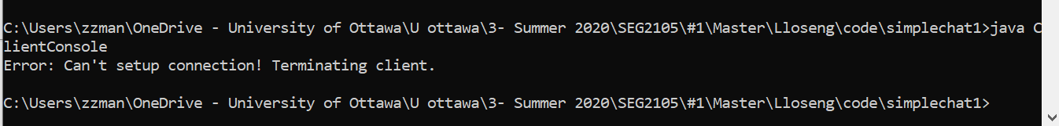

Test case 1003:

Server side:



Client side:

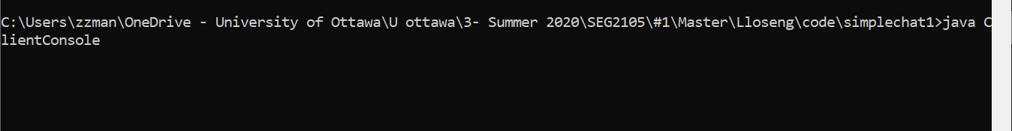

Test case 1004:

Server side:

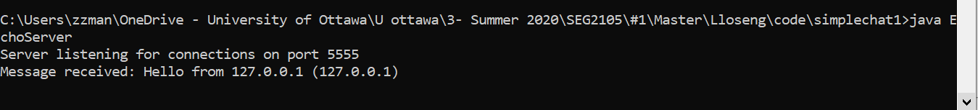

Client side:



Test case 1005:

Server side:

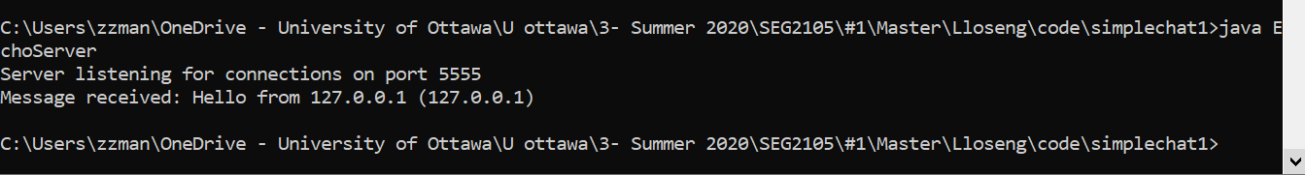

Client side:

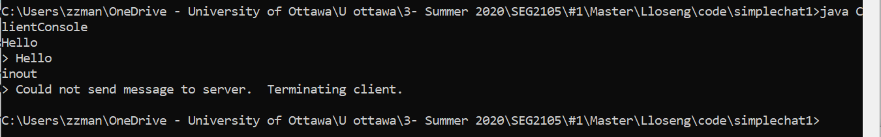

Test case 1006:

Server side:

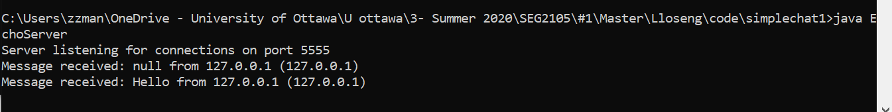

Client 1:

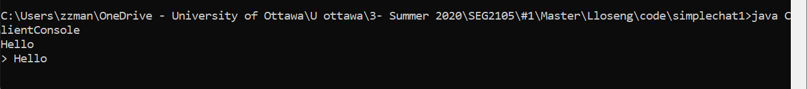

Client 2:

