Name: Émilie Fortin

Student Number: 6338858

Email: [efort063@uottawa.ca](mailto:efort063@uottawa.ca)

Testcase 2001

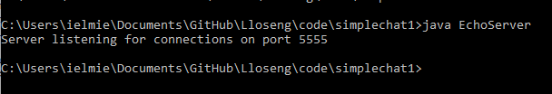

Testcase 2002



Testcase 2003

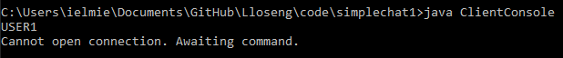

Testcase 2004

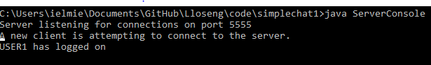

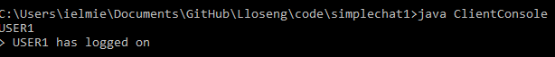

The way I interpreted the instructions was that we didn’t want the #login loginId to be received as a message, we instead wanted all parts of question 7c to happen behind the scenes which is why the following is missing:

A new client is attempting to connect to the server.

Message received #login <loginID> from null.

<loginID> has logged on.

Testcase 2005

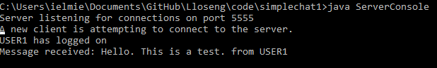

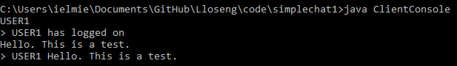

Testcase 2006

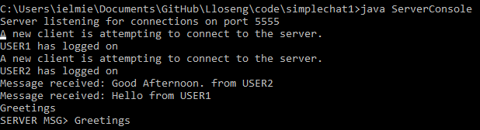

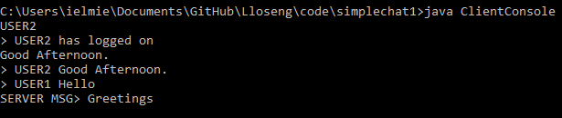

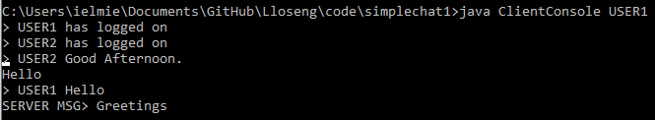

Testcase 2007

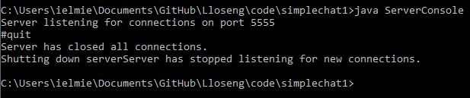

Testcase 2008

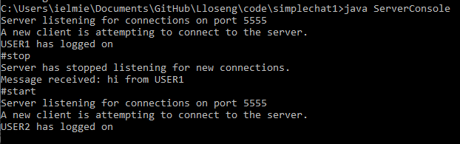

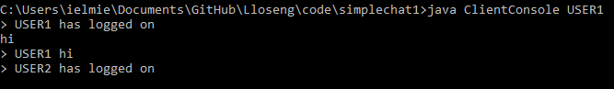



Testcase 2009 (1st)

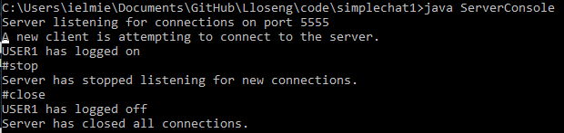

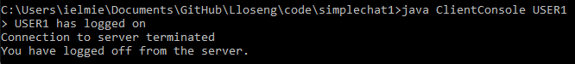

Testcase 2009 (2nd)

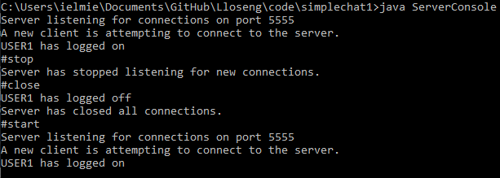



Testcase 2010

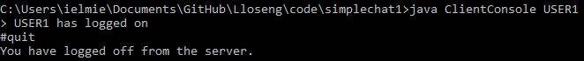

Testcase 2011

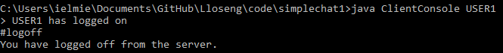

Testcase 2012

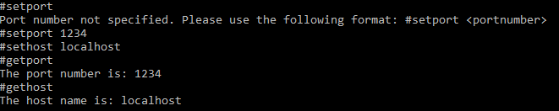

In my implementation, #setport and #sethost do not show anything on screen. You need to call the getters (#getport and #gethost) to see the values printed out.

Testcase 2013



Testcase 2014

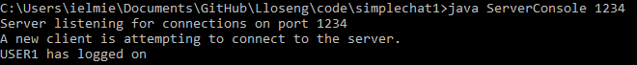



Testcase 2015

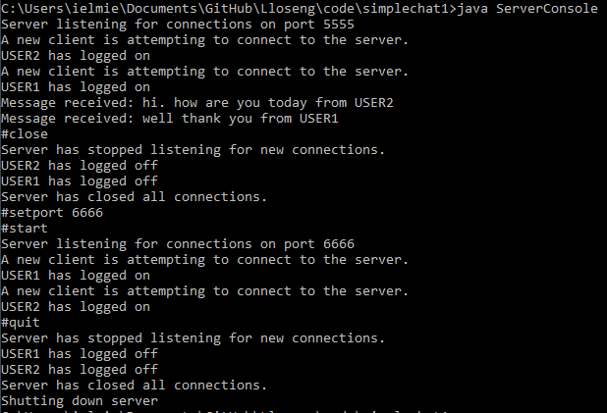

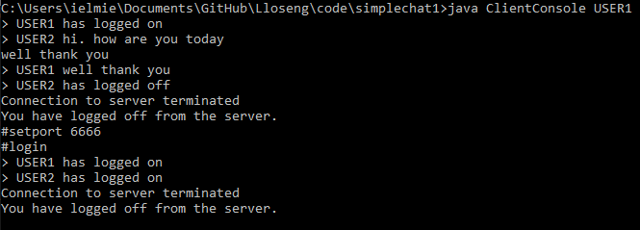

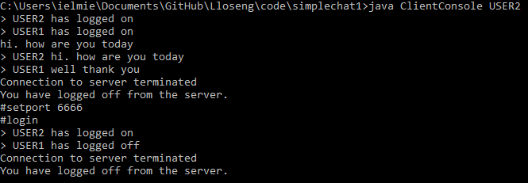

Testcase 2016

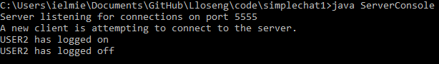

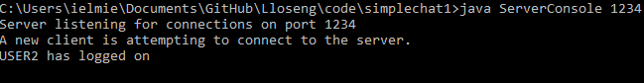

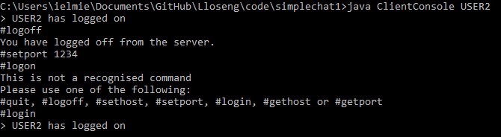

Since I only have one computer at my disposal, I had to change the port number instead since they are both localhosts. Sorry, it’s the best I could do under the circumstances. I’ve also included what happens when someone enters an incorrect command since I made a typo.

Testcase 2017

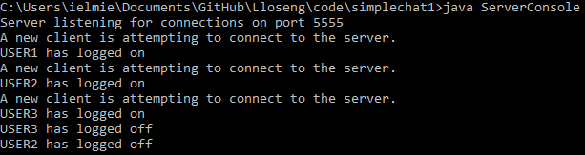

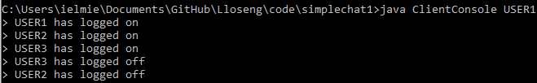

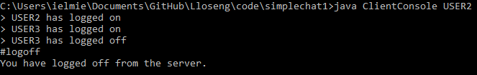

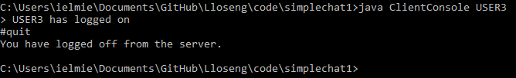

Testcase 2018 & Testcase 2019

Since we do not have access to the school’s computers at the moment, we were told that these tests were not necessary.