Assignment 4.2: High/Low Temperatures
Timothy Martin
CSD 325
June 23, 2026
Program Flow Before:
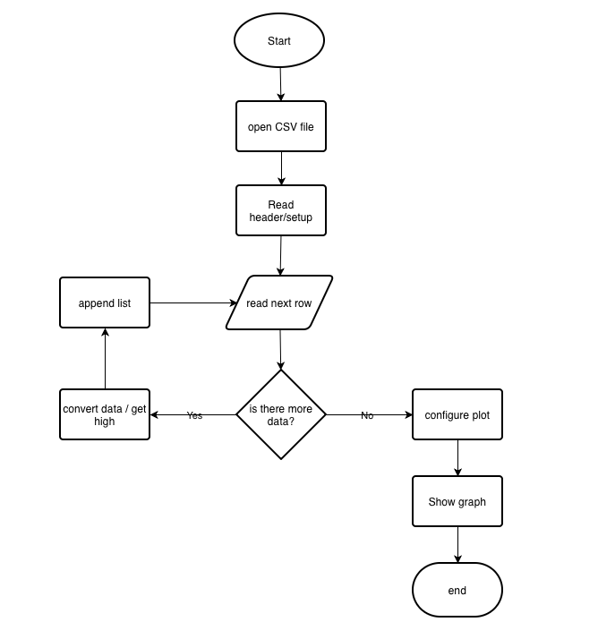
Program Flow After:
