CSD 310 Case Study Group D - Milestone #2
----------------------------------------------------------------------------------------------------------------------------
Timothy Martin
Roxanne Buenaventura
Peter Ddamulira
Jonathon Walmsley
Selected Case Study = Bacchus Winery
----------------------------------------------------------------------------------------------------------------------------
Business rules
Supplier and Delivery Rules
- One supplier can have many deliveries.
- Each delivery comes from one supplier.
- One delivery can contain many inventory items.
- One inventory item can appear in many deliveries over time.
Inventory Rules
- Each inventory item has one inventory record.
- Each inventory item tracks the quantity received and current stock level.
- Inventory items include production supplies such as bottles, corks, labels, boxes, vats, and tubing.
Wine Distribution Rules
- One distributor can carry many wines.
- One wine can be carried by many distributors.
- Each shipment is sent to one distributor.
- One shipment can contain many wines.
- One wine can appear on many shipments.
Employee Rules
- One department can have many employees.
- Each employee belongs to one department.
- One employee can have many timesheets.
- Each timesheet belongs to one employee.
Wine Production Rules
- The winery produces multiple wines.
- Each wine has a unique wine identifier.
- Each wine can be included in many shipments.
Shipment Rules
- One distributor can receive many shipments.
- Each shipment has one shipment date and delivery status.
- Each shipment contains one or more wines.
------------------------------------------------------------------------------------------------------------------
Revised Entity Relationship Diagram (ERD)
------------------------------------------------------------------------------------------------------------------
Screenshots of Database Tables
Suppliers
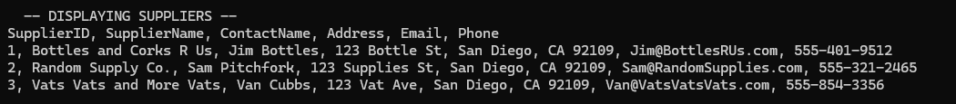
Deliveries
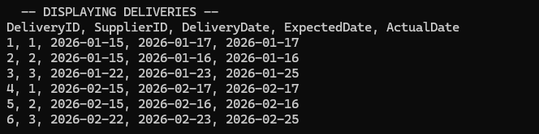
Delivery Items
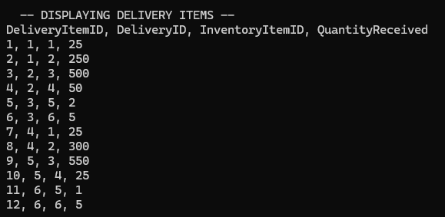
Inventory Items
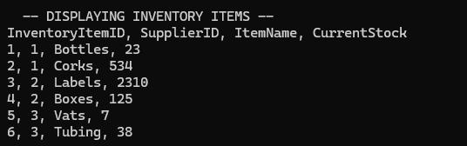
Wines
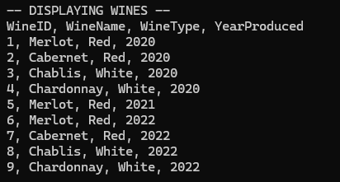
Shipments
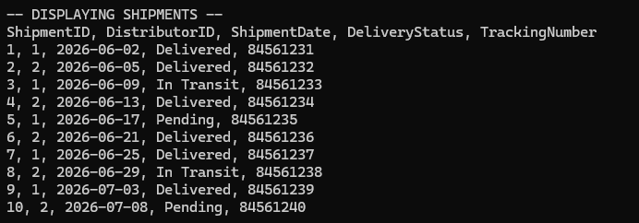
Wine Shipments
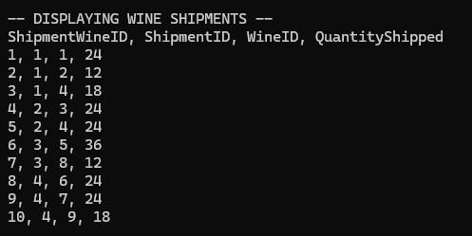
Distributors
Departments
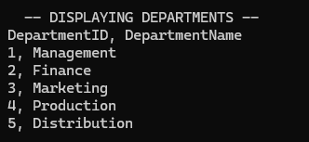
Employees
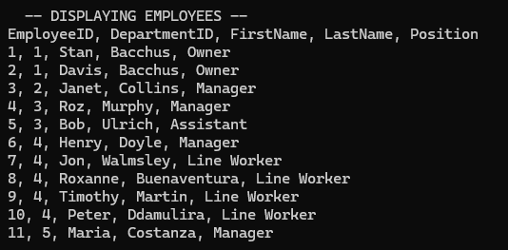
Timesheets
