Assignment 4.2 MySQL Install
Timothy Martin
CSD 310
June 24, 2026

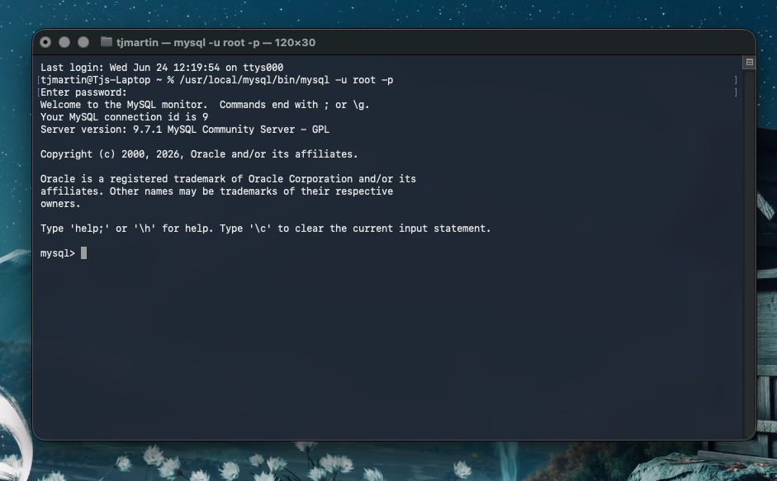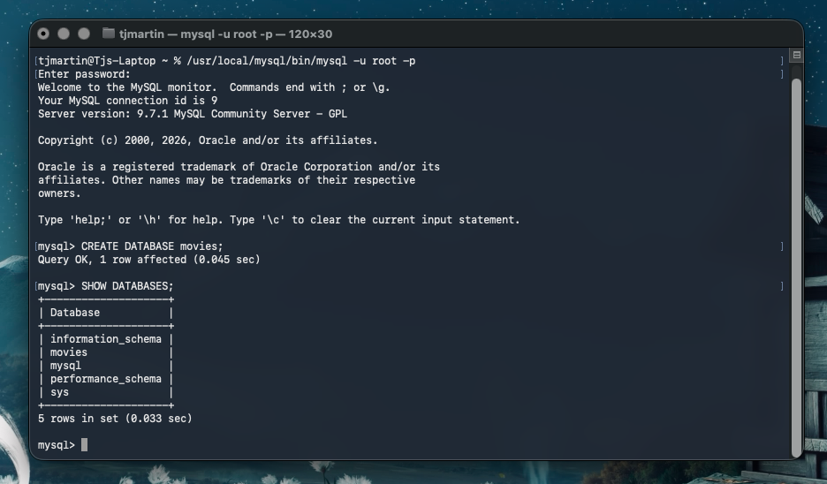

The NOW() function returns the current date and time from the MySQL server. It can be useful when recording timestamps, tracking transactions, or logging activity within a database.
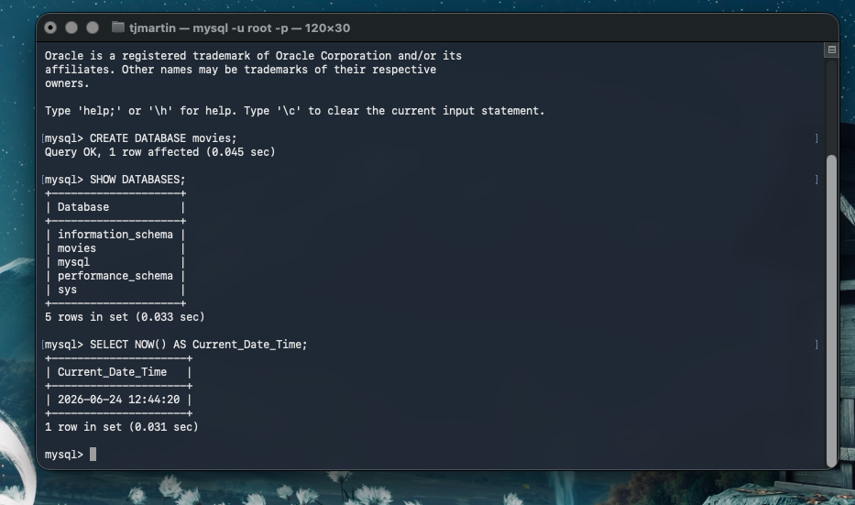
The UPPER() function converts all letters in a string to uppercase. It can be useful when standardizing data or performing case-insensitive comparisons.
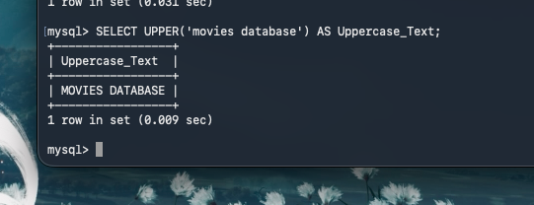

The LENGTH() function returns the number of characters in a string. It can be useful for validating data length requirements or checking input values.
