Assignment 2.2 Documented Debugging + Flowchart
Timothy Martin
CSD 325
June 11, 2026
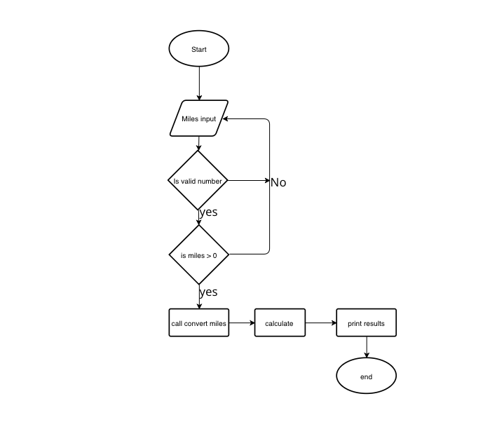
Breakpoint set before the function call.
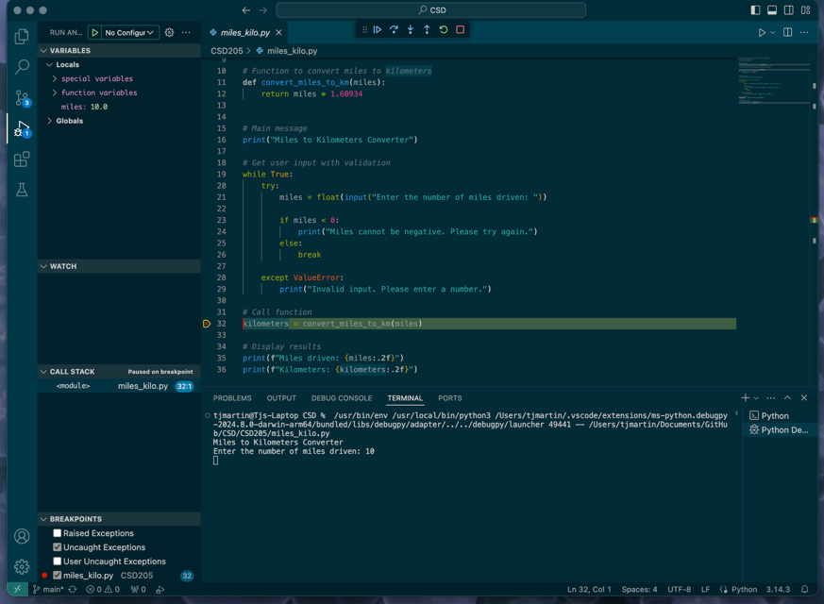
Using Step Into to enter the convert_miles_to_kilometers() function.
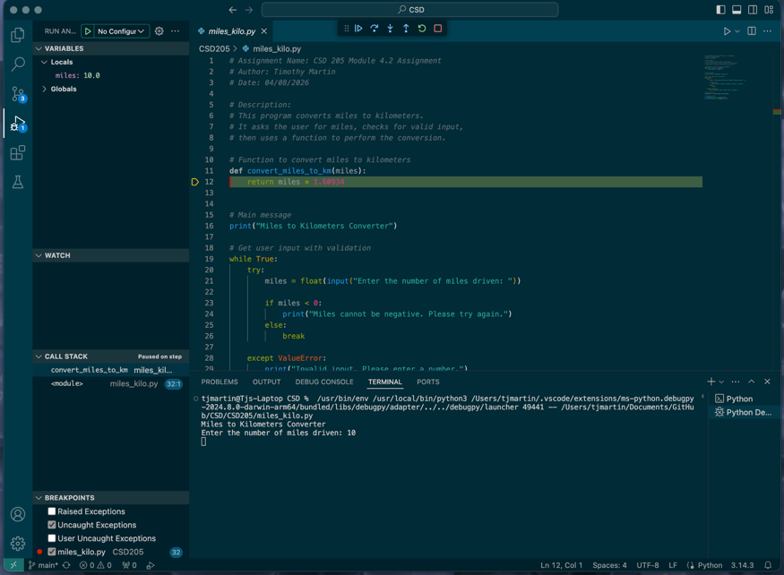
Continuing execution and viewing the calculated kilometers value.
