Klassen übersicht
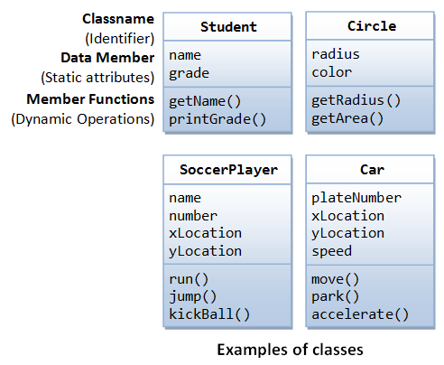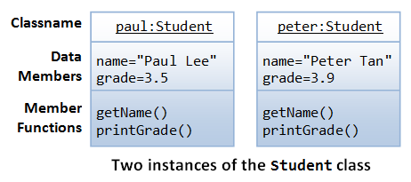

Class Pattern

Attributes

Pattern Type
In this attribute the Type of Pattern will be stored, e.g. is the Pattern a circle, Square, Triangle or rectangle

Colour
In this attribute the Colour of the Pattern will be stored, e.g.

Image
This Attribute saves the Image in which the Patterns are being detected

Methodes

Yolo Pattern detection
Detect all the Patterns which are on the current Image and Create an ROI around it. Then Create the Subclasses belonging to them.
This Methode opens all

