**Compte rendu TP XML 1**

**Step 1**

Question 1

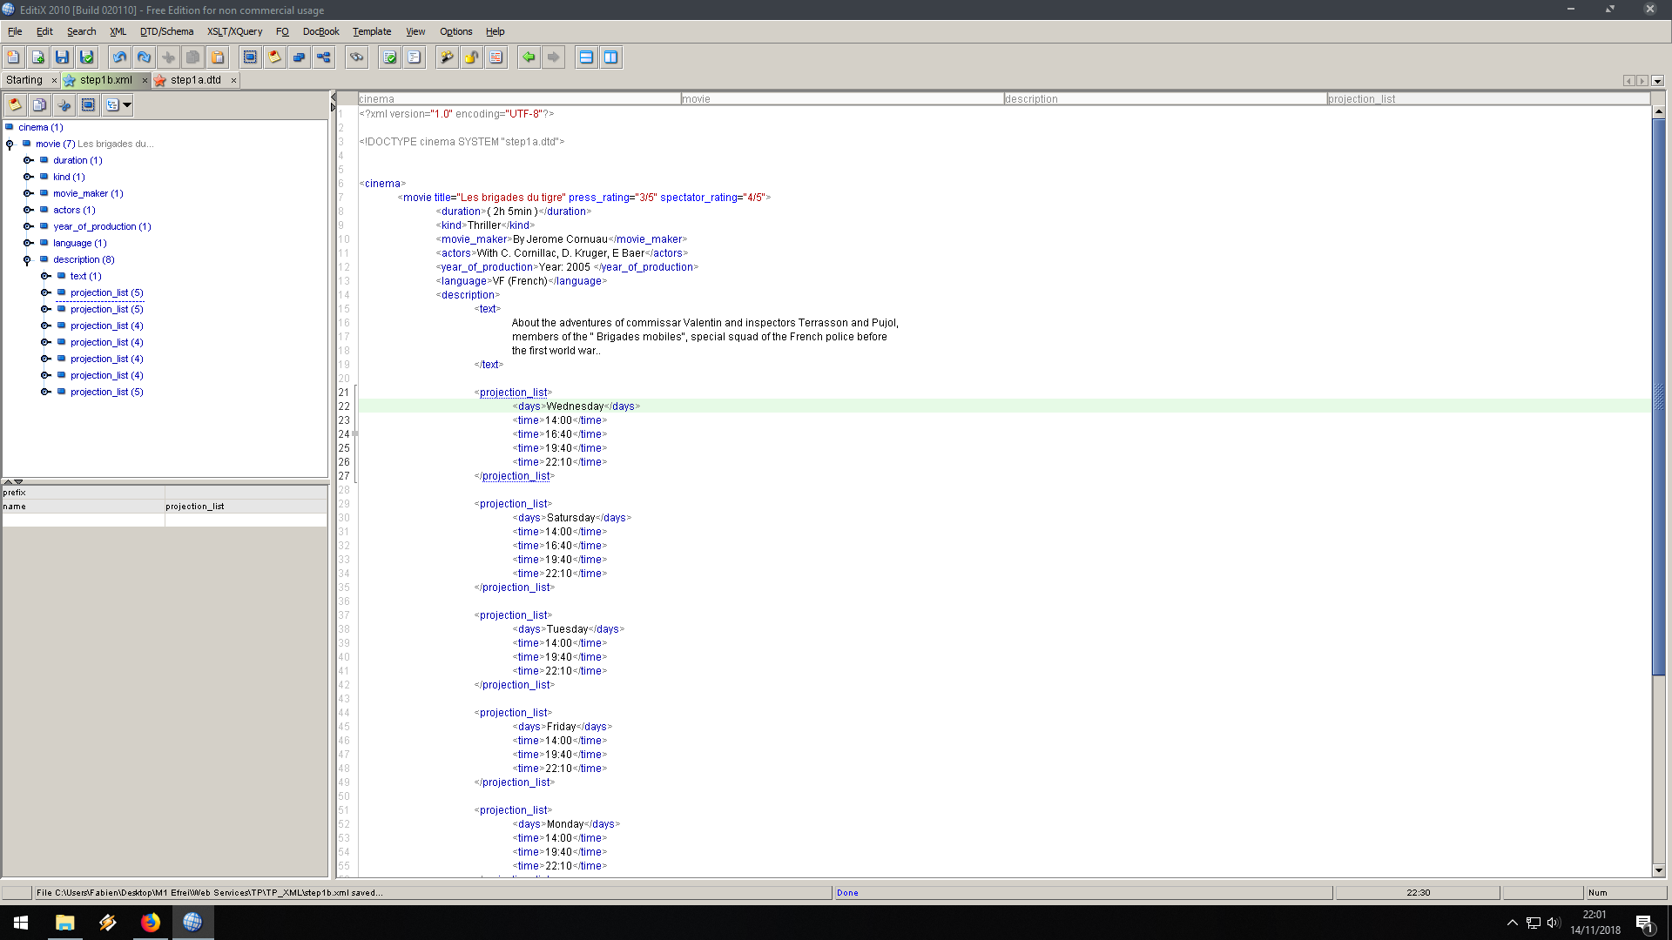

Question 2

To represent the whole cinema programs we can show the movie catalog for each week by adding <week><movie_catalog><movie>…</movie></movie_catalog></week>

Check step1a.xml

Question 3

Check step1b.dtd

Question 4

We should use a xsd to allow film descriptions given in any order. (less restrictive)

**Step 2**

Question a

Check step2a.xml

Question b

Check step2b.xsd

Question c

Check bank.xsd (TO DO)

**Step 3**

Question 1

Check book.xsd (TO DO)