
客 戶：
（Customer）
物料代碼：
（Material code）
產品規格書
Technical Data Sheet

產品描述：5英寸一位紅光數碼管
（Description）
型 號：SM1□5002D3B
（Part No.）

Approved by | Checked by | Issued by | Customer confirm

- Descriptions (摘要):
- These devices are made with ■white □Water Clear segments and■black □grey surface.
筆段：■乳白 □無色透明；表面：■黑色 □灰色

- Selection Guide（选型指南）:
Part No.（型號） |  | Chip（晶片） |  | Lens  Color  （筆段顏色）
Anode（共陽） | Cathode（共陰） | Emitting Color  （發光顏色） | Material  （材質） | Lens  Color  （筆段顏色）
SM125002D3B | SM115002D3B | High Super Red  （超高亮紅） | AlGaInP  （磷化鋁鎵銦） | White  Diffused  （白色散射）
Note：
- Static electricity and surge damages the LED. It is recommend to use a anti-static wrist band on anti-electrostatic glove when handing the LEDS. All devices equipment and machinery must be properly grounded.

- Absolute Maximum Ratings at Ta=25℃（最大額定值）：

Parameter | Symbol | Rating | Unit
Reverse Voltage（反向電壓） | V_{R} | 5 | V
Forward Current（正向電壓） | I_{F} | 20 | mA
Power Dissipation（功耗） | Pd | 65 | mW
Peak Forward Current（峰值電流）  （Duty 1/10 @1KHz） | I_{F}（Peak） | 80 | mA
Operating Temperature（工作溫度） | Topr | -25 to +85 | ℃
Storage Temperature（貯存溫度） | Tstg | -25 to +85 | ℃
Soldering Temperature（焊接溫度） | Tsol | 260±5 | ℃

Notes：
- This is the limit current . It is not allowed to use when the product work continuously.
上述正向電流為極限電流，不能再此電流下持續工作。
- Soldering time≤5 seconds.
焊接時間小於等於5秒。

- Electronic Optical Characteristics at Ta=25℃（光電特性）：
Parameter | Symbol | Typ. | Max. | Unit | Test  Condition
Luminous Intensity（光強） | I_{V} | 30 | 35 | mcd | I_{F}=20mA
Dominant Wavelength（波長） | λd | 632 | 635 | nm | I_{F}=20mA
Spectral Line Half Width（半譜波長） | Δλ | 20 |  | nm | I_{F}=20mA
Forward Voltage（正向電壓） | V_{F} | 2.0 | 2.1 | V | I_{F}=20mA
Reverse Current（反向漏電流） | I_{R} |  | 10 | μA | V_{R}=5V

- Reliability Test Items and Conditions（可靠性試驗項目及條件）：

NO. | Item | Test Conditions | Test Hours/Cycel | Sample | Ac/Re
1 | Solder Heat | TEMP:260℃±5℃ | 10±1 SEC | 60PCS | 0/1
2 | Temperature Cycle | +85℃～+25℃～-35℃～+25℃  30min 5min 30min 5min | 10 CYCEL | 60PCS | 0/1
3 | Thermal Shock | 85℃±5℃～-35℃±5℃  10min 10min | 10 CYCEL | 60PCS | 0/1
4 | High Temperature Storage | TEMP:85℃ | 1000HRS | 60PCS | 0/1
5 | Low Temperature Storage | TEMP:-40℃ | 1000HRS | 60PCS | 0/1
6 | DC Operating Life | I_{F}=12mA | 1000HRS | 60PCS | 0/1
7 | High Temperature/High Humidity | 1、85℃/ 85% RH  2、V_{R}=5V | 500HRS | 20PCS | 0/1

- Reliability Criteria of judging the damage（可靠性試驗評定標準）：

Item | Symbol | Test condition | Criteria for judgement
Item | Symbol | Test condition | Min. | Max.
Forward voltage | V_{F} | IF=12mA/Seg | / | U.S.L*1.1
Reverse current | I_{R} | VR=5V | / | 10uA
Luminous intensity | I_{V} | IF=12mA/Seg | L.S.L*0.7 | /
Wave length | λD/λP | IF=10mA/Seg | / | U.S.L±2nm
Appearance | / | View check | No mechanical damage
Notes：
- U.S.L: Upper standard level.
- L.S.L: Lower standard level.

- Package Dimensions（封裝尺寸）:
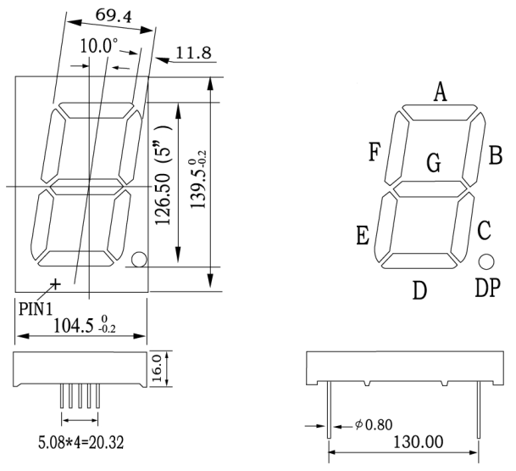
Notes：
- All dimensions are in millimetres (mm), Tolerance is ±0.25mm unless otherwise noted.
除另有說明外，所有尺寸單位均為毫米（mm），公差為± 0.25mm。
- Specifications are subject to change without notice.
產品規格如有變更，恕不另行通知。

- Internal Circuit（內部電路）：
SM125002D3B (CC) SM115002D3B (CA)
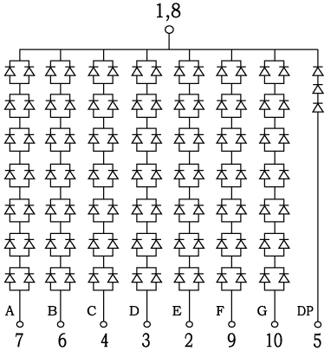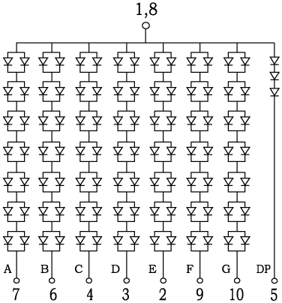
Notes：
- CC：Common Cathode；CA：Common Anode
CC：共陰極；CA：共陽極

- Typical Electro-Optical Characteristics Curves（典型光電特性曲綫）：

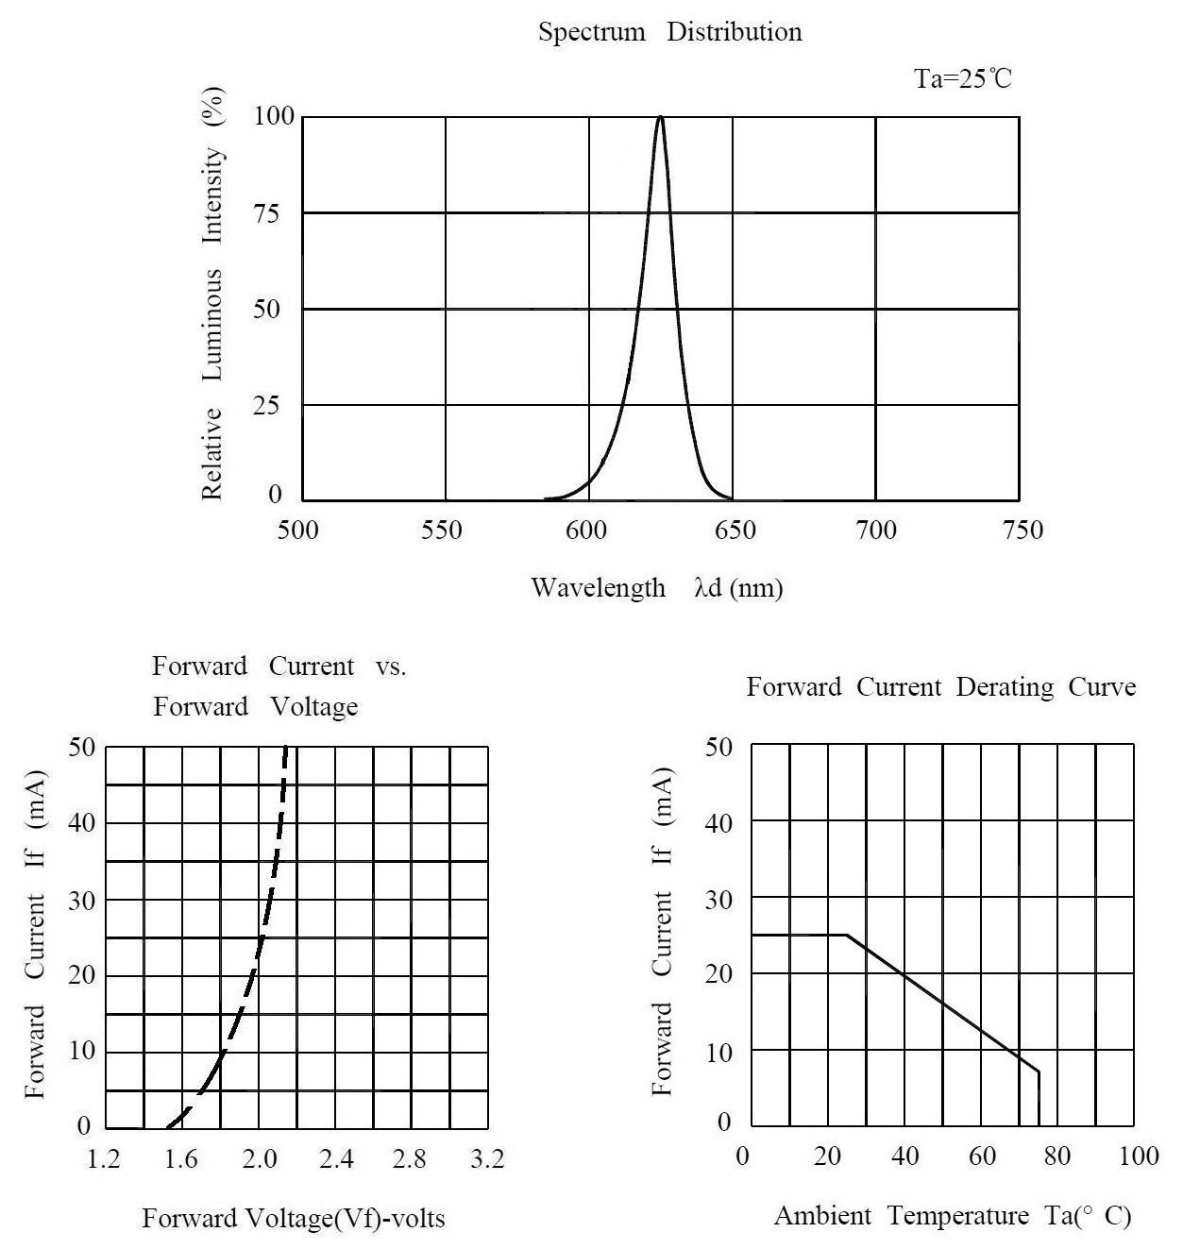
Notes:
- Above specification may be changed without notice. We will reserve authority on material change
for above specification.
以上規格如有變更,恕不另行通知。我們將保留對上述規格更換材質的權利。
- When use this product, please observe the absolute maximum ratings and the instructions for the
specification sheets. We assume no responsibility for any damage resulting from using of the product which
does not comply with the instructions included in the specification sheets.
使用本產品時,請絕對遵守本規格書的指令要求。對不按指令要求使用而造成的損失，我們將不承擔任何責任！

