PURPOSE OF THE EXPERIMENT
This experiment aims to compare different object detection models for a robot used in the REFLECT project, which performs kitchen tasks. The models are evaluated based on their performance in a kitchen environment. Additionally, their ability to detect objects under different textual descriptions is analyzed through their open-vocabulary capabilities.

MODELS
Three object detection models are compared in this experiment: YOLOE, Grounding DINO, and OWLv2.
All selected models support open-vocabulary object detection, enabling them to recognize objects based on diverse textual descriptions. This capability is particularly beneficial for the robotic system, as it allows more flexible interpretation of object names, even when different phrases are used to describe the same item.

EVALUATION METRICS
The models are evaluated through frame-by-frame observation and basic quantitative measures. Since the dataset does not include labels, recall is not used.
Detection Rate: Calculated per object as the percentage of frames in which the object is correctly detected. If an object is visible in all frames and detected every time, the detection rate is 100%. When an object is not visible in some frames, an expected detection threshold is defined.
Confidence Score: Measured per object and per model, indicating how confident the model is in its detections.
Processing Time: Used to evaluate performance. The average processing time of each model is measured and compared.
Each frame is analyzed based on:
- Lowest confidence score
- Highest confidence score
- Missed detections
- Overall detection behavior

DATASET
The experiment uses both simulated and real-world data to evaluate model performance across different environments. This allows comparison between controlled (simulation) and real-world pipelines.
The simulated dataset focuses on the task “make salad,” while the real-world dataset focuses on “put apple in bowl,” a scenario where the scene graph is known to fail.

RESULTS

SIMULATED DATA
The simulated-data analysis was updated to match the newer real-data notebook structure by using one sampled video and varying the textual prompts instead of switching tasks. The task selected for this sweep was boilWater-1, evaluated on 27 sampled frames with the object pair pot and sink. To make the prompt study more meaningful for open-vocabulary detection, the prompts were changed across four experiments: metal pot / sink, cooking pot / kitchen sink, saucepan / sink basin, and container / wash basin.
Grounding DINO was the most reliable model on the simulated data. For the pot object, its best result came from the prompt metal pot, with an average confidence of 0.826 and a detection rate of 88.89%, clearly outperforming YOLOE and OWL-ViT. For the sink object, Grounding DINO again led the comparison, and the prompt wash basin even reached a 100% detection rate with an average confidence of 0.616. This shows that Grounding DINO adapted much better than the other models when the wording changed, especially when the prompt remained semantically close to the visible object.
YOLOE stayed much faster than the transformer-based models, running at roughly 0.53 seconds per frame, but its open-vocabulary flexibility was limited. It detected the sink reasonably often with the simpler prompts, yet it almost completely failed on the pot unless the wording matched the visual concept very closely. OWL-ViT was similarly weak on generic prompts and only improved slightly for the pot when more descriptive wording such as cooking pot was used. The most important finding from the simulated pipeline is therefore the same high-level trend seen in the real-data notebook: prompt engineering matters, and Grounding DINO is the most robust model when the wording is changed while the scene stays fixed.

REAL-WORLD DATA
“PutAppleBowl2” is used for the analysis. The comparison the confidence, the detection rate for apple per object name is shown below in figure 1.
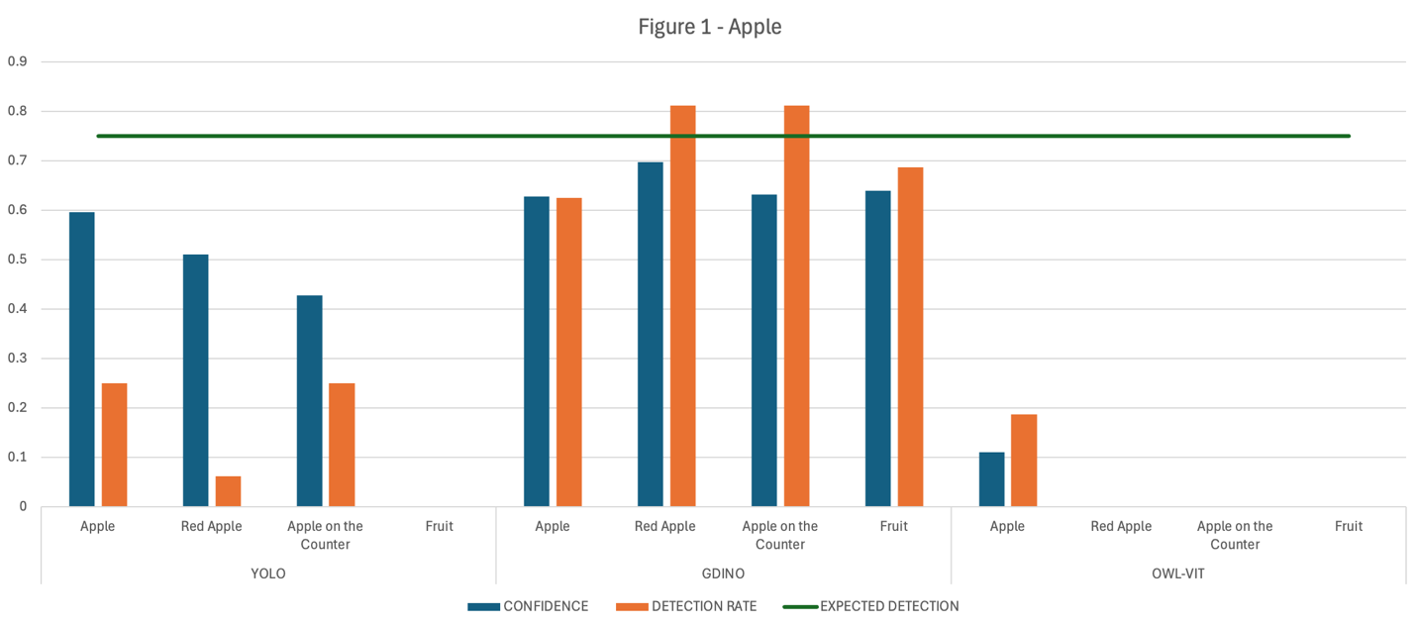

We see that Grounding Dino is more flexible than the other models when it comes to open vocabulary with its higher detection and confidence rate meanwhile being the only model that recognizes the apple when it is prompted “fruit”.

