Grid_resolution = 16

nrmsd_delta_end_condition = 1e-9

analysis_number_end_condition = 500

parameter_move_start_end_value = 0.5

parameter_divergence = 0.25

19 Parameter werden analysiert

NRMSD_total min = 0.1829723

Improved parameter = lfpf

From value: 0.735013 to value: 0.734994

Relative change: 2.6e-05

Elapsed time in seconds: 13643.31

Number of mid values: 53

Number of edge values: 24

NRMSD min: 0.1829723042

Execution time in seconds: 13647.23

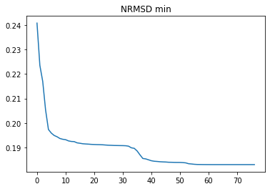

Grid_resolution = 16

nrmsd_delta_end_condition = 1e-10

analysis_number_end_condition = 500

parameter_move_start_end_value = 0.5

parameter_divergence = 0.25

19 Parameter werden analysiert

NRMSD_total min = 0.1829723

Improved parameter = lfpf

From value: 0.734994 to value: 0.734994

Relative change: 0.0

Elapsed time in seconds: 13819.02

Number of mid values: 54

Number of edge values: 24

NRMSD min: 0.1829723042

Execution time in seconds: 13822.65

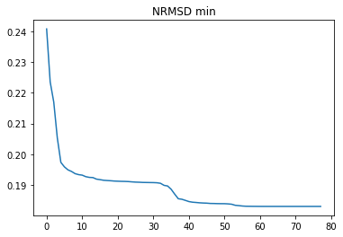

Grid_resolution = 30

nrmsd_delta_end_condition = 1e-10

analysis_number_end_condition = 500

parameter_move_start_end_value = 0.5

parameter_divergence = 0.5

37 Parameter werden analysiert

Number of zooms completed = 266

Number of simulations completed = 295260

NRMSD_total min = 0.17754236

Improved parameter = ici

From value: 198947630551.37378 to value: 198947627818.43375

Relative change: 0.0

Elapsed time in seconds: 219795.73

Number of mid values: 158

Number of edge values: 109

NRMSD min: 0.1775423594