Blue - Orange County, CA

Orange - Madison County, AL

Green - Dallas County, TX

Red - Brooklyn, NY

Pricing per House Number of Bedrooms per House

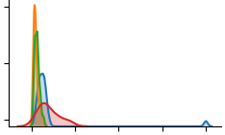 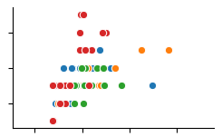

House pricing between Dallas County and Majority of data is mixed together,

Madison County have similar pricing, but Dallas except for some data points of Brooklyn.

has slightly more expensive housing.

Number of Bathrooms per House Square Footage per House

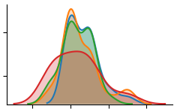 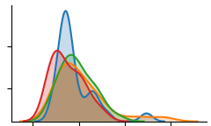

All locations but Brooklyn have similar amounts All data points except for some of the

of bathrooms, making data involving these locations Orange County houses have very

unbeneficial for helping the neural network differentiate similar data

between houses other than Brooklyn.

When doing a grid search, four hidden layers and four nodes produced the best results. The neural network had a 26% accuracy for the training set and a 28% accuracy for the test set. If the hidden layers or nodes were reduced, the training accuracy increased to 28%, but the testing accuracy decreased to 16%. When increasing the hidden layers or nodes, the training accuracy also consistently remained at 28%, and the testing accuracy also at 16%. When cross validating, the best training score remained at 25%, and the best testing score was also 25%.