MediPal

Software Development Plan

Version 1.1

Revision History

| **Date** | **Version** | **Description** | **Author** |
| --- | --- | --- | --- |
| 01/06/2025 | 1.0 | Added the general structure and the main points | Nguyễn Công Toàn |
| 01/06/2025 | 1.0 | Filled in the plan details and schedule | Trần Anh Khoa |
| 01/06/2025 | 1.0 | Proofread & final touch | Nguyễn Kiến Hào |
| 14/06/2025 | 1.1 | Updated the plan and roles to align with the PA, added gantt chart to visualize the schedule | Trần Anh Khoa |
| 15/06/2025 | 1.1 | Proofread | Nguyễn Kiến Hào |

Table of Contents

**1.** **Introduction 4**

**2.** **Project Overview 4**

*2.1* *Project Purpose, Scope, and Objectives 4*

*2.2* *Assumptions and Constraints 4*

*2.3* *Project Deliverables 4*

**3.** **Project Organization 4**

*3.1* *Organizational Structure 4*

*3.2* *Roles and Responsibilities 4*

**4.** **Management Process 4**

*4.1* *Project Estimates 4*

*4.2* *Project Plan 4*

4.2.1 Phase and Iteration Plan 5

4.2.2 Releases 5

4.2.3 Project Schedule 5

4.2.4 Project Resourcing 5

*4.3* *Project Monitoring and Control 5*

4.3.1 Reporting 5

4.3.2 Risk Management 5

4.3.3 Configuration Management 6

Software Development Plan

# 

# Introduction

MediPal is an application dedicated to keeping track of the user's medication schedule, doctor's appointments and daily healthcare reminders.

Main features include taking the user's medication name, dosage and consumption time input to create scheduled reminders, history log of past medications and reminders for follow-up appointments and health check-ups.

# Project Overview

## Project Purpose, Scope, and Objectives

**Purpose:** To assist individuals, teenagers and adults alike, with managing their daily health tasks more reliably and independently.

**Objective:** Develop and release a mobile application by mid August that enables users to schedule and receive medication reminders, log taken doses, and get appointment notifications.

**Scope:**

* Mobile application (Android) – may be ported as a web application
* User profile
* History logs of medications taken
* History logs of appointments
* …

## Assumptions and Constraints

* **Budget:** zero-budget project
* **Staff:** project is developed by 5 people, there are no plans of changing the members
* **Schedule:** No strict schedule for the development of the project, everyone nay work on the project on any day of the week as long as the weekly goal is reached

## Project Deliverables

### **Documents**

* Project Plan (including phases, sprints, schedule, Gantt chart, team roles)
* Vision Document
* Use-case model (with diagrams and specifications)
* Software Architecture Document (SAD)
* Class diagrams
* Database design documents
* Test plan, test cases, and test reports
* Final project report (including lessons learned, review outcomes)
* User manual (if applicable)

### **Software / Features**

* **Alpha prototype (Sprint 4)**
  + Medication reminder core functionality
  + Basic UI and notification system
* **Full app (Sprint 5)**
  + Appointment scheduling
  + Chatbot prototype
  + History log
  + Full feature integration
  + Automated test results

### **Other**

* Demo materials (presentation slides, demo video if required)
* Backlog (maintained in Trello or equivalent)

# Project Organization

## Organizational Structure



## Roles and Responsibilities

The project team consists of five members, each assigned to a predefined role based on their strengths and contributions. The **Project Manager** (Hào) oversees progress and coordination. The **Business Analyst** (Toàn) gathers user needs and defines system requirements. The **Developers** are responsible for implementing and testing application features. The **Tester** (Lượng) ensures that the system meets functional expectations through rigorous testing.

| **Name** | **Role** |
| --- | --- |
| Nguyễn Kiến Hào | **Project Manager**, Developer |
| Trần Anh Khoa | **Developer, DevOps**, Tester |
| Võ Văn Tuấn | **Developer, UI/UX Designer** |
| Trần Hữu Lượng | **Tester**, Developer, DevOps |
| Nguyễn Công Toàn | **Business Analyst**, Developer, Tester |

# Management Process

## Project Estimates

* **Estimated Duration**: ~12 weeks
* **Estimated Effort**: 5 team members × ~5–7 hours/week × 12 weeks ≈ 300–400 person-hours
* **Estimated Cost**: No financial cost incurred; all work done by student team. Free tools and resources (e.g., GitHub, Android Studio, …) are used.
* **Re-estimation Points**:  
   - After each iteration review  
   - When major blockers or scope changes occur  
   - Before final release demo

## Project Plan

**Resources**

* **Personnel:** 1 PM, 1 BA, 5 Devs, 2 DevOps, 3 Tester, 1 UI/UX Designer
* **Tools:** GitHub, Google Docs/Sheets, Trello, Jira
* **Platforms:** Android (target version 9.0+)

**Project Methodology**: Agile with 3 main sprints (iterations)

### Phase and Iteration Plan

**Phases and Iterations overview**

| **Phase** | **Sprint** | **Start** | **End** | **Main objectives** |
| --- | --- | --- | --- | --- |
| Inception | 1 | 19/05/2025 | 01/06/2025 | * Complete the project plan, vision document * Write reports (weekly report, review and planning report |
| Elaboration | 2 | 02/06/2025 | 15/06/2025 | * Revise the project plan and vision document * Create the use-case model and use-case specifications * Schedule backlogs and write reports |
| 3 | 16/06/2025 | 29/06/2025 | * Revise use-case specifications * Draft the software architecture document (SAD) * Model class diagrams * Design DB * Schedule backlogs and write reports |
| Construction | 4 | 14/07/2025 | 27/07/2025 | * Revise the SAD * Sketch the UI for prototype * Implement some of the main use-cases * Prepare a test plan, design test cases, execute test cases, summarize and report test results * Schedule backlogs and write reports |
| 5 | 28/07/2025 | 18/08/2025 | * Implement the remaining features of the app * Finalize testing * Perform automated tests * Prepare for final delivery and demo * Schedule backlogs and write reports |

### Releases

* **Alpha release (29/07/2025):** Initial version with core features implemented for internal testing and feedback
* **Full release (11/08/2025):** Completed version with all planned features, tested and ready for final presentation/demo

### Project Schedule

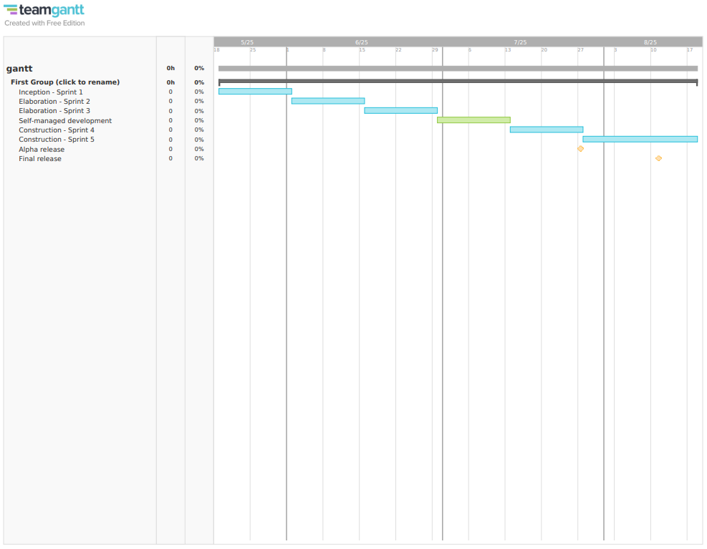

## Project Monitoring and Control

### Reporting

Project status is reported via the following means:

* Weekly face-to-face meeting or Google Meet
* Informal chats on Messenger and Discord for minor reports
* Weekly status report documents

### Risk Management

### Configuration Management

* **Google Drive:** storing and sharing documents and files
* **GitHub:** managing source code and related files