Grapplon (tentative title)

Version Control
Version number | Modifier | Date | Type of modification
0.0.1 | Michael | 09-04-2008 | Created basic format of the document
0.0.2 | Matthijs | 12-04-2008 | Events, Single and Multi Player
0.0.3 | Joris | 13-04-2008 | Added power ups chapter
0.0.4 | Michael | 13-04-2008 | Added grappling hook mechanics, collision and damage system. Updated previous chapters by Matthijs and Joris.
0.0.5 | Michael | 14-04-2008 | Added Menus chapter, added movement chapter, corrected some mistakes.
0.0.6 | Michael | 17-04-2008 | Corrected some mistakes, added gravity chapter
0.0.8 | Michael/Matthijs | 18-04-2008 | Added additional images, corrected chapters
0.0.9 | Joris | 18-04-2008 | Completed score mechanism, updated power ups
1.0.0 | Michael | 18-04-2008 | Corrected mistakes, updated some faulty images
1.0.1 | Michael | 25-04-2008 | Added HUD subchapter in menu

1. Introduction 5
1.1. About this document 5
1.2. Correcting mistakes or changing content 5
2. Game play 6
2.1. Controls – Summary 6
2.2. Controls - Movement 6
2.2.1. Moving the ship around 6
2.2.2. Movement controls 6
2.2.3. Acceleration 7
2.3. Controls - Grappling hook 7
2.3.1. Motion gesture 7
2.3.2. Radius 8
2.3.3. Field of view 8
2.3.4. Automatic aiming 9
2.3.5. The hook gets deflected 9
2.3.6. Swinging an object 10
2.3.7. Retracting the hook 10
2.3.8. Pulling objects 10
2.4. Activating power ups 10
3. Physics 11
3.1. Kinetic energy 11
3.1.1. Base stats 11
3.1.2. Speed after collision 11
3.1.3. Kinetic energy and damage 12
3.2. Collision between objects 13
3.2.1. Deflection 13
3.2.2. Collision Slowdown 14
3.3. Gravitation 14
3.3.1. Gravitaty acceleration formula 14
3.3.2. Switching the visual feedback on 15
3.3.3. Damage intensity of planets 15
4. Power ups 16
4.1. Permanent power ups 16
4.1.1. Speed 16
4.1.2. Health 16
4.1.3. Ice resistance 16
4.1.4. Fire resistance 16
4.1.5. Electric resistance 16
4.1.6. Reduce orbit 16
4.2. Semi permanent power ups 17
4.2.1. Jelly 17
4.2.2. Spiky bumper 17
4.2.3. Shield 18
4.2.4. Miner 18
4.2.5. Ship parts 18
4.2.6. Super mode 19
4.3. Temporary power ups 19
4.3.1. Black Star 19
4.3.2. Carbonate 20
4.3.3. Homey 20
4.3.4. Hyper drive 21
4.3.5. Orbit fire 21
4.3.6. Laser Chain 22
4.3.7. Light speed 22
4.3.8. Repair robot 22
4.3.9. Satellite 23
4.3.10. Clone 23
4.3.11. Hacker 23
4.4. Power up dropper. 23
5. Events 24
5.1. Generic elements 24
5.1.1. Generic Planets 24
5.1.2. Sun 25
5.1.3. Black hole 25
5.1.4. Meteor 25
5.1.5. Time Portal 26
5.1.6. Asteroid 26
5.1.7. Fire Planet 27
5.1.8. Ice Planet 27
5.1.9. Broken Planet 28
5.1.10. Nebula 28
5.1.11. Supernova 28
5.2. Fantasy elements 29
5.2.1. Leprechaun space station 29
5.2.2. Space train 29
5.2.3. Hand of God 29
5.2.4. Traffic Light 29
5.2.5. Space arachnid 29
5.2.6. Gift mine 30
5.2.7. White hole 30
6. Menus 31
6.1. Accessibility of menus 31
6.1.1. Active player 31
6.1.2. Multiple input 31
6.1.3. Cursor 31
6.2. Main menu 32
6.3. Main game 32
6.3.1. Player select 32
6.3.2. Stage select 33
6.3.3. Mode select 33
6.4. Leader boards 34
6.5. Quit 34
6.6. In game menu 35
6.6.1. Control of the menu 35
6.6.2. Options 35
6.7. Entering high score 36
6.8. HUD 37
6.8.1. Scoring feedback 37
6.8.2. Other feedback 37
6.8.3. Stock 37
7. Sound list 38
7.1. Player feedback 38
7.1.1. Ship feedback 38
7.1.2. Power up feedback 39
7.2. Environment feedback 40
7.2.1. Generic object feedback 40
7.2.2. Fantasy object feedback 40
7.3. Menu feedback 41
7.4. Background Music 41
8. Game modes 42
8.1. Multi Player 42
8.1.1. The goal - scoring 42
9. Leveldesign 45
9.1. Orbits 46
9.2. Layout 47

Introduction

About this document
Before adding to this document, you should contact the lead game designer to check whether someone is working on it. While this system might not be fool proof, it will prevent multiple people from making changes, which will create several versions of a document.

When you make changes, please update the version control. In the version control you need to put the current version of the document, the name of the one who did the modification, the date of the modification and the contents of that modification. In case anything goes wrong, the version control can be used to check where the problem lies.

Document naming needs to be done as follows: First Design document, followed by the (working) title, followed by the version number, followed by the revision date. Please use underscores to separate the 4 elements.

Correcting mistakes or changing content
When changing content, always make sure to have the automatic keeping track of changes option turned on. This is to make it easier for the game designers to find the changes made to the document. DO NOT REMOVE these changes; this will be done by the game designers as well.

Game play

Controls – Summary

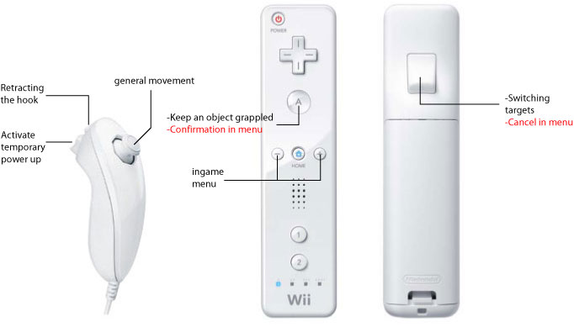
Wii remote controls summary. Text in black is in game controls. Text in red is menu controls

The in game controls will be explained in this chapter. The menu controls will be explained in the menu chapter.

Controls - Movement

Moving the ship around
At the moment, there are 2 control schemes for moving around the ship, both involving the nun-chuck’s analog stick.

Movement controls
The player can use the analog stick to steer the ship directly. Pressing the analog stick in a direction will make the ship move in that direction.

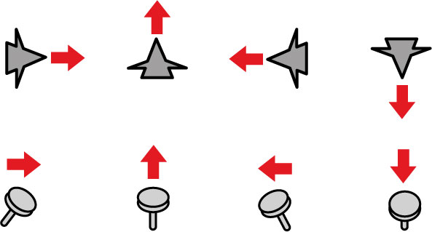
general movement control

Acceleration
During movement, the player will accelerate till a maximum base speed is reached. The maximum base speed is the speed a player can get while not being influenced by other elements such as momentum through using the orbit of a planet or other elements.

The standard maximum base speed is 60 meters per second
The standard acceleration is 20 meters per second

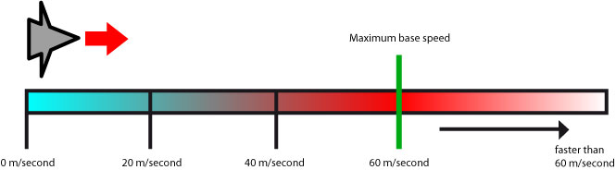

After a player has reached the maximum base speed of 60 meters per second, the player will not accelerate, unless the player stops or the player is influenced by gravity from planets.

Only when the player is influenced by other elements than the basic control scheme (collisions, using the planets gravity for momentum, power ups) will the player be able to go faster than the maximum base speed. There is no limit to the speed a player can get due to these elements.

When the player has exceeded the maximum base speed due to these elements, the player will keep this speed until the player stops moving or hits an object.

Controls - Grappling hook

Motion gesture
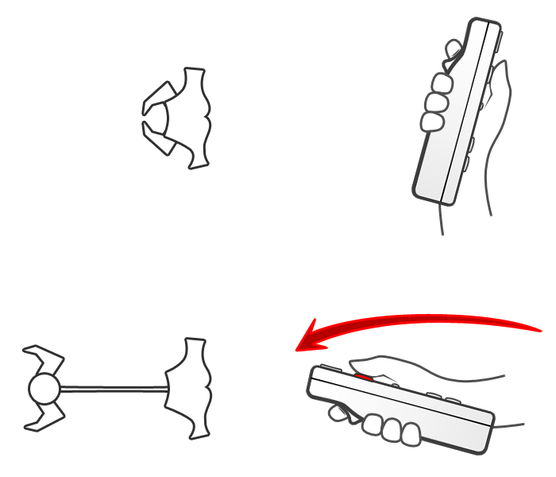 | To throw the hook, the player has to lift the Wii remote in front of himself and then strike it forward, while holding the A button.  When done correctly, the hook will launch and grapple the nearest object automatically.  Holding the A button is needed to check whether an object stays grappled or not (when the A button is released, so is the object).  The angle of the motion does not matter, as the hook will always launch forward. The motion of the hook is not based on actual motion; the motion is only the trigger.

Radius

Each ship has a radius. In this radius, they can grapple anything within their field of view. The radius can be increased using power ups or by affecting the status of the grappling hook.

The radius can also be affected by power ups. The size of the radius can be affected and the size of the field of view can be affected.

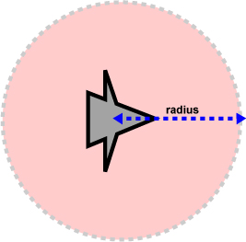

Radius

Field of view
The field of view is the area in front of the player. This area is used to calculate the automatic aiming of the grappling hook.

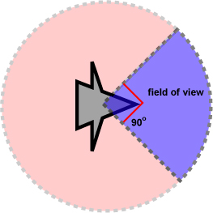

Field of view

Automatic aiming
A small part in front of the ship is used for auto aiming the hook. When shooting the hook using the proper gestures, the hook will instantly be fired to the nearest graspable object.

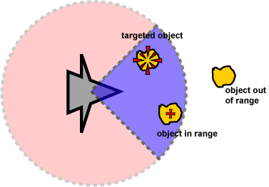

Automatic aiming; with a selected target, a unselected target and a target out of range

To indicate which object the player is going to grapple when he would throw the hook, a crosshair is generated on the object that is going to be targeted automatically when the player would throw the hook.

When there are multiple objects within the automatic grappling range, the crosshair is generated on the first object coming within reach of the hook. Other objects that are within the field of view are indicated by a small version of the crosshair. To switch between targets, the players needs to press the B button on the Wii remote.

Another option can be that the player needs to make a gesture to switch targets. This is not tested yet however, and might hinder the swinging of the remote gesture.

At the moment a player grapples an object, the crosshairs disappear. When the grappled object is released or when the grapple fails, the crosshairs appear again.

As long as the player holds the A button, the object will stay grappled. As soon as the player releases the button, the object will also be released.

The hook gets deflected
When an object is too big to grapple, the hook will deflect upon impact and be automatically retracted.

There are several animations when the hook gets deflected, each indicating how far the player is ahead of grappling the desired object. For each animation, the closer the player is to being able to grapple the object of desire, the longer it will take for the hook to get deflected.

There are 4 levels:
- 4: completely unable to grapple
- 3: grappling hook gets deflected, but not immediately
- 2: grappling hook can grapple the object, but it will slip
- 1: grappling hook can grapple the object longer, but it will slip.

When two players try to grapple one another at the same time, their hooks will get deflected and be retracted automatically. Therefore, the hook also functions indirectly as a shield against other players.

Swinging an object

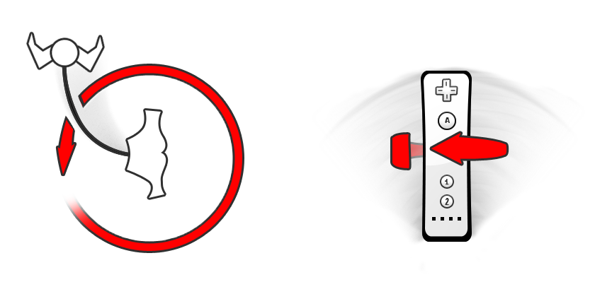 | When the player has grappled an object, the player can swing the object around or the player can drag the object with him. When swinging the object, the players need to rotate the Wii remote like he was using a lasso. The grappled object is going to get rotated around the ship.

The longer the player is rotating the object, the faster the object will go, till it reaches a maximum speed. When the rotated object is released, according to the speed of the rotation, the object will be launched along the path the player is facing. Combined with the power of the throw gesture, the speed of the rotation will be used to calculate how far the object will fly. When an object gets heavier, the object gets harder to rotate and the maximum speed it can reach will drop.

When an object is released, the object will be released in the direction the player’s ship is facing.

Retracting the hook
When an object has been grappled, the player can choose to retract the hook. When retracting the hook, the player can save himself from dire situations. The player can also use this feature to grapple other objects like power ups to get a gain on the other players.

Retracting the hook can be done using the C button of the nun-chuck. By holding the button, the hook will be retracted. When the button is released, the hook will automatically extract again.

A retracted hook cannot be used for swinging an object. To swing an object, the C button needs to be released.

While retracting, the A button needs to be held! Otherwise, when the A button is released, the hook will also be released and retract automatically!

Pulling objects
The player can pull objects by holding the A button, but without swinging the Wii remote.

Activating power ups
There are 3 types of power ups in the game:
- Permanent power ups
- Semi permanent power ups
- Temporary power ups

The permanent and semi permanent power ups will be activated when they are picked up. The temporary power up is picked up as an item and needs to be activated by pressing a button; the Z button.

Physics

Kinetic energy

Base stats

For each object, there are 3 base stats:
- Each object has a mass. This mass can be fixed (for objects other than ships), or variable (for ships). Mass is written with down as m and is always in kg.
- Each object has a speed, even if the speed is 0. Speed is written down as v and is always in km/h.
- Each object has an elasticity, which value ranges from 0 (inelastic) to 1 (elastic). A more elastic object will perfectly deflect objects. Elasticity is written down as Cr and does not have a specific unit.
- Each object has life (a percentage). When the life is 0, it means the object has been destroyed. Life is written down as Li and is always a percentage.

Speed after collision
When two objects collide with one another, their speeds will change. The formula as described below will be used for every object in the game, in the case of a collision.

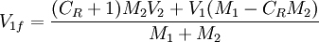

And

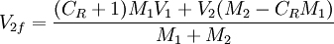

In the formula’s above;
V_{1f} is the final speed of the first object after collision
V_{2f} is the final speed of the second object after collision
V₁ is the initial speed of the first object before collision
V₂ is the initial speed of the second object before collision
M₁ is the mass of the first object
M₂ is the mass of the second object

Kinetic energy and damage
By making something crash into an opponent, kinetic energy from the crash will be lost due to damage. To calculate this damage, the kinetic energy before the collision is compared to the kinetic energy after the collision and the percentage in difference is the damage the object suffers.

To calculate the kinetic energy of an object; the following formula is used:

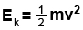

To calculate the damage after collision, the following formula is used:

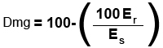

In the formula’s above;
Er is the remaining kinetic energy after collision.
Es is the kinetic energy before the collision (the standard kinetic energy).
Dmg is the damage suffered due to the collision.

Collision between objects

Deflection
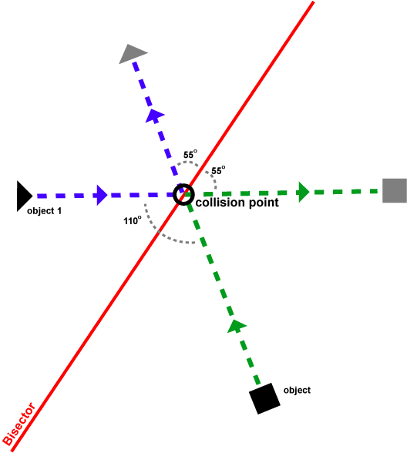

An example of a collision between 2 objects.

- At the moment when one object collides with another, that point of collision will be the collision point.
- Then, using the collision point as a base, the angle between the two or more objects will be calculated.
- This angle is halved, and along that angle a bisector is created. The bisector is needed to calculate the new angle of the objects.
- Using the bisector and angle of the objects in relation to the bisector, the objects deflection is calculated.

Collision Slowdown
When two or more objects collide with one another, they will be stunned for a moment. During this period, the objects will rotate, while moving along the new deflected path and slowing down.

Depending on the resulting new kinetic energy after impact, the object will be stunned for a few seconds, while slowing down. When the object has come to a complete stop, then the object will have recovered from being stunned and the slowdown period will end. If the object is a ship, when stunned, the player cannot move the ship. While the player is stunned, the player can be hit again.

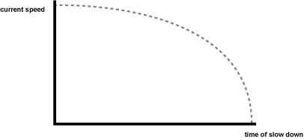

The graph above shows how the speed should slow down.

The maximum slow down a player can experience is 9,9 seconds. The length of the slowdown will be determined by the amount of damage the player has received. For each 10% of damage the player has received, the player will be stunned for 1 second.

Gravitation

Each object has gravity. Depending on the size and the type of object, that gravity can be high or low. Per default, all objects attract each other. However, when the objects are small, the acceleration die to gravity is so small it is barely noticeable.

Gravitaty acceleration formula
To calculate the amount of acceleration due to an object:

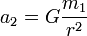

In the formula’s above;
A2 is the acceleration of attracted object (object 2)
G is the gravitational constant. Normally there is a formula for determining the gravitational
constant, but we will fill in the number manually, without any calculation.
M1 is the mass of the object that does the attracting (object 1)
R is the distance between the two objects

When the acceleration is less than 0,1 the acceleration is rounded to 0. This is to make
sure that there is no attraction between all objects, to save on memory.

To determine the size of the gravity field visual feedback; the test results of the first playable need to be communicated with the artists.

Switching the visual feedback on
To switch the visual feedback of a planet on (so that it is easier to use the orbit of a planet to accelerate objects), the acceleration of the formula above needs to be equal to the acceleration of the ship.

The formula to determine when the visual feedback needs to be turned on is:

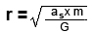

In the formula’s above;
As is the standard acceleration of the ship
G is the gravitational constant.
M1 is the mass of the object that does the attracting (object 1)
R is the distance between the two objects

This formula can also be used for determining the size of the orbit visual feedback. The
only thing that need to be determined first is the minimum amount of acceleration for a
ring to be useful.

Damage intensity of planets
Certain planets can have a damaging effect on objects, such as the fire planet and the sun. How much damage these objects do per second, can be calculated using the formula below.

In the formula’s above;
Dmgi is the damage intensity, calculated in % damage each second.
DmgiM is the modifier for the damage intensity. This can be set for every planet, by default
the value is 0.
A is the current acceleration.
As is the standard acceleration of the ship.

When the damage intensity is more than 5% damage each second, the object will ignite.
Damage intensity will be rounded in absolute numbers.

Power ups
In this chapter we will explain the different kind of power ups you can use during the game. The power ups are categorized in three types. First you got the permanent power ups, then the semi permanent and at last you got the temporary ones.

Each type will be categorized in two different categories; the defend power ups and the attack power ups.

An example of a defend power up is that you can activated a shield that blocks a percentage of the damage that you will receive. An example of the attack power up is the chainsaw. Your battle ship will be surrounded with a chain full of sharp objects. When you come in contact with other players or objects you will damage them.

At last you have power ups that you can use as defend as well as attack. It depends what your purpose is with the power up. An example of this is the carbonate. You can freeze opponent for a couple of seconds. You can grab him and then throw him away to other objects. This will result in damage. On the other side when you are trap by a hook of the opponent you can try to freeze him and so be rescued of getting any damage.

Permanent power ups
These power ups will be remained active during the entire fight. Even when you die you still have these power ups active when you receive a new ship. You only loss these power ups when the battle is finished. You can only have one permanent power up on your ship.

Speed
This will increase the maximum base speed by 25%.

Health
This will increase the health by 25%.

Ice resistance
Damage taken from ice will be reduced by 50%.

Fire resistance
Damage taken from fire will be reduced by 50%.

Electric resistance
Damage taken from electric will be reduced by 50%.

Reduce orbit
The strength of orbits will be reduced by 25%.

Semi permanent power ups
These power ups will only disappear when other players destroy it or deactivate it.

Jelly
After you pick up the power up your ship will get a special shield around your ship. Every object that comes to you will get bounced away even the hook of other player don’t have a chance to get any grip of your ship. When hit by a fire or electricity based object, the jelly shield will melt away. When you picked up an new power up you can replace him by a simple push on a button. You can only have one permanent or temporay power up active.

Strength: Don’t receive damage, objects bounce away and hit other enemies
Weakness: Speed decreased by 25%
Destroyed by: fire or electricity objects

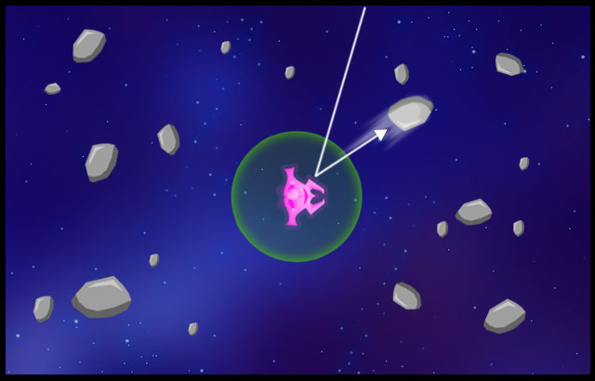

Spiky bumper
This power up gives you a bumper with spikes on it. When you crash into another player he will suffer more damage. You will lose the bumper after you did an amount of damage against the other players. You don’t get any damage when the bumper is still activated when you get attacked from the front. All other sides of your ship will still receive damage when attack however.

Strength: Increase speed by 10% and damage by 25%
Weakness: Increased attraction of orbits by 5%
Destroyed by: After 100 damage points dealt.

Shield
This power up will give you a shield that reduces the damage that you take. This shield stays activated until your shield has blocked an amount of damage. The shield will suffer cracks, to indicate how much shield you have left. If the shield is breached, the shield is destroyed.

Strength: Reduced 10% of health when you get attacked.
Weakness: Speed decreased by 15%
Destroyed by: After 100 damage points received

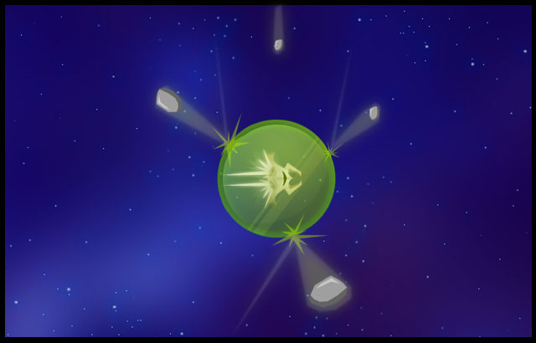

Miner
The miner power up can drop fake power ups. When other players pick up the power up it will explode and will result into damage to nearby enemies.

Strength: Drop mines (fake power ups)
Weakness: When hit by the impact of the mine you receive 15% more damage.
Destroyed by: After you dropped 2 fake power ups

Ship parts
Ship parts will increase the mass of the ship. Ship parts can be stacked to a maximum of 5 parts.

Strength: Increase total health and attack power by 3% for each part.
Weakness: Speed decreased by 4% for each part
Destroyed by: After 250 damage points received for each part

Super mode
This power up will transform your ship to twice his current size. This will result to more damage and more mass. This will be deactivated after that the ship gets damaged by electric or fire damage.

Strength: Increased health and attack power by 10%
Weakness: Speed decreased by 15%
Destroyed by: After 100 damage points received

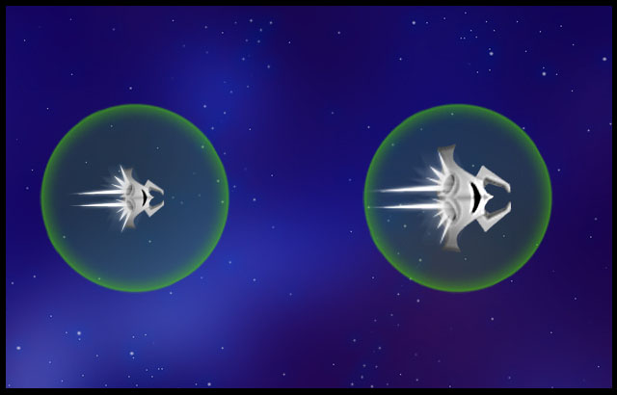

Temporary power ups
The temporary power ups stays active until the time is up. These power ups will start instants after you pick them up. You can only have one permanent or temporary power up active.

Black Star
When you use this power up you will sacrifice yourself in to a black hole for a short amount of time. This black hole will suck nearby players. Not only it will suck but you can move it around in the level. The speed of moving is slow (10% of your maximum base speed).

When an enemy gets sucked by your black hole you gain control over his ship and the present owner will die. When you got a ship a new black hole will spawn on a random place on your screen and your captured ship will come out. All the power ups that the previous player had will be lost and your health will be fully restored.

Strength: Gain control over other player after captured
Weakness: You die if you don’t capture another opponent.
Active time: 30 seconds

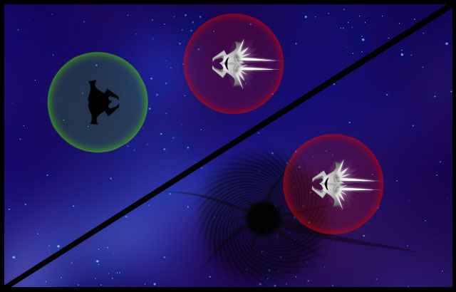

Carbonate
When you pick up the carbonate power up you have 5 seconds to get nearby you opponents before it released a circle of ice beams. The range of the beams is twice the range of your radius. When other players get hit by these beams the players freeze for an amount of time. Affected ships will have a weight increase.

Strength: Ice beam can freeze up to 2 players. Opponents gain weight (+25% weight)
Weakness: Range radius decreased by 15%
Active time: 15 seconds

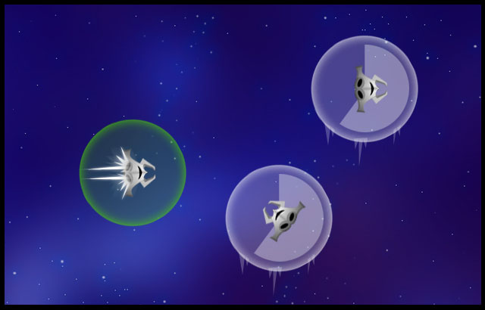

Homey
The homey power up gives you the chance to get objects or enemies automatically with your hook. You don’t need to aim. The range of your homey is three times as the normal ship’s radius.
Homey will make the field of view bigger. Instead of the usual 90 degrees, the field of view will increase to 180 degrees.

Strength: Radius increased by 200%, field of view by 100% and auto aim objects
Weakness: Weight increase by 35%
Active time: 30 seconds

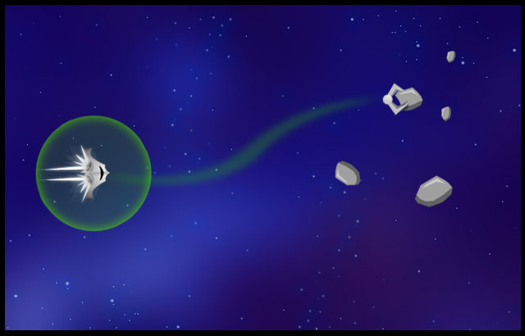

Hyper drive
When you pick up this power up it will be activated instant. Your current speed will be doubled and you will drop a path of electronic gasses for an amount of time. When other enemies come in contact with the beam they suffer damage over time while they are stunned. The player who uses this power up will be protected against the electronic gasses until he stops producing it. When the hyper drive wears off, so will the protection the player had against it.

Strength: Speed increased by 200%, damage done by electronic gasses get players stunned for 5 seconds
Weakness: You can’t control your ship for 5 seconds after the hyper drive is finished.
Active time: 10 seconds

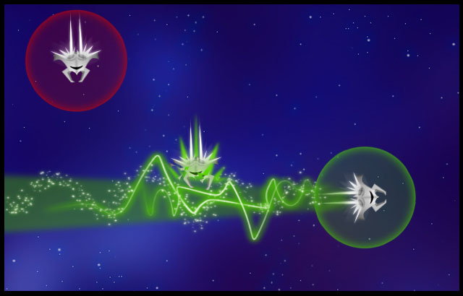

Orbit fire
This power up will trap every object around your ship within the radius of your ship and after an amount of time all the trapped object will shoot away at the same time.

Strength: Create a shield with object reduced damage by 50% when blocked by an object, attack multiple objects at once.
Weakness: Speed decreased by 45%
Active time: 20 seconds

Laser Chain
When you use this power up your chain between your ship and your hook will transform into a laser and your range radius will be doubled until the time has expired. If any enemy comes in contact with the laser they will receive damage. The damage that your opponent gets will be transport as health to the owner of the laser chain.

Strength: Range radius increased by 100%, 20% damage will transforn to 5% health.
Weakness: Orbit attraction and speed increased by 10%
Active time: 15 seconds

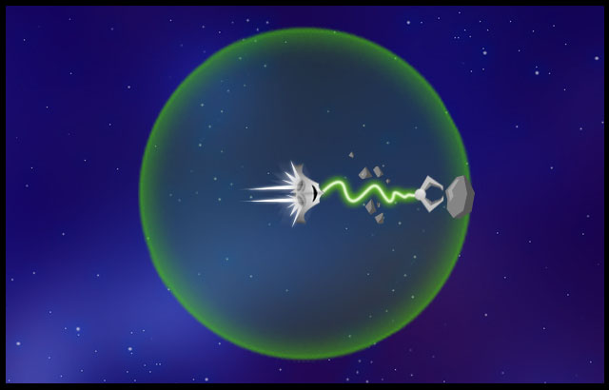

Light speed
This power up gives you a speed boost.

Strength: Increase maximum base speed and base acceleration by 100%
Weakness: Receive 25% more damage
Active time: 15 seconds

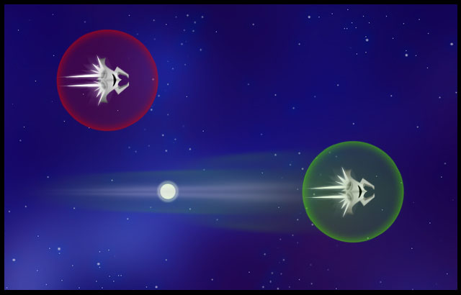

Repair robot
When you come in contact with this robot he will repair your ship. You have also the chance to receive a permanent new power up.

Strength: Restore +2% damage for every 1 second
Weakness: None
Active time: Depends on how many health you need

Satellite
The satellite power up gives you the chance of creating your own object with an orbit around it. When you grab a satellite and then throw it somewhere in the field it will get activated. All enemies will be attracted by the orbit of the satellite. After an amount of time the satellite will destroy itself. The satellite can only be grabbed one time.

Strength: Create own object with orbit that destroys itself. Decrease fire damage by 25%
Weakness: Orbit attraction by 15% satellite not included
Active time: 20

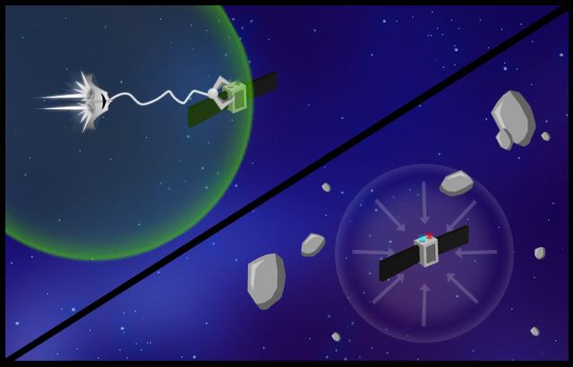

Clone
With this power up you can duplicate your ship. Your main ship will disappear for an amount of time and will be replaced with a clone. The clone itself has only the half of the full health of your main ship. If your clone ship gets destroyed your main ship will appear again and get stunnen for an amount of time. If your clone survives after an amount of time it will destroy himself and do damage to the nearby players.

Strength: Damage blocked by 100%, Cloned ship will destroy after time.
Weakness: If the clone is destroyed you get stunned for 5 seconds
Active time: 20

Hacker
With the hacker power up you have the chance to control an opponent’s ship. Your hook creates an electric bowl and when you throw it to another player it will gets hacked. When a player gets hacked it copied the movement that you do with your ship inverted. These powers will loss his strength after an amount of time.

Strength: Control opponent’s ship. 5% damage will transform to 2% health
Weakness: Get stunned for 2 seconds
Active time: 20

Power up dropper.
In game there will be an object that drops power ups. When you go over these objects they explode. After the explosion power ups will appear and can be picked up by flying over them.

Events

The game has two kinds of elements randomly floating around in the game levels, generic elements and fantasy elements. These elements range from simple objects found in space such as meteoroids, as well as more advanced objects like a manned space station. Some of these objects intervene with the players.

Most objects are circular shaped, which means there is a default formula for it’s behaviour.
Some of the fantasy elements are not however.

Generic elements
Generic elements are objects floating around in the playing field. The objects range from simple asteroids to worm holes. Generic elements are static objects that generally don’t intervene with the players, except when colliding with it.

Generic Planets
A generic planet is a supersized rock, which can be used for momentum and as a projectile. Projectiles can be thrown into an orbit of a planet, to give the projectile a speed boost. This will result in higher damage if the projectile hits.
Every normal planet has a standard gravity-radius around its core. The normal planets have no special power or ability and all they do is suck everything that gets into their radius. If the player is strong enough, he can use the planet as a projectile as well.

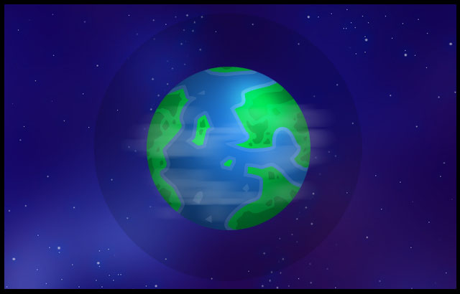

Sun
This planet will combust objects that are in it’s radius. A sun will also attract space ships, and space ships that get too close, will burn to a crisp and be destroyed. It kills players immediately if they get to close. The planet will also shoot projectiles at a regular interval (in the form of magma chunks). Players can grapple the magma chunks.
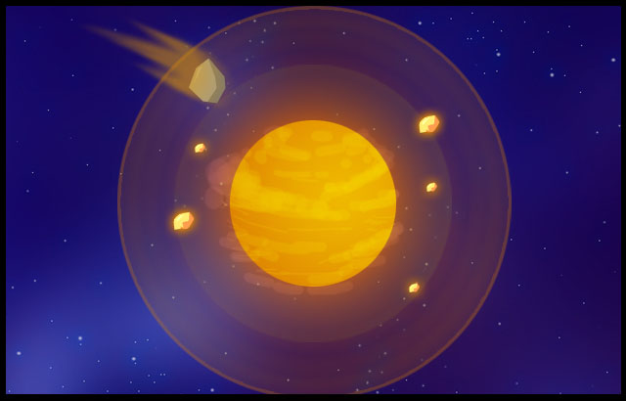

Black hole
A black hole sucks anything in that comes close. The range of a black hole is large, as is its force. Whenever something is sucked in, it is automatically destroyed. A black hole can suck anything in, as long as it is not a part of the border. After a while, a black hole shrinks till there is nothing left. At a certain size, the black hole will have no effect anymore. The power of the black hole power will decrease when shrinking.

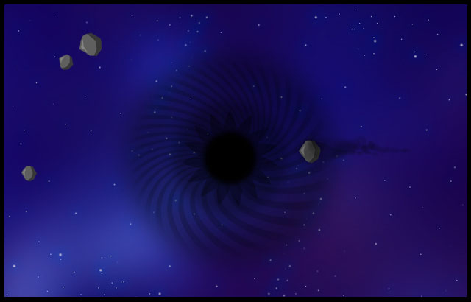

Meteor
A meteor can smash anything with a great force. Players can create meteors by flinging a asteroid into the orbit of a sun, or they can grab a passing meteor. Passing meteor are always faster than created ones and are hard to handle. General ships can only use it as a means of hitchhiking.

Time Portal
A time portal is a portal to another random part of the field. Once a player touches a time portal, it will be teleported on a random place at the screen. When the player has exited the time warp, the player will either be healed or damaged; this is determined on a random basis.

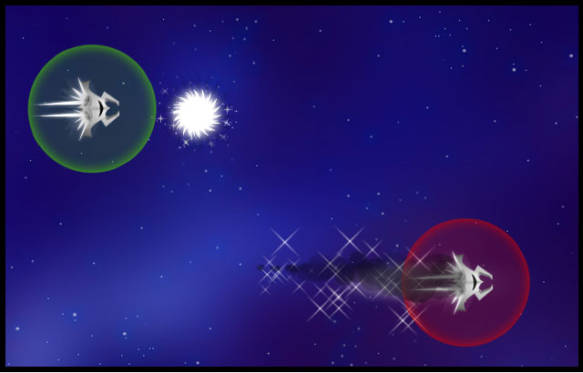

Asteroid
An asteroid is the most basic stone in space. Asteroids are the basic objects to grapple in the game. Asteroids vary in size and can combust, be frozen or be electrified for added effects. To combust an asteroid, the players need to make use of either a sun or fire planet. Freezing an asteroid can be done through the ice planet. Electrifying it can be done through the nebula (when the asteroids are already frozen).

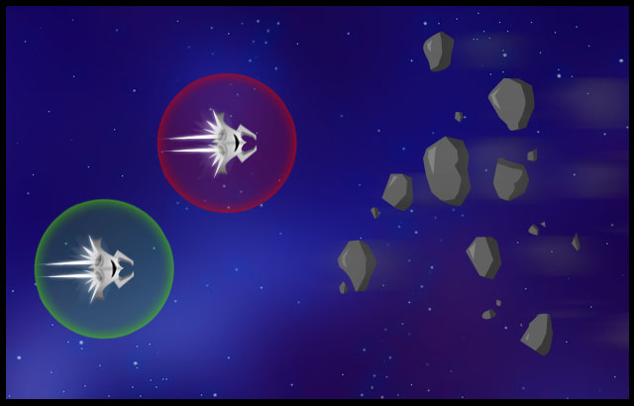

Fire Planet
Fire Planets will not only use their radius to attract objects to the planet like normal planets, but every object that enters the glowing radius, will catch on fire (although the effect of the fire planet is less than that of a sun). Also, the fire planet does not shoot projectiles, which the sun does.

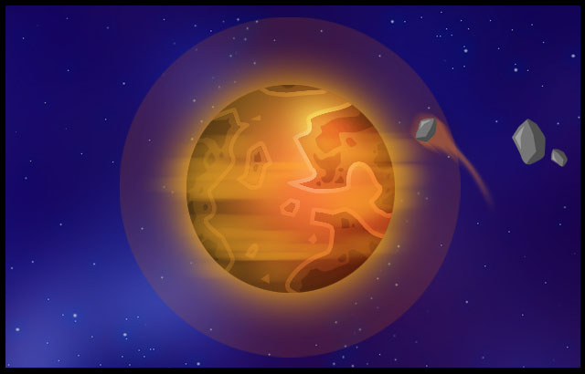

Ice Planet
Ice planets will not only use their radius to attract objects to the planet like normal planets, but every object that enters the radius will instantly freeze.

When an ice planet is destroyed, the debris from the ice planet will remain floating around for a while longer. These objects can be used as projectiles. Anything that touches these chunks will freeze. When the chunks are used as projectile, they are destroyed when they collide. When the chunks are destroyed, it will complete disintegrate into dust.

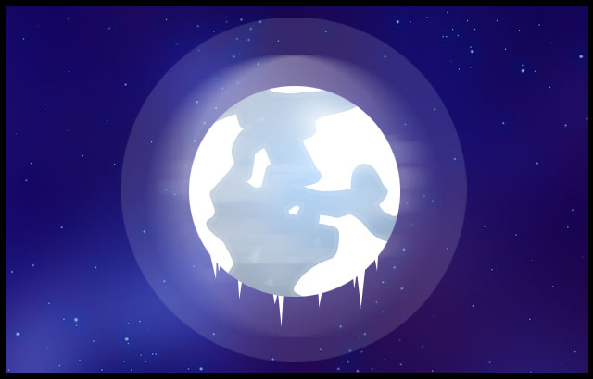

Broken Planet
This planet is nearly destroyed. Because of its state, the planet not only drags objects into it’s radius to its core, but also repels objects. This planet does this completely random, so players do not know when the planet will repel or attract.

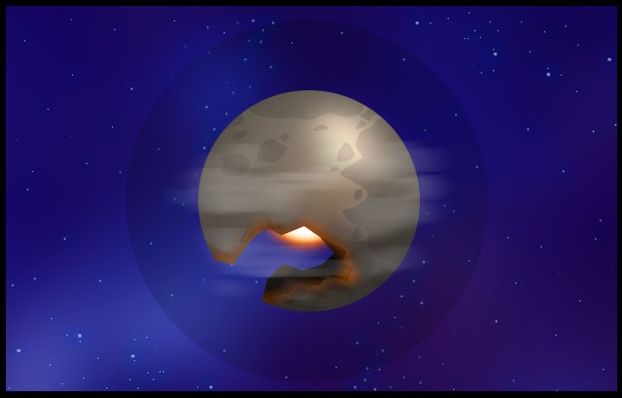

Nebula
The nebula is a very electric hazard floating around. It’s not very noticeable. When players fly through this cloud, they will get electrocuted. When players throw frozen objects through it, the objects will be turned into electric objects. Only frozen objects will be electrocuted as well as spaceships.

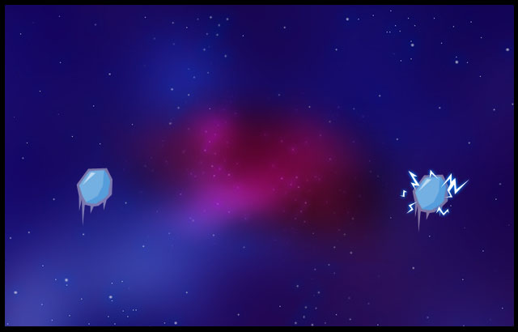

Supernova
The supernova is a star that implodes. It destroys almost everything on the screen. This supernova will appear when the sun gets destroyed.

Fantasy elements

Leprechaun space station

A leprechaun space station will disassemble any player that crosses its path. When a player is caught, the player is changed into a power up. Of course, the player is destroyed and respawns somewhere else. Leprechaun space station also drop power ups at regular intervals.

Leprechaun stations spawn at fixed places and travel a fixed path.

Space train

A space train travels over asteroids, and destroys anything that it hits. A space train has the secondary effect of creating a new set of asteroids. Space trains spawn at fixed places and travels a fixed path.

Colliding with a space train will result into damage using the general collision formula, but the space train will not take any damage.

Hand of God

A hand of god comes down every now and then, and has a few different attacks (such as an attack with a cue stick). The attacks are always aimed at a certain part of the field (not at players), and are always lethal. When the hand of god appears, it always targets the nearest player. The places where the hand of god can spawn are random, but based on the border of the level.

The touch of the hand of god means 50% damage.

Traffic Light

A traffic light emits a force field, which changes properties depending on the state of the traffic light. Green means healing (at a rate of 1% each second), orange means nothing, red means destruction (with a damage intensity of 5). A traffic light can be used as a projectile.

Traffic light spawn randomly on any planet or big sized asteroid. They can be destroyed, but will also disappear automatically when left alone too long.

Space arachnid

A big spider, who likes to make its web among the many planets or asteroids. They therefore spawn at a place where a lot of asteroids or planets are grouped together. The arachnid will make a web, using the asteroids and planets as a base. Each and every planet that is used for its web cannot be used as a projectile anymore.

They will then encage every victim within thread, and after that they will try to eat them. Afterwards, they will always spit out the player again in a random direction, leaving the player paralyzed for the other players. Spiders do 20% damage standard.

Spiders can be killed, but will also go away automatically if left alone for too long.

Gift mine

The Gift Mine will explode when it gets hit by an object. Once hit, it will blink for 2 seconds with a red light before it explodes. Anything caught in the explosion is destroyed. After the explosion, power ups will be summoned out of the debris.

Gift mines will spawn randomly on the field.

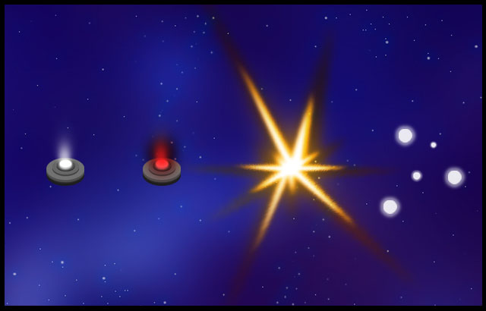
A gift mine in action. The first two indicate the beeping of the mine.
The third is the mine exploding and the fourth is the scattering of power ups after the explosion.

White hole

The polar opposite of the black hole, the white hole spits out new things (planets, suns). As with the black hole, the white hole also shrinks over time, and the smaller the white hole becomes, the smaller the objects it spits out become.

A white hole will appear as a reaction to the black hole, to fill up the area again with new content. The places where a white hole will spawn are fixed and depend on which sun was turned into a supernova/black hole.

Menus

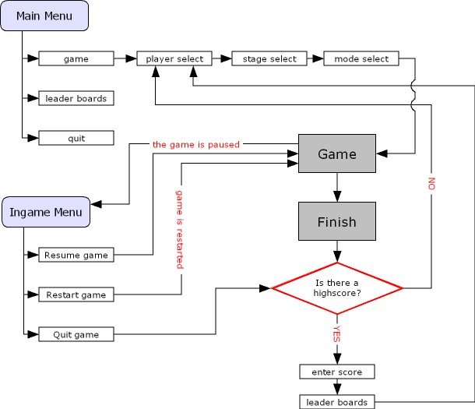

Accessibility of menus

Active player
The menus in the game can only be accessed by the active player. The active player is by default the player with Wii remote number one.

Multiple input
There is only one case where multiple input is needed. This case will be explained in the player select submenu.

Cursor
Every player on the screen is visible through a cursor, but the inactive players will have a transparent cursor, where the only opaque cursor will be the one of the active player.

Main menu
The main menu will be shown when the game is booted. The game will give the player 3 options. These options are:
- Main game
- Leader boards
- Quit

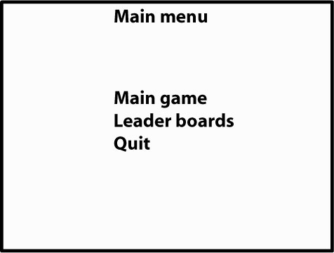

Main game
The main game will lead the player to the options needed to play the game. When this button is pressed, the next submenu will be the player select screen.

Player select
This is the only menu with multiple input. All four player can select their ship of choice. To choose a ship, the player needs to point at it and press A. When the player has chosen a ship, the player needs to confirm it by pressing A once more.

To cancel any choice, the player needs to press B:
- Cancel a choice -> Ship is removed as choice, player needs to select a new ship
- Cancel a confirmation -> Ship is removed as choice, player needs to select a new ship
- Return to previous menu -> active player needs to cancel his choice, and then press B again to return to the previous menu.

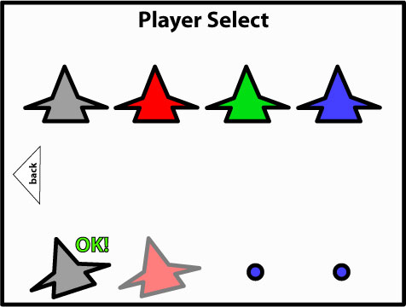

Stage select
The active player can select a stage. Pressing the stage again will confirm it. After a stage is confirmed, the game will automatically go to the next sub menu; mode select. To cancel this screen, the active player needs to press B (if the player has chosen a stage, the player needs to press B twice, to cancel this choice and to cancel the current menu).

When there is more than 1 stage present, there will be the extra option to select a random stage.

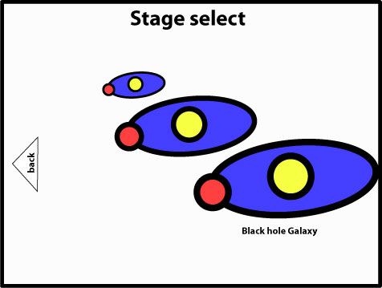

Mode select
In mode select, the active player can select either the use of stock or the use of time. After the player has chosen one of the two, the player can also select how much time or how much stock the player wants to have. The specifics of stock and lives are explained in the chapter game modes.

After the active player has made his choice, the player can press the play button to start playing the game.

The last used settings will be saved and used as default values for the next time this menu is started!

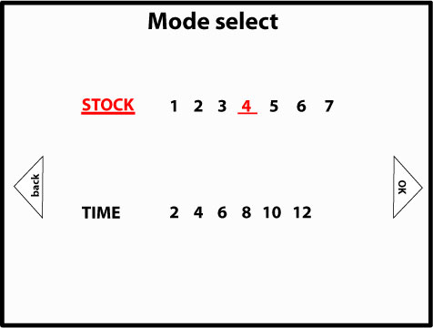

Leader boards
The leader boards will keep track of the high scores of players. As of yet, a standard point based score system has been used, so the leader boards will be limited to the highest amount of points scored.

When accessed through the main menu, the back button in the leader boards will lead back to the main menu. When the leader boards are accessed due to a new score (either due to quitting midgame or finishing the game) the back button will lead the player to the player select screen.

The data in the leader boards will be saved and is meant for review only. Players cannot alter data once they have been inputted into the leader boards, nor can the player delete the content in the leader boards.

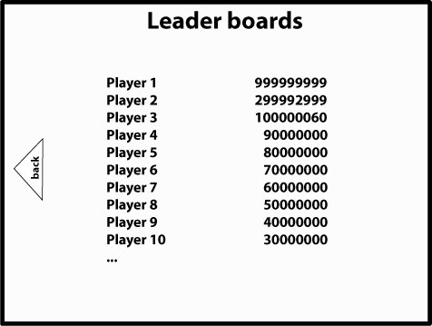

Quit
Since this game will be built on the PC as a demo, the option to quit the game is necessary. This option explains itself; when selected, the game will close down. All data unsaved data will be lost.

The game will give the player a warning first to double check whether the player really wants to quit. When the player has chosen yes to this question, the game will be shut down.

In game menu

Control of the menu
During the game, the players can press the + or - button to pause the game. The game will freeze al action on the screen and zoom in on the player that pressed the button.

The player who pressed the button, will be considered the active player. During a pause, only the active player can continue the game again by pressing the 1 button one more time. When the game continues, the game zooms back to his previous size before the pause, and all action is resumed.

Options
The ingame menu has the following options:
- Resume the game
- Restart the game
- Quit the game

- Resume the game has the same effect as pressing the 1 button; the game will be resumed.

- Restart the game will have the game restart with the settings used in the current game. The players will not be taken to either the player select, stage select or the mode select menu, but will immediately start with the new game.

- Quit the game will quit the game midgame. If there is a high score, the players will be taken to the “enter high score” menu. If there is no high score, the players will be taken towards the player select screen.

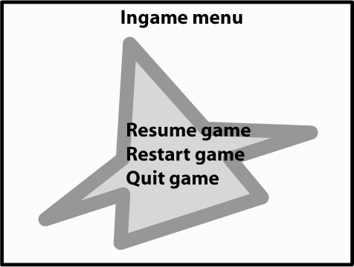

Entering high score
When there is a high score, the game will first take the players to the enter high score menu. The players can enter a name of maximum 10 characters.

Input will be done through a onscreen keyboard, where the players can use the Wii remote to press the keys. The onscreen keyboard will have the lower case letters, and numbers. Through an extra button on the keyboard, the lower case letters will become capitals. Accepting the name can be done by pressing the enter button.

The player with the high score will be considered the active player and is the only one who can input his name. In the event where there is more than 1 high score, the player with the highest high score gets to input his data first and the one with the lowest high score gets to input his data last.

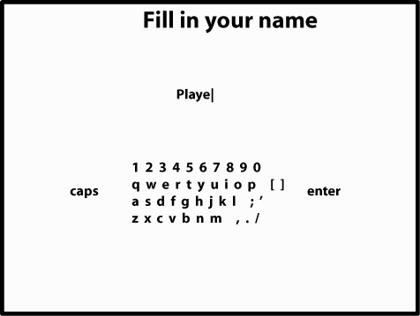

HUD
During the game, the score is always displayed on the HUD. Depending on the game mode selected, there can also be stock or a timer present on the HUD. Time will always be centred on top. Stock will either be present besides the ships themselves, or beneath the ship icon belonging to that player, this is a matter of testing.

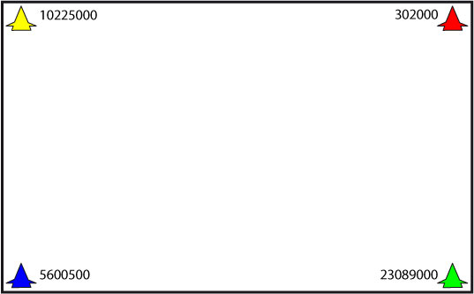

During the game the only thing that can change in the HUD is the amount of score.

Scoring feedback
When the player starts scoring (refer to chapter 8.1.1 for the specifics on how scoring works). The multiplier the player received will appear next to the object responsible for the multiplier. The multiplier will then move the beneath the score of the player who threw the object and be added to any multiplier that was already there (when there is no modifier yet, the modifier will be placed there).

When damage is done, the amount of damage appears next to the damaged object and moves beneath the score of the player who did the damage, next to the multiplier (to show how much the damage will be multiplied by the multiplier). Afterwards, when both the multiplier and the damage have been determined, the total score will be calculated and added to the total score.

Other feedback
Other feedback will be given through the player ships, by changing the appearance or by using animations of the ships. Feedback given through player ships is:

- Damage: the more damaged the player is, the more smoke will come from his ship. Currently the ship will have four animations:
  - 100-75%: perfectly healthy
  - 74-50%: slight smoke coming from the ship
  - 49-25%: heavy smoke coming from the ship
  - 24-1%: extremely heavy smoke and fire coming from the ship
- Temporary power up: each and every power up will have a different animation around the ship
- Semi permanent power: each power up will be added to the ship in the form of an extra part. As long as the semi permanent power up is still active, the part will remain with the ship.
- Permanent power up: the appearance of the ship will change (in color or shape)

Stock
The stock can either be present under the icon of the player ship (in the HUD) or be presented within the radius of the ship as an icon (outside of the HUD). In the last case, you have to think of the balloons as used in Mario Kart as an indicator for how much stock a player has left.

Sound list

This is the sound list; a complete list of all the sounds used in the game and their use. This list contains the sounds that may be used in the Wii remote, as well as the sounds used in the game itself. So far, no decision has been made to use the Wii remote for sound feedback.

Player feedback

Ship feedback

Name | Description | Timing
Truster | When the ships starts moving, the ship’s nozzle will make sound. | When the player starts moving using the analog stick
Collision - metal | When something collides with the ship it will make a metallic sound. | When any object hits against a ship, or when a ship collides with something else
Hook – extend | When the hooks extends, it will make a sound of a pulley | When the player makes the gesture to make the hook extend, as long as the hook is extending, this sound is played
Hook – deflect | When two hooks hit each other, they will make a metallic sound | When two players simultaneously target each other and extend their hooks; when the hooks hit.
Hook – grab | When the hook successfully grapples an object or ship, it makes a mechanic sound | When an object is successfully grappled, no matter which type of object
Hook - unsuccessful | When a player tries to grab something, but is unable to do so, it makes a prolonged mechanical sound, of a machine going wrong | When the hook grabs an object that cannot be grabbed yet.
Explosion | When the ship explodes | When the health of the player reaches 0 or less, this sound is played
Spawn | When a ship spawns in a location | When a ship spawns, a sound is played to indicate the new arrival
Burning start | When a ship ignites due to the orbit of a planet with fire | When a ship exceeds the 5% damage intensity rate when in the orbit of a flame based planet or sun, the ship will ignite
Burning continue | While a ship is ignited, it makes sound | While a ship remains ignited, this sound will be played

Power up feedback

Name | Description
Speed up | A generic sound that indicates a permanent speed power up
Health up | A generic sound that indicates a permanent doubling of health
Ice resistance | A generic sound indicating an increase in ice resistance
Fire resistance | A generic sound indicating an increase in fire resistance
Electric resistance | A generic sound indicating an increase in electricity resistance
Jelly start | A sound effect for when the jelly power up has been picked up
Jelly hit | Whenever a ship infused with jelly gets hit by any object (same from fire or electric objects), this sound is played
Jelly melt | Whenever a ship infused with jelly is hit by an fire or electric object
Spiky Bumper start | Whenever a ship picks up the spiky bumper power up.
Spiky Bumper hit | Whenever a ship infused with spiky bumper collides frontally with another object, this sound is played
Spiky Bumper break | When the spiky bumper is broken, this sound is played
Shield start | When the shield power up has been picked up, this sound is played
Shield hit | When a ship infused with shield power up is hit, this sound is played, unless the shield gets cracked
Shield crack | When a ship infused with shield power up is hit and the shield cracks a little, this sound is played.
Shield shatter | When a ship infused with shield power up is hit and the shield is shattered, this sound is played
Miner start | When a ship picks up the miner power up this sound is played.
Miner place | When a ship infused with miner places a fake power up
Miner deactivate | When a ship infused with miner has placed enough power ups, the miner will power down and disappear. This sound is played then.
Ship parts start | When a ship picks up a part, this sound is played
Ship parts destroy | When a ship gets damaged enough and loses a part, this sound is played
Super mode start | When a ship picks up the super mode power up, this sound is played
Super mode end | When a ship infused with super mode has received a certain amount of damage, this sound is played
Generic Power up Pick up | When a temporary power up is picked up
Generic Power up active | When a temporary power up is activated
Black star start | When the black star power up is activated
Carbonate start | When the carbonate power up is activated
Carbonate hit | Every ship hit with carbonate will be frozen
Homey start | When the homey power up is activated
Hyper drive start | When the hyper drive is activated
Hyper drive hit | Whenever objects are hit by the tail of the hyper drive
Hyper drive loop | While the ship is in hyper drive
Orbit fire start | When the orbit fire power up is activated
Laser chain start | When the laser chain power up is activated
Laser chain hit | Whenever the laser chain hits an object
Light speed start | When the light speed power up is activated
Repair robot start | When the repair robot is activated
Repair robot repair | While the repair robot is repairing the ship
Repair robot failure | When the repair robot is hit while repairing
Satellite start | When the satellite power up is activated
Satellite loop | While the satellite is active
Satellite explosion | When the satellite explodes, when the time is over or due to an impact of any object.
Hacker start | When the hacker power up is activated
Hacker success | When the hacker power up successfully hits another player
Clone start | When the power up is activated

Environment feedback

Generic object feedback
Name | Description
Sun loop | The sun is constantly burning
Sun projectile launch | Whenever a projectile is launched from the sun
Sun nova transform | When the sun is transformed into a nova due to an impact
Black hole loop | While the black hole is active
Supernova explosion | The sound effect for a super nova explosion. Needs to transition into a black hole
Meteor loop | The sound that is played while a meteor on the screen
Time portal loop | The sound a time portal makes when it is on screen
Time portal activate | The sound when a player enters a time portal
Time portal respawn | The sound of the time portal when it respawns when a player has entered earlier.
Fire planet loop | The sound of a fire planet, less intense than the sun
Ice planet loop | The sound loop of an ice planet
Ice planet shatter | When the ice planet is destroyed
Ice planet parts shatter | When the debris of the ice planet is destroyed
Broken planet loop | The sound of a planet breaking down (like the planet is like an old creaky house)
Nebula loop | The sound of a nebula while active
Nebula electrify | The sound when a player enters the nebula and gets electrified
Collision – rock | When two rock based objects collide with each other, they make a rocky sound

Fantasy object feedback
Name | Description
Leprechaun activate | When the space station appears on screen
Leprechaun drop | When the space station drops a power up
Leprechaun dissemble | When the space station captures a player and dissembles him
Leprechaun explosion | When the space station is destroyed
Space train intro | When the arrival of the space train is introduced
Space train loop | While the space train is onscreen
Hand of god loop | While the hand of god is onscreen
Traffic light activate | When the traffic light appears
Traffic light switch | When the traffic light changes light colour
Traffic light destroy | When the traffic light is destroyed
Space arachnid weave | When a web is weaved among planets
Space arachnid loop | While the space arachnid is on screen
Space arachnid capture | When the space arachnid captures a player and binds him with web
Space arachnid leave | When the space arachnid leaves
Space arachnid die | When the space arachnid dies due to an object
Gift mine beep | When the gift mine is activated
Gift mine scatter | When the exploded gift mine scatters power ups
White hole appearance | When the white hole is activated
White hole loop | While the white hole is onscreen
White hole leave | When the white hole disappears

Menu feedback

The menu has a standard set of feedback, used for the main menu as well as the ingame menu.

Name | Description | Timing
Select | Pressing any button while in the menu, this sound is used to let the player know he pressed the button | When a button (visual) is pressed in the menu
Cancel | Pressing the cancel button while in the menu, which causes the player to either cancel a confirmation or return to a previous menu | When the B button (Wii remote) is pressed in the menu
Confirmation | This sound is to let the player know he has confirmed a choice, in a screen where it is necessary to confirm a choice | When the A button (Wii remote) is pressed when confirming an option.
Roll over | When the (active) player rolls over a visual button, this sound is played to let him know he has rolled over a button. | When the cursor of an active player rolls over a visual button.
Roll over ship | In the ship selection screen, the ship icons that can be choosen have a separate, less present SFX then the generic roll over. | When the cursor of a player rolls over the icon of a selectable ship

Background Music

There will be two themes:
- Theme for the main menu
- Theme for in game

When there is enough time, more themes can be discussed (extra levels, extra themes for in the main menu), but for the demo, the two themes and the sound effects need to be prioritized.

Game modes

Multi Player

The Multi Player mode will be playable by at least 2 players and with a maximum of 4 players. Players have infinite lives and a damage bar, as well as a score meter. When their damage bar reaches 0, they respawn in their respective corner of the screen.

Player 1 respawns in the top left corner of the screen, Player 2 top right corner, Player 3 bottom left corner, and Player 4 the bottom right corner of the screen. This rules out people who have to wait for a new round when they are dead, we want to include all players all the time in the game

The goal - scoring
The main goal of this game is to receive the highest score after playing an amount of time. You can see this as a battle round during a boxing match. You receive point by damaging your opponents.

The big trick is to multiply your points. This can be done in different kind of ways. The longer the object is on the way to your opponent the more multipliers you get. So it will be wise to use as many orbits from planets, power ups and objects during the attack. The main rule is that your multipliers will keep going on until one of your opponents gets damaged by your objects. The multiply ability has been separated in 4 phases.

Phase 1
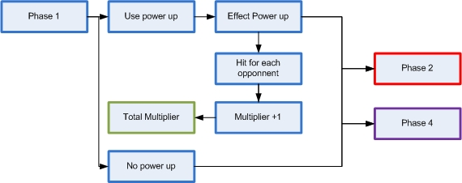

The first phase is based on using a power up or not. Your power up can influence your multiplier. Every opponent that gets hit by you power up get +1 stocked in your total multiplier. From the end of this phase you will either continue to phase 2 or 4.

Phase 2

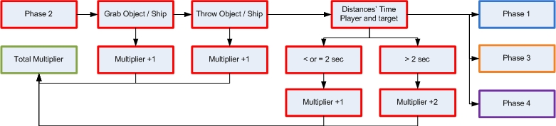

Phase 2 is based on grappling and throwing an object. For every object you grab and throw you will receive +1 multiplier. Also the distance between you and your target will influence your multiplier. If the distances time is equal or lower than 2 seconds you receive +1 and if it takes longer than 2 seconds then you receive +2 additional multiplier. If object does not do any damage to an opponent you will go to phase 1 or phase 3 again. If you do damage you will continue to phase 4.

Phase 3

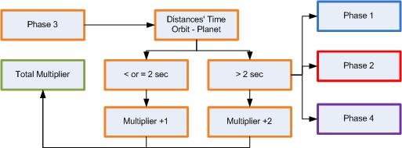

Phase 3 stands for the interaction between your attack object and the orbit of planets. The longer your object is attracted to the orbit the higher your multiplier gets. If your object does not do any damage to an opponent you will go to phase 1 or phase 2 again. If you do damage you’re in phase 4. This is the same as phase 2.

Phase 4

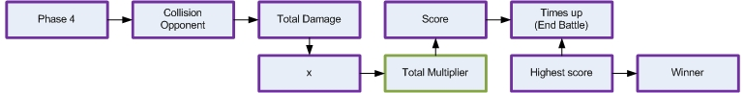

This phase will transform your total multiplier into a score en reset your total multiplier back to 0. When you do damage to an opponent you will receive a score that’s equal to the total damage x total multiplier. If your score reached an amount of points you can be rewarded with a random power up. The winner of the game is the player with the highest score after the current game is completed.

Rewards.

There are 2 kind of rewards in the game. The first is the amount of multipliers you have and the other one is the total points after you have damaged your opponents.

Multiplier rewards
When your reached an amount of multipliers you will receive a bonus. Every new bonus you get will replace the old one. For example when you got your multiplier x5 you will lose the x3 bonus. You cannot have any more than one multiplier bonus at the same time.

Multiplier x3: Total damage increased by 10% for 30 seconds
Multiplier x5: Total radius range increased by 10% for 30 seconds
Multiplier x10: Total damage increased by 15% for 1 minute
Multiplier x15: Total radius range increased by 15% for 1 minute
Multiplier x20: Total damage increased by 15% and 15% speed for 2 minutes
Multiplier x25: Total radius range increased by 15% and 15% speed for 2 minutes

Point rewards
Your will receive another bonus when you have reached an amount of points. You will only receive one bonus at each time.

+ 125: Receive 10% health over 10 seconds
+ 250: Receive Temporary power up
+ 500: Receive 20% health over 10 seconds
+ 750: Receive Permanent power up
+1000: Receive 25% health over 10 seconds and receive one temporary power up
+2000: Receive 25% health over 10 seconds and receive one permanent power up
+3000: Receive 35% health over 8 seconds and receive one temporary power up
+5000: Receive 35% health over 8 seconds and receive one permanent power up
+10000: Full health and 30 seconds indestructible.

Leveldesign

Leveldesign will be moved to a separate document once it is clear what elements shall be used for the first playable.

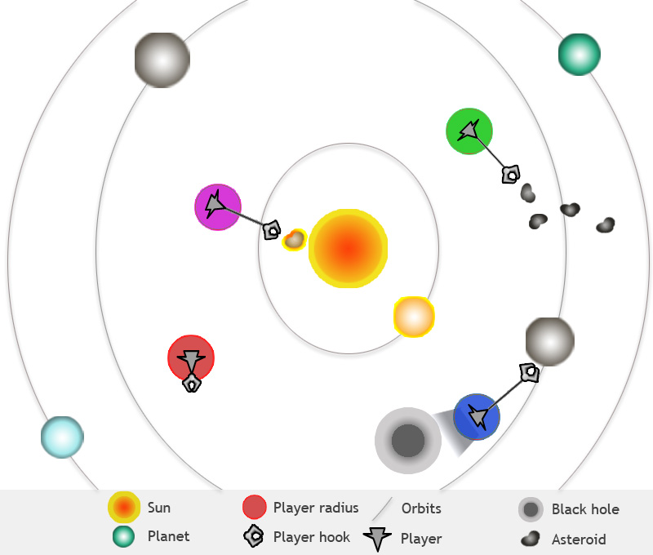

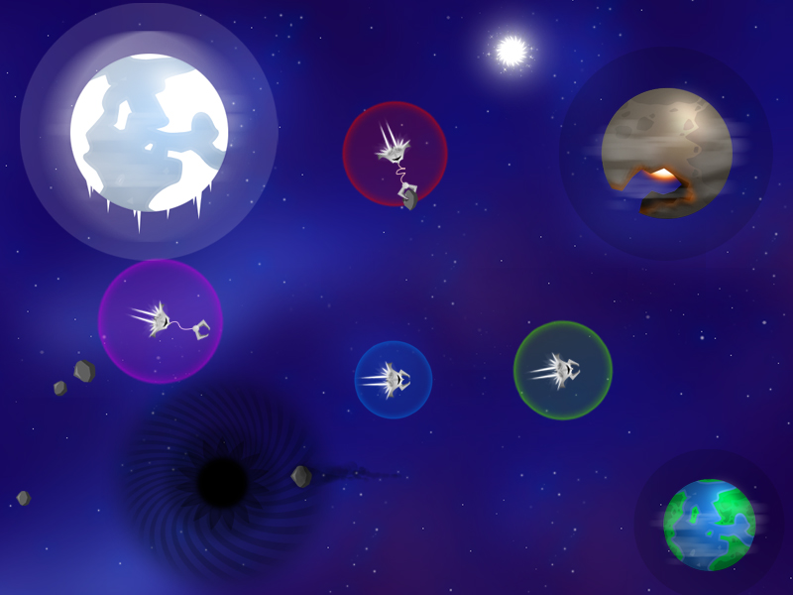

mock-ups of a possible level

Orbits

Planets can also travel on an invisible trail shaped in a circular line.  Planets are always slowly in motion. The circular track is only partly visible in the playfield (see the right example, for a part of the playfield, while the rest remain invisible).  Planets slowly travel across the screen across the path, and when they reach the border of the screen, they disappear.  Because there are multiple invisible trails on the screen, new planets can appear as well, and in opposite directions. | The red borders are the borders of the field 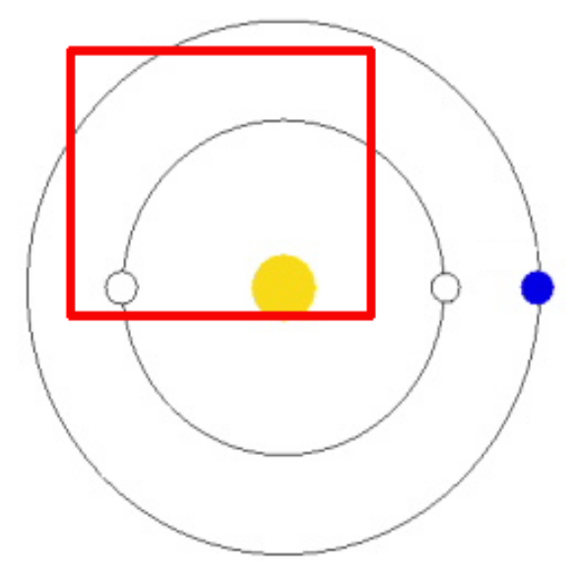

Layout

Every object that orbits around a central position (like a sun) has a predefined path. Other objects that float around in space can either follow a predefined path (with or without random spawn positions) or be randomly generated. Predefined paths can even extend outside of the actual field.
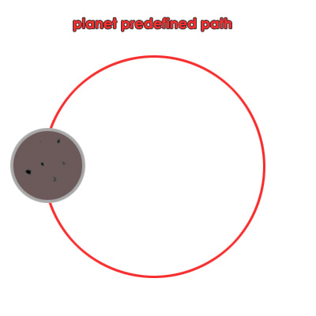

List of elements:

Predefined path | Randomly spawned
Generic planets | Meteor
Sun | Asteroid
Black hole | Nebula
Time Portal | Traffic Light
Fire Planet | Space arachnid
Ice Planet | Gift mine
Broken Planet
Leprechaun space station
Space train
White hole

Black holes, Time Portal, Leprechaun space station, Space train, White hole have several predefined positions, not just one.

Traffic Light is randomly placed on a planet or an asteroid that is big enough.

