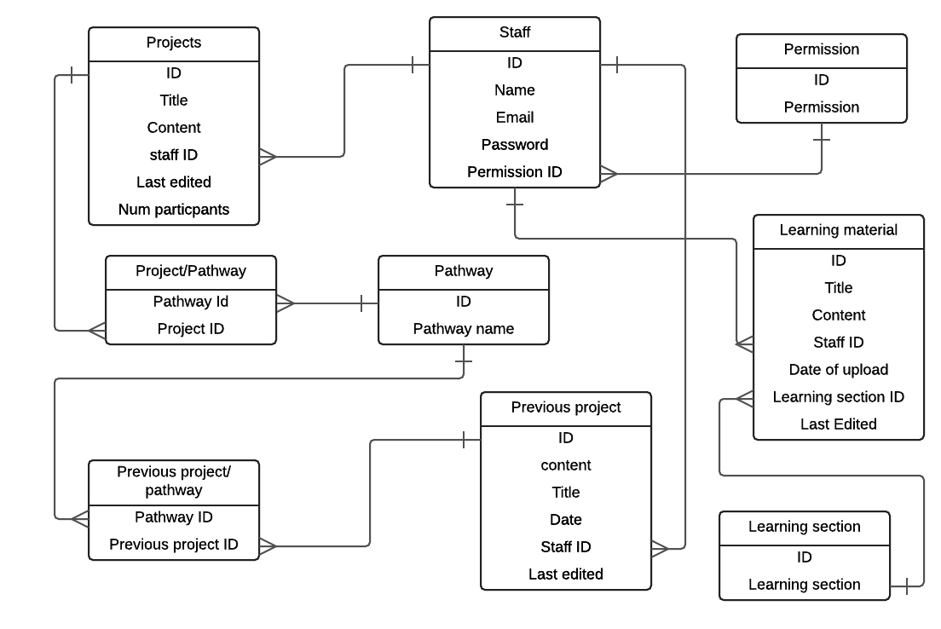

Can belong to

Belong to only

Belong to only

Can have

Belong to only

Belong to only

Can include

Is useful in

Belong to

Can upload

Belong to

Can upload

belong to

Has only

Can upload

Can belong to

Can have

belong to