**Assessment1**

**Zhang Chao t0916014**

**Part 1: IBM Bluemix and Cloud Foundry**

*1. What is Cloud Foundry software in the context of cloud? (2 marks)*

Answer:

**Cloud Foundry, which is known as PaaS, is an open-source, multi cloud application platform to help users or developers create and deploy their apps.**

*2. In which way does Cloud Foundry help us when developing and updating web applications using boilerplates such as Node.js Boilerplate? (2 marks)*

Answer:

**Cloud Foundry automatically transforms source code into containers, scales them on demand, and manages user access and capacity. It also owns a broad community and can connect many other services, such as DB2, Watson, and so on.**

*3. How does Cloud Foundry software determine dependencies for the application which is uploaded/pushed by a user via the Cloud Foundry command line interface (CLI)? (2 marks)*

Answer:

**Firstly, users have to take note of the manifest.yml file. When deploying their app back to IBM Cloud, this file is used to determine the application’s URL, memory allocation, number of instances, and other crucial parameters. Then, they can open the command interface and change to the directory where their code is located. After that, they can connect and log in to IBM Cloud with API, their username, org_name, space as well as password. All of these items ensure Cloud Foundry software determine dependencies for the application.**

*4. What is the use of VCAP_SERVICES environment variable in IBM Bluemix applications? (2 marks)*

Answer:

**The VCAP_SERVICES environment variable contains information about external connection. Developers can leverage on it to interact with service instances in IBM Cloud or IBM Watson. The fields in this environment variable are set when you bind a service to an application.**

**Part 2: Web Application Development (DB)**

*5. Hands-on exercise Example 1 demonstrated a simple example of using a web application to output the result of an SQL script using Node.js. In the example, we output the whole database table into the web interface. Modify the Node.JS code such that the output contains only the first three fields of the database table, and, push the updated app to cloud. (include necessary screenshots including the web page) (5 marks)*

Answer:

**(1) the modified node.js code (index.js) is as follows:**

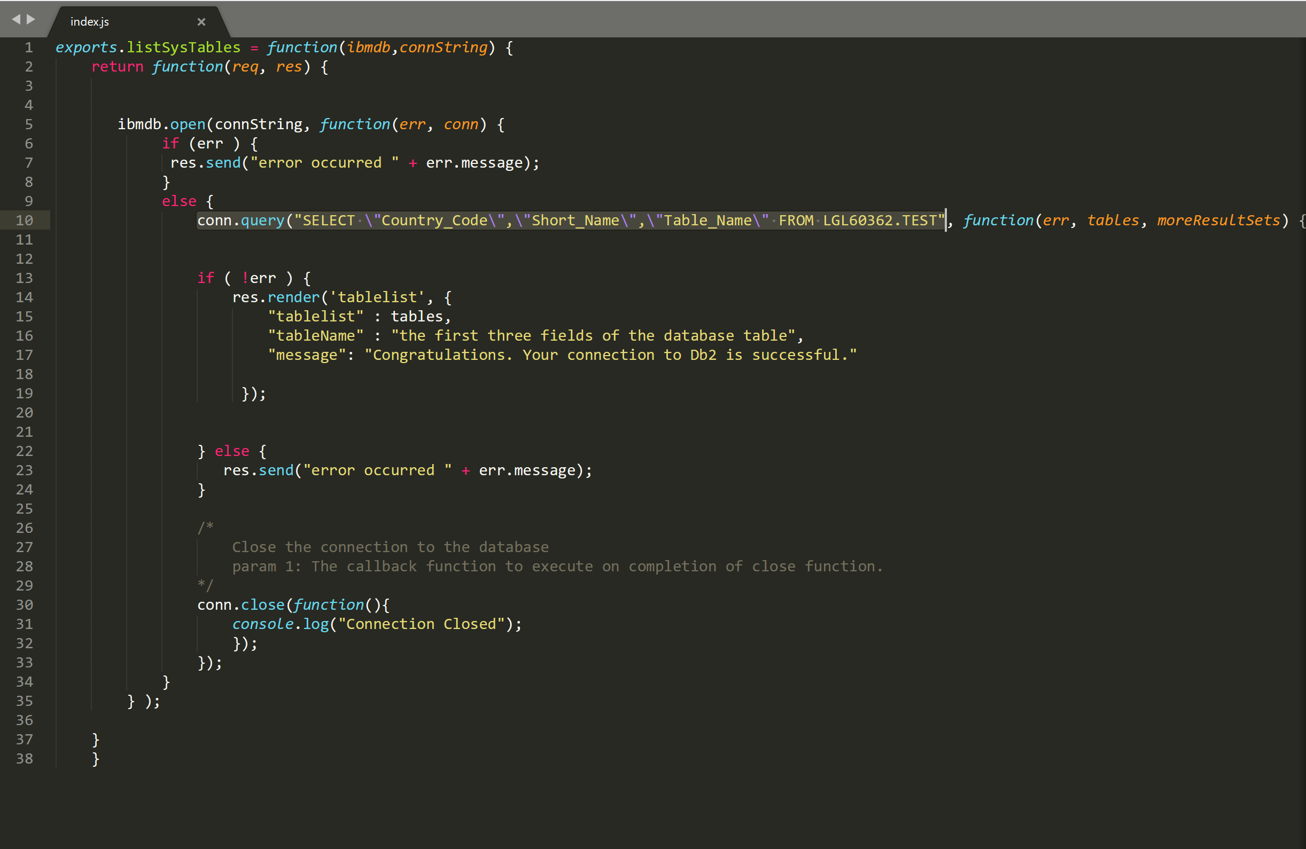

**(2)the output in the web page(click** [**https://assessment1.mybluemix.net/**](https://assessment1.mybluemix.net/) **to view) is as follows:**

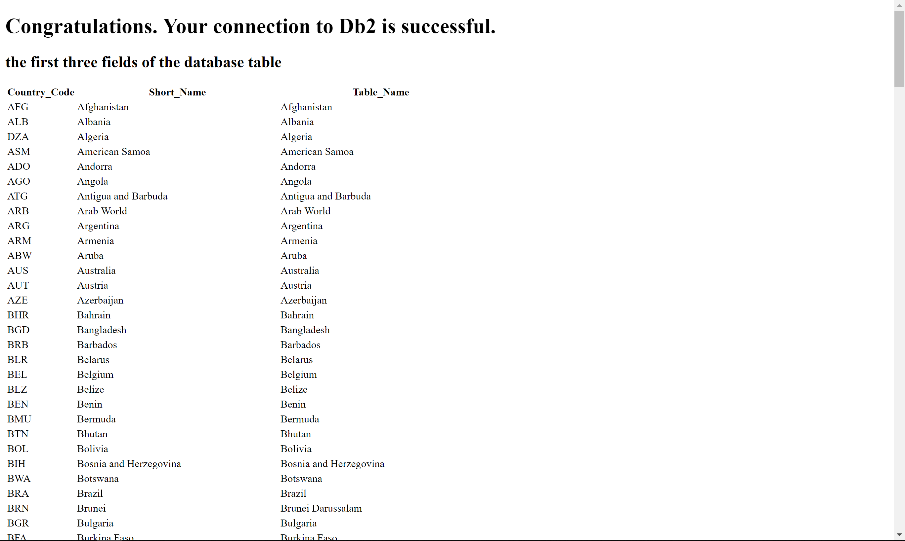

**Part 3: On-cloud Data Analytics (SaaS)**

*6. Download the test-db.csv (contains data of students in a school) from the course web page. Upload the test-db.csv file as a new table in the same database you created in Example 1 in the hands-on exercise. (please include screenshots) (4 marks)*

Answer:

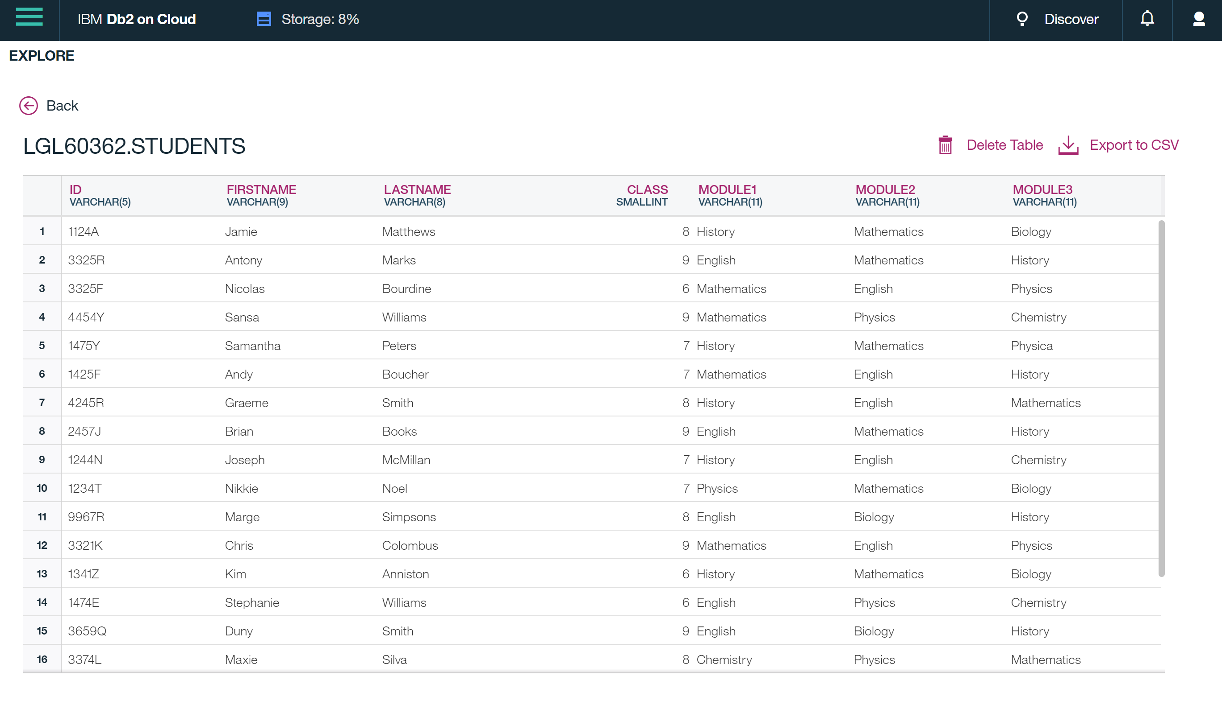

*7. Using an SQL script, find the number of students that are in grade 9 and studying history.*

*(please include screenshots) (3 marks)*

Answer:

**4 students**

