

On quadratic equations of q-regular tree and their applications to Symmetric Cryptography.

Vasyl Ustimenko^{1,2} , Oleksandr Pustovit² , Tymofij Svyrydenko ²

¹ Royal Holloway University of London, United Kingdom
² Institute of telecommunications and global information space, Kyiv, Ukraine
³ University of Maria Curie -Sklodowska . Lublin, Poland
Abstract. Graphs D(n, q) and their connected components CD(n, q) were defined 30 years ago.
We observe shortly their applications to Extremal, Spectral and Algebraic Graph theory together with applications to Theory of Low Density Parity Check
Codes and Symmetric Cryptography.The natural generalizations D(n, K) of D(n, q) are naturally defined over arbitrary commutative ring. We introduce several new flexible stream ciphers
based on special walks on these graphs. Their implementations in the case of arithmetical rings Z_q, q=2^s are discussed. Encryption map of two families of ciphers are nonlinear multivariate maps
Users can vary the degree of these maps to control the resistance against attack of the who has some access to unencrypted information, We modified the encryption and decryption of one of the graph based cipher to violate its multivariate nature. Thus adversary could not use instruments of multivariate cryptanalysis for breaking the system,

Keywords: Application of graphs of large girth, Symmetric Cryptography, Graph based ciphers, Symbolic Computations.

1 Introduction

Let us consider infinite dihedral group W given by generators s_1, s_2 and relations (s_1}^2=e and {s_2}^2=e$\. Its Weyl geometry is the bipartite graph
with partition sets P=\{g<s_1> | g\in W \} and
L=\{g<s_2> | g\in W \} corresponding to binary relation I such that \alpha I \beta if and only if the intersection of \alpha \in P and \beta \in L$ is nonempty. This graph is the binary tree depicted below with the diagram presenting q in regular tree with q>3 in the case of cubic graph/
Fig. 1
Binary tree: …-*-*-*-…
Cubic tree: *
∕ │ \
* * *
∕ \ ∕ \ ∕ \
* * * * * *
∕ \ ∕ \ ∕ \ ∕ \ ∕ \ ∕ \
* * * * * * * * * * * *

It is well known that Tits geometry \Gamma of rank 2 with flag transitive automorphism the group G corresponding to infinite of kind BWB$ infinite dimensional Lie algebra over finite field $F_q$ with the Weyl group as above is a $q+1$-regular forest
(see [1]).
Group G is the BN pair (see {Bourbaki) with the Borel subgroup B=B^{+) generated by root subgroups correspondinh to positive roots. Subgroup B in the ‘’twinning subgroup ‘’ definition of BN pair can be replaced by ‘’twinning subgroup ‘’
B^{-} generated by root subgroups corresponding to negative roots. Then Tits geometry \Gamma is the q+1-regular bipartite graph with partition sets P’={ gP_1| g ϵ G }, L’ ={ gP_2| g ϵ G} where P_i=B^{+}<s_i>B^{+}, i=1, 2 are
standard maximal parabolic subgroups of G.

In [2] (see also [2], [3]) was noticed that the orbits F_i of B^{-} containing P_i, (P_i>B^{+}) are infinite dimensional vector spaces and incidence of element from F_1 \cup F_2 can be given by quadratic equations. The incidence structure on them with the set of points F_1, set of lines F_2 and the restriction I’ of I on them is a bipartite q -regular forest.

In case of root system \tilde{A_1}$ coordinates of vector spaces F_i corresponds to negative roots of kind \alpha, \beta,
k(\alpha)+k(\beta), (k+1)\alpha+ k\beta, k\alpha+ (k+ 1)\beta, k>0 where \alpha and \beta are negative simple roots.
So in the basis of \ alpha, \beta indexes presented as elements of the set \Omega which consist on (1, 0), (0, 1),
(k, k), (k+1, k), (k, k+1)$, $k>0 . We can assume that points are indexed by elements of \Omega-{0, 1} and indexes of lines are elements of \Omega-{1, 0}. In fact inexes of kind (k, k) corresponds to imaginary roots of \tilde{A_1} and other indexes correspond to real roots. In [5] authors add twining roots (i, i)’ for imaginary roots of kind (k, k)
and use extra variables to simplify the quadratic system of equations. It allows them to define an infinite regular forest D(q) with points
(p_1, p_2, … ,p_n, …) and lines
$[l_1, l_2,…, l_n, …]
and incidence relation given by the following equations:

l_2-p_2 = l_1p_1,

l_3-p_3 = l_2p_1,

l_4-p_4 = l_1p_2,

l_i-p_i = l_1p_{i-2}),

l_{i+1}-p_{i+1} = l_{i-1}p_1,

L_{i+2}-p_{i+2} = l_ip_1,

l_{i+3}-p_{i+3} = l_1p_{i+1} where i ≥ 5.

The quadratic equations of single tree
CD(q) of D(q) for odd q can be also written. They are written as conditions on points and lines given via quadratic system of equations in [6].

Let D(n, q) (CD(n,q)) be the homomorphic image of
D(q) (CD(q) respectively) under the
homomorphism of deletion of coordinates of
points and lines of $D(q)$ with indexes that $> n$ (see [7]).
During last 30 years many important applications of
these graphs to Extremal ([7], [8] and further references), Spectral (see [8] and further references) and Algebraic
Graph Theory ([8], [9], [10]), Theory of LDPC Codes (see [11], [12], [13]) and
Cryptography (see [14], [15], [8], [10] and furthere references).

Many of applications are motivated by the fact that the girth of D(n,q) is at least n+5. Recall that the girth of simple graph is the length of its minimal cycle. We can take any commutative ring K and consider the graphs
D(n, K) obtained via the change of F_q for K (see [14]). Various stream ciphers based on walks on graphs D(n, K) are known since 1998 (see [Us Pu ] and further
references)

Alternative research on symmetric graph based cryptography can be found in [16]-[21].

In paper [14] was proven that in the case of integral domain K the girth of D(n. K) is bounded below by n+5. In fact this paper contains the algorithm of construction of enveloping tree of each vertex of D(n, K) of size order t (m)^s where t=|K|, s=[[n+5]/2]-1 where K
is finite commutative ring of order t and n is the order of multiplicative group K* and symbol [x] denotes floor
function from rational number x.
We present new stream cipher with the space
of plaintexts (Z_q)^n defined over arithmetical ring
Z_q of residues modulo q . The parameter q is selected as even prime power 2^s, s>7. Additionally we present
another stream cipher based on homomorphic image

So we define our algorithms in terms of D(n. K) for finite commutative ring K.

2. On multivariate transformations of affine spaces
K^n and constructions of stream ciphers.
Communication Theory widely uses finite commutative rings (K,+, ∙) for the representation of information pieces as tuples of kind v=(p_1, p_2, ..., p_n) ϵK^n where coordinates p_i are elements of the alphabet K. Natural examples of commutative rings are mo
Passwords in form of tuples v are used in symmetric encryption and as access data to use the resources of Information System.
Effective encryption maps can be selected as polynomial transformations of affine space K^n.
In case of classical multivariate cryptography developers of cryptosystems concentrated on appications of maps of degree 2 and 3 defined over finite fields (see []-[]) but on case of symmetric cryptographythese restrictions are immaterial.
Famous affine Cremona semigroup ^nCS(K) (see [51] and [52], [53] and further references) is a natural monoid acting on K^n.
Affine Cremona Semigroup ^nCS(K) is defined as a totallity of endomorphisms of polynomial ring K[x_1, x_2, … , x_n]. It acts naturally on the affine space $(K)^n$ as semigroup of polynomial transformation.
Element \sigma of the semigroup can be given via its values on variables, i. e. as the rule
x_i → f_i(x_1, x_2, … , x), i=1, 2,…, n.
This rule induces the map
\sigma’: (a_1, a_2, … , a_n) → (f_1(a_1, a_2, …, a_n), f_2(x_1, x_2, …, x_n), …, f_n(x_1, x_2, …, x_n)) on the vector space (K)^n.
We assume that \sigma is given in its standard form which is the list of f_i written as sums of their monomial terms ordered lexicographically. We define the density of f_i as the number of their monomial terms and density \den(\signa) of endomorphism
\sigma as maximum of densities of f_i. Degrees and densities of multivariate maps make an impact on the complexity of the compositions of two elements.

Computer algebra of multivariate transformations does not include yet effective quantum computations. That is why these area can serve as the source of encryptions tools in Post Quantum Era and Multivariate Cryptography remains one of the fifth directions of Post
Quantum Cryptography.

The computation of the composition of two ultivariate maps is very costly because of the product of two elements of degree r and s has degree rs. Recall that degree of \sigma is the maximum of degrees of f_i, It means that n-th degree of nonlinear element usually has exponential size and its computation is unfeasible. Note that for in the case of bijective multivariate transformation F of order d the inverse map is F^{d-1}. Thus the general problem of finding the inverse for F or even finding the reimge of given value b of F are not solvable in polynomial time.

We define polynomial accelerator of F as a piece of information T such that its knowledge allows to compute
the reimage of map F in polynomial map.
We will use walks on graphs D(n, K) for the construction of polynomial accelerators of polynomil transformations of affine space K^n.
It is well known that applications of studies of lattice or linear codes could lead to valuable cryptographic algorithms. We will use families of graphs with well defined projective limit for the stream ciphers design.

3. Walks on infinite graphs and cubic transformations of affine spaces.

Note that quadratic equations (1) of infinite graph D(K) gives the description of neighbourhood of each vertex via the infinite system linear system written in its row echelon form. If we take the point (c)=(c_1, c_2, …) then its neighbourhood is described by the equations (1) with variables p_i and l_i is specialised as p_i=c_i. So the choice of l_1=a, a \in K defines the neighbour N_a((c)). We refer to the first coordinate c_1 of point (c) (or line [c]=[c_1, c_2, …) as the colour of the point (line respectively).
So we have well defined operator N_a(v) of taking the neighbour of v. Let I=I(K) stands for the incidence relation of the bipartite graph D(K). If we take
fixed point (u) of colour b and the sequence s=( a_1, b_1, a_2, b_2, …, a_k, b_k)$ of elements K then
it defines the walk of the graph of kind uIv_1Iu_1 Iv_2Iu_2I … v_kIu_k where v_i stands for the
point of colour b_i and u_i is the line of colour a_i.

The standard homomorphism \eta=\eta_n of D(K) onto D(n, K) defined via deleting coordinates with indexes >n allows us to
take the sequence \eta(u), \eta(v_1), \eta(u_1), \eta(v_2),
\eta(u_2), … , \eta(v_k), \eta(u_k).
Graph D(K) is defined over arbitrary commutative ring K. So we can consider the graph \tilde{D(K)}= D(K[x_1, x_2, … x_n, …]) where x_i, i=1, 2,… form an infinite set of unknowns.
If K is an integrity domain, i. e. commutative ring does not contain zero divisors, then both graphs D(K) and \tilde{D(K)} are forests. Even in the case of finite K the neighbourhood of
each vertex of \tilde{D(K)} is an infinite set.

We consider an induced subraph D’ of $ \tilde{D(K)}$ of vertexes with colours from K[x_1]. We take some point of D’ of kind

(p)=(f(x_1), f_2(x_1, x_2,…) , f_3(x_1, x_2, …),…) of colour f(x_1) and sequence w of elements (A_1(x_1),
B_1(x_1), A_2(x_1). B_2(x_1), …, A_k(x_1), B_k(x_1)) from $K[x_1]^k$. It defines walk w in $D’$ with starting point $p$ and colours of other vertexes taken from the sequence
B_1(f(x_1)),A_1(f((x_1), B_2(f(x_1)), A_2(f(x_1)), ,,,

We refer to the sequence w as symbolic word. If we have other symbolic word w’ =(A’_1(x_1),
B’_1(x_1), A_2(x_1), B’_2(x_1), \dots, A_l(x_1) we can take walk w and extend it from its last point ^1p of colour B_k(f(x_1) (via consecutive adding neighbours with colours A’_1(B_k(f_1(x_1)), B’_1(f_1(x_1)),
A’_2(B_k(f_1(x_1)), B’_2(f_1(x_1)), …

This construction motivates the definition of
composition of
symbolic words w and w’ as
(A_1(x_1),
B_1(x_1), A_2(x_1). B_2(x_1), … , A_k(x_1), B_k(x_1).
A’_1(B_k(x_1)), B’_1(B_k(x)), A’_2(B_k(x_1)), B’_2(B_k(x_1)),
… , A’_l(B_k(x_1)), B’l(B_k(x_1))).
.
This operation will define semigroup SD(K). We can see that this
is the semidirect product of free semigroup of words in the alphabet K[x_1] and Cremona semigroup ^1CS(K).

We define homomorphism \phi of SD(K) onto End(K[x_1, x_2….] such that \phi(w) for w = (A_1, B_1, A_2, B_2, …, A_k, B_k) is endomorphism of sending the
tuple (x_1, x_2, x_3, …) to (u_1, u_2, u_3, …) which is the ending point of the walk of length 2k starting from (x)=(x_1, x_2, …) and containing vertexes with colours A_1, B_1, A_2, B_2, …,
A_k, B_k of the graph D’(K).

The rule \eta_n(\phi) define the homomorphism \phi_n of SD(k) onto ^nCS(K). Endomorphisms \phi(w) and \phi_n(w) are automorphisms if
and only if B_k is an automorphism of K[x_1].
(see [10] and further references).

Assume that W(K)=\phi (CD(K)) and W(n, K)=\phi_n(CD(K).

For each symbolic word w=(A_1, B_1, A_2, B_2, …
A_k, B_k ) we define w^{*) as the tuple
({B_k}^{-1}(A_k), {B_k}^{-1}(B_{k-1}),
{B_k}^{-1}(A_{k-1}), … , {B_k}^{-1}(B_1), {B_k}^{-1}(A_1) {B_k}^{-1}).

We can check that \phi(w ∙ w^{*})=e and \phi_n(w w^{*})=e for n ≥ 2.

Let us consider the subsemigroup S(K) of CD(K)
formed by symbolic words with coordinates of kind
x_1+c, c ϵ K. So G(K)=\phi(S(K)) and G(n, K)=\phi_n(S(K)) are subgroups of W(K) and W(n, K) respectively.

Theorem [55].
Maximal degree of elements of G(n, K) is 3.
We can encode the pair of symbolic words of kind w=x_1+a_1, x_1+b_1, \dots, x_1+a_k, x_1 +b_k) , w^{*}=(x_1-b_k+a_k,
x_1-b_k+_b_{k-1}, x_1-b_{k}+a_{k-1}, … . x_1-b_k+a_1, x_1=b_k) as
$(a_1, a_2, …, a_k, b_1, b_2, \dots, b_k$ and
$(-b_k +a_k, -b_k+a_{k-1}, …, -b_k+a_1.-b_k+b_{k-1},
-b_k+b_{k-2}, … , -b_k+b_1, -b_k).

Note that (a_1, a_2, …, a_k , b_1, b_2, …, a_k, b_k)∙
(a’_1, , a’_2, … a’_l, b’_1, b’_2, … , b’_l)=
(a_1, a_2, …, a_k, b_1, b_2, … , b_k, -b_k+a_’1=b_k+a’_2, …,
-b_k+a’_l, - b_k+b’_1, -b_k+b’_2, \dots, -b_k+b’_l).
We will use the following statement which follows
from results of [] (3 colours lemma).

Proposition 1.
Let w=(A_1, B_1, A_2, B_2, …, A_k, B_k) be the
symbolic word of W(K). Then the degree
of \phi(w) is bounded below by
D=1+deg(A_1)+deg(B_1-x_1)+deg(A_2-A_1)
+deg(A_3-A_2)+…deg(A_k-A_k-1) +deg(B_2-B_1)+
deg(B_3-B_2)+…deg (B_k-B_k-1).

Remark. If n>l then deg (\phi(w))=deg(\phi_n(w)).

Remark. Results of computer simulations support the conjecture that deg (w)=D+1.

Let us define regular walk of length k from vertex v as the walk v of kind v I u _1Iv_1u_2v_2….u_kv_k
such that differences of colours c(u_i)-c(u_{i+1)
c(v)-c(v_1) and c(v_i)-c(v_{i+1}) are elements of K*.
Lemma 1. If v and v_k from D(K) are joint by the regular walk of length ≤k then this walk is uniquely defined.
Lemma 2 If v and v_k from D(n, K) with k <[n/4].
are joined by regular walk of length ≤k then this walk is uniquely
defined.
Let us consider the homomorphic image A(K) of D(K)
defined as bipartite graph with the set of points
(p_1, p_2, …) nd [l_1, l_2, …] and incidence relation given by equations
l_2-p_2=l_1p_1
l_3_-p_3= p_1_2
l_4 - p_4=l_1p_3
l_5-p_5=p_1_l_4
…
We define A(n, K) as \eta_n(A(K)).
In all statements of this section we can exchange D(K) for A(K) and D(n, K) for A(n, K).

4. On the families of stream ciphers.

Algorithm 1. Alice and Bob share finite commutative ring K , parameters n and k together with symbolic word (A_1, B_1, A_2, B_2, …, A_k, B_k) with B_k from ^1CS(K) and two affine transformations L_1 and L_2
from AGL_n(K).
So the encryption map is E=L_1\phi_n(w)L_2
For the decryption they use
E^{-1}=(L_2)^{-1}\phi(w*)(L_1)^{-1}.

Complexity estimates.
Assume that k is of size is O(1) and degrees of A(i) and B(i) are independent from n constants. Alice and Bob do not compute the standard form of E.
The information on L_1, L_2 and symbolic word
w allows to compute the cuphertext c of plaintext p via the followings procedure

Step 1. Compite L_1(p)=v=(d_1, d_2,…, d_n)
and compute a_i=A_i(d_1), b_i=B_i(d_1), i=1, 2,…, k

Step 2, Compute the walk of kind
v, ^1v, ^1u, ^2v, ^2u, …, ^kv, ^ku=u in the graph D(n, K) (or A(n, K)) such that r(^iv)=a_i , r(^iu)=b_i.

Step 3. Compute ciphertext c=L_2(^ku).
Notice that the execution of Step 2 takes time O(n). Steps 1 and 2 requires generally O(n^2) elementary operations. If we use affine transformations of kind x→Mx+b where M is sparce matrix with O(n) nonzero entries and b is column tuple from K^n then the execution of Steps 1 and 3 also takes time O(n) as well as computation of the ciphertext.

For the decryption correspondents have to change the symbolic word w for w* and affine trnsformations L_1 for (L_2)^{-1} and L_2 for (L_1)^{-1} in the described above procedure.

If the matrices of affine transformations (L_1)^{-1} and L_2^{-1} are also sparce arrays than the complexity of decryption procedure is O(n).

Remark. The password for this cipher consists on
L_i, i=1, 2 and symbolic word w.

Modification (Algorithm 2).
We introduce the following obfuscation of the algorithm.
After execution of Step 1 and the computation
of vertex ^ku=u we change its colour b_k for
f(d_1) where f is a bijective function on K.
Finally, correspondent applies L_2 to the
vector (f(d_1), u_2. u_3, …, u_n) and gets the
ciphertext.

Here we can use B_k(x_1) such that x_1→B_k(x_1) is not a bijection The decryption procedure is straitforward.
Correspondent applies (L_2)^{-1} to the
ciphertext c and gets
(b , u_2, u_3, …, u_n) where b is the value of f(d_1). He/she solves the equation f(x)=b for x and gets the solution x=d_1 in time O(1). Correspondent restores u_1=B_k(d_1).
and colours a_k=A_k(d_1), b_{k-1}=B_{k-1},
a_{k-1}=A_{k-1}(d_1), …, b_1=B_1(d_1), a_1=
A_1(d_1).
He/she takes u=^ku, its neighbour ^kv of colour a_k , neighbour ^{k-1}u of ^kv of colour b_{k-1}, …. neighbour of ^1u of ^2v of colour b_1, neighbour
of ^1v of ^1u of colour a_1 and neigbour v of ^1v
of colour d_1.
Finally correspondent restores plaintext as
(L_1)^{-1}(v)=p.
Remark. The function f is the part of password of Algorithm 2.

Examples.
In case of arbitrarycommutative ring with unity one can always take f as ax_1+b, a ϵK*.
In case of K=F_q with even q one can take f= a(x_1)^2+b. If K=Z_q, q=2^s we can consider example of f(x_1) which equals (x_1)^t for odd x_1 and equals x_1+b for even x_1 where t is selected odd integer and b is certain even residue.

5. Implementations of algorithms with open graph

5. Implementation of the algorithms.
Algorithm 5. 1.
We select K=Z_q, q=2^s, s ≥8. So Z*_q of order 2^{s-1}consists on
odd residues. We take parameter k, k:>0 and symbolic word w from the subsemigroup S(Z_q)
of kind w=(α_1, β_1. α_2, β_2, …, α_k, β_k) where
α_1ϵK. β_1ϵK*, α_{i+1}- α_iϵK* , β_{i+1}- β_i ϵK*
We select intrger n to work with the space of plaintexts
K^n and linear transformations L_i such that L_i()=x_1
+a_2(i)x_2 +a_3(i)x_3+… a_n(i)x_n, i=1,2 and
L_i(x_j)=x_j for j>1. where a_j(i) are elements of K*.
We refer to the pair k, w as active password and
L_i are passive password data.

The degree of encryption transformation E=L_1FL_2 is 3.
For the computation of homomorphism \phi_n we select graph A(K).
Under condition that k≤[n/4] active distinct passwords of kind
k, w produce different ciphertext from the selected password. The totality of active passwords with symbolic word of length k has
cardinality q(q/2)^{2k-1}.
If adversary has no access to unencrypted data he/she
has to conduct brut force search via the space of active
passwords.

In case of the possibility of interceptions of pairs of kind (plaintext , corresponding ciphertext) adversary has to intercept O(n^3) such pairs and restore the encryption map E in time O(n^{10}).

Implementation of the Algorithms 5.1
We provide a direct implementation of the proposed encryption scheme using the ring K=Z_256​. This choice allows us to utilize the standard 8-bit unsigned integer type (uint8), ensuring computational efficiency and compatibility with standard byte-level data processing.

Data Structures and Parameters The state of the plaintext is represented as a vector Kn. In our implementation, we utilize numpy arrays for vectorized operations. The modulus q=2^8=256 corresponds to the natural overflow behavior of the uint8 data type, which avoids the need for expensive explicit modulo operations in the core loops.

The Encryption Map The core of the algorithm is the neighbor-finding function on the graph A(K). The theoretical relation between a node x (current state) and its neighbor y (next state) given a parameter α (edge label) is defined by a system of equations.
In the provided Python code, the function find_neighbors_v5 implements the edge transition map F. For a given input vector point_in (x) and parameter a (α), it computes the output point_out (y) as follows:

- First Coordinate: y1​=x1​+α(modq).
- Propagation: For indices i>1, the value yi​ is derived recursively to satisfy the graph's incidence relations:
- For even i: y_i​=x_i​−y1​x_i−1​
- For odd i: y+i​=x_i​−x1​y_i−1​

Password and Symbolic Word The "symbolic word" w described in Algorithm 5.1 corresponds to the sequence of parameters used to traverse the graph. In our implementation, randomize_d_mod generates a dynamic permutation of the operational space based on a seed, effectively constructing a unique walk path (the active password) for each session.

Testing and Performance Analysis
To validate the correctness and cryptographic strength of the implementation, we developed a suite of unit tests using the Python unittest framework. The testing strategy focused on: algorithmic consistency (lossless decryption), sensitivity to input changes (avalanche effect), and robustness against noise injection.
Verification of Correctness As demonstrated in the test_encode_decode_consistency method, the system successfully restores the original byte array from the ciphertext in all test cases, confirming the algebraic integrity of the inverse map.
Sensitivity and the Avalanche Effect A critical measure of encryption security is the avalanche effect: a slight alteration in the plaintext should result in a significant and unpredictable change in the ciphertext.
We measured this by flipping a single byte at various positions (1/4, 1/2, 3/4 marks) in a 31MB video file and comparing the resulting ciphertext to the original encryption.
- Static Path (Passive only): When using a static graph traversal (fixed parameters), the change propagation was localized, resulting in a "sameness" of ≈99.9%.
- Active Password (Randomized Path): When the "active password" mechanism (randomize_d_mod) was enabled, changing a single byte resulted in a "sameness" of only 0.80%. This indicates that ≈99.2% of the ciphertext bytes were altered, demonstrating lobal diffusion properties.

Noise Injection and Digest Uniqueness To test the system's resistance to differential attacks, we analyzed the impact of noise injection. We generated digests for a 100MB CSV file with a 5% noise ratio. The results showed that even with identical seeds, the introduction of stochastic noise resulted in distinct digests (0.12% difference), ensuring
that identical plaintexts do not yield identical ciphertexts when noise is applied.

Performance Analysis We measured the execution time for both encryption and decryption processes across a diverse set of file types to evaluate the algorithm's scalability. The algorithm demonstrates linear scaling O(n).

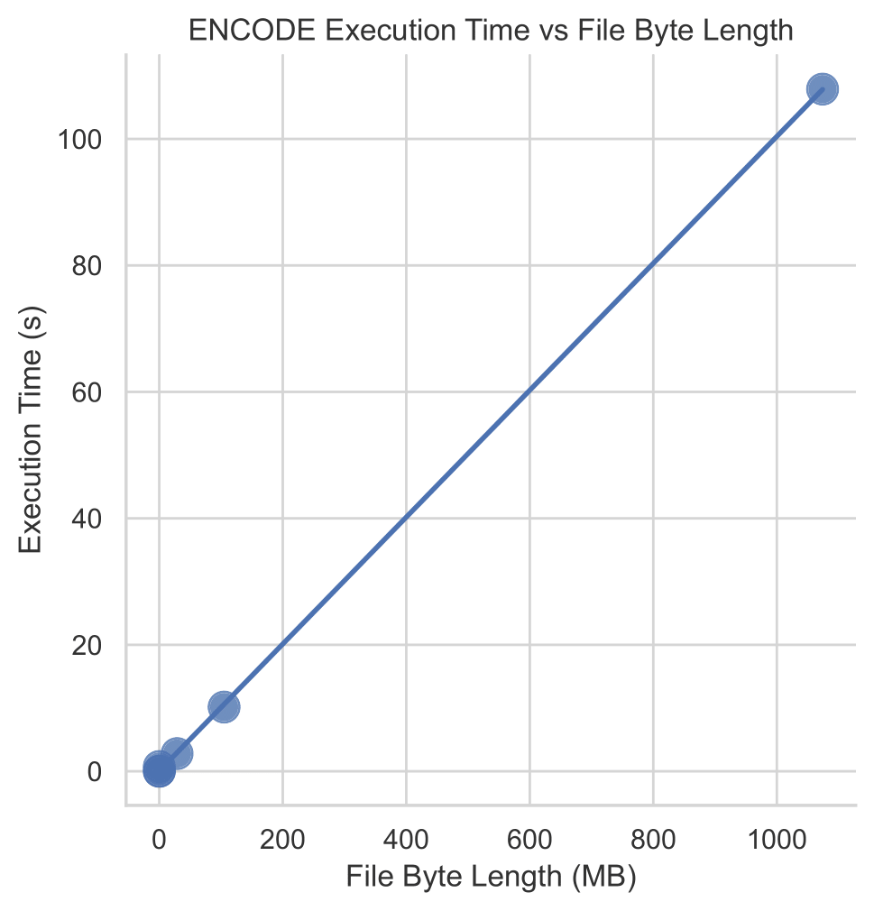
Figure 5.1: Encryption performance.

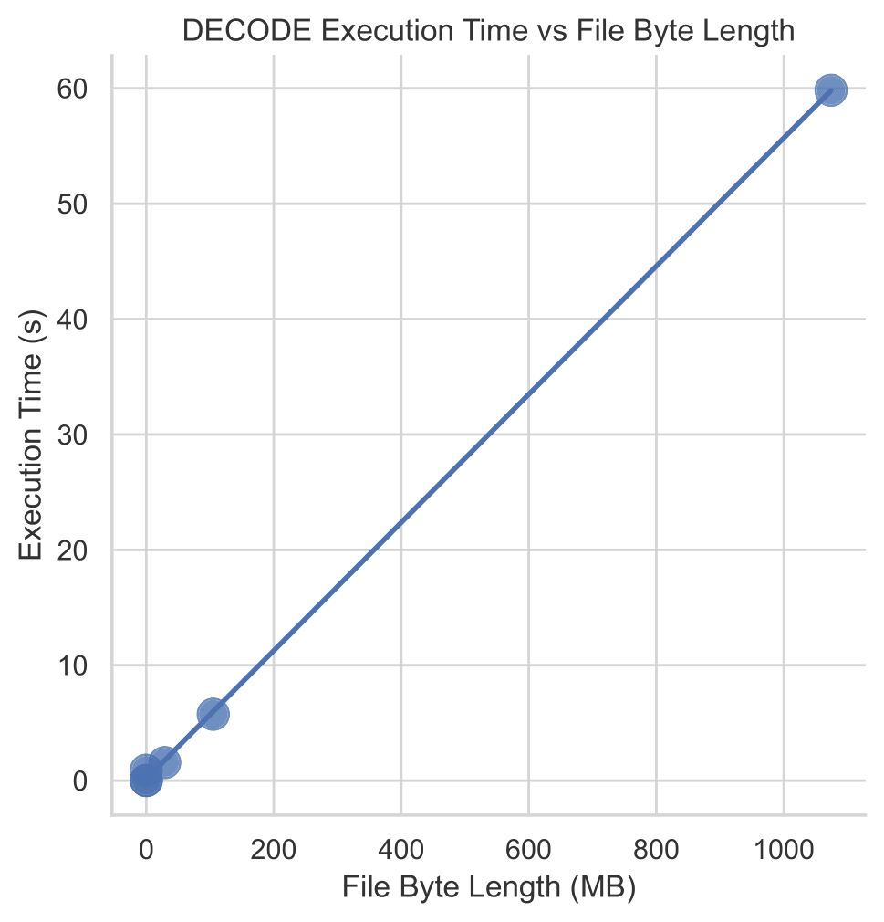
Figure 5.2: Decryption performance.

Algorithm 5. 2.
We select the same data with the case of previous algorithm and the tuple of kind d=(2f_1, 2g_1, 2f_2, 2g_2, …, 2f_k , 2g_k) where f_iϵK[x_1], i=1, 2, …, k, g_i ϵ K[x_1],
i=1, 2, …, k-1 are polynomials of constant degree ≥t>1 such that
deg(f_i-f_{i+1})≥t, deg(g_i-g_{i+1})≥t for g_n=\gamma x_1, \gamma ϵK*
We form symbolic word w’ as the sum of tuple d with the tuple w=(α_1, β_1. α_2, β_2, …, α_k, β_k) of previous algorithm .
Note that degree of map \phi_n(w’) will be at least 1+2kt ( Proposition 1 for the case of graph A(K))
So correspondents will use encryption map
E=L_1\phi_n(w’)L_2, w’ϵW(k) and decryption
map D=(L_2)^{-1}\phi_n((w’)*){L_1}^{-1}.
The theoretical complexity of the encryption or decryption procedure is O(n).
The active password as in the previous algorithm is tuple w. As in previous case each change of the characters of w leads to the change of ciphertext.
The attacks with interceptions of pairs of kind plaintext / corresponding ciphertext are unfeasible
because of high degree of encryption and decryption procedure.

Algorithm 5. 3.
We obfuscate the Algorithm 5. 2 accordingly Algorithm 2 of Section 4/ For the implementation we select f as in Example of section 4. The value of f on odd residue is x^r, where positive odd integer r is
taken from open interval (1, 2^{s-1}) and the value of f on even residue x is x+2b, bϵK.

This modification preserves all nention abope properties of Algorithm 5.2. Encryption and decryption maps of Algorithm 3 are not polynomial
transformations. Thus adversary can not use instruments of multivariate cryptanalysis to break the cryptosystem.

5. Conclusion.

Graphs D(n, K) defined over finite commutative ring
Were used for the design of stream ciphers in the
paper [] . This is one of the first publication on graph based Cryptography (see also [paskievich) .
Graphs D(n, K) are defined by equations, it was the
First application of algebraic graphs to Symmetric Cryptography. In many cryptographic graph applications the adjacency matrices are used. Various
stream ciphers defined in terms D(n, K) and their special homomorphic images are shortly observed in with speed O(recent paper [].
The properties of these algorithms are strongly depend
on the choice of commutative ring. In the case of K=Z_q, q=2^s the fastest known algorithm is suggested
jn [Co Ph ] . The space of passwords of these even cipher
formed by tuples of characters from Z_q of length k
where k \le [(n+5)/2]. The case when distinct passwords produce same ciphertext from seleced plaintext are rare but possible. This algorithm can be modified via the change pf the graph A(n, Z_q). This modification does not eliminate the collision of passwords.
In Algorithm 1 of the paper we change the space of
passwords pf stream cipher C from [Co Ph] for the set of tuples of special kind. This modification eliminates the
case of rwo passwords producing the same ciphertexr. So we can easily estimate complexity of adversarial attacks under condition that adversary does not have access to unencrypted case. Algorithma 1 is also implemented tn cases of graphs D(v, Z_q) and A(n, z_q). Cipher C and Algorithm 1 have many common properties. The encryption and decryprion [rocedures correspond to cubic multivariate maps, Both algorithms have good mixing properties.
Algorithm 2 poseses the mentioned above properties of Algorithm 1 but the degree of multivariate encrtyption map is linearly growing with the increase of n. So attacks of adversary with the interception of plaintexts with corresponding ciphertexts for map approximations are unfeasible.

Algorithm 3 also has the property to have distinct ciphertexts for different passwords, good mixing properties but its decryption and decryption maps are not multivariate transformations. Thus standard cryptanalytic instruments of Computer Algebra are not applicable in this case.

References

[1] F. Buekenhout (Editor), Handbook on Incidence Geometry, North Holland,Amsterdam, 1995.

[2] V. A. Ustimenko, On some properties of Chevalley groups and their generalisations, In: Investigations in Algebraic Theory of Combinatorial objects, Moskow, Institute of System Studies, 1985, 134 - 138 (in Russian), Engl.trans.: Kluwer, Dordrecht, 1992, pp. 112-119.
[3] V. Ustimenko, Affine system of roots and Tits geometries, Voprosy teorii grupp i gomologicheskoy algebry, Yaroslavl, 1989, pp.155-157.

[4] V. Ustimenko. On the embeddings of some geometries and flag systems in Lie algebras and superalgebras, in Root systems, representations and geometries, Kiev, IM AN UkrSSR, pp. 3--16, 1990.
[5] F. Lazebnik, V. Ustimenko, Explicit construction of graphs with arbitrary large girth and of large size, Discrete Applied Mathematics 60 (1995), 275-284.
[6] F. Lazebnik, V. Ustimenko, A. Woldar, A characterization of the components of the graphs D(k, q). Discrete Mathematics
Volume 157, Issues 1–3, 1 October 1996, Pages 271-283.
[7] F. Lazebnik, V. Ustimenko, A.J.Woldar, A new series of dense graphs of high girth,
Bulletin of the AMS 32 (1) (1995), 73-79.

[8] Chojecki, T., Erskine, G., Tuite, J. Ustimenko V. On affine forestry over integral domains and families of deep Jordan–Gauss graphs. European Journal of Mathematics 11, 10 (2025). https://doi.org/10.1007/s40879-024-00798-2. `

[9] T. Shaska, V. Ustimenko, On the homogeneous algebraic graphs of large girth and their applications.
Linear Algebra and its Applications
Volume 430, Issue 7, 1 April 2009, Pages 1826-1837

[10] V. Ustimenko, Graphs in terms of algebraic geometry, symbolic computations and secure
communications in post-quantum world, UMCS Editorial House, Lublin, 2022, 198.

[11] Guinand P., Lodge J., Tanner type codes arising from large girth graphs, Canadian
Workshop onInformation Theory CWIT ’97, Toronto, Ontario, Canada, June
3-6 (1997): 5 (PDF) LDPC codes based on algebraic graphs. Available from:
https://www.researchgate.net/publication/265833663_LDPC_codes_based
_on_algebraic_graphs [accessed Sep 08 2025].

12. Guinand P., Lodge J., Graph theoretic construction of generalized
product codes, IEEE Interna-tional Symposium on Information
Theory ISIT’97 Ulm, Germany June 29-July 4 (1997): 111
(PDF) LDPC codes based on algebraic graphs. Available from:
https://www.researchgate.net/publication/265833663_LDPC_codes_based_on_
algebraic_graphs[accessed Sep 08 2025].

[13] D. MacKay and M. Postol, Weakness of Margulis and Ramanujan Margulis Low
Density Parity Check Codes, Electronic Notes in Theoretical Computer Science,
74 (2003), 8pp.
[14] Ustimenko, V.A. On linguistic dynamical systems, families of graphs of large girth, and cryptography. J Math Sci 140, 461–471 (2007). https://doi.org/10.1007/s10958-007-0453-2

[15] Polak M, Zhupa E., Keyed hash function from large girth expander graphs, Albanian
J. Math., 2022, V. 16, No 1 25 – 39.

[16] A. Paszkiewicz, Z. Kotulski, K. Kulesza, J. Szczepanski, Proposals of graph based
ciphers theory and implementations. Research Gate, 2001.
[17] Costache, A., Feigon, B., Lauter, K., Massierer, M., Puskas, A. , Ramanujan Graphs
in Cryptography. In: Balakrishnan, J., Folsom, A., Lalin, M., Manes, M. (eds),
Research Directions in Number Theory. Association forWomen in Mathematics
Series, vol 19. Springer,
[18] P.L. K. Priyadarsini, A Survey on some Applications of Graph Theory in
Cryptography, Journal of Discrete Mathematical Sciences and Cryptography,
https://www.tandfonline.com/doi/abs/10.1080/09720529.2013.878819.
[19] W. M. Al Etaiwi, Encryption Algorithm Using Graph Theory, Journal of Scientific
Research & Reports, 3(19): 2519-2527, 2014; Article no.JSRR.2014.19.004
[20] Denis X. Charles, Eyal Z. Goren, Kristin E. Lauter., Cryptographic hash functions
from expander graphs. Journal of Cryptology, 2009, V. 22, 93 – 113.
[21] Tomkins H, M. Nevins M, Salmasian H. New Zemor-Tillich type hash functions
over GL2(F). J. Math. Cryptol.,2020, V. 32, No.1. 236 – 253.

Appendix A: Algorithm 5.1 Implementation

import numpy as np
from numba import njit

def encode_bites(
bites: np.ndarray,
char_ecncode_mod: int,
d_mod: int,
seed: int,
noise_ratio: float = 0.00,
) -> np.ndarray:
"""
High-level wrapper for the encryption process.
Generates the dynamic password (random_d_mod_range) and applies
the algebraic graph transformation.
"""
# Pre-processing: Noise injection and initial vector transformation
# (Corresponds to preliminary linear transformations L_i)
bites = add_noise(bites, char_ecncode_mod, seed, noise_ratio)
file_bites = change_first_symbol_based_on_random_vector(bites, seed)

# Generate the symbolic word (sequence of active parameters)
random_d_mod_range = randomize_d_mod(d_mod, seed)

# Apply the core graph walk
encoded_bites = encode_v5(file_bites, char_ecncode_mod, random_d_mod_range)
return encoded_bites

def decode_bites(
bites: np.ndarray,
char_ecncode_mod: int,
d_mod: int,
seed: int,
noise_ratio: float = 0.00,
) -> np.ndarray:
"""
High-level wrapper for the decryption process.
Reverses the graph walk and removes pre-processing artifacts.
"""
random_d_mod_range = randomize_d_mod(d_mod, seed)

# Reverse the graph walk
decoded_bites = decode_v5(bites, char_ecncode_mod, random_d_mod_range)

# Inverse linear transformation and noise removal
decoded_bites = reverse_change_first_symbol_based_on_random_vector(
decoded_bites, seed
)
decoded_bites = remove_noise(decoded_bites, char_ecncode_mod, seed, noise_ratio)
return decoded_bites

@njit
def randomize_d_mod(d_mod: int, seed: int) -> np.ndarray:
range_d_mod = np.arange(d_mod, dtype=np.int64)

if d_mod == 0:
return range_d_mod

index = seed % d_mod
new_val = (seed * 1664525 + 1013904223) % d_mod # LCG hash

if new_val == index:
new_val = (new_val + 1) % d_mod

range_d_mod[index] = new_val
return range_d_mod

def encode_v5(
chars: np.ndarray, char_encode_mod: int, d_mod_range: np.ndarray
) -> np.ndarray:
"""
Iteratively applies the neighbor-finding map F according to the
sequence defined in d_mod_range.
"""
current_state = chars.astype(np.uint8).copy()
next_state = np.empty_like(current_state)

for a in d_mod_range:
find_neighbors_v5(current_state, next_state, a, char_encode_mod)
# Swap buffers to move to the next node in the walk
current_state, next_state = next_state, current_state

return current_state

def decode_v5(
chars: np.ndarray, char_encode_mod: int, d_mod_range: np.ndarray
) -> np.ndarray:
"""
Reverses the graph walk by applying the inverse map in reverse order
of the parameter sequence.
"""
current_state = chars.astype(np.uint8).copy()
next_state = np.empty_like(current_state)

# Traverse the path backwards
for i in range(len(d_mod_range) - 1, -1, -1):
a = d_mod_range[i]
reverse_find_neighbors_v5(current_state, next_state, a, char_encode_mod)
current_state, next_state = next_state, current_state

return current_state

@njit
def find_neighbors_v5(
point_in: np.ndarray, point_out: np.ndarray, a: int, mod: int
) -> None:
"""
Implements the algebraic relations of the graph edge.
Maps input vector X to neighbor Y given parameter a.

Equations:
y_1 = x_1 + a
y_i = x_i - y_1 * x_{i-1} (even i)
y_i = x_i - x_1 * y_{i-1} (odd i)
"""
n = len(point_in)
point_out[0] = (point_in[0] + a) % mod
x0 = point_in[0]

for i in range(1, n):
# Using implicit modulo 256 via uint8 overflow for efficiency
if i % 2 == 0:
point_out[i] = np.uint8(point_in[i] - point_out[0] * point_in[i - 1])
else:
point_out[i] = np.uint8(point_in[i] - x0 * point_out[i - 1])

@njit
def reverse_find_neighbors_v5(
point_in: np.ndarray, point_out: np.ndarray, a: int, mod: int
) -> None:
"""
Implements the inverse algebraic relations.
Maps vector Y back to X given parameter a.

Equations:
x_1 = y_1 - a
x_i = y_i + y_1 * x_{i-1} (even i)
x_i = y_i + x_1 * y_{i-1} (odd i)
"""
n = len(point_in)
point_out[0] = (point_in[0] - a) % mod
x0 = point_out[0]
y0 = point_in[0]

for i in range(1, n):
if i % 2 == 0:
point_out[i] = np.uint8(point_in[i] + y0 * point_out[i - 1])
else:
point_out[i] = np.uint8(point_in[i] + x0 * point_in[i – 1])

Appendix B: Test results

Input: 31MB Video File, 1 Byte Modified
Table 1: Avalanche Effect Analysis (Active Password)
Quarter 1 change at index 8138112
Original byte: 0, Modified byte: 128
Sameness %: 0.8055215079369761%
--------------------------------------------------
Quarter 2 change at index 16276224
Original byte: 78, Modified byte: 9
Sameness %: 0.8055216000959436%
--------------------------------------------------
Quarter 3 change at index 24414336
Original byte: 0, Modified byte: 40
Sameness %: 0.8055214157780085%
--------------------------------------------------
Quarter 4 change at index 32552447
Original byte: 97, Modified byte: 214
Sameness %: 0.8055216000959436%
--------------------------------------------------
Table 2: Avalanche Effect Analysis (Static Path)
Quarter 1 change at index 8138112
Original byte: 0, Modified byte: 213
Sameness %: 0.9999996313641296%
--------------------------------------------------
Quarter 2 change at index 16276224
Sameness %: 0.9999999692803442%
--------------------------------------------------
Original byte: 78, Modified byte: 94
Quarter 3 change at index 24414336
Original byte: 0, Modified byte: 49
Sameness %: 0.9999996313641296%
--------------------------------------------------
Quarter 4 change at index 32552447
Original byte: 97, Modified byte: 205
Sameness %: 0.9999999692803442%
--------------------------------------------------

Table 3: Noise Injection and Digest Uniqueness

File name: ./tests/test_files/csv_100mb.csv
File size: 104957620
number_of_digests: 10
noise_ratio: 0.05

Digest 0: DIFFERENT — 0.12307224573118179 bytes differ
Digest 1: DIFFERENT — 0.12316399704947578 bytes differ
Digest 2: DIFFERENT — 0.12332644356836597 bytes differ
Digest 3: DIFFERENT — 0.12320696677382738 bytes differ
Digest 4: DIFFERENT — 0.12323088118804523 bytes differ
Digest 5: DIFFERENT — 0.12326956346761674 bytes differ
Digest 6: DIFFERENT — 0.12320553762556735 bytes differ
Digest 7: DIFFERENT — 0.12332196557048454 bytes differ
Digest 8: DIFFERENT — 0.1233778929057271 bytes differ
Digest 9: DIFFERENT — 0.12325060343403366 bytes differ

