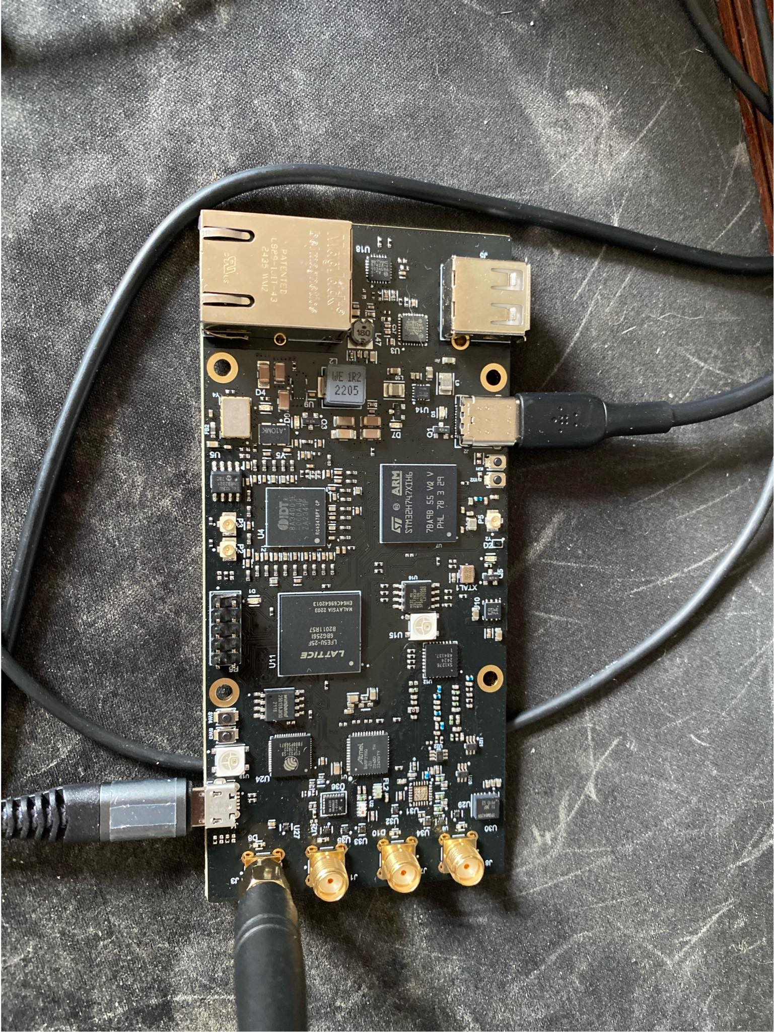

STM32 (Main) Quick start
- Connect USB-C to USB-C port
- Open Arduino IDE project for STM32H747, Board target is Arduino Giga R1
  - Source code: https://github.com/Time-Appliances-Project/Incubation-Projects/tree/master/Software/WiWi/SDR/V4/WiWi_SDR
- Upload this to the COM port for the board
  - If COM port not found, put into boot mode. Hold Boot button (SW2, button further from USB-C) and press Reset button (SW1, button closer to USB-C), and let go of SW2. This will put into default STM32 bootloader
  - If you want to reflash Arduino bootloader as well, use the Arduino bootloader programming procedure, should not be necessary more than once per board
    - https://support.arduino.cc/hc/en-us/articles/7991505977116-Burn-the-bootloader-on-GIGA-R1-WiFi
- Open Tera term to the COM port for the board, you should now see CLI for STM32.
  - The CLI is like a single layer file system. For example, you can access things related to the dpll by typing dpll . To leave the dpll menu system, just use cd ..
- Now you have the source code and access to the STM32, the main controller of the board

ESP32S3 Quick Start
- ESP32S3 access
  - With USB-C plugged in (power is from USB-C), connect to Micro-USB port near the SMA antenna ports
  - Put into bootloader mode if never flashed before or want to reflash from scratch:
    - Hold SW3 (GPIO0 , Button closer to Micro USB) and toggle SW4 (Reset , Button further from Micro USB) , then let go of SW3
- Program with Arduino IDE example ESP32S3 sketch, Arduino options are below in ESP32S3 section
  - Source: https://github.com/Time-Appliances-Project/Incubation-Projects/tree/master/Software/WiWi/SDR/V4/ESP32S3_SDR
- Open Tera Term to serial port of ESP32S3, then have CLI to access functions of ESP32S3 and source code

SDR (RX) Quick Start
- Start injecting RF signal into Sub-GHz path, SDR antenna is J8, top left SMA
  - I injected using LimeSDR a 100KHz sine wave with a 900MHz carrier
- On STM32 , pause the IQ stream (it will be running by default at bootup) and print it
  - In tera term, start logging to a text file , then run these commands
    - cd ..
    - spi_iq
    - subg_pause
    - channel_print_samples 0 5000
- Now you will have 5000 I/Q samples as signed 16-bit values printed as hex values

Hardware components

STM32H747 Microcontroller

IDE / Programming
- Arduino IDE ( Arduino Giga R1 as board ) - https://docs.arduino.cc/tutorials/giga-r1-wifi/giga-getting-started/
- USB Programming / Debug serial port is the USB-C connector close to the STM32H747
- Boot button -> SW2, button further from USB-C
- RST Button -> SW1, button closer to USB-C
- Reference code uses Arduino Giga R1 bootloader and IDE, but the code uses all STM32 HAL code
- STM32 HAL code -> https://github.com/STMicroelectronics/stm32h7xx-hal-driver
- My source code: https://github.com/Time-Appliances-Project/Incubation-Projects/tree/master/Software/WiWi/SDR/V4/WiWi_SDR

CLI
- Implemented using embedded cli library -> https://github.com/funbiscuit/embedded-cli
- Currently implemented a one layer menu, different hardware / systems have their own menus . Look at CLI sections for other components in this usage guide to see some examples and what is implemented

Datasheet
https://www.st.com/resource/en/datasheet/stm32h747ag.pdf

Reference manual
https://www.st.com/resource/en/reference_manual/rm0399-stm32h745755-and-stm32h747757-advanced-armbased-32bit-mcus-stmicroelectronics.pdf

Still not tested
- USB High speed through USB3320, should be same as Arduino Giga
- 100M Ethernet through LAN8472 phy. Should be same as Arduino Portenta? The lan8472.c code from STM32 library is included in libmbed.a which is included in Arduino Giga compilation, but haven’t tested any functionality

8A34001 DPLL

Purpose
- Extremely high resolution Tunable frequency source for all components except STM32 core clock
- Extremely high resolution timestamper
- Time and frequency alignment and measurement, with external U.FL connectors for measurement and injection of time and/or frequency sources

GUI
- 8A34001 documentation -> https://www.renesas.com/en/products/clocks-timing/application-specific-clocks/network-synchronization/ieee-1588-and-synchronous-ethernet-clocks/8a34001-system-synchronizer-ieee-1588-eight-channels?srsltid=AfmBOooG1SNjJe9RvMbQirHlspVYP4Z1xA2yP6WvAmFFQsMtCW_i4wAy#design_development
- Renesas Timing Commander -> https://www.renesas.com/en/software-tool/timing-commander
- Needs personality files for 8A34001 -> https://www.renesas.com/en/document/swo/timing-commander-personality-file-clockmatrix-8a34001-v10130-fw488-fw498?r=455866
- GUI generates a .tcs file which is the live config
- For programming purposes , GUI generates an EEPROM .hex file

CLI
- From main menu, dpll
  - To update EEPROM (only do for new boards) , flash with Xmodem
    - Xmodem_update
    - Tera term -> File -> Transfer -> Xmodem -> Send, select .hex file generated from timing commander EEPROM GUI

SiT5501 TCXO

Purpose
- High stability (10ppb) frequency source for the board
- Also is I2C tunable (depends on BOM)

Datasheet
- https://www.sitime.com/support/resource-library/datasheets/sit5501-datasheet

CLI

LFE5U-25F FPGA

Purpose
- Convert Sub-GHz and 2.4GHz IQ data stream from AT86RF215IQ to format usable by STM32H747 Microcontroller. Default is multiple SPI streams
- Control select signals on the board, like RF switch controls
- Optional: Process IQ data streams before sending to STM32H747 , not implemented now
- Optional: Send TX signal out of AT86RF215IQ, not implemented now

IDE
- Lattice Diamond: https://www.latticesemi.com/latticediamond
- Source code: https://github.com/Time-Appliances-Project/Incubation-Projects/blob/master/Software/WiWi/SDR/V4/ECP5_Test.7z

Datasheet
- https://www.latticesemi.com/Products/FPGAandCPLD/ECP5
- Datasheet: https://www.latticesemi.com/view_document?document_id=50461

CLI
- From top level: fpga
- Update image (my example using tera term)
  - update_xmodem
  - Tera term -> File -> Transfer -> Xmodem -> Send , select .bit file generated by Diamond
- I2C access
  - read_reg
  - write_reg

AT86RF215IQ SDR

Purpose
- RF Front-end to digital IQ data stream converter
- Parallel transceiver paths for Sub-GHz and 2.4GHz , both operate at the same time

Datasheet
- https://ww1.microchip.com/downloads/en/DeviceDoc/Atmel-42415-WIRELESS-AT86RF215_Datasheet.pdf

Reference code
- https://github.com/cariboulabs/cariboulite/tree/main/software/libcariboulite/src/at86rf215
- https://github.com/uw-x/tinysdr/tree/main/firmware/at86rf215

CLI
- From main, at86
  - Read_reg
  - Write_reg

SX1276 LoRA / GFSK Transceiver

Purpose
- Standard LoRA / GFSK Sub-GHz transceiver, configurable over SPI, has interrupt pins for packet operation (TX done / RX done / others)

Datasheet
- https://www.mouser.com/datasheet/2/761/sx1276-1278113.pdf?srsltid=AfmBOoroVoWihTFWYKwrhVO9QEcf5YYK2sFgTSESLSAekwR4-rMPhS78

CLI
- From main, sx1276
  - Read_reg
  - Write_reg

ESP32S3 Microcontroller & WiFi Transceiver

IDE / Programming
- Use Arduino IDE with ESP32 board manager installed
  - https://docs.espressif.com/projects/arduino-esp32/en/latest/installing.html
- Connect to Micro USB port near the SMAs on the board to program
  - SW3 is GPIO0 , Button closer to Micro USB
  - SW4 is reset , Button further from Micro USB
  - To put into boot mode (first time, or issue) , hold SW3 and toggle SW4, then let go of SW3
- This is a standalone microcontroller, my reference code uses the same CLI library on it
  - Source code: https://github.com/Time-Appliances-Project/Incubation-Projects/tree/master/Software/WiWi/SDR/V4/ESP32S3_SDR
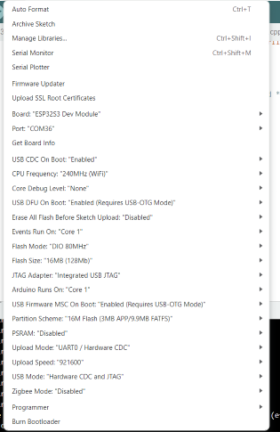

CLI
- From main menu, esp32
- To access ESP32 UART through the STM32 (Uses UART0 of ESP32S3 on the board)
  - passthrough

Datasheet
- https://www.espressif.com/sites/default/files/documentation/esp32-s3_datasheet_en.pdf

Reference manual
- https://www.espressif.com/sites/default/files/documentation/esp32-s3_technical_reference_manual_en.pdf

