PTP Architecture Time Synchronization Test

# Test Objective and Expected Results

Using two AX88279 devices to execute the PTP time-synchronization function:

**Device_1** Use the AX88279 as the PTP master.

**Device_2** Configure the AX88279 as a PTP slave and follow the grandmaster’s time corrections.

# Test Equipment

Linux Platform * 2

AX88279 *2

Oscilloscope *1

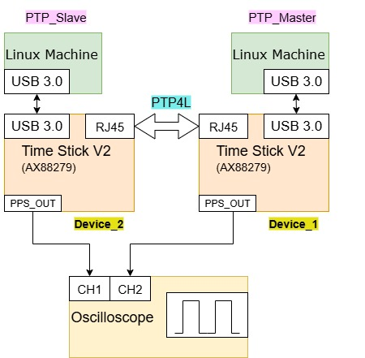

# Environment Configuration

## 3.1 PTP Master setting

Build The Driver

1. Open the asix_usb_nic_linux_driver_v3.5.16.
2. Extract the source code from the compressed file.

**$ tar -xf asix_usb_nic_linux_driver_v3.5.16.zip**

1. Edit the Makefile and enable PTP

**ENABLE_PTP_FUNC = y** // The PTP_FUNC flag must be enabled.

1. In a terminal, navigate to the driver source code folder.
2. From within the driver source code folder, build the driver

**$ make**

Running the Driver

1. Install the driver if you’d like to use the modprobe command to mount the driver.

**$ sudo make install**

1. To load the driver by modprobe command

**$ sudo modprobe ax_usb_nic**

1. To unload the driver by modprobe command

**$ sudo modprobe -r ax_usb_nic**

1. To check driver information

**$ modinfo ax_usb_nic**

Remove the driver and cdc_ncm

**$ sudo modprobe -r ax_usb_nic**

**$ sudo rmmod cdc_mbim**

**$ sudo rmmod cdc_ncm**

**$ sudo rmmod ax88179_178a**

Run the driver

**$ sudo modprobe ax_usb_nic**

// After the parameters are configured, connect the network cable and verify the network connectivity.

The DUT runs PTP4L and configured as the PTP master.

**$ sudo ip addr add 192.168.200.2/24 dev [interface name]**

**$ sudo ip link set [interface name] up**

**$ ip addr show [interface name]**

**// Add an option to specify the interface!**

**$ ping 192.168.200.1**

**$ sudo ptp4l -i [interface name] -m -H --masterOnly 1 --priority1 100**

## 3.3 PTP slave

The driver configuration is the same as in **Section 3.1**.

// After the parameters are configured, connect the network cable and verify the network connectivity.

The DUT runs PTP4L and configured as the PTP Salve.

**$ sudo ip addr add 192.168.200.1/24 dev [interface name]**

**$ sudo ip link set [interface name]up**

**$ ip addr show [interface name]**

**// Add an option to specify the interface!**

**$ ping 192.168.200.2**

**$ sudo ptp4l -i [interface name]-m -H --slaveOnly 1**

Check whether the PPS out of Device_1 and the PPS out of Device_2 are synchronized.