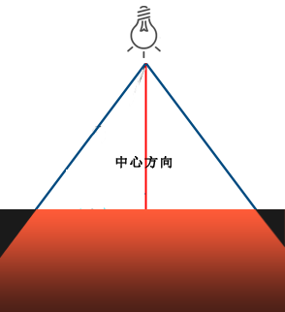

$$softness$$

$$softness$$

**光照渐变区**

$$span_angle$$

**光照渐变区**