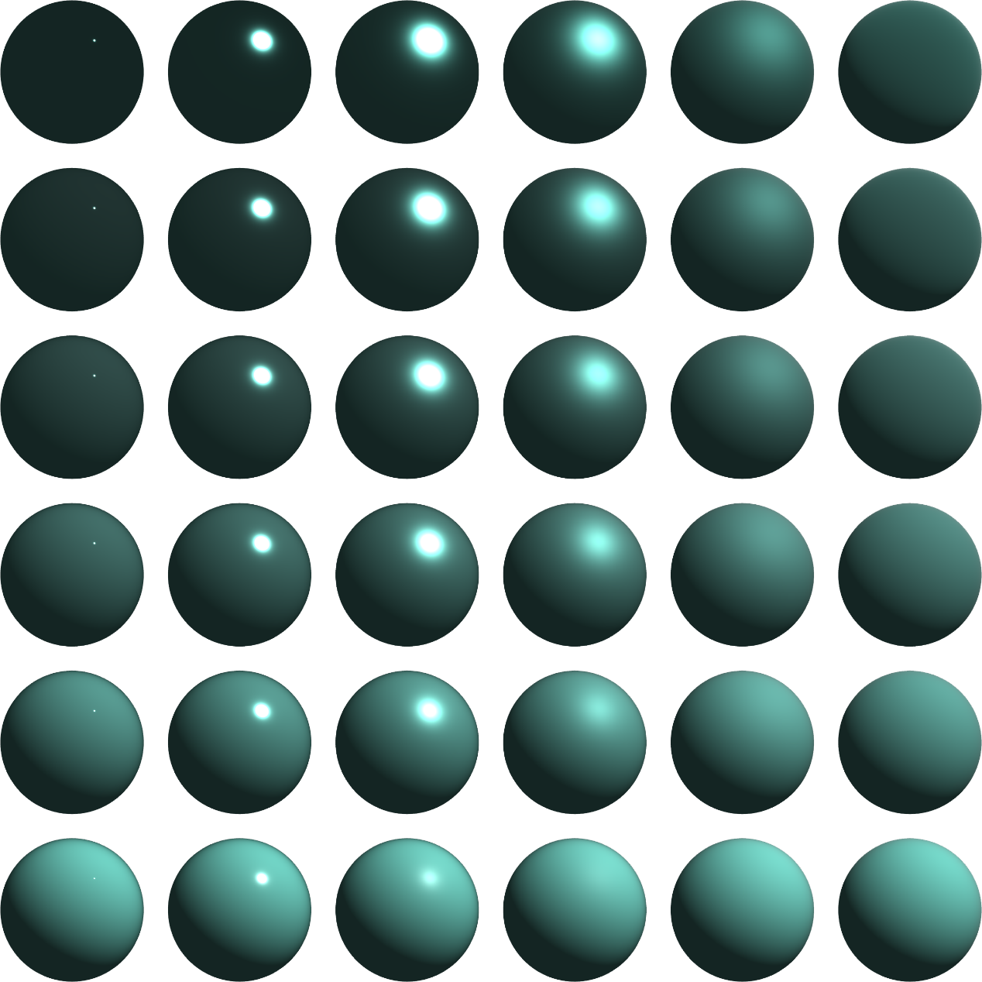

metallic

1.0

0.8

0.6

0.4

0.2

0.0

roughness

1.0

0.8

0.6

0.4

0.2

0.0