# AtlanticRecords

# Created on October 26 2020

# Table of Contents

1.0. Index

2.0. Artist

3.0. Contact

# 1.0. Index

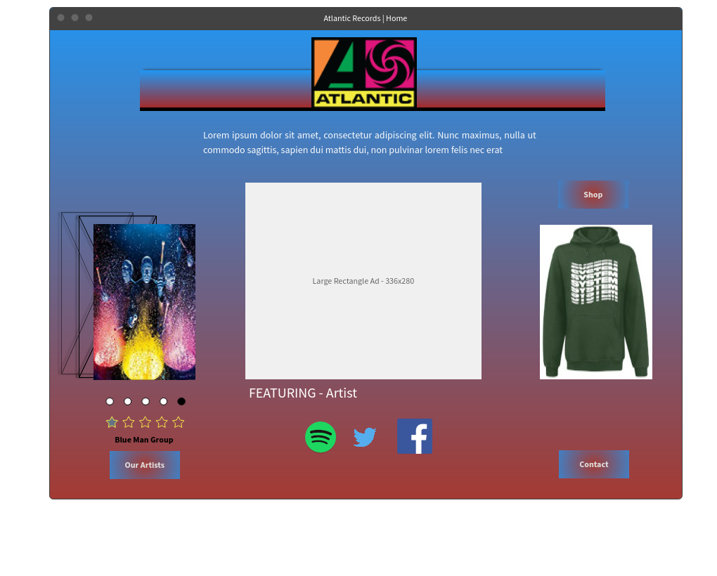

# 2.0. Artist

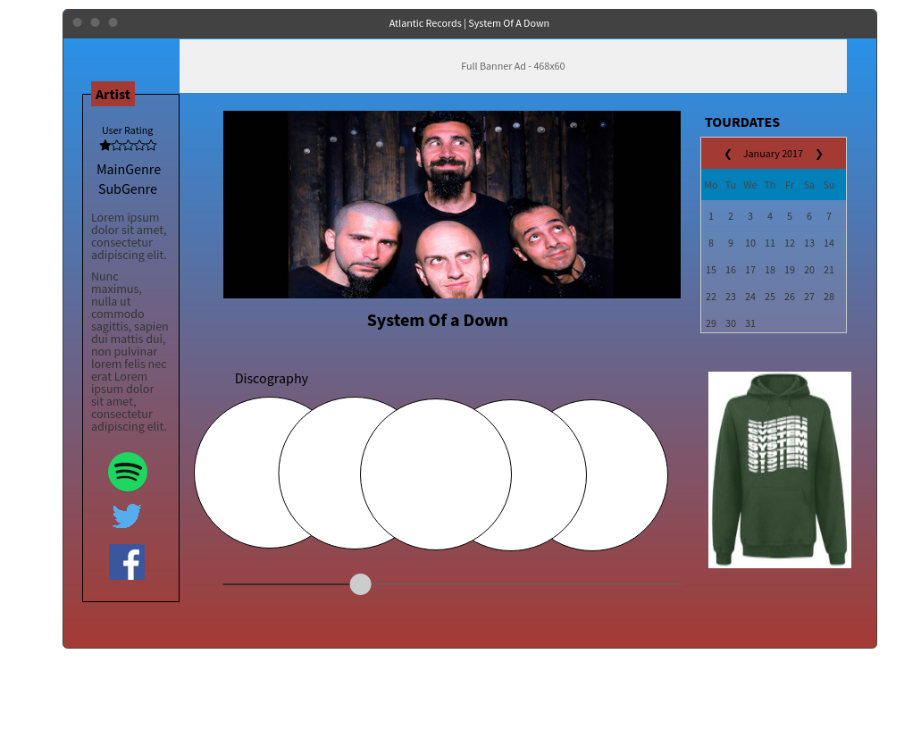

# 3.0. Contact

