**CX-5组数学创新实验第二次报告（多人追逐）**

**队员：漆宇豪 郭志猛 陈天翔 邵戈文**

**1.实验目的**：

利用MATLAB中的循环、判断、矩阵运算等操作实现坐标点的自动生成，并绘制出相应图像，实现对多人追逐问题的模拟。并

**2.实验思想：**

首先在平面内考虑任意人数的追逐轨迹，通过循环程序近似模拟n人追逐轨迹，其中n通过input函数由用户定义。然后再将问题拓展到空间，考虑多面体顶点出发的追逐问题。

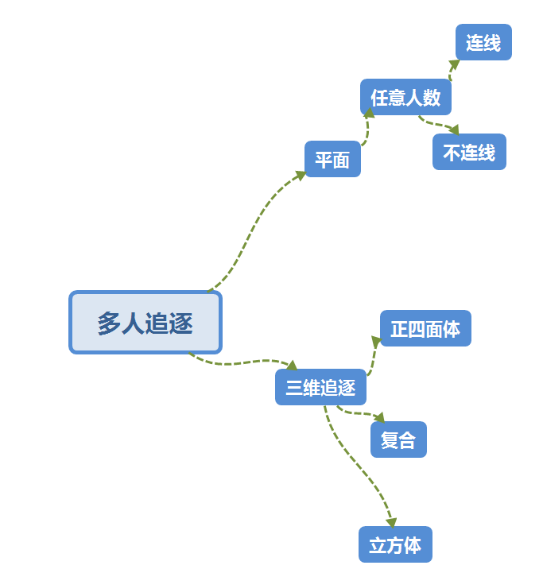

**3.实验结果：**

**1、平面的情况（任意多人追逐有连线）**

程序：

shape=input('你就说你要正几边形（例如3）：');

p=[0 1 0;0 0 0];

for k=3:shape

angle=pi*2/shape*(k-2);

q1=p(:,k-1)+[cos(angle);sin(angle)];

p=[p(:,1:k-1),q1,p(:,k:end)];

end

%this is for the second homework

%this is the first method

q=zeros(2,shape+1);

while(length(p)<220)

for ii=1:shape

q(:,ii)=p(:,length(p)-shape-1+ii)+0.1.*(p(:,length(p)-shape-1+ii)-p(:,length(p)-shape+ii));

end

q(:,end)=q(:,1);

p=[p q];

end

x=p(1,:);

y=p(2,:);

plot(x,y)

**运行结果：6人情形**

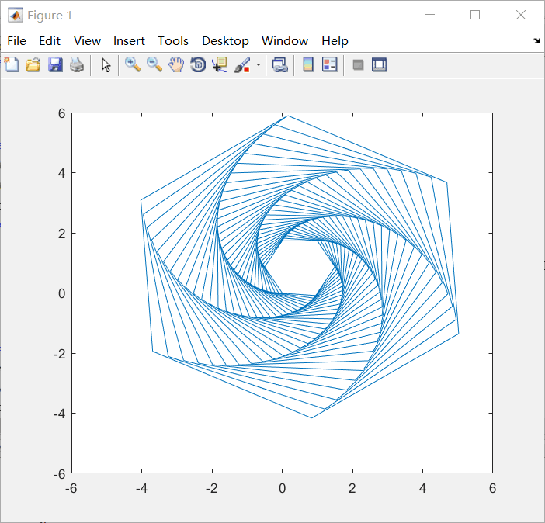

**2、平面的情况（任意多人追逐无连线）**

程序：

shape=input('你就说你要正几边形（例如3）：');

p=[0 1 0;0 0 0];

for k=3:shape

angle=pi*2/shape*(k-2);

q1=p(:,k-1)+[cos(angle);sin(angle)];

p=[p(:,1:k-1),q1,p(:,k:end)];

end

%this is for the second homework

%this is the first method

q=zeros(2,shape+1);

while(length(p)<200*shape)

for ii=1:shape

q(:,ii)=p(:,length(p)-shape-1+ii)+0.1.*(p(:,length(p)-shape-1+ii)-p(:,length(p)-shape+ii));

end

q(:,end)=q(:,1);

p=[p q];

end

for jj=1:shape

plot(p(1,jj:shape+1:end-shape-1+jj),p(2,jj:shape+1:end-shape-1+jj));

hold on;

end

**运行结果：15人情形**

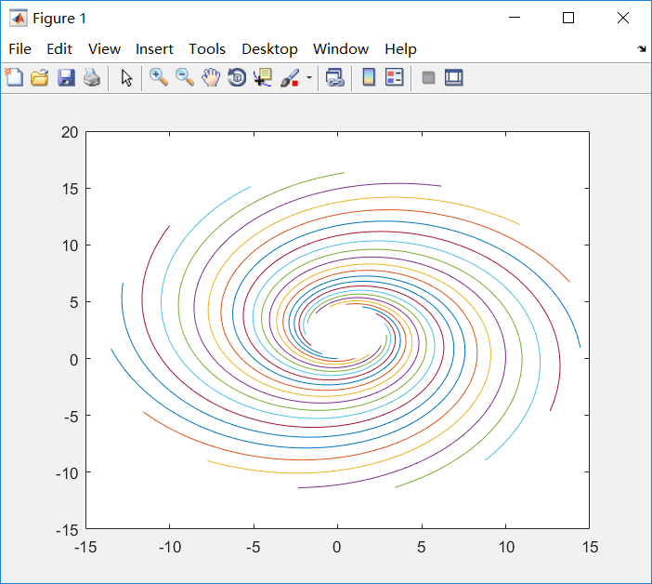

**运行结果：100人情形**

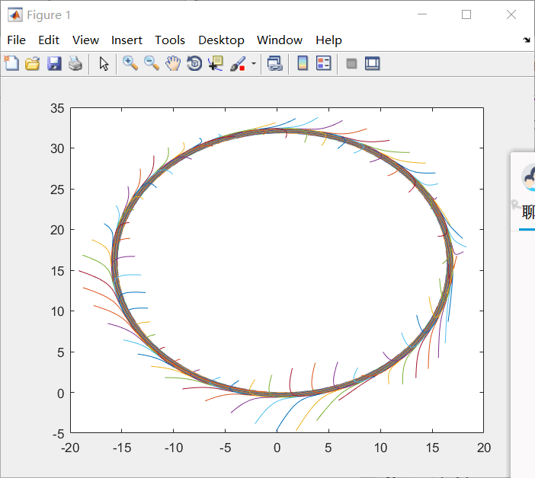

**本程序效率很高，经测试在人数达到500人时也可迅速得出图像**

**3、立体空间的情况**

**程序1：（正四面体顶点出发）**

%this is the new thought of the second homeworkp=[1 1 -1 -1 1;1 -1 1 -1 1;1 -1 -1 1 1];q=p;ratio=0.1;ahead=[1-ratio 0 0 0 1-ratio; ratio 1-ratio 0 0 ratio; 0 ratio 1-ratio 0 0; 0 0 ratio 1-ratio 0; 0 0 0 ratio 0];for ii=1:100 p=p*ahead; q=[q p];endx=q(1,:);y=q(2,:);z=q(3,:);plot3(x,y,z)

运行结果：

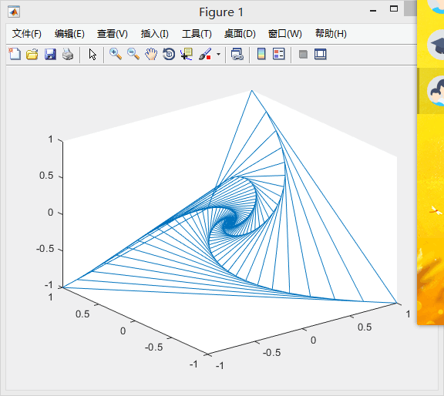

**程序2：（正四面体顶点出发）**

%this is the new thought with some different colors  
clear;  
p=[1 1 -1 -2 1;1 -1 1 -2 1;1 -1 -1 1 1];  
q1=p;  
ratio=0.1;  
ahead=[1-ratio 0       0       0 1-ratio;  
       ratio   1-ratio 0       0 ratio;  
       0       ratio   1-ratio 0 0;  
       0       0       ratio   1-ratio 0;  
       0       0       0       ratio 0];  
x=4;  
for ii=1:x  
    p=p*ahead;  
    q1=[q1 p];  
end  
  
for ii=x+1:2.*x  
    p=p*ahead;  
      
end  
x=2.*x;  
q3=p;  
for ii=x+1:2.*x  
    p=p*ahead;  
    q3=[q3 p];  
end  
  
x=2.*x;  
for ii=x+1:2.*x  
    p=p*ahead;  
      
end  
  
q5=p;  
x=2.*x;  
for ii=x+1:2.*x  
    p=p*ahead;  
    q5=[q5 p];  
end  
  
x=2.*x;  
for ii=x+1:2.*x  
    p=p*ahead;  
      
end  
q7=p;  
x=2.*x;  
for ii=x+1:2.*x  
    p=p*ahead;  
    q7=[q7 p];  
end  
  
x=2.*x;  
for ii=x+1:2.*x  
    p=p*ahead;  
      
end  
q9=p;  
x=2.*x;  
for ii=x+1:2.*x  
    p=p*ahead;  
    q9=[q9 p];  
end  
  
x1=q1(1,:);  
y1=q1(2,:);  
z1=q1(3,:);  
  
x3=q3(1,:);  
y3=q3(2,:);  
z3=q3(3,:);  
  
x5=q5(1,:);  
y5=q5(2,:);  
z5=q5(3,:);  
  
x7=q7(1,:);  
y7=q7(2,:);  
z7=q7(3,:);  
x9=q9(1,:);  
y9=q9(2,:);  
z9=q9(3,:);  
plot3(x1,y1,z1,x3,y3,z3,x5,y5,z5,x7,y7,z7,x9,y9,z9)

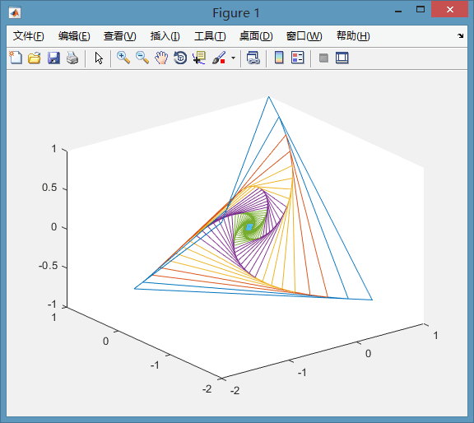**运行结果：**

**程序3：**

%this is the new thought with some different colors

clear;

p=[1 1 -1 -2 1;1 -1 1 -2 1;1 -1 -1 1 1];

q1=p;

ratio=0.1;

ahead=[1-ratio 0 0 0 1-ratio;

ratio 1-ratio 0 0 ratio;

0 ratio 1-ratio 0 0;

0 0 ratio 1-ratio 0;

0 0 0 ratio 0];

x=4;

for ii=1:x

p=p*ahead;

q1=[q1 p];

end

for ii=x+1:2.*x

p=p*ahead;

end

x=2.*x;

q3=p;

for ii=x+1:2.*x

p=p*ahead;

q3=[q3 p];

end

x=2.*x;

for ii=x+1:2.*x

p=p*ahead;

end

q5=p;

x=2.*x;

for ii=x+1:2.*x

p=p*ahead;

q5=[q5 p];

end

x=2.*x;

for ii=x+1:2.*x

p=p*ahead;

end

q7=p;

x=2.*x;

for ii=x+1:2.*x

p=p*ahead;

q7=[q7 p];

end

x=2.*x;

for ii=x+1:2.*x

p=p*ahead;

end

q9=p;

x=2.*x;

for ii=x+1:2.*x

p=p*ahead;

q9=[q9 p];

end

x1=q1(1,:); y1=q1(2,:); z1=q1(3,:);

x3=q3(1,:); y3=q3(2,:); z3=q3(3,:);

x5=q5(1,:); y5=q5(2,:); z5=q5(3,:);

x7=q7(1,:); y7=q7(2,:); z7=q7(3,:);

x9=q9(1,:); y9=q9(2,:); z9=q9(3,:);

plot3(x1,y1,z1,x3,y3,z3,x5,y5,z5,x7,y7,z7,x9,y9,z9)

运行结果：

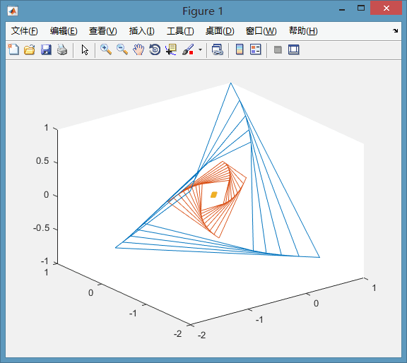

**程序4：(正方形顶点出发)**

%this is the new thought with some different colorsclear;p=[1 1 -1 -2 1;1 -1 1 -2 1;1 -1 -1 1 1];q1=p;ratio=0.1;ahead=[1-ratio 0 0 0 1-ratio; ratio 1-ratio 0 0 ratio; 0 ratio 1-ratio 0 0; 0 0 ratio 1-ratio 0; 0 0 0 ratio 0];x=4;for ii=1:x p=p*ahead; q1=[q1 p];endfor ii=x+1:2.*x p=p*ahead; endx=2.*x;q3=p;for ii=x+1:2.*x p=p*ahead; q3=[q3 p];endx=2.*x;for ii=x+1:2.*x p=p*ahead; endq5=p;x=2.*x;for ii=x+1:2.*x p=p*ahead; q5=[q5 p];endx=2.*x;for ii=x+1:2.*x p=p*ahead; endq7=p;x=2.*x;for ii=x+1:2.*x p=p*ahead; q7=[q7 p];endx=2.*x;for ii=x+1:2.*x p=p*ahead; endq9=p;x=2.*x;for ii=x+1:2.*x p=p*ahead; q9=[q9 p];endx1=q1(1,:); y1=q1(2,:); z1=q1(3,:);x3=q3(1,:); y3=q3(2,:); z3=q3(3,:);x5=q5(1,:); y5=q5(2,:); z5=q5(3,:);x7=q7(1,:); y7=q7(2,:); z7=q7(3,:);x9=q9(1,:); y9=q9(2,:); z9=q9(3,:);plot3(x1,y1,z1,x3,y3,z3,x5,y5,z5,x7,y7,z7,x9,y9,z9)%this is the first thought in cubeclear;p1=[1 1 -1 -1 1; 1 -1 1 -1 1; 1 -1 -1 1 1];q1=p1;p2=[1 -1 1 -1 1; -1 -1 1 1 -1; 1 -1 -1 1 1];q2=p2;ratio=0.1;ahead=[1-ratio 0 0 0 1-ratio; ratio 1-ratio 0 0 ratio; 0 ratio 1-ratio 0 0; 0 0 ratio 1-ratio 0; 0 0 0 ratio 0];for ii=1:100 p1=p1*ahead; p2=p2*ahead; q1=[q1 p1]; q2=[q2 p2];endx1=q1(1,:);y1=q1(2,:);z1=q1(3,:);x2=q2(1,:);y2=q2(2,:);z2=q2(3,:);plot3(x1,y1,z1,x2,y2,z2)

运行结果：

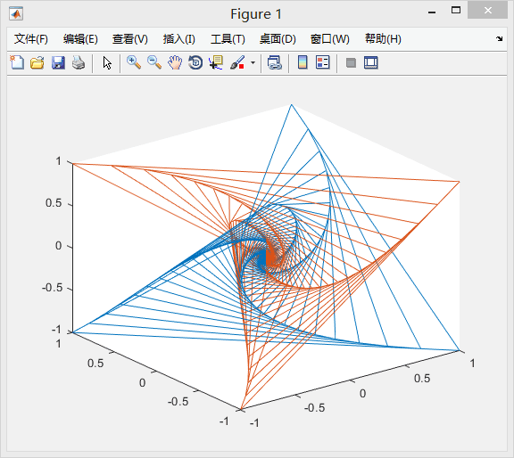

**程序5：无连线情况**

%this is the new thought of the second homework

p=[1 1 -1 -1 1;1 -1 1 -1 1;1 -1 -1 1 1];

q=p;

ratio=0.1;

ahead=[1-ratio 0 0 0 1-ratio;

ratio 1-ratio 0 0 ratio;

0 ratio 1-ratio 0 0;

0 0 ratio 1-ratio 0;

0 0 0 ratio 0];

for ii=1:100

p=p*ahead;

q=[q p];

end

x=q(1,:);

y=q(2,:);

z=q(3,:);

plot3(x,y,z)

**运行结果：**

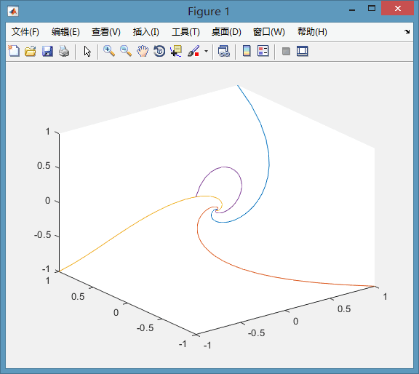

**6.人员分工：**

编程拓展：漆宇豪25%

编程及成果总结：邵戈文25%

编程拓展：郭志猛25%

编程及成果总结：陈天翔25%