**Course Paper for Academic Writing in English**

**Title**

Shared Bikes Fall Flat: An Analysis of the Characteristics and Business Model of Shared Bikes

**Author: Guo Zhimeng**

**Student Number: 2017080201005**

**Score:**

Shared Bikes Fall Flat: An Analysis of the Characteristics and Business Model of Shared Bikes

Zhimeng Guo∗

*Yingcai Honors College, University of Electronic Science and Technology of China, Chengdu, China* [*guozhimeng98@outlook.com*](mailto:guozhimeng98@outlook.com)

**Abstract**

Nowadays, a lot of shared bikes emerge on the streets of China and the market competition is so fierce that some of the companies go bankrupt just in a short period. What factors lead to the success and failure of a shared bikes company is a critical question for both companies and researchers. Here a survey of the population through focus groups interview and questionnaires were conducted. Based on 120 valid questionnaires, we applied a binary logic model to quantify the impact of various factors on residents and found that shared bikes companies do not have a loyal customer group. We also identified that the mode of shared bikes is a pseudo-sharing mode and it is difficult to pass revenue to offset high costs. Our findings may have implications for sharing economy and research upon it.

**Key Words:** China; shared economy; shared bicycles; pseudo-shared mode; binary logistic regression.

# Introduction

Since Rachel Carson wrote "Silent Spring," people have begun to pay attention to environmental issues that are closely related to us. The society has begun to promote low-carbon, environmentally-friendly transportation. At the same time, as the number of cars increases, urban congestion problems intensify. Bicycles have gradually become a good travel option for people. In recent years, the rise of the Internet and smart phones has enabled the sharing economy around us to continue to develop. PricewaterhouseCoopers has predicted that the global sharing economy will grow 20 times in ten years. Uber, Airbnb and other companies that are constantly appearing around us continue to hint at the correctness of this prediction. In the context of such demand, companies such as ofo, Mobile, etc. came into being. In China, a large number of shared bicycle companies appeared in the short term, and all

*Correspondence to: Zhimeng Guo, Yingcai Honors College, University of Electronic Science and Technology of China, Chengdu, China; E-mail: [guozhimeng98@outlook.com](mailto:guozhimeng98@outlook.com)

areas of the country can see shared bicycles.

A lot of research has been done on the reasons for the rise of shared bicycles. Some researchers are concerned about users who share bicycles. Buck et al. (2013) analyzed shared bike users in the Washington area, arguing that female users, poorer users prefer to share bicycles. Shaheen et al. (2011) analyzed the bicycle users in Hangzhou and thought that the number of bicycles and the quality of bicycles are all important factors affecting bicycle satisfaction. In 2017, Li et al. (2018) conducted a detailed analysis of the use of shared bicycles in Jiangsu. He believed that the higher the education level within a certain range, the higher the income and the shorter the travel distance, the users prefer to use shared bicycles. Some of these conclusions contradict previous Buck’s research, which suggests that the actual situation of shared bicycles may be different at different times and in different regions. Zhou (2018) believed that sharing bicycles is good for environmental protection and optimizing traffic structure. Huang et al. (2018) predicted the number of shared bicycles in the future. Bao et al. (2017) analysis solved the planning problem of bicycle lanes. Pal and Zhang (2017) proposed a solution to the problem of balancing the number of shared bicycles. Cohen and Kietzmann (2014) explored the shared mobile economy model and provided direction for shared bicycle development.

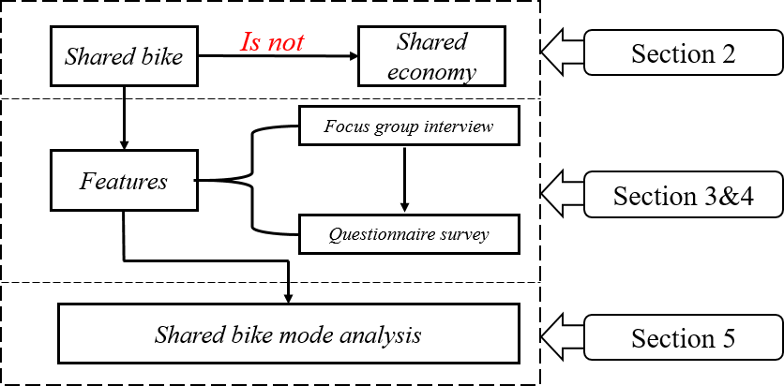However, previous research mistakenly believed that the shared bicycles provided by ofo belonged to the category of shared economy. Due to the lag of time, few literatures analyze the reasons for the failure of shared bicycles. Chardon et al. analyzed the reasons for the success of shared bicycles, but only from the perspective of enterprises and users. In contrast, the study of shared bicycle models is much less. In our research, we compare the shared cycling model to other shared economic forms. We believe that the shared bicycle model is not a shared economy, but a short-term rental service. We use focus groups and questionnaires to get the pros and cons of shared bike models. We analyze the shortcomings of the shared bike model to find the cause of the failure. Based on the research in this paper, we believe that the existing shared bicycle model is not sustainable. Our research can provide a reference for other sharing models, and can also help shared bikes find new outlets.

**Figure 1:** Article structure

In section 2 we first analyze the relationship between shared bicycles and the sharing economy. Section 3 describes our focus group design and surveys. Section 4 describes shared bike usage. In section 5, we have analyzed the shared bicycle profit model and gives us conclusions, and we have also given some suggestions.

# Shared Bicycle and Sharing Economy

The sharing economy is characterized by "building a platform for C-side suppliers and demanders to complete the docking of resources". The platform does not participate in the actual transaction, but plays the role of rule maker and executor. Sharing bicycles, the name of "sharing", no sharing economy. Taking shared bicycles as an example, the so-called sharing economy in the shared bicycle mode is essentially a leasing economy packaged by the Internet. The shared bicycle company participates in the transaction with the user as a direct service provider. This is obviously the core concept of the sharing economy. Does not match the characteristics.In a word, the sharing economy is C2C(consumer to consumer ), and the shared bike is B2C(business to consumer).

Sharing a bicycle mode requires a huge cost to make a bicycle and maintain a bicycle. The true sharing economy does not need to bear these costs. At the same time, sharing bicycles not only does not utilize idle resources, but also a large number of shared bicycles also occupy a lot of public resources. The shared bike mode is actually just a short-term rental mode. Being called a shared bicycle is just a hype slogan for the operator.

# Research Methods

Our research was divided into two steps. In the first step, we first explored the user’s evaluation of shared bicycles through focus groups. As a second step, we used the results of the focus group and the results of the relevant literature to determine the usage scenarios and advantages and disadvantages of shared bicycles.

## Focus Group Interview

We started the study through focus group interviews. We believe focus groups can help provide a valuable understanding of consumer behavior. Through focus group interviews, some concepts or mechanisms not covered in previous studies were discovered.

Three participants (three men) of different academic backgrounds between the ages of 20-40 were recruited, and the focus group once again expressed their views on shared bicycles from different perspectives. They have experienced different sharing economic services.

The interview was conducted in a closed room. There were a total of four people in the room, three people to discuss, one person using ipad to shoot video. The three people discussing were around a table. There was a piece of paper and a pen on the table. At the beginning of the experiment, the voice assistant used Chinese to inform the discussants about the advantages and disadvantages of sharing bicycles. At the same time tell them to record the results on paper. Inform the discussion time as five minutes.

The content of the participants’ discussions was very instructive. A man said that he had participated in a bicycle marathon. In the competition, a player rode a bicycle all the time. Despite the poor ranking of the player, he won a lot of applause. Based on this, we believed that the rise of shared bicycles may be that everyone is chasing fashion trends.

The discussion of the focus group had inspired us in many ways. Further, we used the questionnaire to investigate.

## Survey Design and Data Collection

### Questionnaire Design

Based on the focus group discussion and previous literature studies, our questionnaires were divided into four aspects: demographic attributes, usage, travel needs, experience and external reasons. The demographic attributes of the user, including gender, age, income level, and education level; travel needs include usage purpose, usage distance, frequency of use, and input cost; sharing bicycle experience, including time, cost, operation, riding process, Easy to find and park; external causes include protecting the environment, keeping up with trends, pushing for technological advances, and sharing the economy.

The study was divided into four steps, namely questionnaire design, data collection, model building and model interpretation. First, the questionnaire design and data collection were completed. Then the binary logistic regression model analysis was used. Finally, the obtained model was explained.

### Case Study

Questionnaires were conducted online, and the questionnaires were disseminated through social media such as QQ and WeChat. A total of 141 questionnaires were collected, of which 120 were valid questionnaires. The demographic information of the sample is shown in the table, in which the proportion of women is slightly above average. Most of the respondents were in the 19-40 age range. The monthly income of most people is between 1,000 and 5,000 yuan. Most people are undergraduates. The reason for this ratio may be

that they are more likely to be Internet users, so it is easier to respond to the survey.

We performed a confidence test on the collected data. The Cronbach’s alpha is 0.825, which is greater than 0.7, indicating a higher reliability. We performed a factor analysis on the data with a KMO value of 0.799, indicating that the structure of the questionnaire was good.

## Characteristics of Sharing Bike Use

Through the questionnaire survey, we found that most consumers ride for the purpose of going to school, class or shopping. This may have a lot to do with the age range of our respondents. At the same time,

consumer word riding distance is mostly concentrated in 1-2 kilometers. This may be because the user will choose to walk if the distance is too short, and if they are too long, they will choose to take the bus. The frequency of users using shared bicycles in a week is mostly 5-10 times, which can be considered to be relatively high. The monthly input costs are mostly concentrated at 11-20 yuan, we can think that this is due to the consumption of the monthly card.

**Figure 2:** Travel purpose

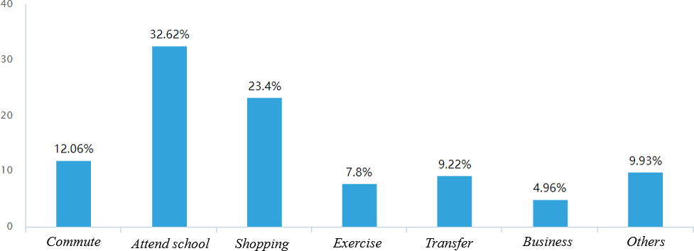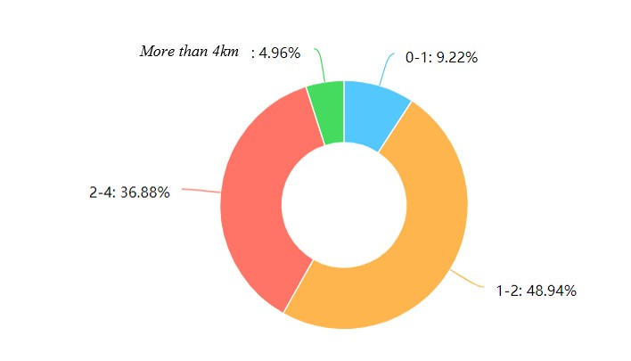

**Figure 3:** Travel distance(km)

**Figure 5:** Travel frequency(times)

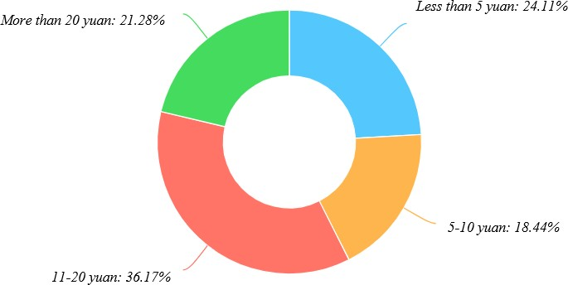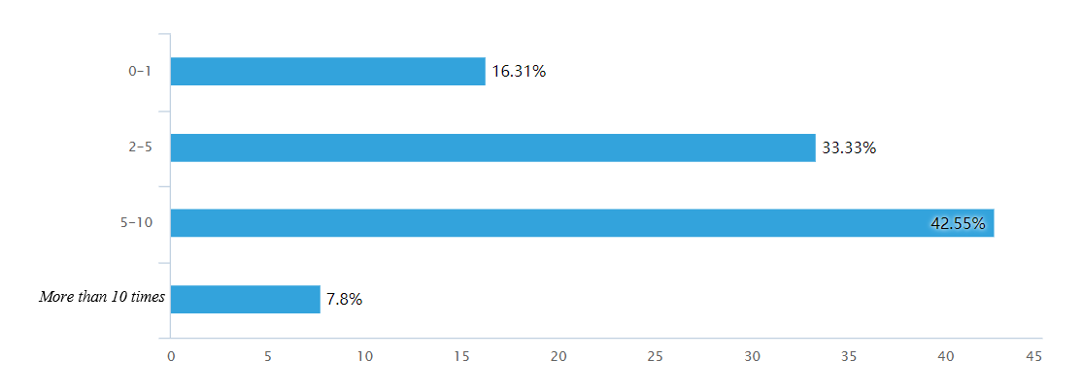

**Figure 4:** Travel cost(yuan)

**Figure 6:** Travel characteristics

# Model and Results

## Model Description

We used binary logistic regression models for research. Our dependent variable was chosen whether the user chooses to use shared bikes. Our independent variables were set to other factors in the questionnaire. We can see the model as:

(1)

Where *U* is the dependent variable, *x* is the vector of independent variables, θ is the parameter to be obtained, and E is the error term that is not available.

The random variable in Equation 1 follows a double exponential distribution, and the probability can be expressed as:

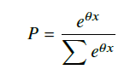

(2)

When the model is established, the decision variables are defined as:

*ln P*2*n* = *a* + θ1 *x*1*n* + ... + θ*k xkn* (3)

*P*1*n*

Where *P*2n is the ratio of the two selected probabilities.

*P*1

n

### Variable Definitions

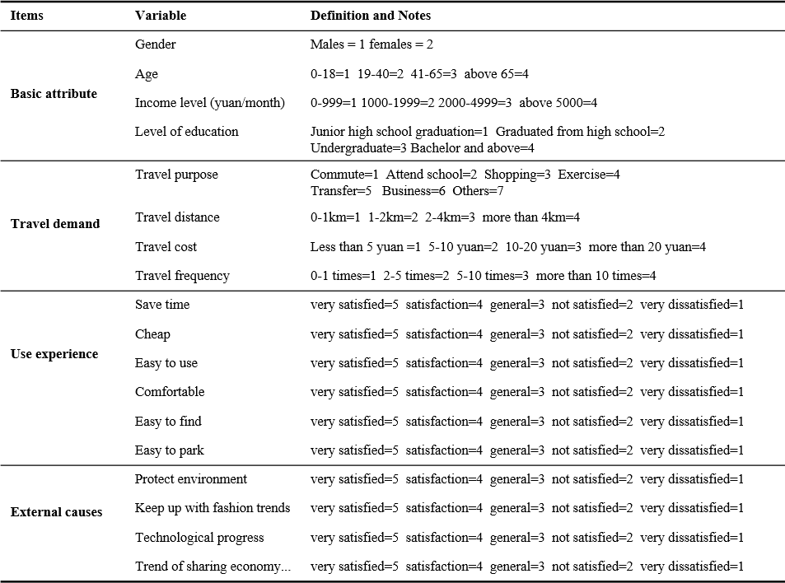

**Figure 7:** The variables chosen to analyze the shared bike’s features

The use of shared bicycles is influenced by user attributes, travel needs, user experience and external meta-infant. Therefore, these factors were used as independent variables to analyze the characteristics of shared bicycles. In this article, whether the respondent used a shared bicycle as a dependent variable within one month. 1 indicated that the user has used the shared bicycle, and 2 indicated that the shared bicycle has not been used. Because the dependent variable was binary, we build a binary logistic regression model.

### Model Result

In order to find the real reason why users use shared bicycles, the utility function of the binary logic model was calibrated with maximum likelihood estimation. An estimate of the prediction parameters was obtained by finding a maximum likelihood estimation function of the logarithm. The bivariate analysis of the independent variables was performed by SPSS with an acceptance probability of 0.05 and a rejection probability of 0.1. Independent variables and significance test results are listed in the table.

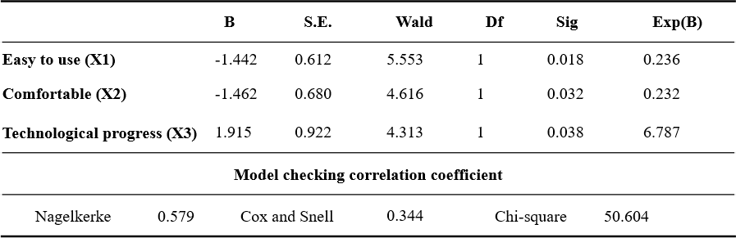

**Figure 8:** Estimation results of the model

According to statistical theory, three variables with a significance value less than 0.05 were selected. In addition, the model was tested using Nagelkerke, Cox and Snell, Chi-square and other parameters. According to statistical theory, Nagelkerke, Cox and Snell proves that the model fits well. In addition to this, the chi square is 50 and the significance is less than 0.05. This indicates that at 95% confidence, the selected variables have a significant impact on the use of shared bicycles.

According to the binary logistic regression model, the probability that the user chooses to share a bicycle is as follows:

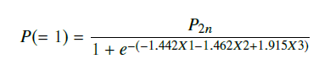

(4)

1. **Conclusions and Discussion**

## Analysis of the Results of the Questionnaire

A survey of the population through focus groups interview and questionnaires were conducted. Based on 120 valid questionnaires, we applied a binary logic model to quantify the impact of various factors on residents.

The result was beyond my expectations. The better the shared bicycle is, the lower the probability of user use. This result is very unreasonable, and I will analyze it in the next section. In this part I tried to explain the result. For the user community, a bicycle is more used, so users will be more inclined to use this bicycle. Then, it is difficult for the user to access other types of bicycles, and the problem of other bicycles will not be found. At the same time, more usage means that this bicycle is more prone to problems. Then, this may lead to the emergence of results.

The more comfortable the bicycle, the lower the probability of user use. I think the reason is as follows. Comfort is the user experience. When the user has a better experience with a bicycle, the corresponding expectation for this bicycle is higher. Then when there is a problem with this bicycle, the problem is easily magnified. Similar to the analysis in the previous paragraph, more usage will make bicycles harder to find and more likely to break. This causes the user experience to drop, resulting in a reduced probability of user usage.

The more advanced the technology, the higher the user’s probability of use. I think this is due to people’s curiosity and ostentation. For new things, people always want to try them. When sharing a bicycle just entered the city, it also became a trend. People don’t want to be considered conservative, by riding a shared bicycle to reflect their own trend of the times. Based on this psychology, the probability of user use increases.

Many researchers use questionnaires to investigate the use of shared bicycles. Buck et al. (2013) believes that poorer users prefer to share bicycles. Li et al. (2018) believes that the higher the income, the more preferred users prefer to use shared bicycles. This contradicts Buck’s research. According to the results of this paper, the income level does not significantly affect the user’s choice. The emergence of such a result, I think there are two reasons.

The first reason is the difference in time and place. Although we are all studying shared bicycles, the shared bicycle experience in different countries and regions varies greatly from time to time. Shared bicycles appeared in Europe in the 20th century. Since then there have been many studies on shared bicycles. China’s shared bicycles were launched in 2015. This makes different people’s research objects different. In addition, the development of shared bicycles in China is too rapid, and the rise and decline phases are very fast. There is a certain lag in the emergence of academic achievements. So many people are not studying the sharing of bicycles in the same period.

The second reason is the substitutability of shared bicycles. Many times sharing a bicycle is an irrelevant choice when traveling. People don’t change too much travel planning because of sharing bicycles. The role of shared bicycles is not great. This makes people have no strong preference for the choice of sharing bicycles. More often, people choose the bike that can be seen and paid. There are not many choices in front of many bicycles, and it doesn’t matter. This makes the value of the questionnaire greatly reduced.

## Shared Bicycle Mode Analysis

As we saw above, sharing bicycles is not part of the sharing economy. The shared bike mode is actually just a short-term rental mode. Being called a shared bicycle is just a hype slogan for the operator. At the same time, shared bicycles have strong substitutability and rarely participate in the decision-making process of people traveling.

The shared bike mode has two fatal flaws.

The first drawback is that the cost is huge and the benefits are small. The upfront investment in shared bicycles is huge, and the profit model is limited. The initial investment includes the production cost and maintenance cost of the bicycle. For every bicycle, operators will pay a lot of money. Operators also have to pay for technology research and development, employee salaries and so on. At the same time, shared bicycles are easily destroyed, which makes the cost even greater. Shared bicycle profit model is limited. Most of the revenue depends on the user’s charge when riding. (The deposit misappropriation does not comply with the law, the ministry discusses) the income is difficult to offset the expense

The second drawback is that instead of using idle resources, it increases idle resources. The biggest advantage of the sharing economy is the effective use of idle resources. Shared bicycles made by operators are not something that people need urgently, and they have strong alternatives. The emergence of a large number of shared bicycles actually means the emergence of a large number of idle resources. This is contrary to the trend of economic operation. Excessive sharing of bicycles has disrupted the city’s traffic order and has not been effectively utilized.

Therefore, I think the current shared bike model is not sustainable.

## Direction of development

The following three suggestions are for the development of the shared bicycle mode.

The first point is to explore new profit models. Shared bicycles are active throughout the country and have strong advertising value. You can earn a portion of your income by adding an ad. Shared bikes have precise GPS location services that can be used to collect user data and earn revenue.

The second point is to open a shared bicycle purchase service. For example, a user spends 100 yuan to purchase a shared bicycle. The purchased shared bicycle is still involved in the flow, but will be limited by the purchase of the bicycle user. For example, only a car owner can ride a car at a certain time. Alternatively, the bicycle can only be parked within 500 meters of the owner. This can solve the problem that the user can’t find the car, and can also increase the income of the enterprise.

The third point is to make the private bicycle a shared bicycle. There are a lot of idle bicycles now, and owners can choose to share these bikes. The owner can add restrictions to the shared bike, such as not being able to park outside 10km. This allows shared bikes to truly become part of the shared economy. Let idle resources be used, and the company will not add other costs.

# References

**Bao, Jie, Tianfu He, Sijie Ruan, Yanhua Li, and Yu Zheng**, “Planning bike lanes based on sharing-bikes’ trajectories,” in “Proceedings of the 23rd ACM SIGKDD international conference on knowledge discovery and data mining” ACM 2017,  pp. 1377–1386.

**Buck, Darren, Ralph Buehler, Patricia Happ, Bradley Rawls, Payton Chung, and Natalie Borecki**, “Are bikeshare users different from regular cyclists? A first look at short-term users, annual members, and area cyclists in the Washington, DC, region,” *Transportation Research Record: Journal of the Transportation Research Board*, 2013, (2387), 112–119.

**Cohen, Boyd and Jan Kietzmann**, “Ride on! Mobility business models for the sharing economy,” *Organization & Environment*, 2014, *27* (3), 279–296.

**Huang, Feihu, Shaojie Qiao, Jian Peng, and Bing Guo**, “A Bimodal Gaussian Inhomogeneous Poisson Algorithm for Bike Number Prediction in a Bike-Sharing System,” *IEEE Transactions on Intelligent Transportation Systems*, 2018.

**Li, Xuefeng, Yong Zhang, Li Sun, and Qiyang Liu**, “Free-Floating Bike Sharing in Jiangsu: Usersï£¡ï£¡ Behaviors and Influencing Factors,” *Energies*, 2018, *11* (7), 1664.

**Pal, Aritra and Yu Zhang**, “Free-floating bike sharing: solving real-life large-scale static rebalancing problems,” *Transportation* *Research Part C: Emerging Technologies*, 2017, *80*, 92–116.

**Shaheen, Susan A, Hua Zhang, Elliot Martin, and Stacey Guzman**, “China’s Hangzhou public bicycle: understanding early adoption and behavioral response to bikesharing,” *Transportation Research Record*, 2011, *2247* (1), 33–41.

**Zhou, Chang**, “Reseearch on the countermeasures of sharing mobility service in environmental protection and sustainable development,” 2018.