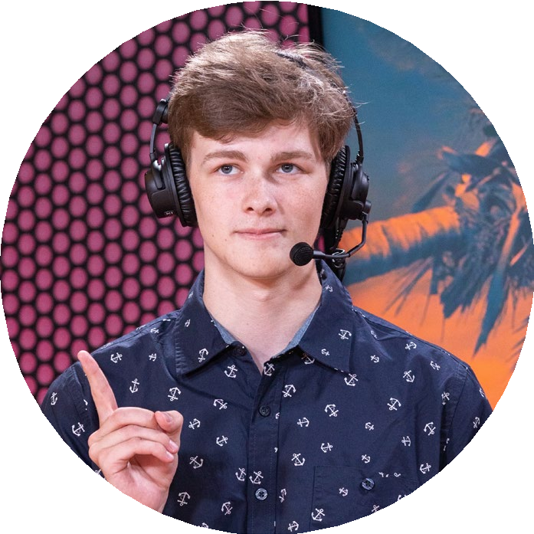

DANIEL RODIER
Sports & Esports Broadcaster | Live Production Specialist
PROFILE | PREVIOUS EXPERIENCE
Versatile sports and esports broadcaster with extensive experience in live production and commentary.  Proficient in both in-person and online broadcast tools, with a strong background in directing, technical directing, replays, and graphics. Skilled in working with diverse production teams and adapting to dynamic broadcast environments. | SIUE Athletics – Sports Broadcast Production Asst. & Commentator  September 2024 – Present | Intern from August 2025 - Present  Producing SIUE Athletic broadcasts for ESPN+, serving in various production roles, including directing, technical directing, graphics, replays, and on-air commentary.  Prepcasts LLC - Sports Broadcasting Contractor  February 2024 - Present  Broadcasted and produced live coverage of high school and college sports for the Prepcasts/Collegecasts platforms.  Freelance Esports Broadcasting  April 2020 - Present  Freelance Production and Commentary of competitive video gaming. Experience with both in person and online events.  Sales Associate – Food Lion  October 2020 – May 2021  Provided customer service, operated points of sale with cash and card transactions. Maintained cleanliness to support daily operations.
CONTACT | EDUCATION
PHONE:  443-252-0157  WEBSITE:  Linktr.ee/TTLCasts | Southern Illinois University Edwardsville  January 2023 – Present  Bachelor’s in Mass Communication (Media Production) | Minor in Business Administration (Expected graduation: May 2026)
EMAIL:  TTL.Casts@gmail.com | Cyber Security – Harford Techincal High School  Graduated June 2022  Received a certification in Information Technology Fundamentals.
REFERENCES | SKILLS
Available upon request | Soft Skills: Written & Spoken Communication, Typing 80+ WPM  Live Production Roles: Director, Replays, Cam Op, Graphics, Commentary  Live Broadcast Programs: Tricaster, OBS, vMix, 3Play, AJT  Microsoft Office, Adobe Suite, Python Integration

