**PHY 108**

**Assignment 1**

*You do* ***not*** *need to include the question paper with your answer script.*

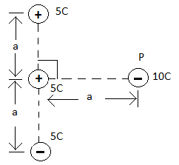

1) (a) What is Coulomb’s Law?

(b) Find the net electrostatic force on the charge

labeled ‘P’ in figure 1. Take a = 55cm.

**Figure 1**

2) In figure 2, the charges A, B and M are situated in a straight line. If A and B are fixed charges, find the distance L for which the net electrostatic force on the charge M will be zero.

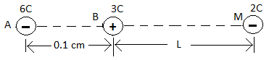

**Figure 2**

