**Individual Project**

**Dashboard**

**Dr. Michael Schermann**

**Tingchen Shi**

**May 27th, 2017**

**Trade Analysis on Kevin Durant in Season 2016-2017**

**Links to the dashboard:**

[1] <https://us-east-1.online.tableau.com/#/site/stc/views/TradingAnalysisofKevinDurantinSeason2016-2017/Dashboard2?:iid=1>

[2] <https://us-east-1.online.tableau.com/#/site/stc/views/TradingAnalysisofKevinDurantinSeason2016-20172/Dashboard1?:iid=4>

**Link to the Github:**

https://github.com/Timeister/Kevin-Durant-Trade-Analysis/

**Trigger:**

Warriors achieves 67 wins in the regular season and beats Spurs and wins NBA western conference two days ago. In order to get this achievement, Warriors made a huge step by signing up one of the hottest players Kevin Durant to their team. [3] They traded Andrew Bogut and Harrison Barnes to welcome this superstar. This dashboard will provide the analysis on whether it is worth for the team to make this trade based on two aspects – both from the technical perspective and financial perspective.

**Claim:**

It is worth for Warriors team to trade Andrew Bogut and Harrison Barnes for Kevin Durant in season 2016-2017.

**Audience:**

This dashboard is for Warriors Team to see whether they made a good decide in trading Andrew Bogut and Harrison Barnes for Kevin Durant in season 2016-2017.

**Technical Perspective:**

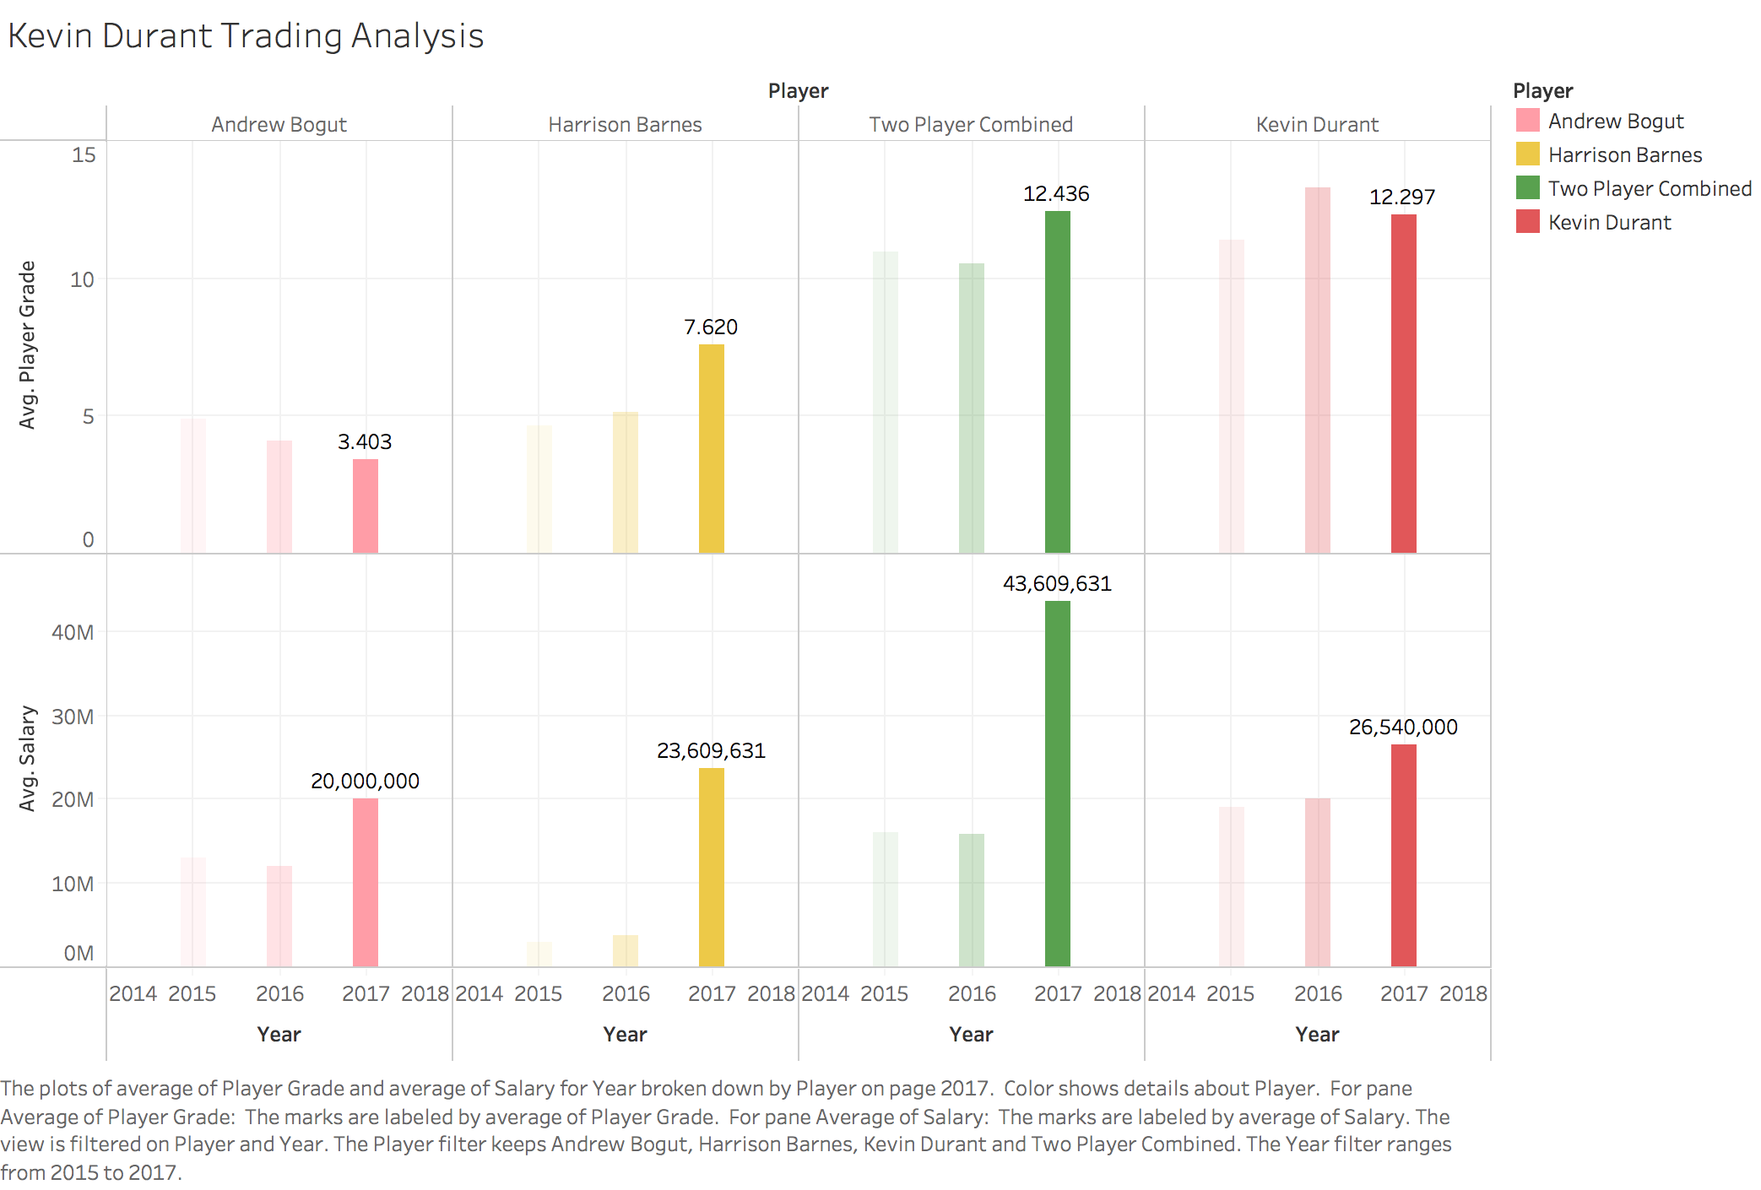

This is the graph on efficiency and salary analysis of Kevin Durant, Andrew Bogut and Harrison Barnes on this trade between 2015 and 2017. Color shows the details between different players. The two player combined means the total performance and salary of both Andrew Bogut and Harrison Barnes. The goal of this graph is to show whether it is worth for the Warriors to sign Kevin Durant.

According to the model built by Bellotti and Oliver, each statistic performed by NBA players has a correlation coefficient, which related to NBA winning percentages. [1] For example, points per game and assist play an extremely important role and have the positive impact on winning the game. So they have the high positive correlation coefficient compared to others, which are 0.34 and 0.38. However, turnover has a negative impact on winning a game. Therefore, it has a negative coefficient of -0.39. In the Bellotti and Oliver’s model, it also requires both offensive rebound number and defensive rebound number. But I only have the total rebound number in my data set. So I calculated the ratio of offensive and defensive among all the players in year 2017. [2] After calculation, the ratio between offensive rebound and defensive rebound is 2:8. Based on that, the new coefficient for rebound is 0.352. Moreover, my dataset is missing the data on turnover. In order to keep the data be consistent, I make an assumption that each player will have 4 turnovers every game. When combining each statistic and their correlation coefficients together, we can get a total score of player, which represents his overall efficiency on winning the games during the year. This score is called average player grade in this graph.

From this graph, if we focus on the average player grade, we can tell that the total performance of both player is almost the same as Kevin Durant. However, based on the same efficiency, the total salary of both player is almost two times as the salary of Kevin Durant. Besides that, if we separate the performance and salary of both player, we can see that the performance of Andrew Bogut is in a down trend. In other words, Andrew Bogut may have a worse performance than he has in 2017 and his salary is still increasing. So it is worth to trade this player. Compared to Andrew Bogut, Harrison Barnes increases his performance each year and has his peak season in 2017. However, the salary for the player jumps from under 5M to nearly 25M, almost 5 times of growth. It will cause the huge financial burden for the warrior team. Therefore, from the technical and salary perspective, it is worth for the warrior team to trade both Andrew Bogut and Harrison Barnes for Kevin Durant.

**Trading Alternatives:**

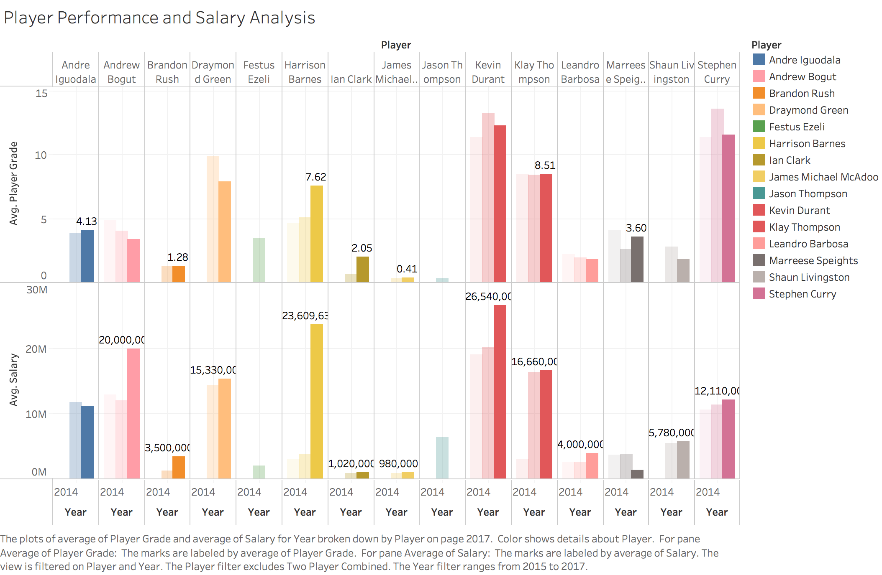

This is the graph on efficiency and salary analysis of each Warriors players between 2015 and 2017. Color shows the details between different players. This graph aims to find whether there is a substitution of Andrew Bogut or Harrison Barnes in trading Kevin Durant.

In this graph, I combined all the data for Warrior players together and I’m looking for whether there is a better trading choice for Warrior to get Kevin Durant. For example, if Warrior doesn’t trade Andrew Bogut or Harrison Barnes, but use other players who have the same player grades with higher salaries or use those players who have the same salary with lower player grades, who will be a better choice? However, we can tell from the graph that Andrew Bogut and Harrison Barnes have the top one and two salaries in the Warrior team. Only when we add Draymond Green, Klay Thompson and Stephen Curry together, we can have the same salary as Andrew Bogut and Harrison Barnes have. However, those three players have relative high performance. Therefore, the combination of Andrew Bogut and Harrison Barnes will be the best choice for trading in Kevin Durant.

**Financial Perspective:**

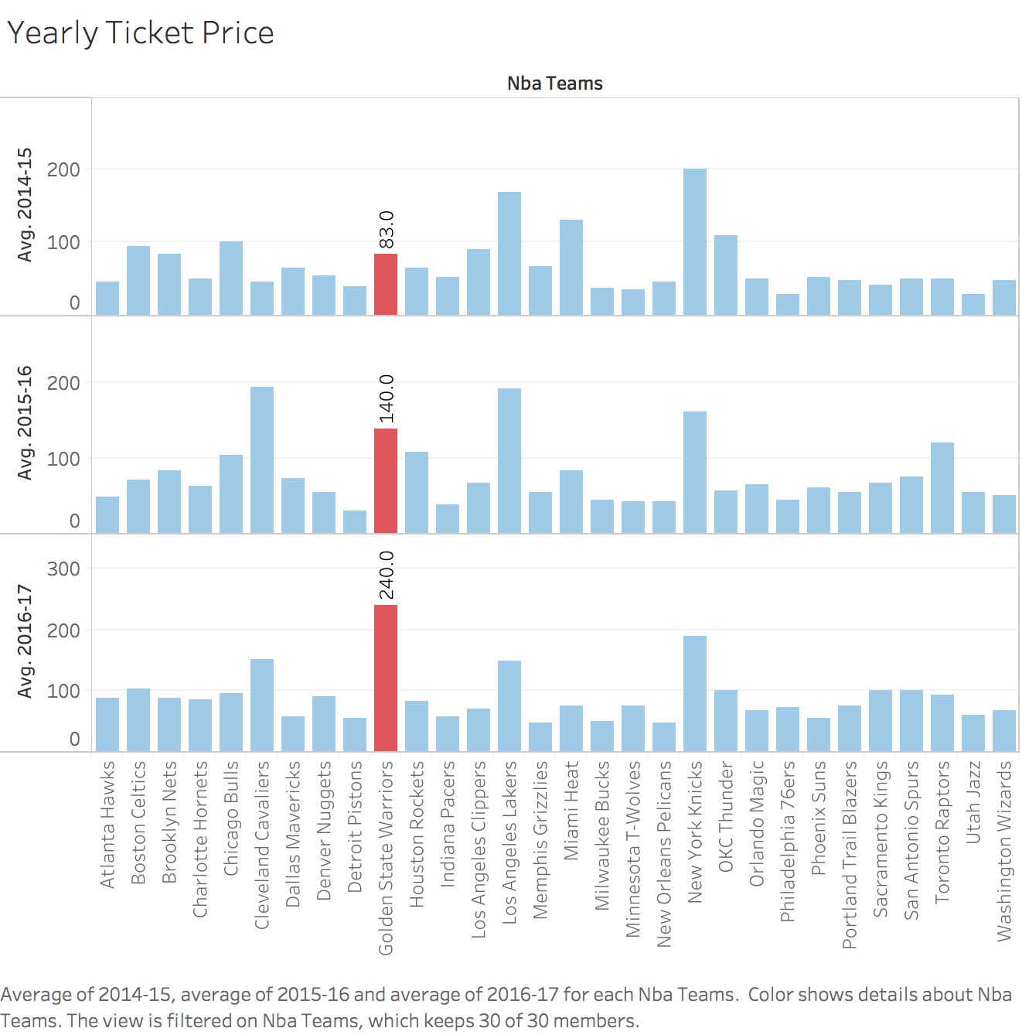

This graph focus on the annual ticket price of each NBA team across three seasons. Color shows the different teams. Warrior is in red and others are in blue. According to the graph, Warrior’s ticket price increases from $83 to $140 in season 2015-2016, because Warrior earns a championship in the previous season. It also has a $100 jumps in season 2016-2017. This is because Warrior trades in Kevin Durant. Kevin Durant has been a super star for a long time and he beefs up the team in order to win the championship this year, attracts huge amount of audience to watch the Warrior game in this season. Therefore, based on the financial perspective, it is worth for the Warrior team to trade in Kevin Durant this season.

**Project Critique:**

If I have more time and more available data, I’ll do the following:

* In order to make the analysis (average player grade) more accurate, I’ll add the actual turnover data into the dataset and separate the rebound into both offensive and defensive rebound.
* I’ll focus on the growth rate of each player. With the same salary value, which player should the Warrior trade in and trade out in the coming season.
* If I have the data for each game in season 2016-2017, I can also do clutch time analysis for each player and also see the trend of their scoring, assisting and etc. This allows me to evaluate the players more accurate.
* I can also focus on the potential growth rate of each player based on their game time and performance. For example, a player may only have 5min game time per game, but can score 8 points each game. This player owns a very high potential growth rate. I’ll recommend Warrior to trade in this player.

**Reference:**

[1] <http://scholarship.claremont.edu/cgi/viewcontent.cgi?article=2302&context=cmc_theses>

[2] <https://www.teamrankings.com/nba/stat/offensive-rebounds-per-game>

[3] <http://www.cleveland.com/cavs/index.ssf/2016/07/what_the_warriors_gained_and_l.html>

**Source:**

Dataset for Kevin Durant Trading Analysis & Player Performance and Salary Ananlysis: (NBA.csv)

1. <http://www.nbastuffer.com/2016-2017_NBA_Regular_Season_Player_Stats.html>

This is the data for NBA player statistic in season 2016-2017.

2. <http://www.nbastuffer.com/2015-2016_NBA_Regular_Season_Player_Stats.html>

This is the data for NBA player statistic in season 2015-2016.

3. <http://www.nbastuffer.com/2014-2015_NBA_Regular_Season_Player_Stats.html>

This is the data for NBA player statistic in season 2014-2015.

4. <https://nba.hupu.com/players/warriors>

This is the data for Warrior players’ salaries in season 2016-2017.

5. <http://www.qiuball.com/NBA/22637.html>

This is the data for Warrior players’ salaries in season 2015-2016.

6. <http://www.qiuball.com/NBA/11983.html>

This is the data for Warrior players’ salaries in season 2014-2015.

Dataset for Yearly Ticket Price: (NBAticketprice.xlsx)

1. <https://www.barrystickets.com/blog/nba-ticket-prices/>

This is the annual ticket price from season 2014-2015 to season 2016-2017.