**Endpoint 9:**

|  |  |  |  |
| --- | --- | --- | --- |
| |  | | --- | | **POST** | | /rental | |
|  | Add a new rental of a film and payment | |
|  | | |
| **Parameters** | | |
| Name | Type | Description |
| object | body | Example Value:   |  | | --- | | **{**  **“film_id”: “1”,**  **“store_id”: “1”,**  **“customer_id”:”1”,**  **“staff_id”:”1”,**  **“amount”:”5.44”**  **}** | |
|  | | |
| **Responses** | Content Type: application.json | |
| Code | Description | |
| 201 | Record was created successfully  Example Value:   |  | | --- | | {      "rental_id": 16050,      "payment_id": 16050  } |   Note: the rental_id and payment_id is an auto increment number. | |
| 400 | Missing information from body object.  Example Value:   |  | | --- | | **{**  **“error_msg”: “missing data”**  **}** |     No stock of the given film id is available in the store id given  { "error_msg": "No Stock" } | |
| 500 | Example Value:   |  | | --- | | **{**  **“error_msg”: “Internal server error”**  **}** | | |

## Response 201

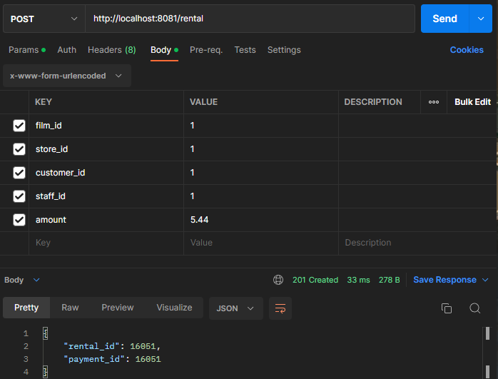

## Response 400

If no stock

## Response 500

**Endpoint 10:**

|  |  |  |  |
| --- | --- | --- | --- |
| |  | | --- | | **POST** | | /staff | |
|  | Add a new staff to the database | |
|  | | |
| **Parameters** | | |
| Name | Type | Description |
| object | body | Example Value:   |  | | --- | | **{**  **"store_id": "1"**  **"first_name":"MARTIN",**  **"last_name": "SIM",**  **"email":"martin_sim@gmail.com";**  **"address": {**  **"address_line1": "77 elm street",**  **"address_line2": "",**  **"district": "California",**  **"city_id" "449",**  **"postal_code": "17886",**  **"phone": "6325-8596",**  **}**  **}** | |
|  | | |
| **Responses** | Content Type: application.json | |
| Code | Description | |
| 201 | Record was created successfully  Example Value:   |  | | --- | | **{**  **“staff_id”: “3”**  **}** |   Note: the staff_id is an auto increment number. | |
| 400 | Missing information from body object.  Example Value:   |  | | --- | | **{**  **“error_msg”: “missing data”**  **}** | | |
| 500 | Example Value:   |  | | --- | | **{**  **“error_msg”: “Internal server error”**  **}** | | |

## Response 201

## Response 400

## Response 500

