Name: Leong Yu Zhi Andy

Class: DIT/FT/1B/02

Admission Number: P2205865

# Endpoint 1: GET /actors/:actor_id

## Response 200 OK:

## Response 204 No Content:

## Response 500 Internal Server Error:

Code was made to parseInt any value in the params so that a 500 error would be sent if actor id is not a number

# Endpoint 2 GET /actors?limit=1&offset=2

## Response 200 OK:

Example call /actors?limit=3&offset=2

No record found:  
Example Call:/actors?limit=10&offset=5000

When limit and offset are not provided, limit will be defaulted to 20 and offset will be defaulted to 0

No offset, offset defaulted to 0

No limit, limit defaulted to 20

## Response 500:

Example when parsing a non numeric offset/limit

# Endpoint 3 POST /actors

## Response 201 created:

Verifying that Ken Lee has been created under actor id 203 in the sql



## Response 400:

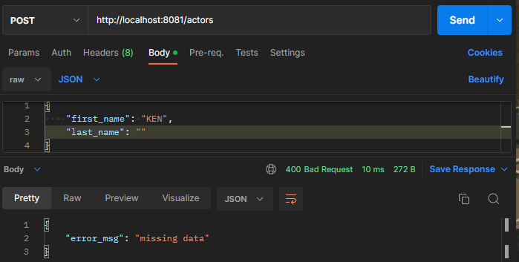

Sends a error 400 if first name or last name is either “”,null or undefined

## Response 500:

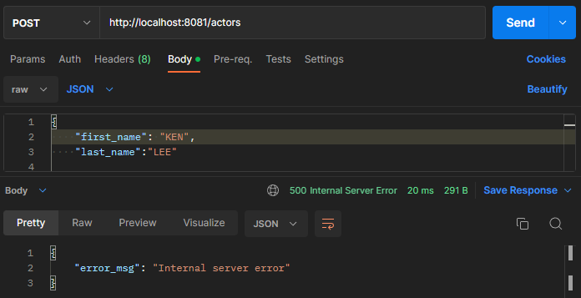

This was intentionally caused by changing the code to cause an error

# Endpoint 4 PUT /actors/:actor_id

## Response 200 OK:

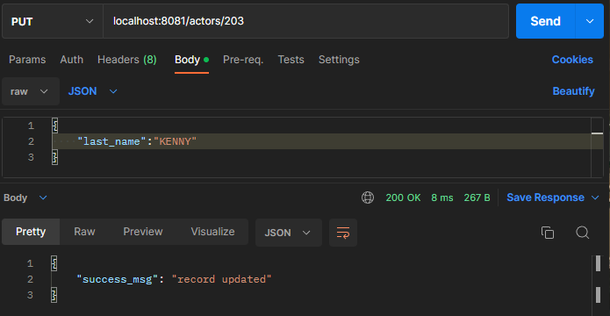

Verifying both first name and last name for actor id 203 has been changed to KENNY



Updating both first name and last name

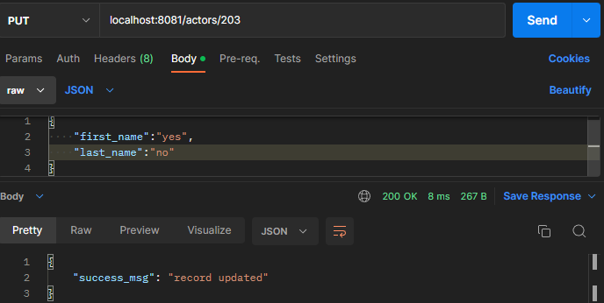



## Response 204

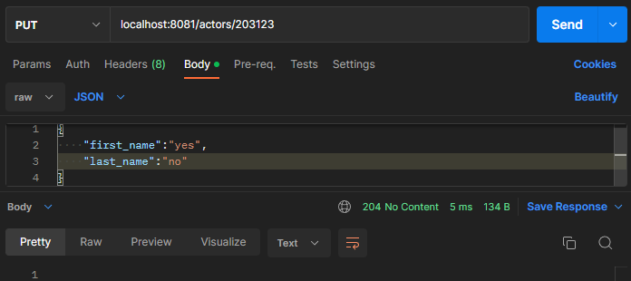

No content, Record of given actor_id cannot be found

## Response 400

## Response 500

# Endpoint 5 DELETE /actors/:actor_id

## Response 200:

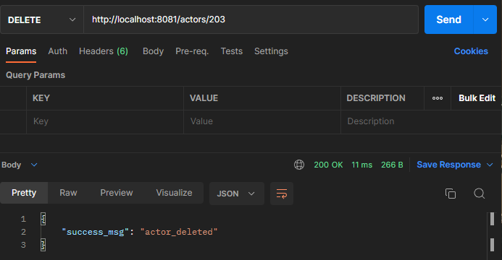

## Response 204:

Record of given actor id is not found

## Response 500

# Endpoint 6 GET /film_categories/:category_id/films

## Response 200

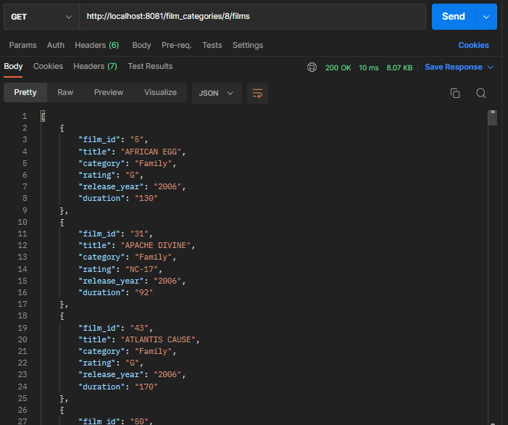

No record example

## Response 500

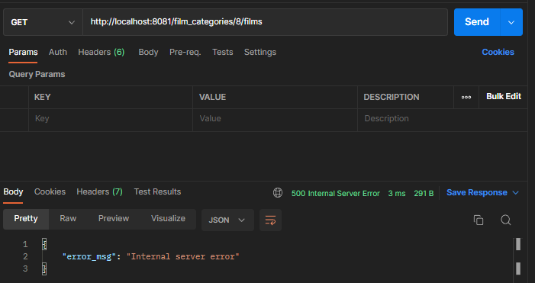  
Example by intentionally placing a error causing code in the app.js

# Endpoint 7 GET/customer/:customer_id/payment

## Response 200

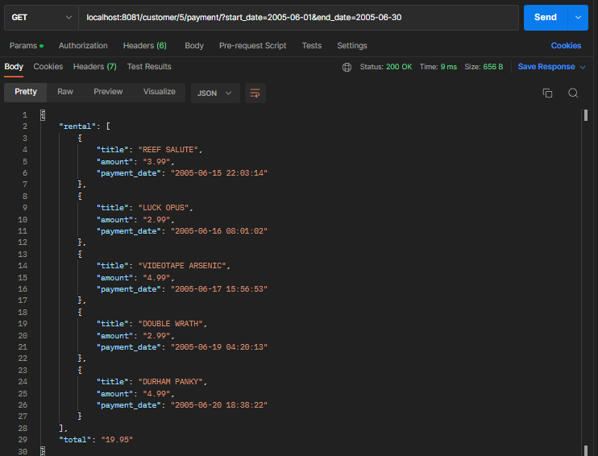

No payment details example

## Response 500

Example by intentionally causing an error causing code in the app.js

# Endpoint 8 POST /customers

## Response 201 created:

## Response 400

## Response 409

## Response 500

This response was caused by intentionally placing a error in the code