**在 ~/.vimrc 的顶部添加以下行**

“lightline.vim插件

call plug#begin('~/.vim/plugged')

Plug 'itchyny/lightline.vim'call

plug#end()

“NERDTree插件

call plug#begin()

Plug 'preservim/nerdtree'

call plug#end()

map <C-n> :NERDTreeToggle<CR>“ctrl n 快捷键设置

“auto-pairs插件

call plug#begin()

Plug 'jiangmiao/auto-pair’”自动配置双引号 括号等

call plug#end()

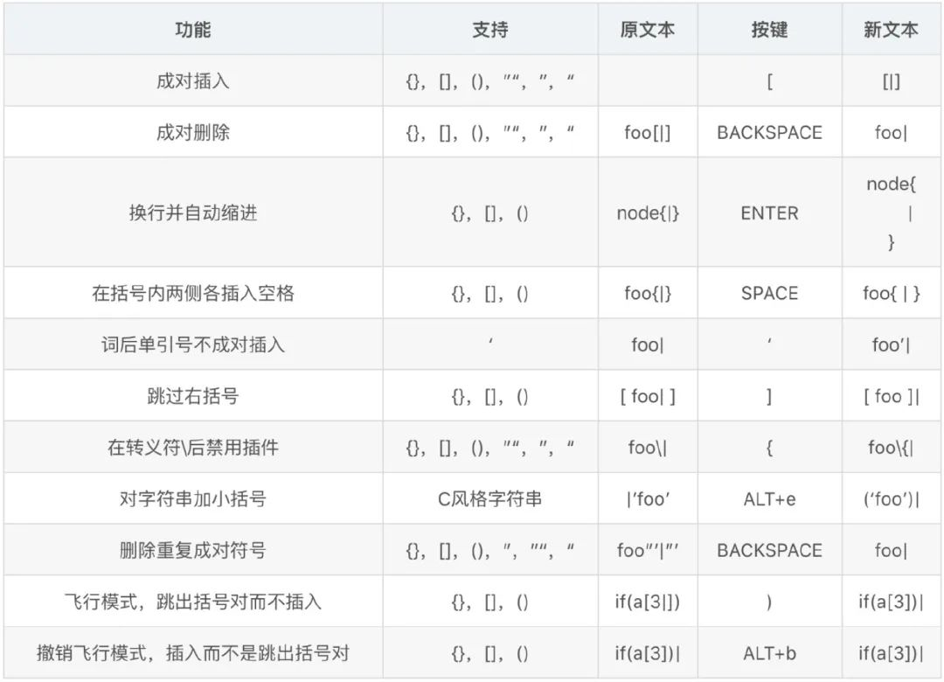

auto-pairs插件

call plug#begin()

Plug 'vim-airline/vim-airline'

Plug 'vim-airline/vim-airline-themes'”美化界面

call plug#end()

set laststatus=2 "永远显示状态栏

let g:airline_powerline_fonts = 1 " 支持 powerline 字体

let g:airline#extensions#tabline#enabled = 1 “ 显示窗口tab和buffer

let g:airline_theme='moloai' " murmur配色不错

if !exists('g:airline_symbols')

let g:airline_symbols = {}

endif

let g:airline_left_sep = '▶'

let g:airline_left_alt_sep = '❯'

let g:airline_right_sep = '◀'

let g:airline_right_alt_sep = '❮'

let g:airline_symbols.linenr = '¶'

let g:airline_symbols.branch = '⎇'

Ctag插件

跳转追踪

<http://ctags.sourceforge.net中下载，使用的时候需要给代码提前添加tag> ctags -R 就会对该目录下的路径进行一个遍历加tag

$ tar -xzvf ctags-5.6.tar.gz   
$ cd ctags-5.6  
$ make  
# make install   // 需要root权限

添加：

:set tags=/home/wooin/vim71/tags

按下ctrl ] 即可跳转函数

Tlist插件

<http://www.vim.org/scripts/script.php?script_id=273>

下载，然后在taglist解压

let Tlist_Show_One_File=1

let Tlist_Exit_OnlyWindow=1

此时用vim打开一个c源文件试试:

$ vim ~/vim/src/main.c

进入vim后用下面的:Tlist命令打开taglist窗口,会显示tag

