**Navigation app**

Project for SENLAB D.O.O

Author: Tim Hrovat

Table of contents

1. Introduction 1

2. Design in Figma 2

3. Programming 3

3.1. MainActivity.java 3

3.2. FindLocationActivity.java 3

3.3. NavigationActivity.java 4

4. Conclusion 5

# Introduction

The Navigation app is mobile application for Android designed to provide navigation assistance to users. It uses GPS and orientation sensors on user’s device to determine their location and orientation and guides them towards wanted location.

**Features:**

1. Location tracking: App uses device’s GPS to track the user’s location in real-time.
2. Compass integration: The app integrates with the device’s compass sensor to determine the user’s orientation relative to their destination.
3. Distance calculation: App calculates the distance between user’s current location and specific destination using longitude and latitude difference.
4. Azimuth calculation: App calculates the azimuth angle, which represents the direction from the user’s current location to the destination. It users sensor’s orientation and geographic coordinates to calculate this angle.
5. User interface: App provides visually appealing user interface that displays buttons that allow user to save and navigate to location and compass that shows direction of wanted location.

**I distributed my work into three main parts:**

* Design basic style of app in Figma.
* Look up what is best way to take care of main parts of app (locations, location-updates, directions…)
* Programming app.

# Design in Figma

The design of the app is minimalistic, emphasizing simplicity and ease of use. The key aspect of the design is the central image showcasing the functionality of the app. By placing them at the center, users can instantly see features of the app and predicts its functionalities.

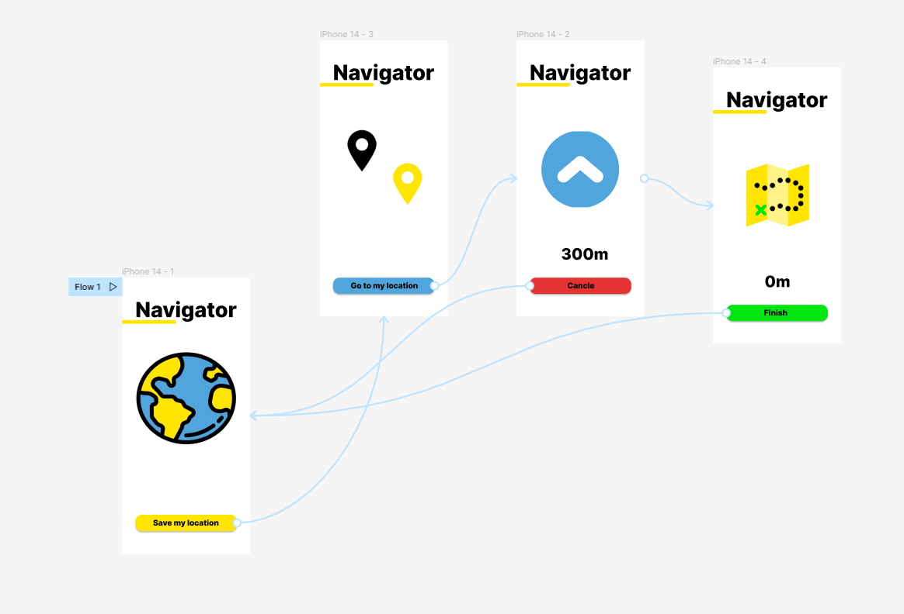

# Programming

## 3.1. MainActivity.java

In the MainActivity.java, users can save their desired locations for future navigation.

* Saving location after getting permission. After location is saved it redirects to FindLocationActivity.java:

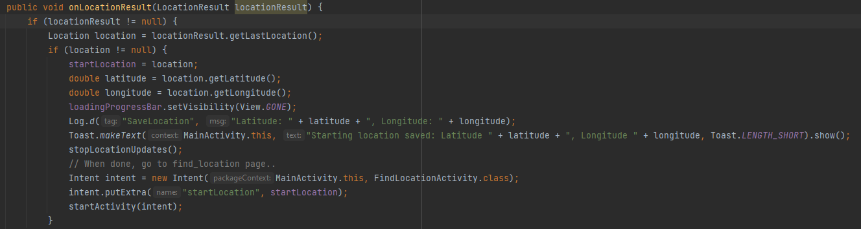

To let user know location is saved it displays Toast with informative text.



* For location I used:

## 3.2. FindLocationActivity.java

In the FindActivity.java is only one button that enables user to start navigation back to desired location.

* Button redirects user to SuccessActivity.java and passes startLocation to it:

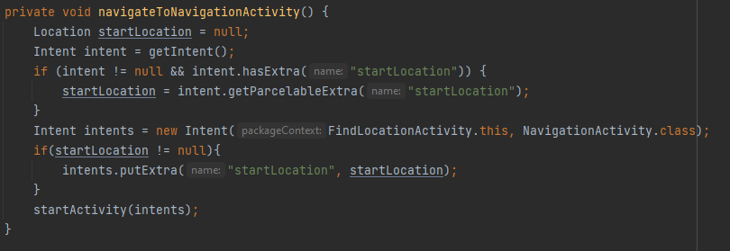

## 3.3. NavigationActivity.java

NavigationActivity.java is most important part of application.

* Updating user location in intervals:

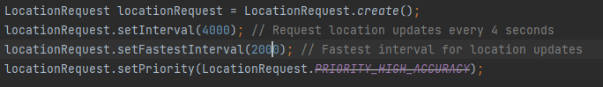

* Calculating distance between last location and desired location using geographiclib:

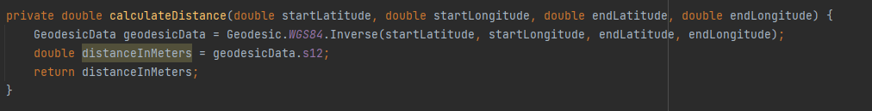

If distance is lower or equal than 1 meter it redirects to SuccessActivity.java:

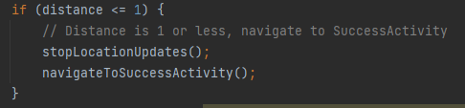

* Rotating navigation arrow towards desired location:

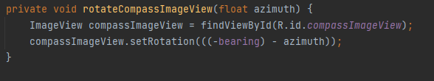

I get bearing (angle between current coordinates and desired location’s coordinates) and subtract azimuth (angle of tiling phone on z-axis):

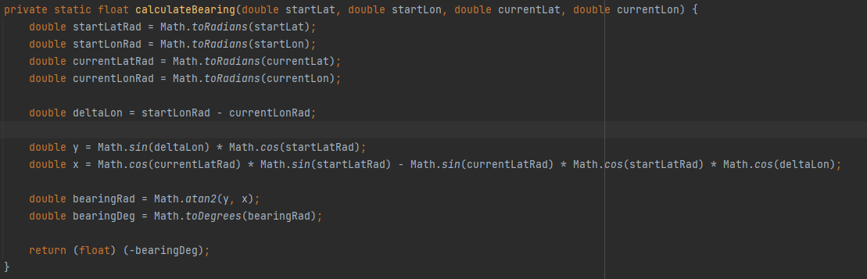

And for azimuth I use device’s sensors:

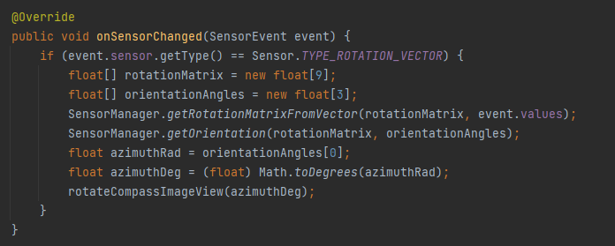

# Conclusion

Biggest issue when programming the app was imprecise GPS location while using wireless debugging, which caused latitude and longitude change even when my device was not moving. For that reason compass was not moving into right direction.

But I was very interested working on this app, especially because I can see it being used for tourists while hiking in unknow areas with bad visibility (forest, rainy day…).