
A Comparative Data Mining Study of Mushroom and Ionosphere
CDS535 - Data Mining

Date: November 2026

Team Name: Datawarts
A1 He Haodong 3162500
A2 BEI Xuecheng 3162378
A3 GU Ruiqi 3163437
B1 GONG Tinglu 3163358
B2 HE Mingen 3162445
B3 Hu Shuaishuai 3163425

Instructor: DONG Chengzu

My Github link：https://github.com/Timi-prj/GroupAssignment

Abstract
This project compares traditional data mining methods on the UCI Mushroom and Ionosphere datasets using a consistent protocol of stratified 10-fold cross-validation, an 80/20 split, and seed=42. Evaluation considers F1, ROC-AUC, error patterns, and model cost. Mushroom uses ZeroR, J48, logistic regression, KNN, and Apriori; logistic regression is selected after several candidate models tie with perfect scores. Ionosphere uses a decision tree, RandomForest, logistic regression, and RBF-SVM; RBF-SVM achieves the best overall performance, with F1=0.956 and ROC-AUC=0.980. The findings indicate that model advantages depend on the data: strong class signals in Mushroom make simple models sufficient, whereas nonlinear numerical boundaries in Ionosphere favour kernel methods.
Keywords: Data Mining; Classification; Association Rules; Mushroom; Ionosphere; Cross-validation

Contents
1 Group Project Requirement 1
1.1 Project Objectives and Scope 1
1.2 Division of Labour 1
2 Introduction 1
2.1 Background and Motivation for Research 1
2.2 Research Implication 1
2.3 Key Points of Innovation 2
3 Data Distribution and Preprocessing 2
3.1 Data Visualisation and Analysis 2
3.2 Data Preprocessing 3
4 Basic Concepts of Algorithms 4
5 Model Training 5
5.1 Model Initialization and Configuration 5
5.2 Mushroom Training and Internal Selection 6
5.3 Ionosphere Training 8
5.4 Training the Unsupervised Components 12
6 Results and Evaluation 12
6.1 Mushroom: Comparison of F1 and ROC-AUC 12
6.2 Mushroom: Error Patterns and Final Selection 13
6.3 Mushroom: Apriori Results 14
6.4 Ionosphere: Model Comparison and Final Selection 15
6.5 Ionosphere: KMeans Results 16
6.6 Cross-dataset Comparison 16
7 Conclusion and Future Work 17
7.1 Future Work 18
References and Data Provenance 18

1 Group Project Requirement

1.1 Project Objectives and Scope
Both UCI datasets follow the complete workflow of data inspection, preprocessing, modelling, and evaluation. Classification uses F1 for the target positive class as the primary metric and ROC-AUC as the secondary metric, alongside Accuracy, Precision, Recall, and confusion matrices. The unsupervised components use Apriori and KMeans. All random processes use seed=42, and supervised preprocessing is performed within training folds to prevent data leakage.

1.2 Division of Labour
Member | Dataset/Role | Specific Contributions
A1 He Haodong | Mushroom | Preprocessing, J48 variants, tree diagrams, and Weka workflow
A2 BEI Xuecheng | Mushroom | Logistic regression, KNN, within-fold tuning, Apriori, and charts
A3 GU Ruiqi | Mushroom | ZeroR, results compilation, and report and PPT support
Member | Dataset/Role | Specific Contributions
B1 GONG Tinglu | Ionosphere | Preprocessing, J48, ablation studies, and visualisation
B2 HE Mingen | Ionosphere | RandomForest, Logistic, learning curves, and leakage checks
B3 Hu Shuaishuai | Ionosphere | RBF-SVM, PCA/SelectKBest, results compilation, and PPT integration

2 Introduction

2.1 Background and Motivation for Research
Mushroom edibility identification and Ionosphere radar return identification are both binary classification tasks, but their data characteristics differ substantially. The former has more samples, exclusively nominal attributes, and missing values; the latter has fewer samples, relatively high numerical dimensionality, and mild class imbalance. These differences provide a direct comparison for studying the suitability of preprocessing and algorithms.
Accuracy can mask failures in a key class when classes are imbalanced or the baseline is strong. This project therefore prioritises F1, supplemented by ROC-AUC, confusion matrices, and error types.

2.2 Research Implication
RQ1: How do the shared J48 and logistic regression models differ in F1, ROC-AUC, and error patterns across the two datasets?
RQ2: When suitable candidate models are added for each dataset, does the additional model complexity yield sufficient benefits?
RQ3: What preprocessing is required by attribute types, sample sizes, and data quality, and how do these choices affect results?
RQ4: How closely do unsupervised clusters align with actual classes, and can clustering replace supervised classification?

2.3 Key Points of Innovation
Use consistent seed=42, stratified 10-fold validation, and an 80/20 split to improve reproducibility.
Perform one-hot encoding, standardisation, supervised feature selection, and resampling within training folds to reduce leakage risk.
First select variants within each algorithm, then compare algorithms in the order F1 → ROC-AUC → error patterns → complexity.
Report classification and unsupervised analysis separately to avoid conflating classification, association, and clustering metrics.

3 Data Distribution and Preprocessing

3.1 Data Visualisation and Analysis

3.1.1 Mushroom
Mushroom was provided by Schlimmer (1987), with DOI 10.24432/C5959T, under the CC BY 4.0 licence. The original dataset contains 8,124 samples and 22 nominal input attributes, with labels e (edible) and p (poisonous).https://doi.org/10.24432/C5959T
stalk-root contains 2,480 missing values, while veil-type has only one value. Cleaning retains 21 effective input attributes. There are 4,208 edible and 3,916 poisonous samples, approximately 51.80%:48.20%, making the classes nearly balanced.
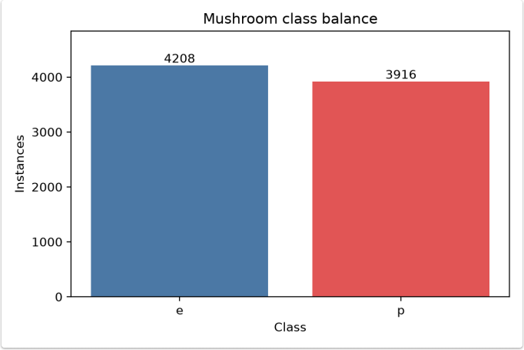

3.1.2 Ionosphere
Ionosphere was provided by Vince Sigillito and colleagues at the Johns Hopkins University Applied Physics Laboratory. Its UCI ID is 52 and its DOI is 10.24432/C5W01B; it is licensed under CC BY 4.0. The data originate from a system of 16 high-frequency antennas at Goose Bay. good indicates identifiable ionospheric structure, whereas bad indicates that the signal passes directly through.
The dataset contains 351 samples and 34 numerical input attributes, representing the real and imaginary components of 17 pulse signals. a02 is an all-zero constant attribute; removing it leaves 33 input attributes. There are no missing values. There are 225 good samples (64.1%) and 126 bad samples (35.9%), indicating mild imbalance. Evaluation treats good as the positive class.
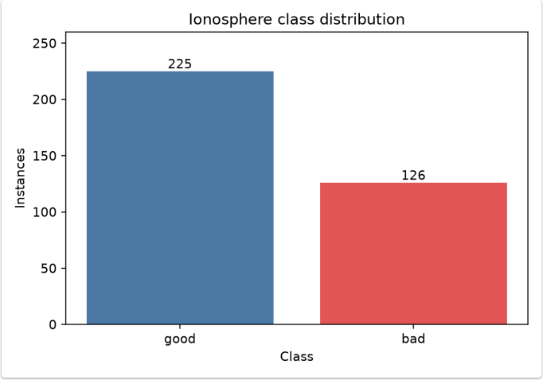

3.2 Data Preprocessing

3.2.1 General Preprocessing for Mushroom
ReplaceMissingValues imputes stalk-root with its mode to avoid discarding many samples.
RemoveUseless -M 99.0 removes the single-valued veil-type attribute; no exact duplicate samples remain after cleaning.
NominalToBinary expands the 21 nominal input attributes into 115 binary attributes, providing a common numerical representation. The transformation is fitted within training folds to prevent preprocessing leakage.
AttributeSelection (InfoGainAttributeEval+Ranker, numToSelect=1) only ranks attributes by information gain without removing any, identifying strong attributes such as “order” and “spore-print-color”. Actual dimensionality reduction occurs within J48's within-fold FilteredClassifier.
All inputs are nominal attributes; IQR or Z-score methods are not used to remove rare categories.

3.2.2 General Preprocessing for Ionosphere
Check for missing values. ReplaceMissingValues is retained for workflow consistency, although there are no missing values to handle.
Use RemoveUseless to remove the all-zero constant attribute a02, retaining 33 effective numerical attributes.
Do not apply one-hot encoding to numerical attributes; preserve their original continuous information.
Inspect extreme values, but do not automatically remove plausible strong radar returns as outliers.
Retain one duplicate record to avoid changing the sample distribution without sufficient justification.

3.2.3 Workflow Differences
Step | Mushroom | Ionosphere
Missing values | Mode imputation for stalk-root | None
Uninformative attributes | Remove single-valued veil-type | Remove all-zero a02
Attribute transformation | General NominalToBinary transformation to 115 dimensions | Retain numerical inputs
Model-specific processing | Within-fold feature selection for J48 | Standardize, SelectKBest, PCA, and resampling within pipelines
Leakage prevention | FilteredClassifier / sklearn Pipeline | sklearn Pipeline
Weka 3.8.7 Explorer is used for filters, ZeroR, J48, RandomForest, Logistic, and cross-validation, with models, logs, and commands saved. Python and scikit-learn are used for logistic regression, KNN, RBF-SVM, fixed indices, within-fold tuning, charts, and Apriori. The unified comparison tables are generated from reproducible outputs, providing an Experimenter-equivalent approach permitted by the original requirements.
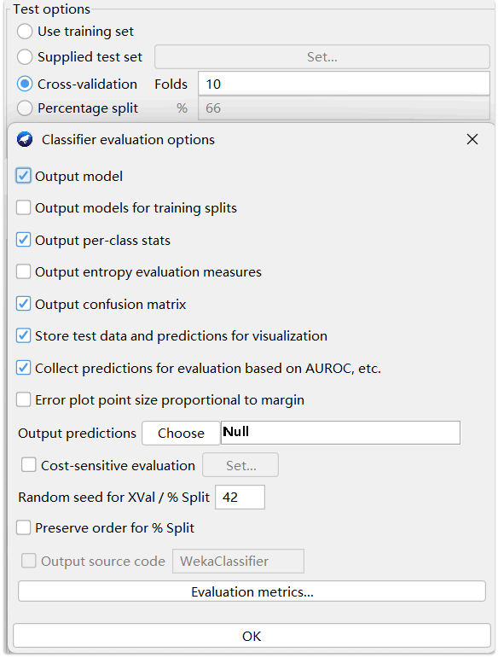

4 Basic Concepts of Algorithms
ZeroR: Always predicts the majority class, providing a baseline for determining whether other models learn class patterns.
J48/decision tree: Recursively selects splitting attributes to form rules. J48 uses information gain and pruning; the Python comparison uses an optimised CART model.
Logistic regression: Weights input features and uses a sigmoid function to output class probabilities, providing a stable linear reference.
KNN: Votes using the labels of nearest neighbours, testing local similarity among Mushroom's categorical attributes.
RandomForest: Builds and combines multiple trees using bootstrap samples and random feature subsets, reducing single-tree variance.
RBF-SVM: Uses a maximum-margin approach and an RBF kernel to learn nonlinear boundaries, making it suitable for small numerical datasets.
Apriori: Mines frequent itemsets and association rules, measuring co-occurrence through Support, Confidence, and Lift.
KMeans: Minimises within-cluster SSE without labels; silhouette scores and external label comparisons are used to analyse cluster structure.

5 Model Training

5.1 Model Initialization and Configuration
Formal classification metrics use seed=42, stratified 10-fold cross-validation, and a stratified 80/20 split. The shared J48 and logistic regression models use training/validation F1 and ROC-AUC learning curves. RandomForest uses OOB curves, while RBF-SVM uses feature-count sensitivity curves. These traditional-model curves are not interpreted as a common batch-by-batch loss.
Dataset | Model | Fixed Parameters | Search/Selection Settings
Mushroom | ZeroR | Majority-class rule | None
Mushroom | J48-top9 | C=0.25, M=2 | Within-fold InfoGain top9
Mushroom | Logistic regression | L2, lbfgs, max_iter=5000 | C=0.01–100; C=10 on the training portion of the holdout split
Mushroom | KNN | Euclidean | k=1–20; uniform/distance; tied result recorded as k=1, uniform
Ionosphere | Decision tree | min_samples_leaf=2, min_samples_split=4 | Feature-selection and depth ablation
Ionosphere | RandomForest | 100 trees, bootstrap, random feature subsets | OOB curve checks the plateau in tree count
Ionosphere | Logistic | L-BFGS, max_iter=5000 | Compare preprocessing pipelines
Ionosphere | RBF-SVM | RBF kernel, default C/gamma | Standardize,  SelectKBest/PCA,SMOTE

5.2 Mushroom Training and Internal Selection
ZeroR
Model Training
ZeroR provides only a majority-class baseline and is excluded from the final candidates.
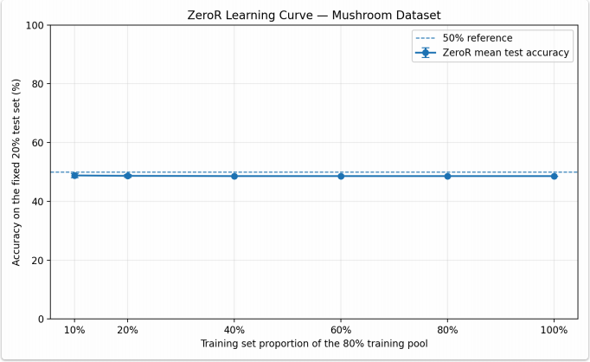
J48
Additional Preprocessing
In addition to the general NominalToBinary representation, J48 uses FilteredClassifier to perform InfoGain, CFS, or Wrapper attribute selection within each training fold, preventing test folds from influencing feature selection.
Model Training
J48 variants include all attributes, InfoGain top8/top9, CFS, and Wrapper. CFS and top8 miss some poisonous samples; all22, top9, and Wrapper achieve perfect scores. top9 uses fewer attributes than all22 and avoids Wrapper's costly search and more complex structure. Thus, only J48-top9 proceeds to the cross-model comparison.
Internal Variant | Attributes | Poisonous Samples Missed in 10 Folds | F1 | Structure/Cost
all22 | 21 | 0 | 1.0000 | 25 leaves
top8 | 8 | 8 | 0.9990 | 27 leaves
top9 | 9 | 0 | 1.0000 | 28 leaves
CFS | 4 | 80 | 0.9898 | 17 leaves
Wrapper | 5 | 0 | 1.0000 | 32 leaves; higher search cost
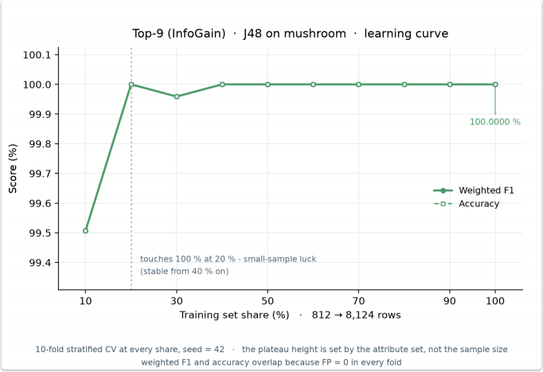
Training and validation performance converge as sample size increases, with no obvious generalisation gap.
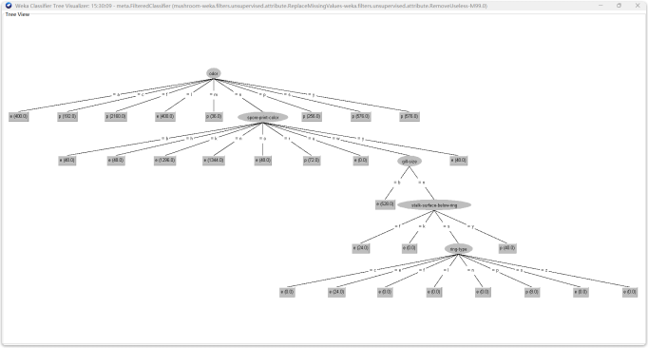
Logistic Regression
Model Training
Validation F1 and ROC-AUC reach 1.0 as sample size increases, and the training–validation gap disappears, indicating that linear combinations are sufficient for this dataset.
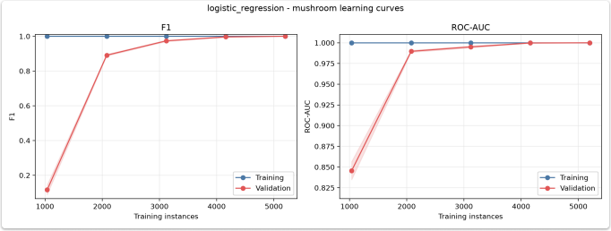
KNN
Model Training
KNN achieves perfect scores for k=1–9. Grid search records k=1 and weights='uniform' according to the tie order. Since training scores for k=1 are inherently 1, generalisation is assessed using validation curves and outer cross-validation.
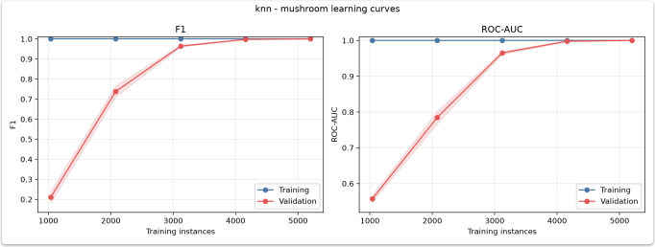

5.3 Ionosphere Training
J48
Additional Preprocessing
Standardize and InfoGain Top16 are tested separately within training pipelines to distinguish the effects of scaling and supervised attribute selection.
In the standardisation ablation, F1 remains 0.9011, indicating that monotonic scaling does not change tree splits. InfoGain Top16 raises F1 to 0.9173 and ROC-AUC to 0.9125, demonstrating the role of attribute selection in small, high-dimensional datasets.
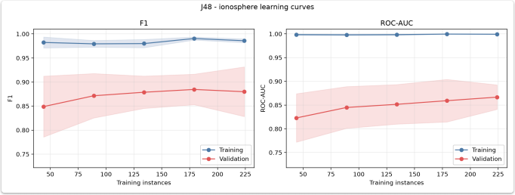
Training scores exceed validation scores. Validation F1 and ROC-AUC generally improve with more samples, but fluctuations remain.
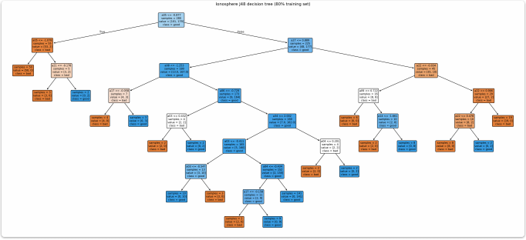
The tree diagram shows numerical splitting thresholds, node sample counts, and class composition, providing an inspectable rule structure as in Mushroom.
RandomForest
Additional Preprocessing
Within training folds, compare pipelines with no selection/no balancing, SelectKBest, RandomOverSampler, and SMOTE.
RandomOverSampler produces slightly higher Accuracy, but overall differences are small, suggesting that RandomForest is relatively insensitive to these preprocessing changes.
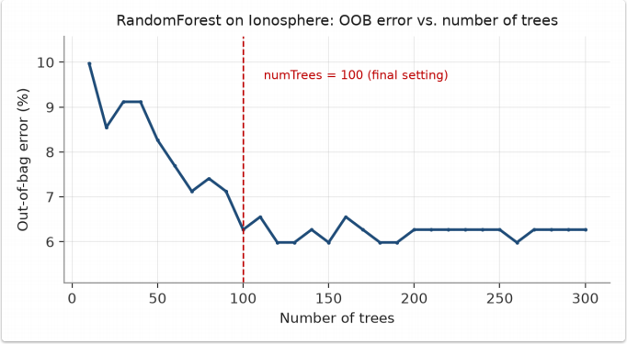
OOB error falls from approximately 10% with 10 trees to approximately 6.3% with 100 trees, then mainly fluctuates between 6% and 6.7%. Therefore, 100 trees provide a reasonable balance between performance and computational cost.
Logistic
Additional Preprocessing
Logistic regression compares the same within-fold preprocessing pipelines. The variant without feature selection or balancing performs best. Feature selection and resampling do not improve its linear input structure; Recall is high, while Precision is relatively low.
Model Training
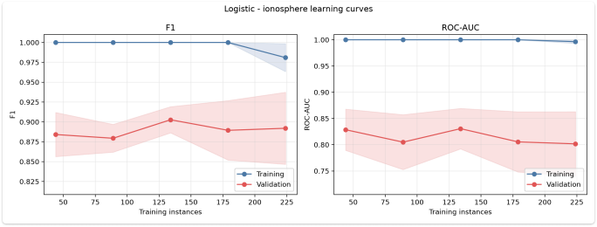
Training scores are nearly perfect, whereas validation F1 and ROC-AUC are lower and fluctuate, revealing a training–validation gap.
RBF-SVM
Additional Preprocessing
All variants apply Standardize, feature processing, and optional resampling sequentially within each fold before fitting SVM.
Model Training
SelectKBest+SMOTE performs well in the initial scan. Further scanning shows Accuracy=0.957 and F1=0.967 at k=30, with an F1 standard deviation of 0.015, below the 0.031 at k=15.
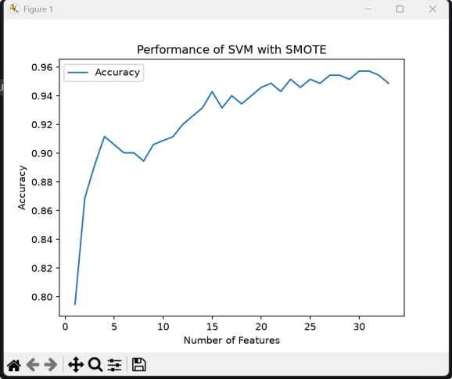
PCA component-count experiment. To examine compression of correlated numerical attributes, each training fold first applies Standardize, then extracts k=1–33 principal components using PCA, followed by SMOTE and RBF-SVM classification. Standardisation prevents attributes with larger scales from dominating variance directions. PCA extracts orthogonal components from the training-fold variance structure without using class labels.
Principal Components  k | Accuracy (approx.) | Intermediate Results and Interpretation
1 | 0.795 | One component retains only the dominant variance direction, losing substantial class information
10 | 0.940 | Additional components rapidly restore discriminative information, approaching strong performance
15 | 0.943 | Improvement begins to level off; added components yield diminishing returns
29 | 0.9577 | Highest Accuracy in this PCA scan, with substantial information retained
Principal Components  k | Accuracy (approx.) | Intermediate Results and Interpretation
33 | Slight decline | Retaining all dimensions yields no further improvement; later components may mainly contain redundancy or noise
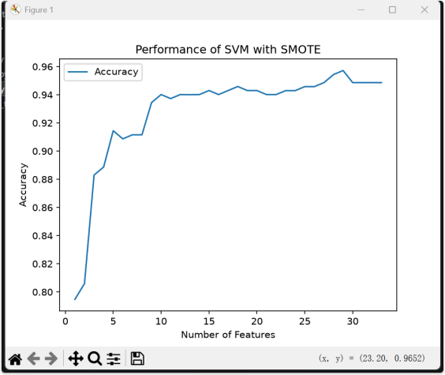
The curve rises rapidly, reaches a plateau, and fluctuates slightly; more components are not always better. PCA compresses correlated attributes into fewer orthogonal directions, but its components do not directly correspond to original radar attributes, reducing interpretability. Its highest Accuracy of 0.9577 differs from SelectKBest's 0.9572 by only about 0.0005, which does not establish PCA's superiority.
SelectKBest uses training-fold labels to retain original features, making interpretation more direct. PCA does not use labels and is better suited to compressing correlated structure.

5.4 Training the Unsupervised Components
Apriori (Mushroom)
Model Training
Apriori uses Support≥0.20, Confidence≥0.80, and a maximum itemset length of 3, retaining rules with class=e/p as the consequent.
KMeans (Ionosphere)
Apply Standardize before clustering and compare different SelectKBest feature counts in exploratory experiments to prevent scale or irrelevant dimensions from dominating distances.
Model Training
KMeans compares cluster and feature counts on standardised attributes, evaluating SSE, silhouette scores, and label purity. Label-assisted exploratory results using SelectKBest are separately identified and are not conflated with fully unsupervised results.

6 Results and Evaluation

6.1 Mushroom: Comparison of F1 and ROC-AUC
Model | Accuracy | Precision | Recall | F1 | ROC-AUC
ZeroR | 0.5180 | 0.0000 | 0.0000 | 0.0000 | 0.5000
J48-  top9 | 1.0000 | 1.0000 | 1.0000 | 1.0000 | 1.0000
Logistic regression | 1.0000 ± 0.0000 | 1.0000 ± 0.0000 | 1.0000 ± 0.0000 | 1.0000 ± 0.0000 | 1.0000 ± 0.0000
KNN | 1.0000 ± 0.0000 | 1.0000 ± 0.0000 | 1.0000 ± 0.0000 | 1.0000 ± 0.0000 | 1.0000 ± 0.0000
The table reports stratified 10-fold results, with poisonous p as the positive class. Although ZeroR achieves 51.80% Accuracy, it identifies no poisonous samples and is excluded. The other three models tie for the best F1 and ROC-AUC, with holdout results also equal to 1.0.
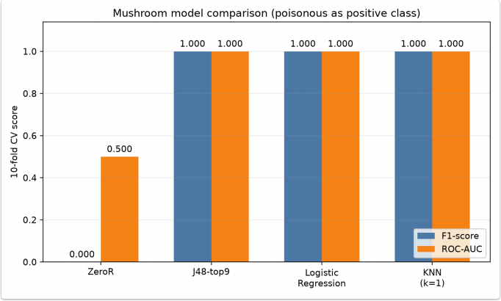

6.2 Mushroom: Error Patterns and Final Selection
All three candidate models produce no FP or FN in aggregated 10-fold results or the holdout set. For both logistic regression and KNN, holdout results are TN=842, FP=0, FN=0, and TP=783. J48-top9 also makes no errors on its independent test, so error patterns still cannot distinguish the three models.
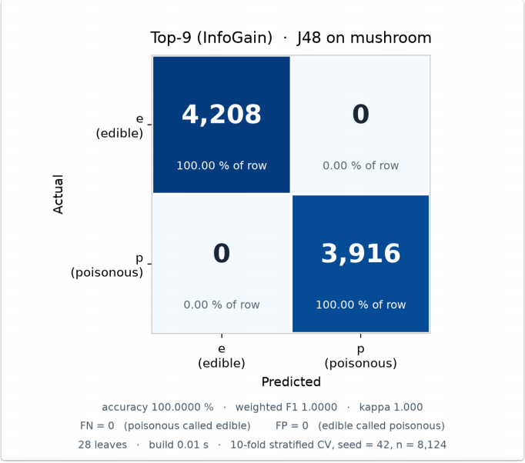
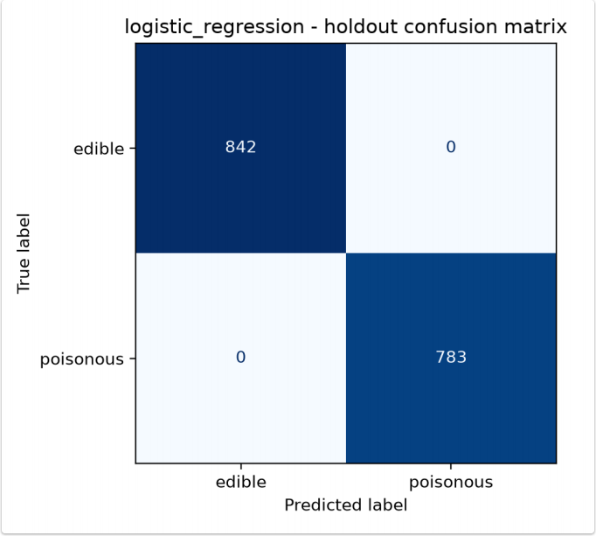
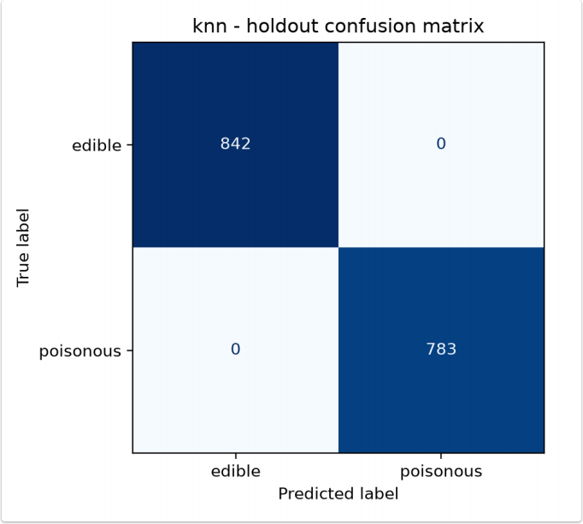
Model | Structure | Interpretability | Main Cost
J48-top9 | 9 attributes, 28 leaves | High; intuitive rules | Requires within-fold feature selection
Logistic regression | 115-dimensional linear weighting | Relatively high; weights can be analysed | Direct pipeline; only C is tuned
KNN | Stores training data and votes by nearest neighbours | Moderate; neighbours can be displayed | Distance calculations at prediction time
With performance and error patterns fully tied, logistic regression is selected under the “simpler/faster” rule. J48-top9 is the best interpretable alternative. KNN confirms the effectiveness of local similarity but offers no additional performance benefit.

6.3 Mushroom: Apriori Results
Apriori produces 1,568 frequent itemsets and 104 class rules.
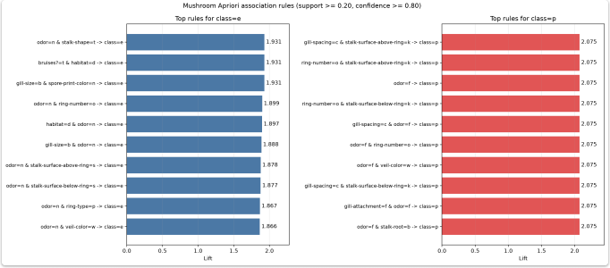
odor=f → class=p has Support=0.2659, Confidence=1.0000, and Lift=2.0746; odor=n → class=e has Support=0.4195, Confidence=0.9660, and Lift=1.8649. These rules indicate strong attribute–class co-occurrence, not causality or real-world advice on mushroom consumption.

6.4 Ionosphere: Model Comparison and Final Selection
Model | Accuracy | Precision | Recall | F1 | ROC-AUC
Decision tree | 0.914 | 0.935 | 0.933 | 0.933 | 0.907
RandomForest | 0.937 | 0.944 | 0.969 | 0.952 | 0.977
Logistic regression | 0.883 | 0.879 | 0.960 | 0.914 | 0.897
RBF-SVM | 0.943 | 0.946 | 0.982 | 0.956 | 0.980
RBF-SVM ranks highest on the primary metric, F1, making it the best current model. Its highest ROC-AUC further supports this choice. Its Recall of 0.982 is also the highest among the four models, indicating the fewest missed good samples. Thus, no complexity-based tie-break is required, and RBF-SVM is selected for Ionosphere.
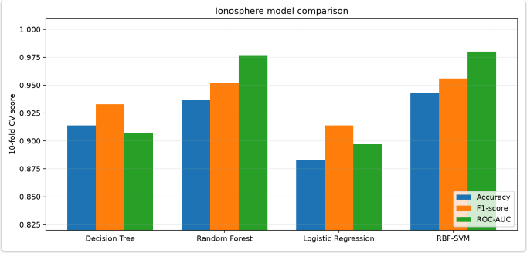
Decision trees can fit nonlinear patterns but have limited single-tree stability. RandomForest improves performance through ensembling; logistic regression is constrained by linear boundaries. RBF-SVM's kernel boundaries and maximum-margin mechanism better suit small numerical datasets. These rankings reflect cross-validation means and do not establish statistical significance.

6.5 Ionosphere: KMeans Results
With all features, SSE decreases most sharply from k=1 to k=2, although the elbow is not pronounced. In label-assisted feature exploration, purity is approximately 0.83 with only the top three features; retaining more features reduces purity, indicating that weakly related structure and noise affect distance calculations. KMeans helps explore relationships between data structure and classes but cannot replace supervised classification.
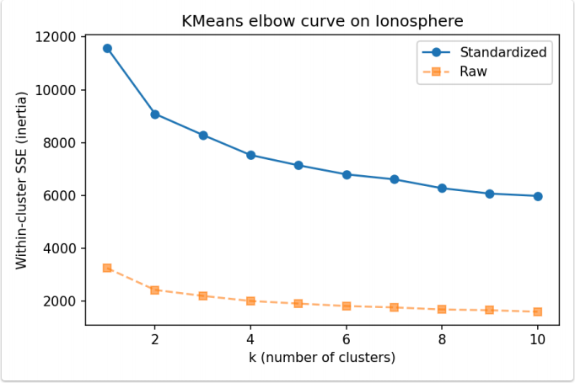
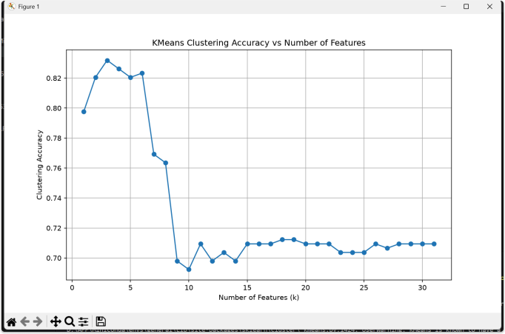

6.6 Cross-dataset Comparison
Results for the shared models show clear dependence on the dataset:
Shared Model | Mushroom F1 / ROC-AUC | Ionosphere F1 / ROC-AUC | Explanation
J48/decision tree | 1.000 / 1.000 | 0.933 / 0.907 | Strong rules in nominal attributes are easy to split; single trees are less stable on small numerical datasets
Logistic regression | 1.000 / 1.000 | 0.914 / 0.897 | Linear weighting is sufficient for Mushroom; Ionosphere contains more complex nonlinear boundaries
Adding candidates such as KNN does not outperform the simple linear model on Mushroom, so logistic regression is selected. On Ionosphere, RBF-SVM's nonlinear kernel boundary achieves the highest F1 and ROC-AUC. This explains why model advantages differ across datasets: the deciding factor is whether the inductive bias matches the data structure, rather than algorithmic complexity itself.

7 Conclusion and Future Work
This project completes preprocessing, classification, unsupervised analysis, and model selection for two UCI datasets under a unified protocol.
Several models achieve perfect scores on Mushroom; logistic regression is selected for its simplicity, stability, and probability outputs. On Ionosphere, RBF-SVM wins with the highest F1 and ROC-AUC. Both shared models, J48 and logistic regression, perform better on Mushroom, suggesting that strong class signals in nominal attributes are easier to learn than complex boundaries in small numerical datasets.
Unsupervised results complement classification: Apriori identifies strong associations involving attributes such as odour, while KMeans shows that natural clusters do not fully coincide with radar labels. All results represent cross-validation means and evidence within the current parameter ranges; no statistical significance is claimed.
Mushroom contains hypothetical samples, so its results cannot be extrapolated into real-world consumption advice. Repeated parameter comparisons on Ionosphere may introduce selection bias; formal performance still requires confirmation through independent testing or nested validation.
Summary of responses to the research questions:
Research Question | Conclusion
RQ1: Shared models across datasets | J48 and logistic regression achieve perfect scores on Mushroom, but F1 scores of 0.933 and 0.914, respectively, on Ionosphere. Alignment between data structure and inductive bias determines performance differences.
RQ2: Is additional complexity worthwhile? | Mushroom gains no additional benefit, so logistic regression is selected. On Ionosphere, RBF-SVM wins with F1=0.956 and ROC-AUC=0.980, demonstrating practical value from nonlinear complexity.
RQ3: Data-dependent preprocessing | Cleaning Mushroom does not improve J48 scores. Standardisation does not benefit trees on Ionosphere, while appropriate attribute selection, PCA, or SelectKBest can affect SVM performance. No preprocessing scheme is universally optimal across models.
RQ4: Can clustering replace supervised classification? | No. KMeans clusters correspond only partially to actual labels. They support structural exploration but are unsuitable as a replacement for supervised classification in this task.

7.1 Future Work
Validate model-selection conclusions on datasets with more varied sizes, noise levels, and class imbalance.
Study probability calibration, threshold adjustment, and cost-sensitive evaluation to further distinguish class ranking from fixed-threshold performance.
Apply redundancy filtering and external validation to association rules, and explore more discriminative feature representations for clustering.

References and Data Provenance
Agrawal, R., & Srikant, R. (1994). Fast algorithms for mining association rules. Proceedings of the 20th VLDB Conference, 487–499.
Admojo, F. T., Radhitya, M. L., Zein, H., & Naswin, A. (2024). Classification of mushroom edibility using K-Nearest Neighbors: A machine learning approach. Indonesian Journal of Data and Science, 5(3), 243–250. https://doi.org/10.56705/ijodas.v5i3.199
Breiman, L. (2001). Random forests. Machine Learning, 45, 5–32. https://doi.org/10.1023/A:1010933404324
Chawla, N. V., et al. (2002). SMOTE: Synthetic minority over-sampling technique. Journal of Artificial Intelligence Research, 16, 321–357. https://doi.org/10.1613/jair.953
Dua, D., & Graff, C. (2019). UCI Machine Learning Repository. https://archive.ics.uci.edu/
Duy, H. A., et al. (2023). An improved Apriori algorithm for interestingness of association rules: A case study on the Mushroom dataset. https://doi.org/10.1007/978-981-99-3091- 3_20
Frank, E., Hall, M. A., & Witten, I. H. (2016). The WEKA Workbench: Online Appendix for Data Mining: Practical Machine Learning Tools and Techniques (4th ed.).
Pedregosa, F., et al. (2011). Scikit-learn: Machine learning in Python. Journal of Machine Learning Research, 12, 2825–2830.
Quinlan, J. R. (1986). Induction of decision trees. Machine Learning, 1, 81–106. https://doi.org/10.1007/BF00116251
Schlimmer, J. (1987). Mushroom [Dataset]. UCI Machine Learning Repository. https://doi.org/10.24432/C5959T (CC BY 4.0)
Sigillito, V. G., Wing, S. P., Hutton, L. V., & Baker, K. B. (1989). Classification of radar returns from the ionosphere using neural networks. Johns Hopkins APL Technical Digest, 10(3), 262– 266.
Sigillito, V. G. (1988). Ionosphere [Dataset]. UCI Machine Learning Repository, ID 52. https://doi.org/10.24432/C5W01B (CC BY 4.0)

