Physical intimacy
Relationship Anarchy Worksheet  Smorgasbord |  | Participants:

- no touch
- platonic touch
- erotic touch
- safer sex
- shared fluids

Kink
- BDSM
- power exchange
- roleplaying
- taboo

Emotional Intimacy
- venting
- support
- attend to one another’s love languages

Communication Frequency
- most days
- a few times per week
- most weeks
- 1-2 times per month
- most months

Communication Response
- always immediate
- priority response
- considerate response
- asynchronous

Together Frequency
- most days
- a few times per week
- most weeks
- 1-2 times per month
- most months

Together Quality
- adjacent
- collaborative
- focused on one another

Domestic
- chores and duties
- cooking together
- housemates
- roommates

Relationship Publicity
- secret
- family
- community
- work
- social media

Labels
- friends
- lovers
- partners
- chosen family

Life Partners
- long term goals
- political alignment
- embracing change
- emergency contacts

Structure
- open & non-hierarchical
- open & hierarchical
- closed/exclusive

Caregiving
- plants
- pets
- children
- adults needing care

Finances
- support
- shared expenses
- shared possessions
- shared accounts
- shared property
- inheritor/beneficiary

Legal
- marriage
- adoption
- power of attorney
- corporate/professional

Instructions
A digital copy of this worksheet can be found at:
Use the Smorgasbord as a starting point to negotiate what will be included in your relationship:
- HALT (Hungry, Angry, Lonely, Tired): Remember to take care of yourself.
- Discuss the definition of any terms that are not clear. What matters is the understanding between participants.
- Each participant marks their own own individual desires and dislikes:
  - If you do not have a preference, leave it blank/unmodified. You may mark none or more than one.
  - “” desired items: draw a circle around the list item box you want now or in possibly in the future (best to make the circle larger than the list item box)
  - “X” disliked items: draw an X through the list item box that are off the table (best to make the X larger than the list item box)
- Together, all participants negotiate and mark results
  - “” agreed items: fill in the circle you drew around the list item box y’all mutually agreed upon
  - For marked items, consider discussing and negotiating: exceptions, exclusivity, frequency, power dynamics, priority, and privacy

References and Influences

Worksheets
- 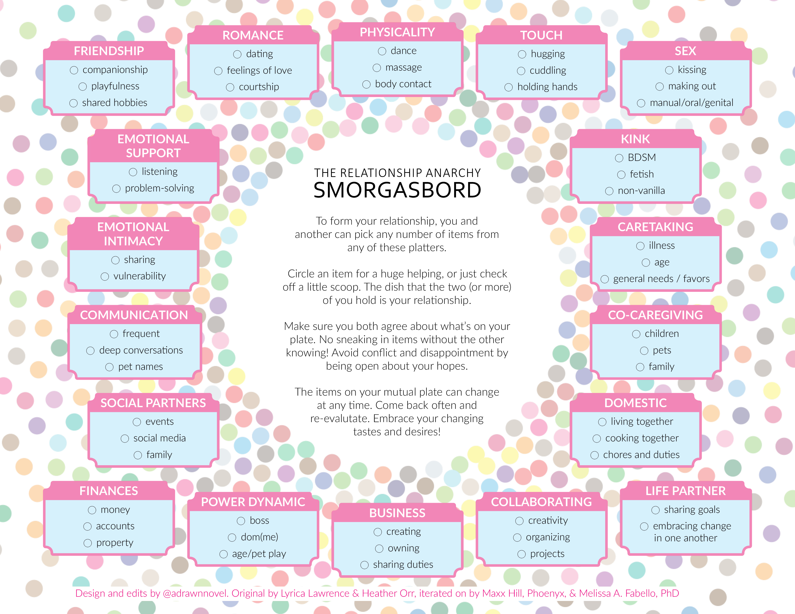 | I made my own version of the Relationship Anarchy Smorgasbord! - r/Polyamory, 2019-12-30
- 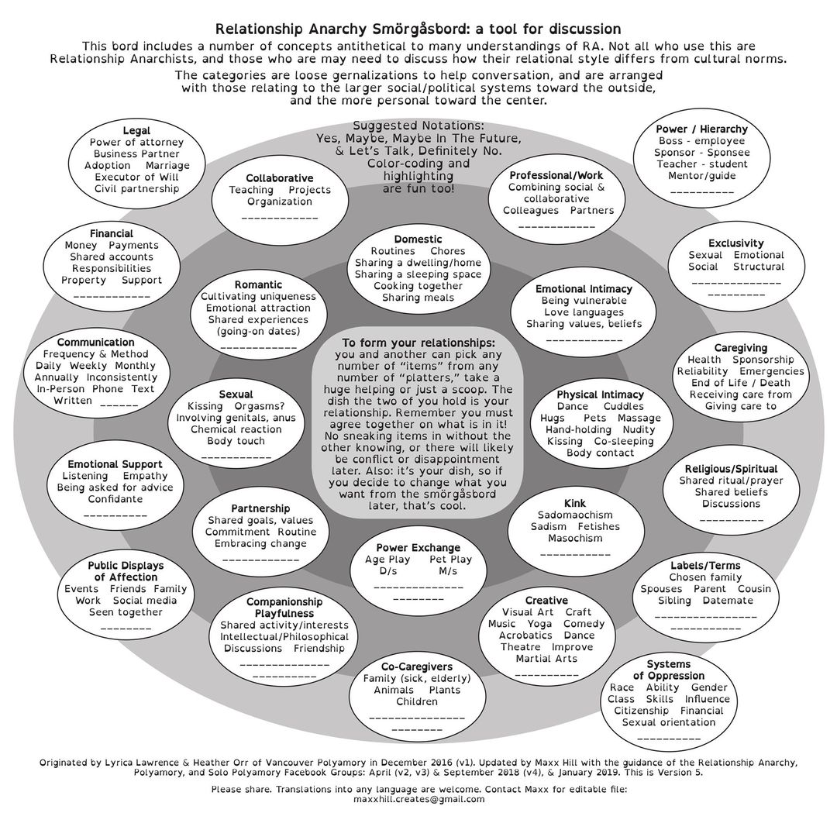 | Relationship Anarchy Smörgåsbord: a tool for discussion (version 5) - Sinclair Sexsmith - Posts | Facebook, 2019-03-29
- 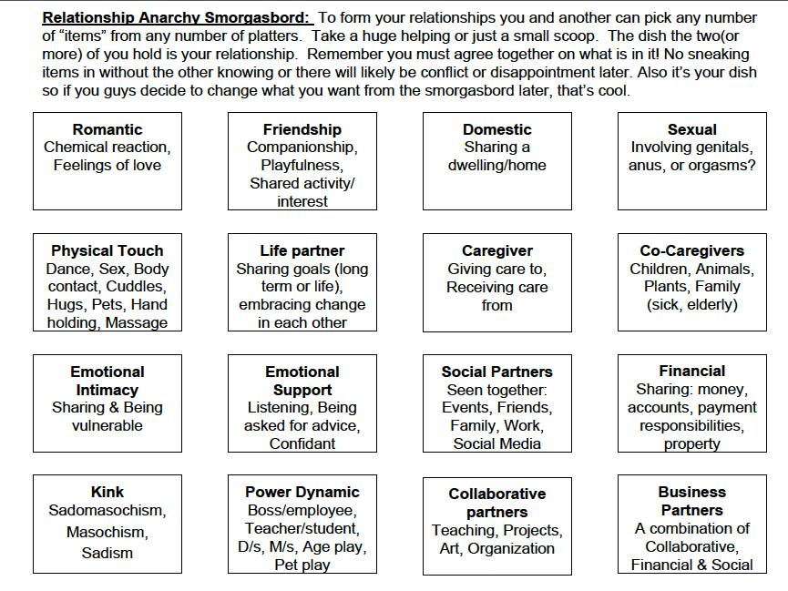 | Relationship Anarchy Smorgasbord! Choose your Adventure! - r/Polyamory, 2016-12-20
- Queer Platonic Relationship Request Form - Queerplatonic and Aromantic Advice, 2014-09-24

Check-ins
- RADAR — Multiamory, 2017-11-28

Essays
- The short instructional manifesto for relationship anarchy | The Anarchist Library, 2006

