Timothy Stewart

ATCA Gas Converter

Contents

Introduction 2

Use of Github 3

Debugging 3

Testing Plan 4

# Introduction

The project was to develop a converter program from existing code. The program would take in a double value and convert it from metric to imperial. The expanded program stores the converted values in an array, and displays the history of values converted in case one needs to check it.\

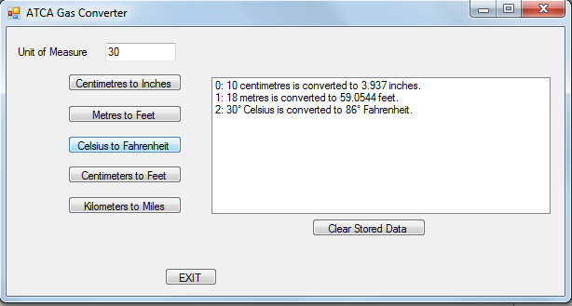  
[Image 1](Documentation%20Screenshots/1.png)

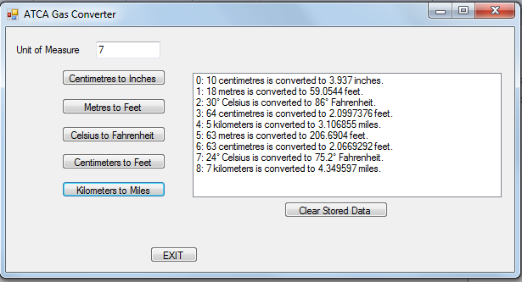  
[Image 2](Documentation%20Screenshots/2.png)

# Use of Github

Github was chosen as the open source tool of choice for many reasons. It allows an easy way to assign different branches of work to merge together and can reveal conflicts when merging that may be missed in manual operations. In addition, it keeps a history of versions which can be helpful when considering new features or when reusing specific pieces of code for other projects. A much less amazing feature is the ability to have your code available practically anywhere, which can be a lifesaver. This has the additional benefit of having your comments directly available, so returning to a project after an absence can be easier.

The Github repository for this project is located [here](https://github.com/TimmarIsPro/Assessment-2---OS-Cluster) and includes the history of commits as well as previous versions of the program.

# Debugging

The main debugging issues that were encountered on the development of this program were copying existing code without checking it thoroughly and attempting to overflow the array storing the data. On writing the Celsius to Fahrenheit converter, it was discovered that applying the calculation to convert (F = C * 9/5 + 32) directly as a constant would create an issue (see: [C_TO_Ferror1](Debugging%20Screenshots/C_TO_F%20error1.png)). By removing this and just using the calculation proper, this was solved (see: [C_TO_Ferror2](Debugging%20Screenshots/C_TO_F%20error2.png)). The other issue encountered was the overflowing of the array. 100 spaces were assigned to this as a start, but on the chance that this number is hit the program ceases function (see: [Overflow_Array error1](Debugging%20Screenshots/Overflow_Array%20error1.png), [Overflow_Array error2](Debugging%20Screenshots/Overflow_Array%20error2.png)). The simple solution to this would be to add more spaces to the array, but given the scope of the requirements, I do not believe that any more then 100 is necessary for current operations.

# Testing Plan

|  |  |  |  |  |  |  |
| --- | --- | --- | --- | --- | --- | --- |
| Test Number | Test Purpose | Test Data Type | Data Input Value | Expected Output | Actual Output | Evidence |
| 1.0 | Test a correct value with the Centimeters to Inches calculation | Double | 14.6 | 5.748031 | 5.74802 | [1.0](Test%20Screenshots/1.0.png) |
| 1.1 | As above, with Meters to Feet | Double | 5.8 | 19.0289 | 19.02864 | [1.1](Test%20Screenshots/1.1.png) |
| 1.2 | As above, with Celsius to Fahrenheit | Double | 22.4 | 72.32 | 72.32 | [1.2](Test%20Screenshots/1.2.png) |
| 1.3 | As above, with Centimeters to Feet | Double | 67.7 | 2.221129 | 2.22112868 | [1.3](Test%20Screenshots/1.3.png) |
| 1.4 | As above, with Kilometers to Miles | double | 3.9 | 2.42335 | 2.4233469 | [1.4](Test%20Screenshots/1.4.png) |
| 2.0 | Convert a negative value with a distance calculation | Double | -15.6 | -51.1811 | -51.18048 | [2.0](Test%20Screenshots/2.0.png) |
| 2.1 | Convert a negative value with a temperature calculation | Double | -12.5 | 9.5 | 9.5 | [2.1](Test%20Screenshots/2.1.png) |
| 3.0 | Test a non-double value | Char | a | Error Message | Error Message | [3.0](Test%20Screenshots/3.0.png) |
|  |  |  |  |  |  |  |