Timothy Stewart

assessment 2

Invoice System

Contents

Project Introduction 2

User Requirements 2

Prototype tool used 2

UI and design 2

Test Table 4

Test Table Cont. 5

# Project Introduction

The project was to develop an invoicing system for an unknown client. The various requirements that the invoice system must abide by are described below.

# User Requirements

The invoice system must record customer details such as Customer Name, Customer Number, Contact Number and Address. It must also record invoice details such as Invoice Number, a description, the payment date and cost. This information must be stored in an array. The system must have the ability to search for entries by customer name and invoice number, and provide the ability to edit these entries. A login screen must be included. The ability to modify the background image of the form is a required feature. The overall design of the system must be simple, sleek and consistent throughout.

# Prototype tool used

The prototype tool used for this project was Visual Studio 2015.

# UI and design

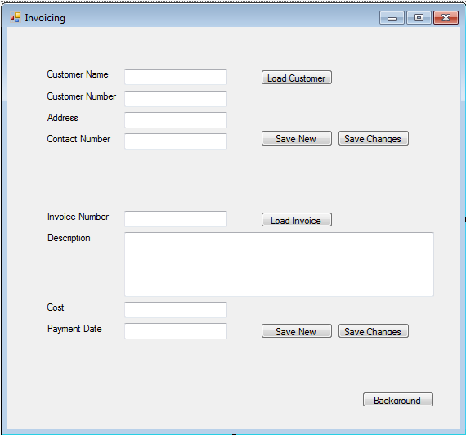The basic design of the invoice system form is as follows.

It strives to use a consistent design throughout, using similar sizes for buttons and input textboxes where necessary. As the textboxes double in displaying information when it is loaded, they are lined up appropriately to ease both input and readability. The load buttons for both customers and invoices are located adjacent to the textbox which is used as the source of searching, enabling a fast ability to load the relevant information. The save and edit buttons are grouped together as they have similar roles. They are located at the end of the cluster of information as it is most convenient when rapidly entering information to have it located after all the information has been entered.  
The background button is located out of the way to keep it from getting in the way of rapid data input.

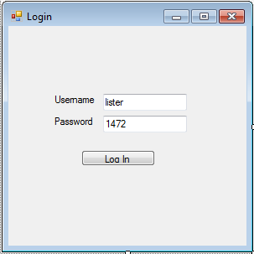The login UI is very simple, yet maintains the consistent button size of the input form. This maintains that the login form is of the same program as the input form. Otherwise it remains simple as no important information needs to be represented on it.

Buttons are reused throughout the system as a primary method of confirming inputs. The consistent use of this element provides a clear idea of what they do. In the event of future expansion of the program, striving to maintain this consistency would give users an understanding of what a button might do without the need to explicitly mention it.

# Test Table

|  |  |  |  |  |
| --- | --- | --- | --- | --- |
| Test ID | Test Description | Test Instructions | Expected Result | Actual result |
| 1.0 | Log into the invoice system with the correct username and password. | Input “lister” as the username and “1472” as the password. | Form with inputs opens. | Form with inputs opens.  [Img1](Documentation%20Screenshots/TT%201.0%201.png)  [Img2](Documentation%20Screenshots/TT%201.0%202.png) |
| 1.1 | Attempt to log into the invoice system with the incorrect password. | Input “lister” as the username and “1477” as the password. | Alertbox with “Incorrect Password” | Alertbox with “Incorrect Password”  [Img](Documentation%20Screenshots/TT%201.1.png) |
| 1.2 | Attempt to log into the invoice system with an incorrect username. | Input “listerr” as the username and “1472” as the password. | Alertbox with “Invalid Username” | Alertbox with “Invalid Username”  [Img](Documentation%20Screenshots/TT%201.2.png) |
| 2.0 | Save a customer. | Input customer details into the relevant boxes. | “Customer successfully saved.” | “Customer successfully saved.”  [Img](Documentation%20Screenshots/TT%202.0.png) |
| 2.1 | Load a customer. | Input a Customer Name that has already been saved, make sure all other textboxes are empty and click Load Customer | “Customer successfully loaded.”, information is loaded into textboxes. | “Customer successfully loaded.”  [Img1](Documentation%20Screenshots/TT%202.1%201.png)  [Img2](Documentation%20Screenshots/TT%202.1%202.png) |
| 2.2 | Edit a customer’s details. | Load the details of a customer that has already been saved, modify an entry and click Edit Customer | “Customer successfully edited.” | “Customer successfully edited.”  [Img1](Documentation%20Screenshots/TT%202.2%201.png)  [Img2](Documentation%20Screenshots/TT%202.2%202.png) |
| 2.3 | Load a customer whose details have been edited. | Edit the details of a customer, empty the textboxes, and then load that customer. | “Customer successfully loaded.”, with the newly edited data. | “Customer successfully loaded.”  [Img1](Documentation%20Screenshots/TT%202.3%201.png)  [Img2](Documentation%20Screenshots/TT%202.3%202.png)  [Img3](Documentation%20Screenshots/TT%202.3%203.png) |

# Test Table Cont.

|  |  |  |  |  |
| --- | --- | --- | --- | --- |
| Test ID | Test Description | Test Instructions | Expected Result | Actual result |
| 3.0 | Save an invoice. | Input or load a customer’s details, then input the details for an invoice and click save new. | “Invoice information saved.” | “Invoice information saved.”  [Img1](Documentation%20Screenshots/TT%203.0%201.png)  [Img2](Documentation%20Screenshots/TT%203.0%202.png) |
| 3.1 | Load an invoice. | Input an invoice number that has previously saved, empty all other textboxes, and then click Load Invoice. | “Invoice information loaded.”, all textboxes are filled with information. | “Invoice information loaded.”  [Img1](Documentation%20Screenshots/TT%203.1%201.png)  [Img2](Documentation%20Screenshots/TT%203.1%202.png)  [Img3](Documentation%20Screenshots/TT%203.1%203.png) |
| 3.2 | Edit an invoice’s details. | Load an invoice that has previously been entered, edit a textbox and then click Edit invoice. | “Invoice information edited.” | “Invoice information edited.”  [Img1](Documentation%20Screenshots/TT%203.2%201.png)  [Img2](Documentation%20Screenshots/TT%203.2%202.png) |
| 3.3 | Load an invoice’s details that have already been edited. | Edit the details of an invoice that has previously been entered and save the edit. Clear all other textboxes, other than the Invoice number, then load the invoice. | “Invoice information loaded.”, all textboxes are filled with the correct information. | “Invoice information loaded.”, all textboxes are filled with the correct information.  [Img1](Documentation%20Screenshots/TT%203.3%201.png)  [Img2](Documentation%20Screenshots/TT%203.3%202.png)  [Img3](Documentation%20Screenshots/TT%203.3%203.png) |
| 4.0 | Change the background of the form. | Click the Background button to change the background of the form. | Background of the form is changed. | Background of the form is changed.  [Img1](Documentation%20Screenshots/TT%204.0%201.png)  [Img2](Documentation%20Screenshots/TT%204.0%202.png) |

Github: <https://github.com/TimmarIsPro/Assignment-2---NET-Cluster>