README

This is a Pokemon Trading Card Battle game. You will take it up to the computer. Each of you will receive five cards in a deck, and a side deck. Every time you pick a Pokemon to battle, a new Pokemon will take it’s place. The player and computer both have a HP-bar. The game starts with 1000 HP points, the goal is to beat your player to 0 before you get there.

The first key was hit on monday 16 sept. 2019 and the last one fell on friday 20 sept. 2019. Our team of five:

- Mehdi Annouri https://github.com/MehdiAnn
- Mouad Soufiani https://github.com/MouadSoufiani
- Robin Mariën https://github.com/RobinMarien
- Tim https://github.com/Timmeahi
- Barend Stroobants https://github.com/BarendStroobants

Our team worked hard for five day’s on 2 pages, the landing page / homepage, and the arena. Mouad put all his knowledge in the homepage. Mehdi and Barend worked on the styling of the arena. Robin and Tim build the javascript. Not bad for 5 student junior web-developers, right!?

What does it look like?

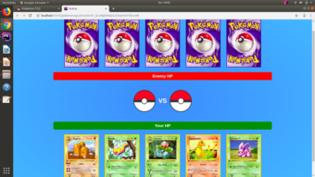

Both players are placed across from each other. In the middle you see 2 Pokemon, both with their own HP-bar, and stats like Atk and Type. At the bottom of the screen you’ll see your HP-bar and your 5 cards. At the top is the computer. It was a fun exercise and we’re past the deadline, but like every web-developer would say; there is no such thing as “finished”.

Enjoy this Pokemon Trading Card Battle game!

