Research Proposal
A Self-Improving Cognitive Digital Twin for Design-for-X Forecasting
Candidate | Tim, Hu TianYu
Programme | PhD, ACE, City University of Hong Kong
Supervisor | Prof. Thomas Ng
Field | AECO — Architecture, Engineering, Construction, Operations

Background
The Architecture, Engineering, Construction, and Operations (AECO) industry get used to the current scattered and piecemeal delivery mode by phases. The flaws are twofold. First, analysis of quality and safety are not integrated across the planning, conceptual design, and development phases. Second, valuable information is lost massively at every node crossing phases. As result, project value is reduced in the form of more defects, safety incidents and even catastrophic rework.
Digital twin (DT) has emerged as a promising paradigm for managing built assets across their lifecycle. However, the current development of DT remains largely limited to state synchronisation by mirroring physical assets digitally and visualizing sensor streams and focusing on operation stage of built asset. None of these systems realized real DT which must be real-time, of autonomy and bi-directional communication between virtual and physical world. Due to these limitations, none has enabled the DT to iterate, reflect on past decisions to predict forward, or claim convergence properties across design, construction, and operational phases.

  - Research gap:
This research addresses a gap that is simultaneously theoretical and practical:
- The absence of a self-improving AECO digital twin that can formally co-evolve a forward predictor for design for safety and design for quality (DfX) with an iterative cross-phase convergence loop, such that improvements in prediction tighten convergence, and convergence iterations generate new training signal that improves prediction. The closest analogues in adjacent fields — expert iteration and self-play in reinforcement learning [2], cognitive digital twin frameworks in manufacturing [3], and closed-loop BIM research [1] — either lack cross-phase scope, formal convergence characterisation, or embedded forward prediction. Their existence confirms the intellectual lineage of this work; their limitations define its contribution.
- This research brings a rare combination of assets to this problem: active full-time employment in the AECO industry providing direct access to real cross-project data (BIM models, incident records, quality defect logs, correspondence, and site photography).
- Traditional machine learning with feature engineering algorithms (XGBoost, CNN) fail because empirical accident reports are highly unstructured, human biased and suffer from data incompleteness. However, this Cognitive Digital Twin is proposed to bypass this limitation by leveraging LLM semantic reasoning to extract root-cause logic such as institutional inspection failures and design-construction decoupling/discontinuity, which effectively turns incomplete reports into high-value DfS design constraints.

Research Aims and Objectives
This research aims to build a self-improving AECO digital twin prototype comprising two tightly coupled intellectual contributions, which will be a novel decision-making paradigm.
  - Forward predictor for DfX (Core 1)
A multi-modal, element-level quality defect and safety predictor trained on real cross-project AECO data, comprising three discipline-specific sub-models (structural, envelope, MEP) consuming IFC graph topology, text extracts from specifications and correspondence, and site photography. A project-phase-level safety incident risk classifier consuming Core 1 outputs as features constitutes a secondary target, demonstrating the framework's extensibility.

  - Self-improving convergence loop (Core 2)
By securing the core 1 first, the research proceeds towards an iterative loop spanning design, construction, and operation phases in which Core 1 serves as the forward operator. The loop stores iteration history, updates design proposals using Core 1 predictions, and terminates under formally stated convergence conditions.
The convergence conditions tentatively target for lowering the safety incident man-hour rate down to the regulation baseline while the performance (cost & time) throughout life cycle is optimal. Defining the convergence conditions are also the expected outcome of this research.

  - Coupling the core 1 and 2 - Merge the forward operator into convergence loop
The self-improving convergence iterations loop of core 2 generate new training signal that further improves the forward predictor of core 1. Improved Core 1 subsequently accelerates the convergence. This is the central theoretical claim of the thesis.

In summary, the specific research objectives are:
- Design and validate Core 1 as a standalone multi-modal element-level defect predictor on real cross-project AECO data, with cross-project leave-one-project-out evaluation and calibrated uncertainty outputs.
- Design and implement Core 2 as a convergence loop with a formally stated update rule, convergence metric, and termination conditions, targeting a Lyapunov-style argument under bounded Core 1 error.
- A prototype to be developed based on outcome of core 1 and 2 to demonstrate the new paradigm of a real time, autonomous and full-life-cycle digital twin agent.

Methodology
  - Data strategy
Available data is rarely uniform. It resides in diverse formats across multiple platforms and creates silos that hinder effective analysis and prediction. Data collection, classification and pre-processing will be completed at the beginning to fine-tune the technical architecture.

Table 1 - Data Availability
Data Modality | Typical Sources  Available / Not available | Processing Technology | Forecasting Role  (Whether, When, How)
Geometric | BIM, CAD Drawings | GNN, Model Derivative API | How: Identifies design flaws and spatial clashes.
Semantic | Regulation, Specifications, Bills of Quantities | NLP (BERT/GPT), RAG, CLIP | Whether: Contextualizes the probability of risk based on materials(gas, asbestos, etc.) and methods (demolition, lifting, etc.) .
Visual | Photos, Video, UAVs | YOLOv8, Vision Transformers (ViT), EfficientNet | Whether/How: Detects real-time deviations from design for safety principle.
Temporal | 4D Schedules, Progress Reports | LSTM, VMD, Monte Carlo | When: Identifies high-risk phases and peak activity windows.  The system treats activity durations and resource availability as probabilistic variables, runs thousands of iterations to determine the probability of a safety event occurring at various points in the schedule, generate “safety risk heat map” for probability, time and location.
Environmental | Sensor Data, Weather APIs | IoT Integration, Time-series | When: Predicts weather-related hazards (e.g., rain and wind exaggerate lifting/fall hazard).
Relational | Site Letters, RFIs, Email, quality and safety incident reports | GraphRAG, Neo4j | Whether/How: Identifies cascading risks, system, institutional and management failures.

  - Technical Stacks
- Core 1 will be implemented as three graph neural network sub-models over IFC element topology (PyTorch Geometric), one per discipline family (structural, envelope, MEP), with cross-modal attention incorporating text embeddings from specifications and CLIP-derived embeddings from site photographs. Calibration will be enforced via conformal prediction (MAPIE library), enabling coverage-guaranteed uncertainty outputs that Core 2 consumes as confidence weights.
- Core 2 will be implemented as a Python loop calling the Core 1 Vertex AI Endpoint service, maintaining iteration history in BigQuery, and applying an update rule that perturbs design parameters in the direction of reduced predicted defect density. Convergence will be declared when the Chebyshev distance between successive parameter vectors falls below a calibration-derived threshold for three consecutive iterations. The Lyapunov-style argument constructs a candidate function L(state) equal to the expected future defect density under the current design; the update rule is designed to enforce L(t+1) less than or equal to L(t) given bounded Core 1 error, establishing expected monotone decrease.
- Software and Hardware:
The entire stack will run on Google Cloud Platform using Vertex AI Custom Training (A2 instances with A100 GPUs), Cloud Storage for the raw and feature stores, Cloud SQL for PostgreSQL as the project registry, and Vertex AI Endpoints for Core 1 model serving.
- Bayesian Networks and Causal Reasoning
Bayesian Networks (BNs) are probabilistic models that represent the interrelationships between safety factors and performance outcomes. A BN is constructed by identifying causal factors such as "Complex Facade Geometry," "Inadequate Edge Protection," and "High Wind Speed" and modeling their conditional dependencies.

Using Bayesian inference, the system can quantify the probability of an accident (e.g., a fall from height) given specific design parameters. Output of Tornado Sensitivity Analysis Diagrams allows practitioners to identify the "root causes" of predicted risks. If the model predicts a high probability of a fall, the BN can trace this risk back to a specific design element, such as an unconventional or ample nos. floor opening that complicates the installation of guardrails.

Available Algorithm / Framework | Mathematical Basis | Application in Design-for-Safety
Graph Neural Networks (GNN) | Agg({hj​,j∈N(i)}) | Capturing spatial and functional dependencies in BIM objects.
Bayesian Networks (BN) | $P(A | $$B) = ⍁\{P(B$$
Monte Carlo Simulation | $$\int{f\left(x\right)P\left(x\right)dx}≈\frac{1}{N}\sum{f\left(x_{i}\right)}$$ | Modeling schedule uncertainty and spatial movement risk.
Contrastive Alignment | $$L=-\log{}\frac{\exp\left(\text{sim}\left(z_{i},z_{j}\right)/τ\right)}{\sum{\exp\left(\text{sim}\left(z_{i},z_{k}\right)/τ\right)}}$$ | Fusing site photos with BIM semantic data. To predict and tag the risk attributes.
LSTM / GRU | Recurrent State Gates | Forecasting temporal accident trends and recovery periods.
YOLOv8-ADSC | Spatial Feature Fusion (ASFF) | Real-time detection of PPE and hazards in complex site video.
Contrastive Language-Image Pre-training (CLIP) by OpenAI | Given a batch of N (image, text) pairs, the model is trained to predict which of the NxN possible pairings across the batch actually occurred.[1] | Train a contrastive model on pairs of [Site Inspection Photos] and [BIM Property Strings / RFI Log Text].  Zero-shot capability for site monitoring
Remarks – tentative approaches only, to be selected based on the data

  - System Architecture
The digital twin system will be built by adopting classic 5-layer architecture (Figure 1).

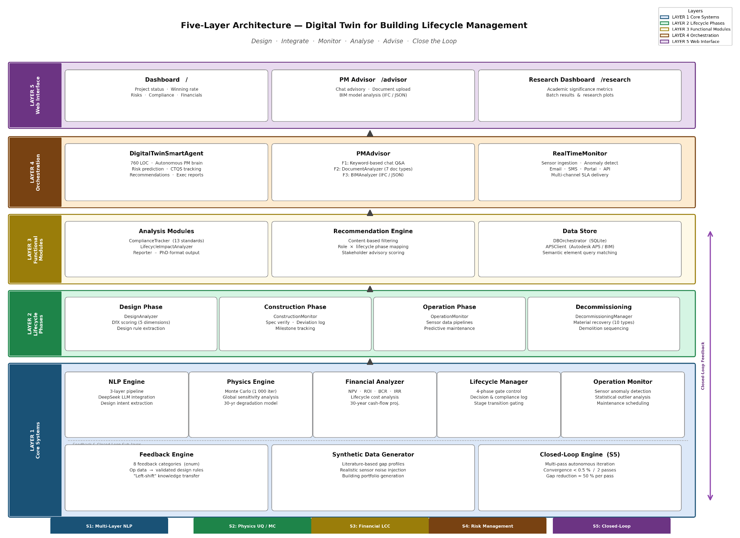
Fig. 1 System Architecture for Cognitive Digital Twin

  - Validation and evaluation
Core 1 forward predictor for DfX will be evaluated using project-level leave-one-project-out cross-validation.
Core 2 self-improving convergence will be evaluated against two baselines - A gradient-free Bayesian optimiser (such as Optuna TPE sampler) applied to the same parametric design space, and the best published cognitive-DT proposal that can be instantiated on the same case study. Metrics for performance evaluation for the convergence are iteration count toward the convergence, quality of the converged solution (Pareto frontier position in defect-density/cost space), and elapsed time. Co-improvement will be measured as the correlation between iteration index and as the reduction in iterations-to-convergence between early and late model checkpoints.

Proposed validation case study:
Given a series of input i (BIM element such as a wall, beam, or MEP fitting) and design phase features (parameters, geometry, adjacency relations, logic link, code references), predict whether (binary classification) input i will lead to incident and defects during construction and if positive, the expected number of defects and incidents (regression) .

Significance and Novelty
- Existing cognitive digital twin frameworks [2] propose self-improvement conceptually but do not formalise convergence.
- Existing digital twin proposed 5-layersystem architecture [3] and demonstrated with case study but focus on operation only and lack feedback loop backward to design and construction phases, i.e., no life cycle analysis.
- Existing closed-loop BIM research [4] feeds operational data back episodically without iteration and is only conceptual.
- Existing expert-iteration and self-play methods [5] being fed by no domain knowledge establish convergence theory in games of chess in single-phase design but have not been instantiated for cross-phase AECO with embedded forward prediction.
This research aims to build the real system architecture in section 3.3 and occupies the intersection of these three bodies of work: formal cross-phase convergence instantiated in AECO with an embedded multi-modal predictor.

Expected Contributions in stage 1 (year 1 -2)
Upon successful completion of the project in year 1-2, this research will deliver:
- A formalised self-improving AECO digital twin architecture with proven convergence conditions, which will be the first such system in the AECO literature to characterise cross-phase convergence mathematically.
- A trained, calibrated, multi-modal element-level quality defect and safety predictor validated on real cross-project data.
- An open-source cross-phases digital twin prototype has potential for industry level application.
- The thesis integrates all the theoretical, algorithmic, system-level, empirical, and prototype demonstration into a single coherent argument.

Potential future works in stage 2 (year 3 – 4)
  - Dynamic Success Prediction via FRS-Calibrated Agent-Based Modeling.
In Stage 2, the Cognitive Digital Twin (CDT) framework will transition from diagnostic risk scoring to predictive "Goal Navigation." A spatiotemporal Agent-Based Model (ABM) will be constructed to simulate autonomous worker behaviors and site dynamics. Crucially, instead of using rigid heuristics, the ABM’s parameter thresholds will be dynamically calibrated using the machine learning risk surfaces learned in preceding Stage 1. Operating as a "Front Running Simulation" (FRS) adopted by NASA [6], this engine will execute thousands of forward-looking Monte Carlo scenarios. The live forecasting will output real-time safety incident probability distributions and dynamic hazard heatmaps. This will enable planners to conduct proactive "what-if" scenario analyses thereby bridging construction realities directly back to design-stage optimization, i.e., achieving design-for-safety in a continuous information flow system.

  - Multimodal (Tacit-to-Explicit) Knowledge Fusion for Cognitive Safety Reasoning
Concurrently, the research will pioneer an AI-native reasoning paradigm by fine-tuning a multimodal Foundation Model on the curated domain-specific AECO corpus established in Stage 1. Moving beyond simple tabular classification, this engine will utilize Chain-of-Thought (CoT) prompting to process heterogeneous project inputs simultaneously (e.g., IFC geometry, site photos, and contractual emails). It will translate unstructured text, such as historical incident reports, into actionable "Shift-Left" design constraints, outputting natural language risk explanations alongside prescriptive design alternatives.

References
[1] Alec Radford, “Learning transferable visual models from natural language supervision,” in Proceedings of Machine Learning Research, OpenAI. [Online]. Available: https://proceedings.mlr.press/v139/radford21a/radford21a.pdf
[2] Y. Zheng, S. Yang, and H. Cheng, “An application framework of digital twin and its case study,” J. Ambient Intell. Humaniz. Comput., vol. 10, no. 3, pp. 1141–1153, Mar. 2019, doi: 10.1007/s12652-018-0911-3.
[3] Q. Lu et al., “Developing a Digital Twin at Building and City Levels: Case Study of West Cambridge Campus,” J. Manag. Eng., vol. 36, no. 3, p. 05020004, May 2020, doi: 10.1061/(ASCE)ME.1943-5479.0000763.
[4] E. A. Pärn, D. J. Edwards, and M. C. P. Sing, “The building information modelling trajectory in facilities management: A review,” Autom. Constr., vol. 75, pp. 45–55, Mar. 2017, doi: 10.1016/j.autcon.2016.12.003.
[5] D. Silver et al., “Mastering chess and shogi by self-play with a general reinforcement learning algorithm,” Dec. 05, 2017, arXiv: arXiv:1712.01815. doi: https://doi.org/10.48550/arXiv.1712.01815.
[6] M. Grieves and J. Vickers, “Digital Twin: Mitigating Unpredictable, Undesirable Emergent Behavior in Complex Systems,” pp. 85–113, 2017, doi: 10.1007/978-3-319-38756-7_4.

