4x4 DRAM Design with Refresh
Timmy Phan
UHID: 1677104
ECE 6346 VLSI Design
11/25/2025

Introduction
This project implements a 4x4 DRAM in LTspice. The DRAM consists of a CPU that controls what cells to access, bit line discharge and precharge, word line selection through a row decoder, sense amplifiers, row buffers, column decoders, and a writeback that writes the row buffer values back into the cell. A refresh mechanism was also added to refresh the contents of the cells row by row after every 5 read/write operations since DRAM memory is volatile and is lost over time.

DRAM Architecture Overview
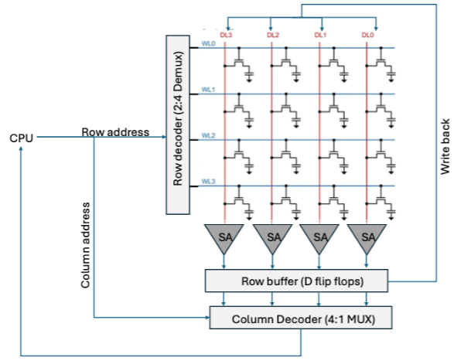
Figure 1 4x4 DRAM schematic (11/25/2025 1:31 PM)
Figure 1 shows the schematic used for the 4x4 DRAM. It consists of, as stated earlier, a CPU, a 4x4 DRAM array, discharge and precharge conditioning, a row decoder, sense amplifiers, row buffers, a column decoder, and a writeback.

CPU
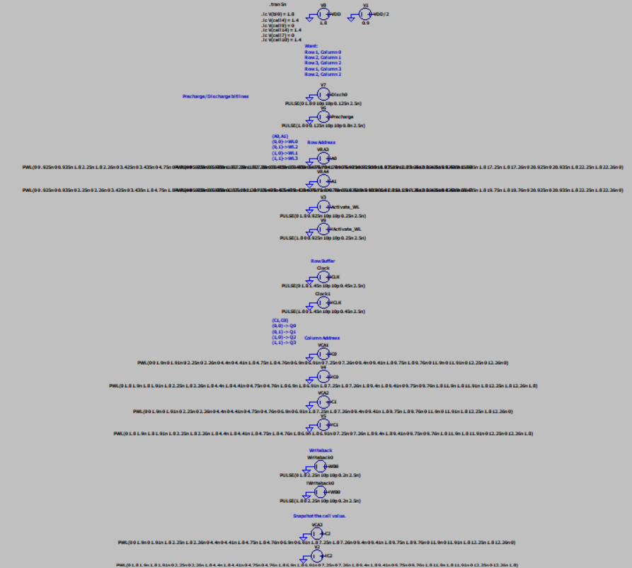
Figure 2 CPU is used to control the steps performed. Piece wise linear voltage sources were used to control the row addresses and column addresses. (11/25/2025 8:20 PM)
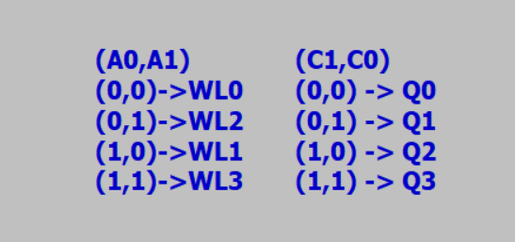
Figure 3 Row and column addresses based on their inputs in the CPU. (11/25/2025 1:46 PM)
Figure 2 shows the CPU where voltage sources were used to perform the steps of reading a DRAM. Pulses were output for the discharge, precharge, row buffer clock, and writeback. The row addresses and column addresses were controlled by piecewise linear voltage sources to control what rows and columns the CPU wants to access. Figure 3 shows which input combinations result in what row and column are selected.

4x4 DRAM Array
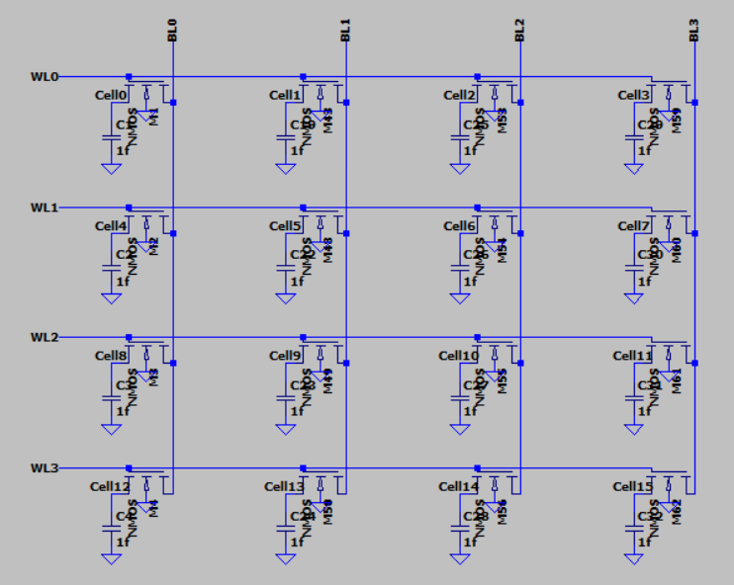
Figure 4 4x4 DRAM array. Each cell NMOS is sized at a width of 440nm. (11/25/2025 1:08 PM)
Figure 4 shows the DRAM array with its connecting word lines and bit lines. The cells hold a value until a read or write operation is declared. Each cell contains an NMOS transistor and a capacitor. The cells connect to its bit line only when its word line is on. The cell NMOS are sized to a width of 440nm and the capacitors are 1fF.

Precharge/Discharge
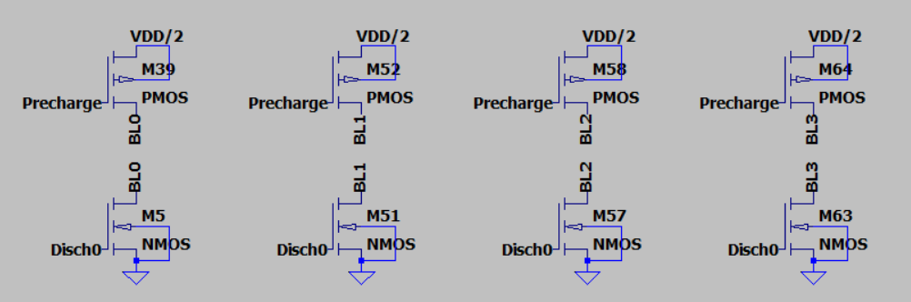
Figure 5 Precharge and discharge conditioning circuit for the DRAM. The precharge charges the bit lines to V_{DD}/2 which is 0.9V. (11/25/2025 1:09 PM)
Figure 5 shows the pre-charge and discharge conditioning. At the beginning of every read and write operation, the bit lines are discharged to get rid of residual charges and then pre-charged to V_{DD}/2. The discharge uses an NMOS since NMOS are good at discharging and the pre-charge uses a PMOS since PMOS are good at charging. Both are sized with a width of 440nm.

Row Decoder
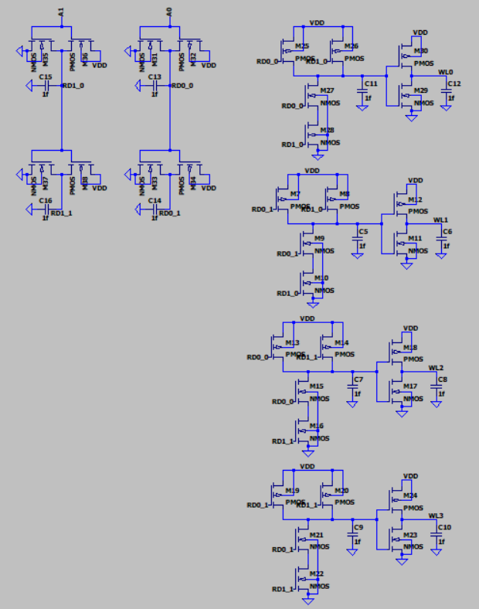
Figure 6 Row decoder using a 2:4 DEMUX. (11/25/2025 1:07 PM)
Figure 6 shows the row decoder DEMUX used. It uses NOT and NAND gates with 2:1 sizing. The row decoder takes a row address from the CPU in the form of A0 and A1 and then turns on the corresponding word line.

Sense Amplifier
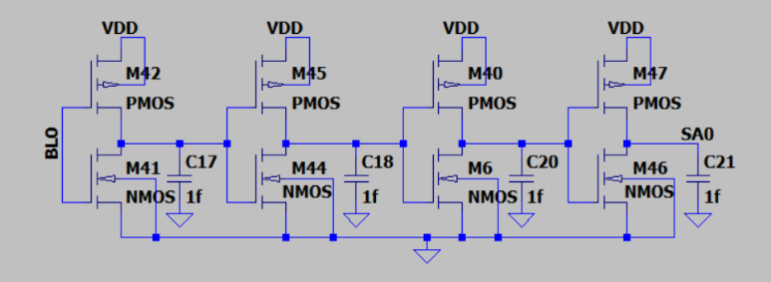
Figure 7 Sense amplifier circuit using 4 back-to-back not gates with 2:1 sizing. (11/25/2025 1:10 PM)
Figure 7 shows the sense amplifier used for the DRAM. The sense amplifier is made of 4 back-to-back not gates. Because charge sharing only transfers a small amount of voltage, the sense amplifier’s job is to amplify this small swing in voltage. It takes the bit line and either outputs a 1 or 0 based on the value of the bit line. This is used to find small voltage swings through charge sharing from the pre-charged V_{DD}/2.

Row Buffer
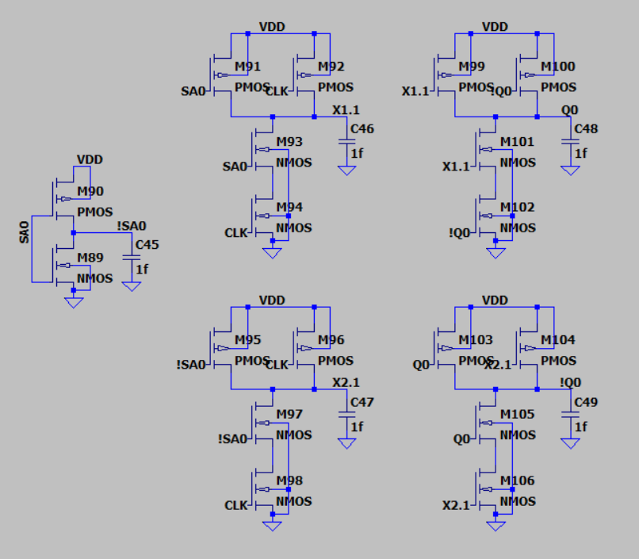
Figure 8 Row buffer using a D-flip flop. It is sized 2:1. (11/25/2025 1:11 PM)
Figure 8 shows the row buffer used. The row buffer is made using a D-flip flop and its purpose of to store the value of the sense amplifier for later use in both the column decoder and the writeback. It is controlled by timed pulses from the clock voltage source.

Column Decoder
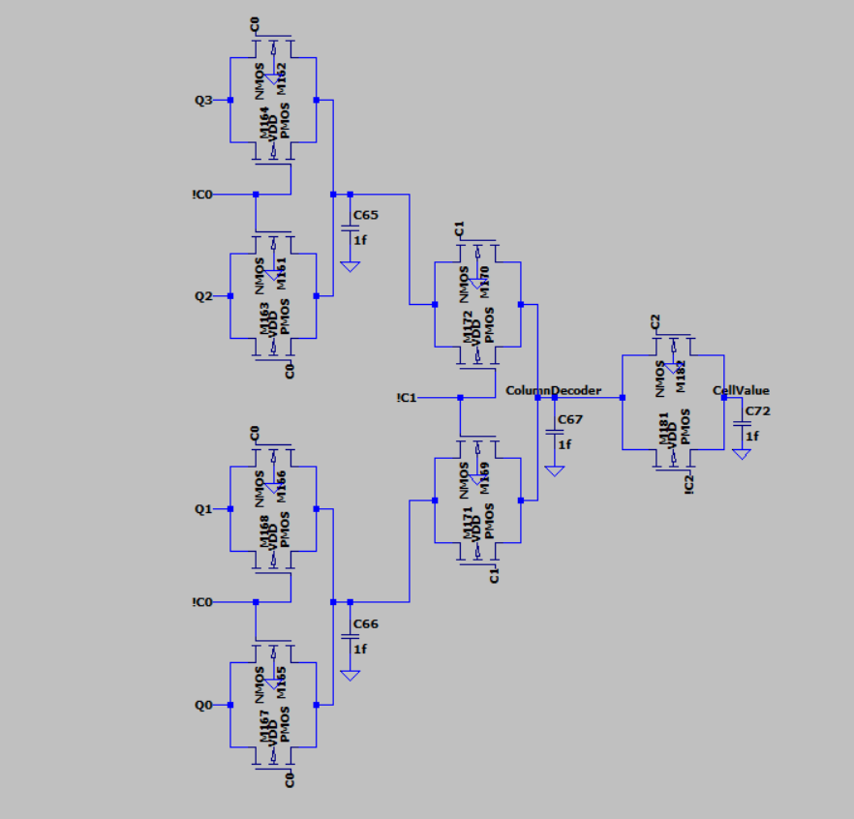
Figure 9 Column decoder using a 4:1 MUX. A transmission gate that snapshots the value to be sent to the CPU is added at the end. (11/25/2025 1:11 PM)
Figure 9 shows the column decoder MUX used. It uses transmission gates and takes column addresses from the CPU in the form of C0 and C1. The column decoder then selects one of the four row buffer outputs based on C0 and C1. A transmission gate was added near the end to gate the value to be sent to the CPU.

Writeback
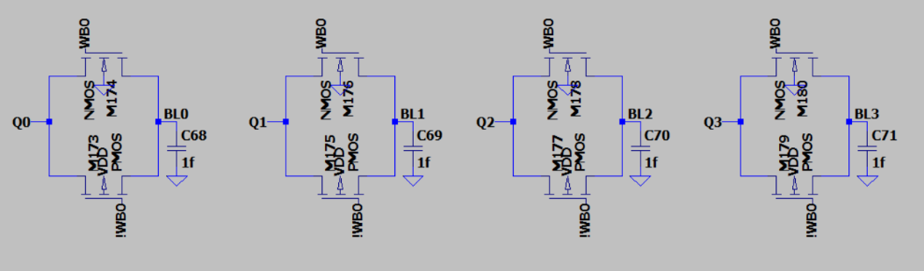
Figure 10 Writeback circuit transmission gate. (11/25/2025 1:10 PM)
Figure 10 shows the writeback circuit used to write the value stored in the row buffers back into the cells. It uses transmission gates which act like switches controlled by a writeback voltage source.

Read Operation Analysis
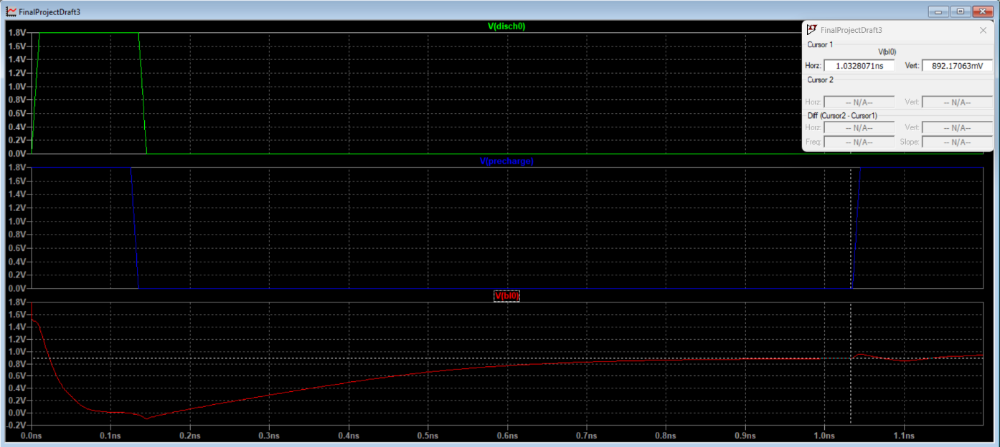
Figure 11 The bit lines are first discharged then pre-charged to V_{DD}/2. (11/26/2025 12:04 PM)
The following analysis of the read operation was done using row 1, column 0 (e.g. cell 4) which has an initial value of 1. The first part of reading a DRAM cell involves discharging and then pre-charging the bit lines to V_{DD}/2. This is done so that the sense amplifiers can pick up voltage swings slightly above or below V_{DD}/2 which is caused by charge sharing with the cell. The discharge takes around 0.125ns to reach 0V and the pre-charge takes around 0.9ns to reach V_{DD}/2.
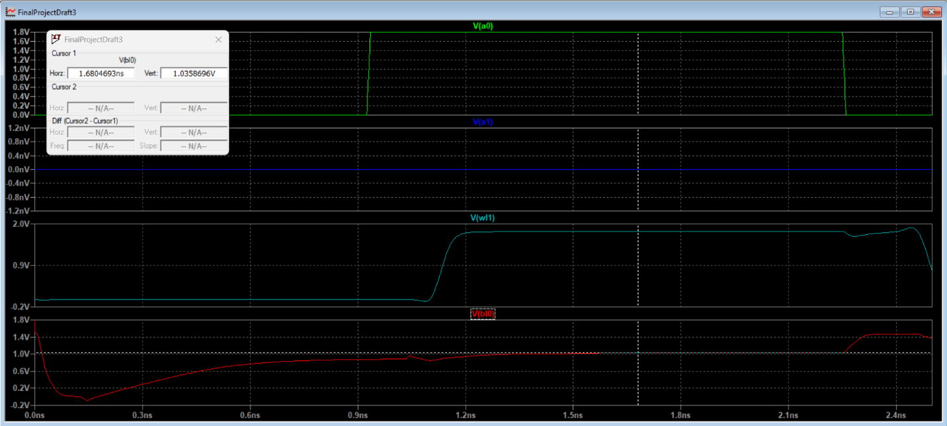
Figure 12 The row decoder takes the row addresses and turns on the corresponding word lines. (11/26/2025 12:17 PM)
After the bit lines are pre-charged, the row addresses provided by the voltage sources turn on the corresponding word lines. The instance shown in Figure 12 has word line 1 turned on. It takes around 0.325ns for the word line to activate from the time the row addresses are applied to the row decoder to when the word line reaches 1.8V. The bit line charges to around 1.036V which is expected since some of the charge from the cell, which was set at 1, is shared with the bit line. The resulting bit line is then fed into a sense amplifier which senses small voltage swings. In this case, the sense amplifier, as shown in Figure 13, outputs 1.8V which is expected since the cell has a value of 1 and takes around 0.35ns to do so. The sense amplifier outputs are then fed and stored into the D-flip flop row buffers. From the rising edge of the row buffer clock, it takes around 0.45ns for the stored value, Q, to reach 1.8V.

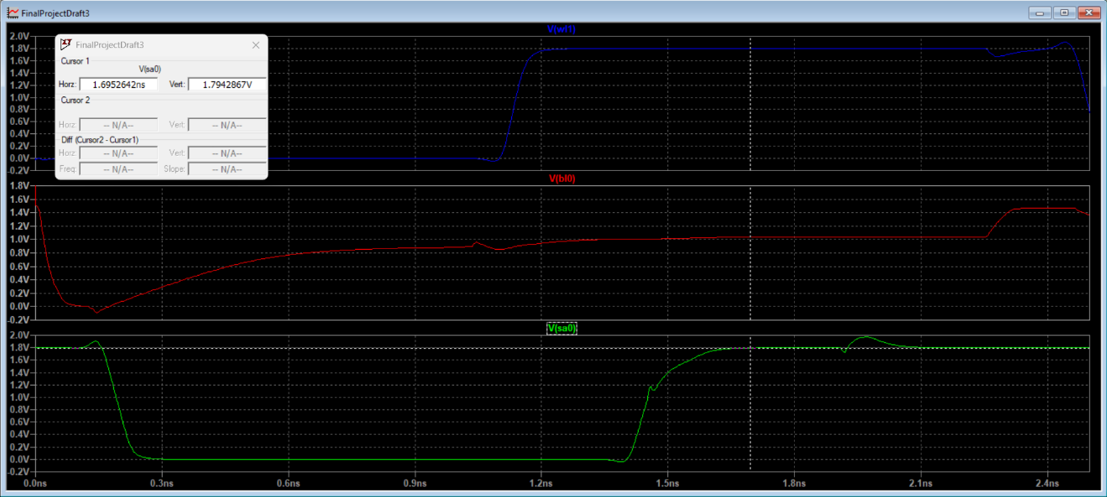
Figure 13 Sense amplifier timing plot. (11/26/2025 12:31 PM)
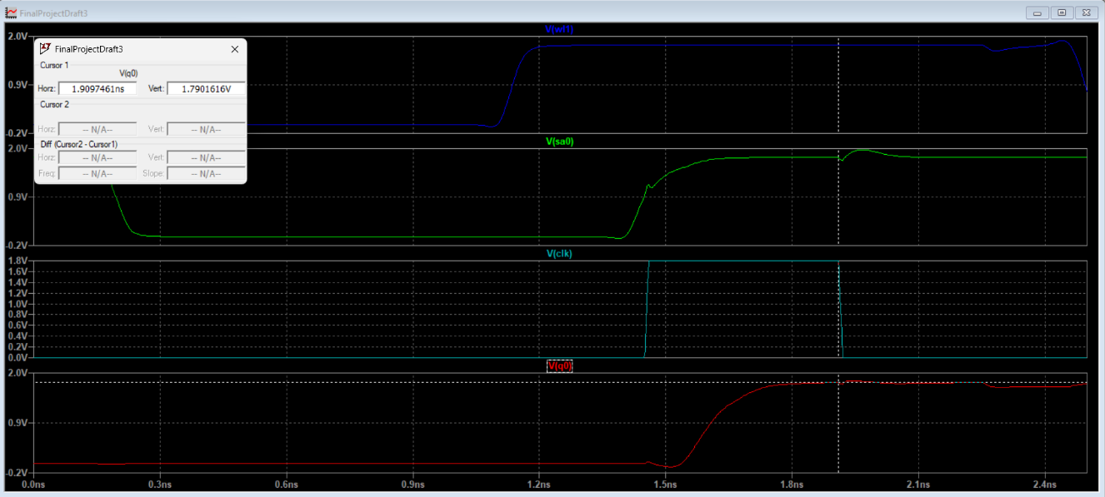
Figure 14 Timing plot for the row buffer which takes in the sense amplifier output and outputs the value Q. (11/26/2025 12:42 PM)
The last step for the read operation is the column decoder. The column decoder takes the column addresses, which are in this case both 0, and returns the corresponding value of the selected column. As shown in Figure 15, it takes around 0.35ns to output the row buffer value to the CPU. Although not shown in the figure due to both values being 0, C0 and C1 have the same timings as C2.
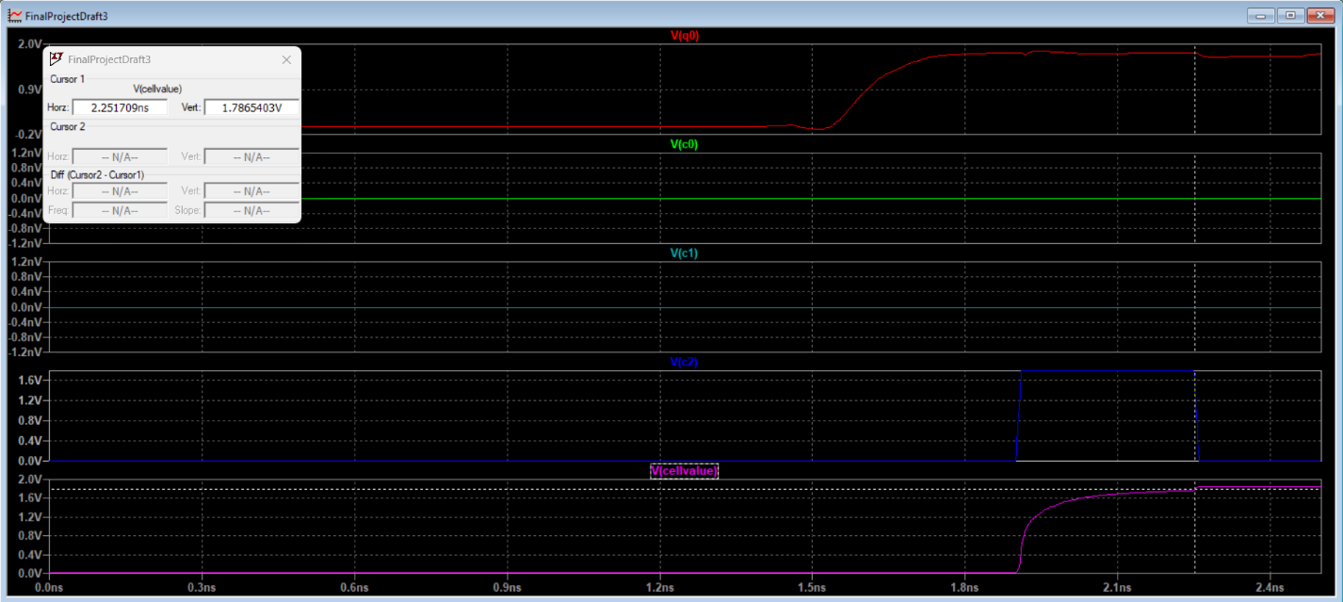
Figure 15 Column decoder timing plot with the column addresses C0 and C1 along with the CPU output enable and the cell value (11/26/2025 12:52 PM)
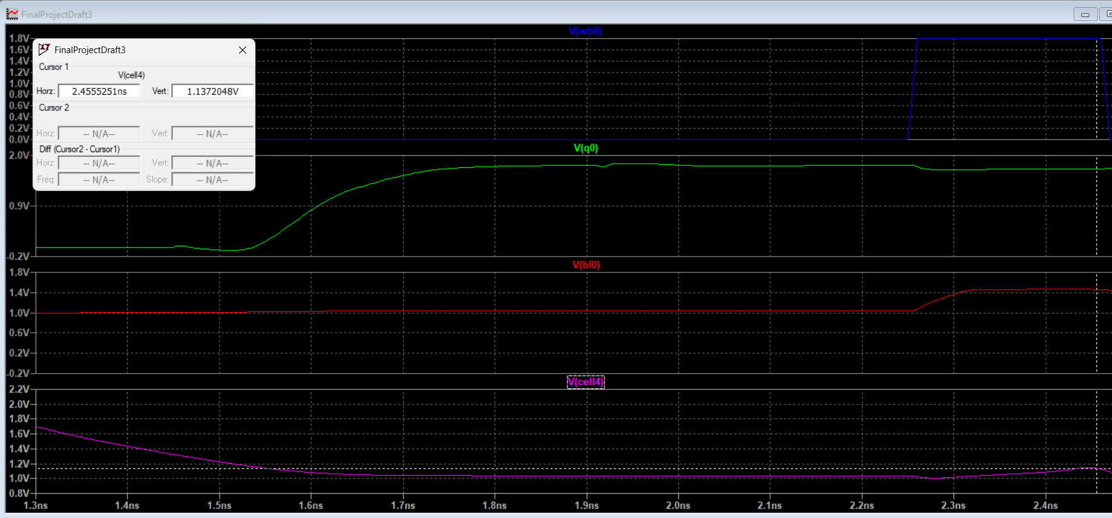
Figure 16 Writeback for cell 4. (11/26/2025 1:14 PM)
Lastly, after the read operation is done, a writeback is initiated since DRAM is destructive and corrupts the cell data after reading from it. Oddly enough, the cell only charges to around 1.137V unlike the expected voltage of V_{DD} - V_{t} which is around 1.4V. A possible explanation for this lower value could be charge sharing between the cell capacitor and the bit line capacitor which will cause the cell voltage to drop below what is expected. The writeback was given around 0.2ns as values higher didn’t yield much of a difference as the voltage levels out after 0.2ns.
Table 1 Timings for each step
Operation | Time [ns]
Discharge | 0.125
Pre-charge | 0.9
Row Decoder | 0.325
Sense Amplifier | 0.35
Row Buffer | 0.45
Column Decoder | 0.35
Writeback | 0.2

Overall, a full read operation takes about 2.25ns with a 0.2ns writeback.

Refresh
Since DRAM memory is volatile and is lost over time, a refresh is needed to preserve the data. After every read/write operation, all rows are refreshed one by one by outputting the cell value to the row buffer and then reading it back into the same row. Figure 17 shows the timings of the 5 read/write operations and the 4 row refreshes after them happening one by one. The refresh begins after 12.5ns.
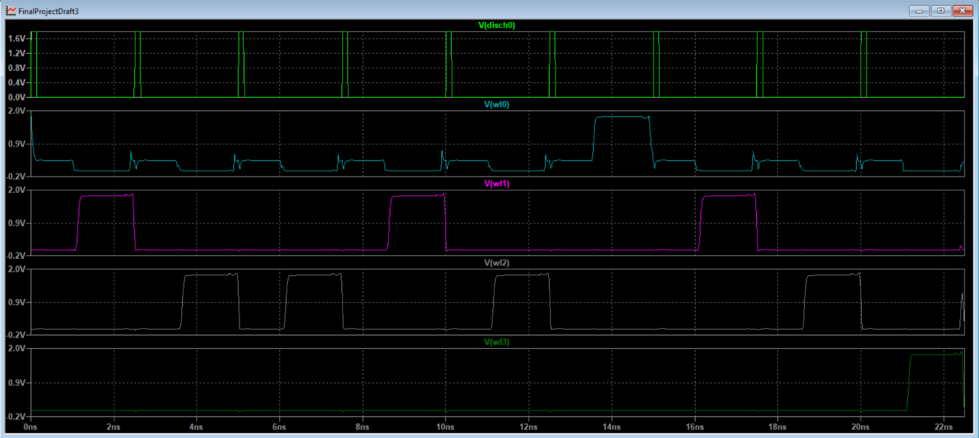
Figure 17 5 read/write operations and a full DRAM refresh. (11/26/2025 1:52 PM)
Like the writeback from the earlier read operation, Figure 18 shows that the refresh only charges the voltage to around 1.16V meaning that something is wrong with the refresh. Like with the writeback, a possible explanation could be charge sharing with the cell capacitor and the bit line capacitor causing it to stabilize below the expected value.
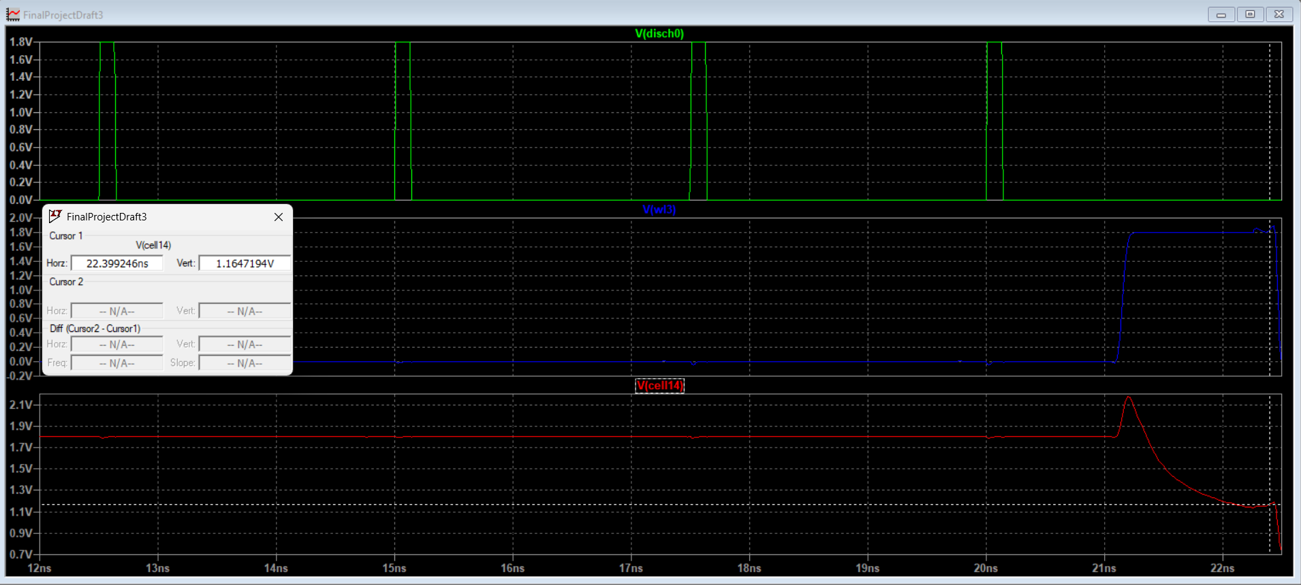
Figure 18 Refresh for row 3 along with cell 14 which has an initial value of 1. (11/26/2025 2:11 PM)

Conclusion
This project implements a 4x4 DRAM array read by discharging and pre-charging the bit lines, decoding the row addresses using a 2:4 DEMUX row decoder, storing the values of the row into a row buffer using sense amplifiers and D-flipflops, finding the desired cell using a column decoder along with the column addresses and a 4:1 MUX, a writeback that writes the cell value from the row buffer back into the cell, and a full refresh that triggers after 5 read/write instructions. The time taken for a read operation was about 2.25ns and the writeback was around 0.2ns. Each row was refreshed in about 2.45ns. Overall, the DRAM demonstrates the correct behavior, but the writeback voltage is lower than expected which could be a result of charge sharing. Further improvements would be to improve the read operation speed and to fix the lower voltage from the writeback.

