中文版(**English version on page 3**)：

1. 選取課程

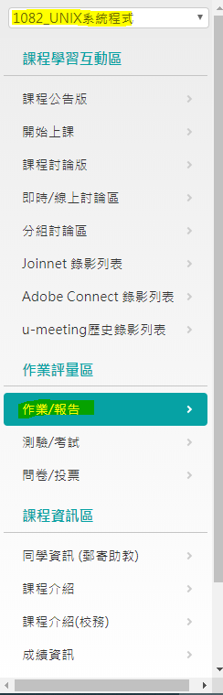

2. 選擇要交的作業，選擇進行繳交作業

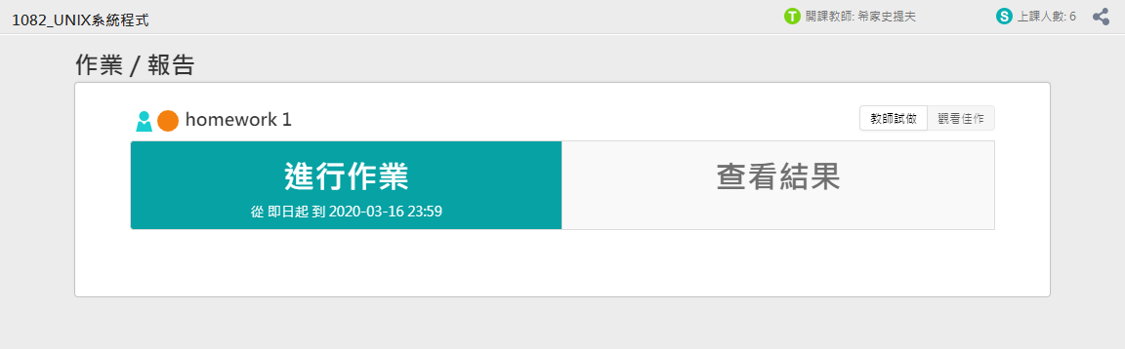

3. 點選開始作答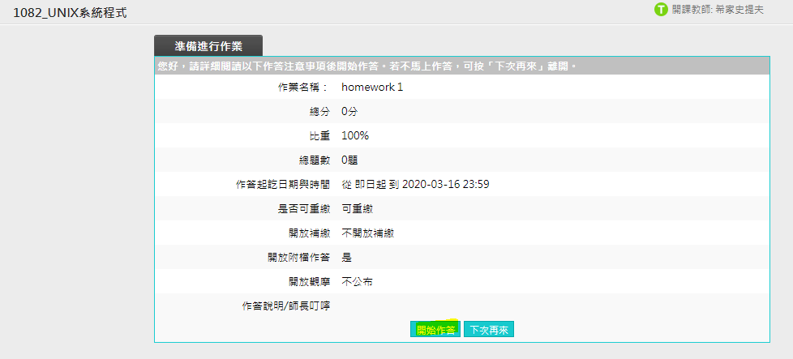

4. 點選選擇檔案，完成上傳後按確定提交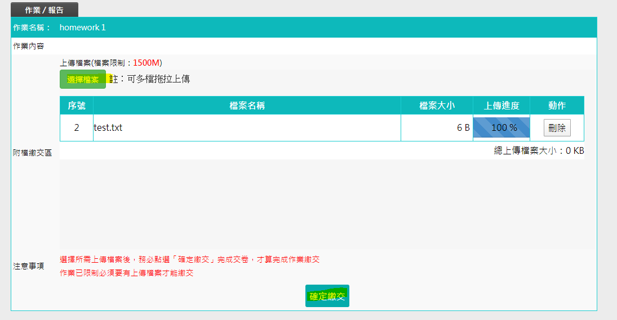

English version:

1. select course and click assignments

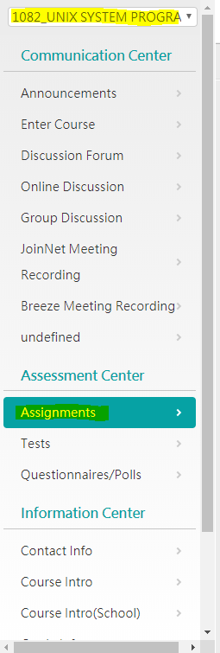

2. click “Do assignment”

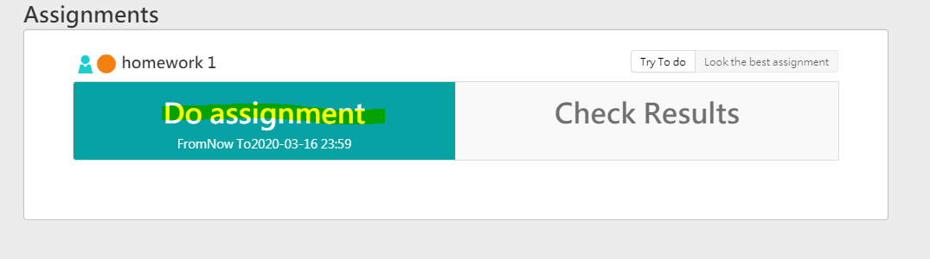

3. click “start”

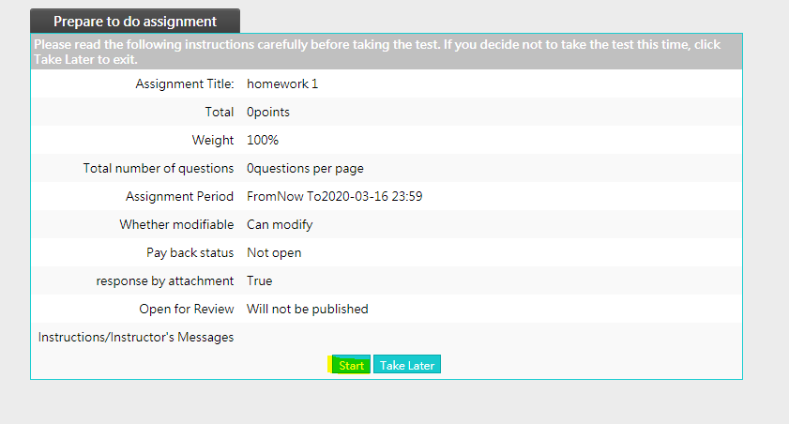

4. click “select file(s)” and select files to upload, then click submit.

