COVID-19 Deaths Data Analysis Report

Overview
This report presents a comprehensive analysis of global COVID-19 deaths data, focusing on case and death trends in conjunction with population demographics and country-level indicators. The dataset originally consisted of over 60 columns capturing a wide range of COVID-related metrics, including hospitalizations, testing rates, vaccination levels, and policy stringency indices.
However, after a data completeness assessment, it was found that many fields had over 70% missing data — particularly in variables related to vaccination, hospitalization, excess mortality, and government response indices. These fields were removed in favor of a cleaner, more consistent dataset that enables reliable analysis.
The attached Power BI report provides interactive visualizations that align with the cleaned dataset and help answer a set of targeted research questions.
Note: Dataset was downloaded on 21 July,2025.

Data Reduction Summary
Note: Dataset was Downloaded as at July 21, 2025.
The original dataset was quite sparse. Fields like total_boosters, hospital_beds_per_thousand, new_tests_smoothed, weekly_icu_admissions, stringency_index, and many testing or booster-related columns were removed after profiling revealed over 70% null values across countries.
The cleaned dataset now retains 21 fields:
- Epidemiological Metrics: Total cases, new cases, smoothed cases, total deaths, new deaths, smoothed deaths, and their per-million counterparts.
- Geographic Indicators: Country, continent, ISO code.
- Demographic Factors: Population, population density, median age, GDP per capita, and diabetes prevalence.
- Date Dimension: To support trend analysis over time.

Star Schema Data Model
The dataset was structured into a star schema, consisting of one central fact table and three dimension tables:
- Fact Table (Fact_CovidCases): This includes all measurable data such as case counts, death counts, and per-million indicators. Each record represents a daily observation for a specific country.
- Date Dimension (Dim_Date): Breaks down the date into day, month, and year components for use in time-series analysis.
- Country Dimension (Dim_Country): Contains descriptive attributes such as country, code, and continent, enabling geographic breakdowns.
- Demographic Dimension (Dim_Demographics): Houses country-level demographic and socioeconomic indicators such as population, population_density, median_age, gdp_per_capita, and diabetes_prevalence.
This schema supports flexible filtering, grouping, and aggregation in Power BI without data duplication.
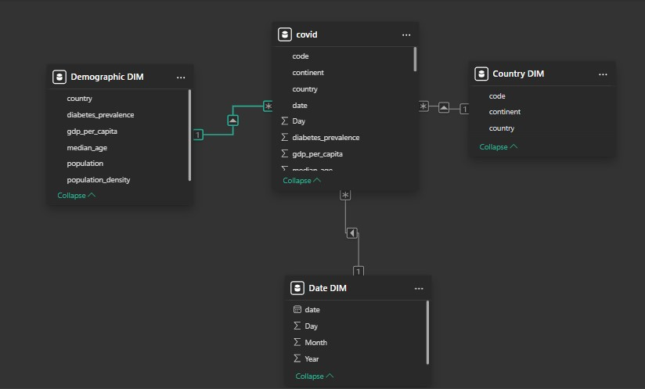

Research Questions from the Power BI Report

1. What is the total number of COVID-19 cases per country? – (TOP 5)
The report ranks countries by total confirmed cases, revealing that populous countries like the United States, India, and Brazil reported the highest absolute case numbers.

2. How many new cases are recorded in each country? – (TOP 5)
The chart shows number of cases on new daily case counts shows the top 5 countries experiencing recent surges in infection.

3. What is the death rate (case fatality rate) for each country? – (TOP 10)
The case fatality rate reveals differences across countries.

4. How does the number of cases per million vary across continents?
Data shows distribution of cases-per-million across the various continents listed/provided in the dataset.

5. What is the trend of new cases over time globally?
Trends show distinct waves corresponding to the month and year of the various entries.

6. What is the death rate over time for the Top 5 countries?
Fatality trends in various countries (in this case top 5) over time.

7. Countries with the highest number of deaths per million – (TOP 10)
When adjusted for population, smaller nations experienced higher losses due to vulnerable demographics.

8. New deaths smoothed per million change over time
Smoothed data reveals long-term mortality trends, filtering daily reporting noise.

9. Average median age of countries with the highest death rate – (TOP 10)
Older populations are confirmed to have higher fatality rates, as reflected in median age analysis.

10. What is the smoothed trend of new cases per million in each continent?
This metric illustrates the timeline differences in pandemic surges across different continents.
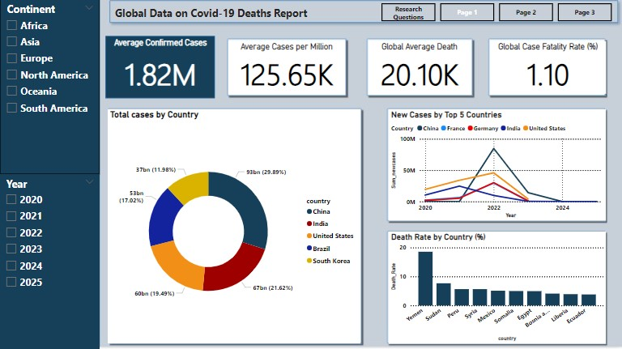
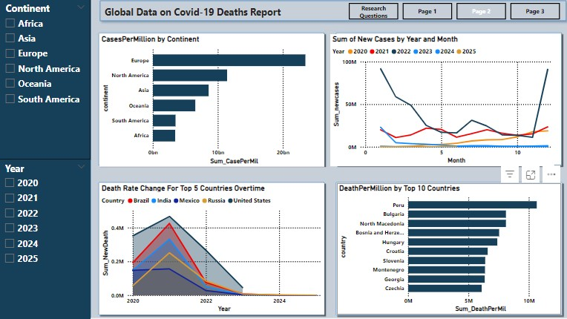
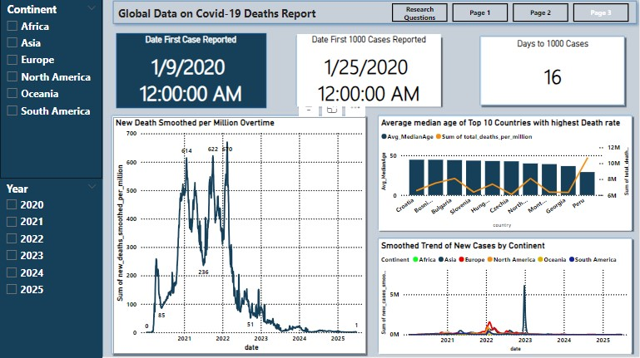

Conclusion
The refined and cleaned COVID-19 dataset, structured star schema data model and the accompanying Power BI report, offers a deep and flexible foundation for global Covid-19 pandemic analysis over the stated time in the dataset. By focusing on consistent, interpretable fields, this project avoids data sparsity while still enabling meaningful insights into the virus's spread, mortality, and correlations with demographics.
The Power BI dashboard complements this report by offering interactive charts and metrics to explore case counts, death rates, demographic trends, and time-based patterns across regions and continents.
This report and its visual companion together provide a strong platform for public health evaluation, policy guidance, and further research.

