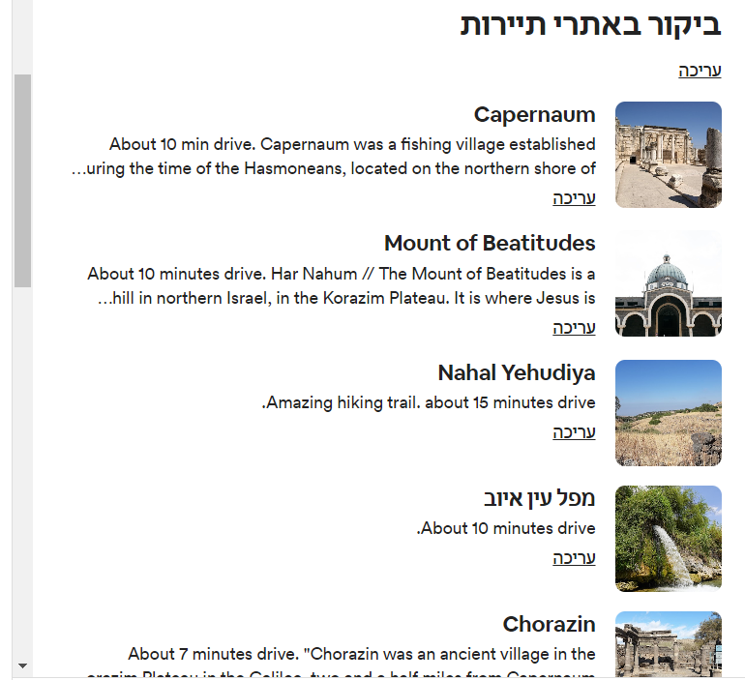

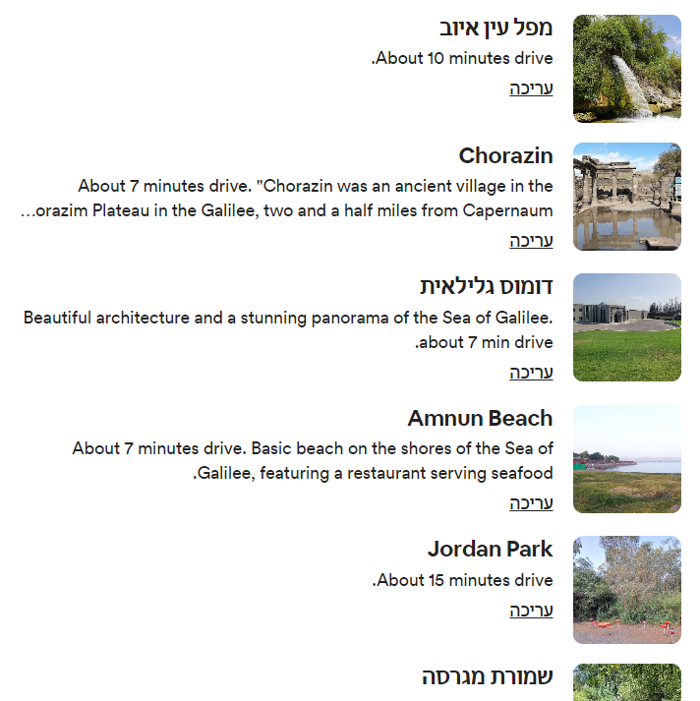

**Chorazin - About 7 minutes drive from 'Maayan Kasoom'.**

Chorazin was an ancient village in the Roman and Byzantine periods, best known from the Christian Gospels. It stood on the Korazim Plateau in the Upper Galilee on a hill above the northern shore of the Sea of Galilee.

Findings -

The main settlement dates to the 3rd and 4th centuries. The majority of the structures found were made from basalt. The town's ruins are spread over an area of 25 acres, subdivided into five separate quarters, in the center the large, impressive synagogue which was built of basalt stones and decorated with Jewish motifs is the most striking of the surviving structures, in the center. Close by is a ritual bath (mikvah), surrounded by public and residential buildings.