Year 1 Block A

**Plateau of Leng: Level Design Document**

Timo Bron - 170388 - Team 7

horizontal line

# Placeholder image

# Introduction

This document will describe the design, plan and execution of my Unreal Tournament level titled “Plateau of Leng”. It will detail the purpose and goal of the level, as well as a high level plan on how to approach this.

# Table of Contents

**Introduction** **1**

**Table of Contents** **2**

**The Theme** **3**

**The Intended Gameplay** **4**

**Maps & Flow** **5**

Node Map 5

Top Down Map 6

**Weapons** **7**

**Pickups & the Wall-Dodge Mechanic** **8**

**Landmarks** **9**

# The Theme

The Plateau of Leng is a location described in Lovecraft’s stories; a cold, arid plateau where different realities converge. The plateau is always described as being in a different geographical location, but often having a monastery on it.[1]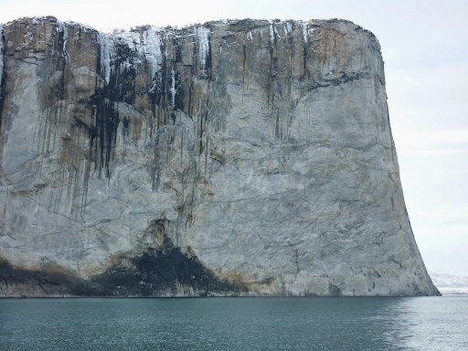

The level will therefore be mostly exterior, but with some interior places like the monastery or some basic ice caves. Because a plateau isn’t exactly suited for Unreal Tournament’s amount of verticality, I decided to have the plateau consist out of multiple smaller different plateaus instead of just a single big one.

The ruined monastery will be the focal point of the level, in particular a dilapidated tower. The monastery’s main building will appear to be torn in half, each half appearing to hang over two different plateaus opposite of each other. The rest of the ruined buildings will be scattered across other plateaus.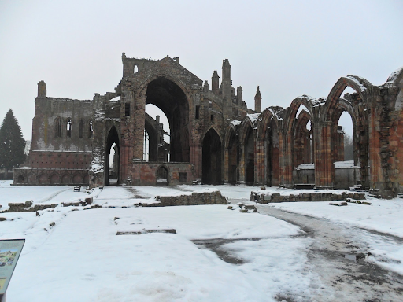

The Lovecraft theme will be emphasized by the tentacles, a hallmark element in Lovecraftian horror, that appear to be invading the Plateau from the sea surrounding it, giving the feeling of realities converging. The tentacles will not only be environmental, but will also serve as platforms, walls to perform wall kicks on, et cetera.

As architecture style, we decided on a mix of two of the most popular architecture style of the 19th century: the Queen Anne and Gothic Revival style. We want to combine the different house elements and irregular roof shapes of the Queen Anne style with the less picturesque massing, classical Gothic elements and somber feel of the Gothic Revival style. Seeing as the two styles already are quite similar, we think we can pull this off quite well, making it fit the Lovecraftian horror theme we adopted.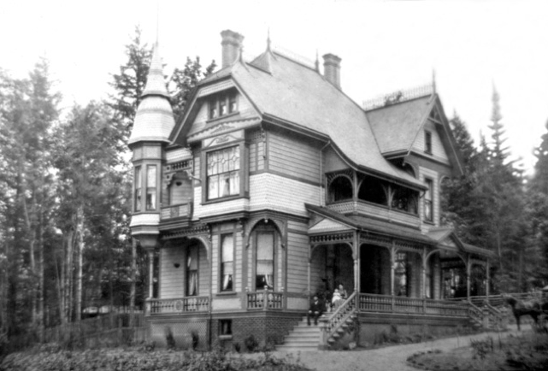

# The Intended Gameplay

The level will focus mostly around having around 3 or 4 distinct vertical layers in an outside environment, together with a focus on the wall-dodge mechanic to reach higher or further away places.

The primary route will go through all vertical layers, starting from the bottom, where at the top, the player will either cross a large gap using the wall-dodge mechanic to reach the other plateau on the other side of the level, or jump back down to the first, lowest vertical layer.

Secondary routes will offer different ways of reaching certain vertical layers to bring variety, choice and dynamic gameplay into the level.

Even though there is a focus on the wall-dodge mechanic, it must not break flow and must be placed in such a way that it feels natural and intuitive to move around using this mechanic. Wall-dodges can break flow if used in the wrong places, as the player may need multiple attempts to make the jump correctly. This is why flow will have priority over the usage of wall-dodge.

# Design Pillars

*These were written by Jente van Rooij, 170567.*

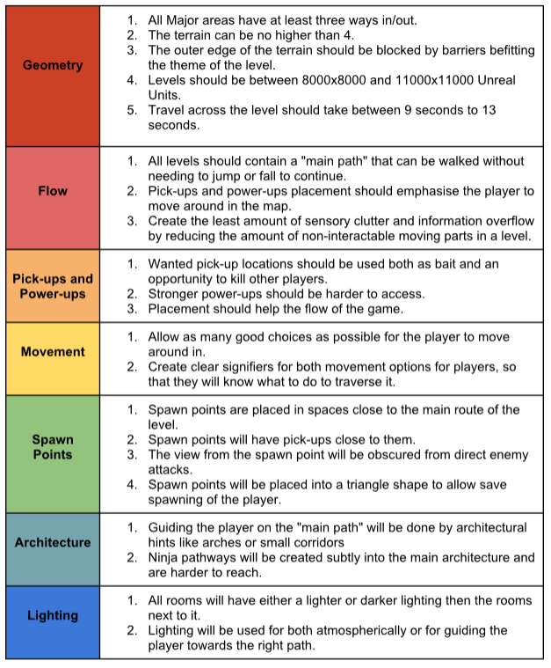

# 

# Maps & Flow

### Node Map

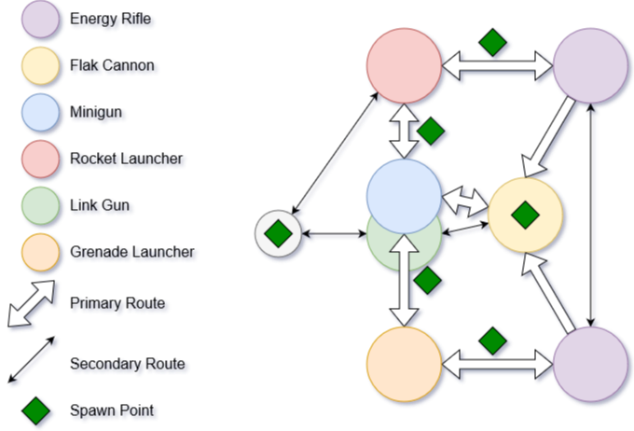

This nodemap details navigation, routes, flow, weapon placement and spawn points in the level.

### Top Down Map

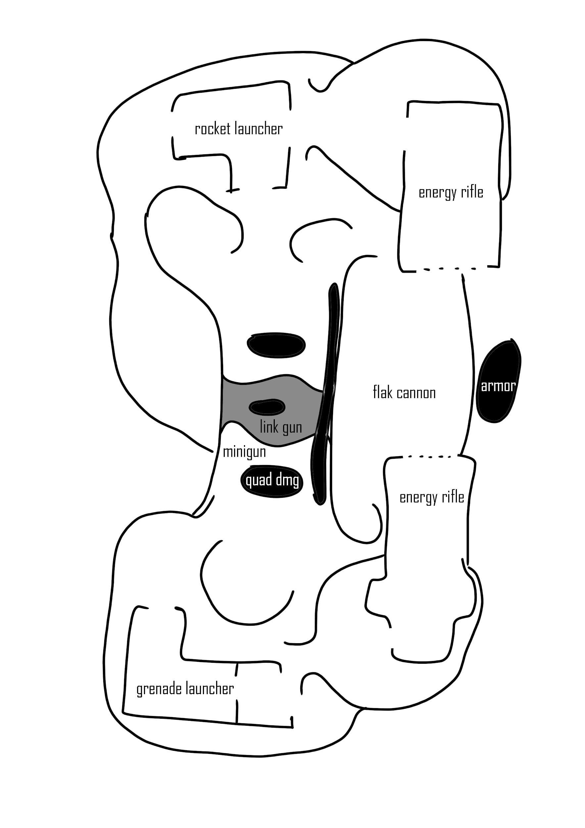

A top down sketch of the level.

The general flow through the level, starting from the lowest area, goes through the central area, then goes up one layer through either the bottom or the top area, then ends in either halves of the church building, where the player either jumps back down to the lowest area or takes a ninja path to the opposite side.

The player should be encouraged to leave the lower areas of the level, as they are more vulnerable here. Playing this level should be a battle for the high ground, where the player who has most control of their character wins the match.

# Weapons

***Flak Cannon:*** The Flak Cannon is placed in the lowest area to offer a risk-reward aspect to the player; they can get a good weapon, but being in the lowest area is dangerous. They are encouraged to grab the weapon and quickly flow to the next area, where the weapon can be used to its maximum potential.

***Link Gun:*** Offering a close-to-medium range weapon to counter against the Flak Cannon, but is also used best in a higher area, specifically the centre part of the level.

***Minigun:*** Good for a long, narrow path with good lines of sight between the two areas next to it. Cover is placed to break otherwise too strong lines of sight.

***Rocket Launcher:*** The Rocket Launcher benefits from shooting at targets below it, making it a very strong weapon in a level with a lot of verticality. This weapon is one of the weapons that will potentially make the lower areas of the level dangerous to be in. The power of this weapon is somewhat countered by the Shock Rifles, as well as the layout of the levels below it; the player must truly search for the high ground to fully make use of this weapon.

***Grenade Launcher:*** The Grenade Launcher benefits from the area it is found in; it is placed on an elevated platform where players can come from only two directions, making it easy to predict where to shoot. It is also especially lethal in close-quarters areas like the Link Gun area.

***Shock Rifle:*** Two Shock Rifles are placed across from each other, with very good lines of sight to the other side of the level. This encourages Shock Rifle battles with other players from across the map, truly testing their aim and skill with the weapon. The area also has a good view over the Flak Cannon area, making this area even more lethal. Cover in the Minigun area is placed in such a way that it is protected from Shock Rifle attacks coming from the church. The Shock Rifles also prevent players from camping with the Rocket Launcher in the church, as the Shock Rifle has a slight knockback on hit, potentially knocking players off who are standing near the edges, shooting rockets at players below them.

# Pickups & the Wall-Dodge Mechanic

To test the player’s control of the character, almost every pickup will require the player to go through a ninja route. How difficult these routes are depends on the power of the pickup. All ninja routes however will focus on the wall-dodge mechanic to reach higher or further away places.

There will be an armor pickup between the two Shock Rifle areas, placed against a small wall representing a tentacle coming out of the ocean. Players have to dodge off the edge of the first platform, then grab the pickup and wall-dodge off of the tentacle to reach the other side of the church. Even though this pickup is placed as a ninja route, it is still possible to grab the armor while not making the jump to the other side. This allows for less skilled players to also be able to grab this pickup.

UDamage is a more powerful pickup and thus requires more effort to reach; it is placed on a high pillar in the Minigun area that can only be reached with Jump Boots. The Jump Boots are found in the Rocket Launcher area on a ledge above a doorway. The player must wall-dodge against a wall to reach this platform, after which they can grab the Jump Boots and go for the UDamage. Because of this extra step, only players who are skilled enough with movement are able to acquire the UDamage. Players who are less skilled with movement either have to kill the player after they picked up the Jump Boots, or after they already picked up the UDamage.

Any additional ninja paths will follow a similar pattern, each featuring a wall-dodge jump of varying difficulty.

# Landmarks

The ruined church will act as the main focal point and landmark. It can be seen from all parts of the level and is distinguishable enough in its shape, size and architecture to always be recognized. In addition, a strong armor pickup can be found in between the two halves of the church, and the armor can only be acquired after going through either parts of the building, making this area a point of interest for the player.

Because the level is quite symmetrical, the centre area will act as the centre of circulation of flow. To prevent confusion because of this symmetry, the two buildings next to the centre area will have recognizable architecture to help players orientate themselves and recognize where they are.

1. <http://lovecraft.wikia.com/wiki/Plateau_of_Leng>