Year 2 Block A

Timo Bron - 170388 - Team 7

LEVEL DESIGN  
PLAYTESTING LOG

___

# TABLE OF CONTENTS

**TABLE OF CONTENTS** **1**

**FIRST BLOCKOUT - V01** **2**

**FIRST WHITEBOX - V02** **4**

**1ST ITERATION WHITEBOX - V03** **8**

**2ND ITERATION WHITEBOX - V04** **13**

**3RD ITERATION WHITEBOX - V05** **18**

**4TH ITERATION WHITEBOX - V06** **23**

**5TH (FINAL) ITERATION WHITEBOX - V07** **26**

**LINK TO ALL SURVEYS:** [**https://drive.google.com/open?id=11vaQqy3BhPFOonq5O_mQue-JSnTmriw1**](https://drive.google.com/open?id=11vaQqy3BhPFOonq5O_mQue-JSnTmriw1)

___

# FIRST BLOCKOUT - V01

**PLAYTEST PLAN**

**REASON FOR TEST:**This is the first version of my level. I am especially curious about how well the level flows, the scale of the level, and the weapon placement. I also want to be sure if players are able to successfully wall-dodge in the ninja routes.

**HYPOTHESIS:**I suspect the scale to be alright, but the size of the level itself to be a little too small. I think weapons are placed mostly in the right spots, and the rooms to be suited well to the weapon. The wall-dodges might be a bit too hard for some players.

**TEST SETUP:**6 players participate in a round of Deathmatch on the first blockout version of the level. The round is 15 minutes long. After the round is over, the players are asked to give feedback on the level in general, and are asked a few questions regarding scale, weapon placement, areas of combat, and ninja routes.

**TEST METHOD:**Players have not played previous iterations before. Players are all roughly equal skill level. I was also participating in the matches as one of the players.

**NO. OF INDIVIDUAL PARTICIPANTS:**5.

**OBSERVATIONS**

* Testers found that weapon placement often does not fit the room, particularly the Bio Rifle, Grenade Launcher and Minigun.
* The scale of the level is too small.
  + Doors are too small.
  + Walls are too thin.
  + Some rooms are too cramped.
  + Flak Cannon is too strong as a result.
* Wall-dodge opportunities are not marked well. Testers often did not know how to complete ninja routes.
* Wall-dodging is inconsistent; it took testers several attempts to complete a ninja route even after telling them what to do.
* The Flak Cannon and Grenade Launcher are too close to each other.
* Lower areas of the level are utter chaos; everyone seems to converge around this area. It does not play well.

**CONCLUSIONS**

* The scale is off; almost the entire level is too small. The best way to fix this would be to grab the info I now got from this playtest, and start rebuilding the level from scratch in a different file.
* Some areas don’t suit the weapon that is found in them. I will have to go back and read the research we have done on weapons to make sure the weapons can benefit from the area they’re found in.
* The level doesn’t flow as intended. The Bio Rifle room is too far out of the main route and is thus barely visited. The Link Gun area isn’t visited often, while the Flak Cannon is too crowded. I will have to make a new node map and rework the flow to fix these issues.
* Wall-dodging is not a well-known mechanic and can be very inconsistent. The ninja routes I have right now break flow and are not suited for combat scenarios. I will need to find a way to make use of the wall-dodge mechanic without breaking flow and improving consistency.

___

# FIRST WHITEBOX - V02

**PLAYTEST PLAN**

**REASON FOR TEST:**This version was playtested by teachers. I need to know whether weapon placement has improved and if the scale is now correct. I also want to know whether the level has enough different areas. Lastly, I want to know how many players were able to complete the ninja routes.

**HYPOTHESIS:**I think weapon placement has improved overall, but that the Flak Cannon will feel out of place. I think the scale is now corrected and doesn’t need much improving. I also think wall-dodge ninja routes are more clear now. I am suspecting the level could use one more new area.

**TEST SETUP:**6 players participate in a round of Deathmatch on the first whitebox version of the level. The round is 5 minutes long. After the round is over, the players will fill in a survey about several topics, ending with a field where they can give additional feedback. Any feedback given during playtesting is written down.

**TEST METHOD:**Playtests were done with teachers. Players are all roughly equal skill level. I did not participate in this playtest myself.

**NO. OF INDIVIDUAL PARTICIPANTS:**6 (of which one did not fill in the survey).

**OBSERVATIONS**

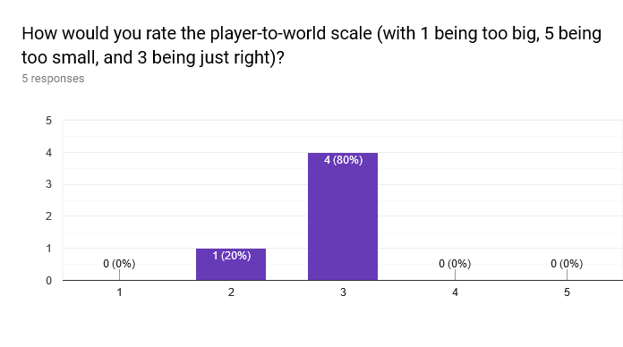

* The scale seems to be fine and does not need to be altered heavily.

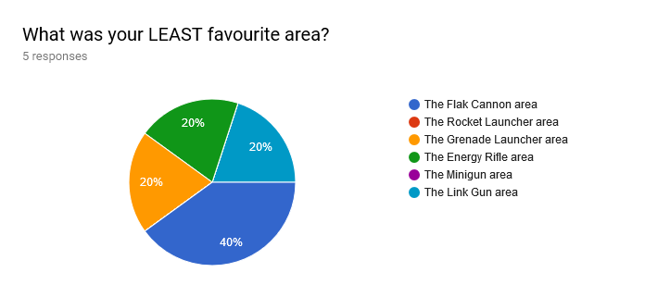

* The Flak Cannon was the least popular area, as expected.

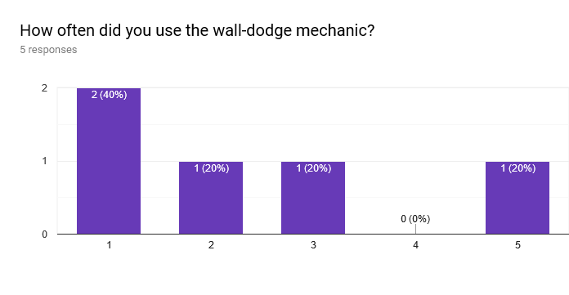

* Where 1 was “not at all” and 5 was “very often”, the results were fairly leaning to 1. Wall-dodge is still not being used as much as I would like.

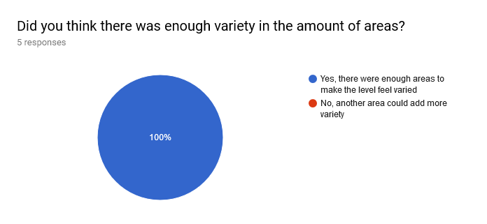

* Testers agreed unanimously that the level has enough different areas.
* The players found a lot of different areas where they weren’t supposed to be able to go, and also quite a bunch of spots where they could get stuck. It was very easy for them to go out of bounds.

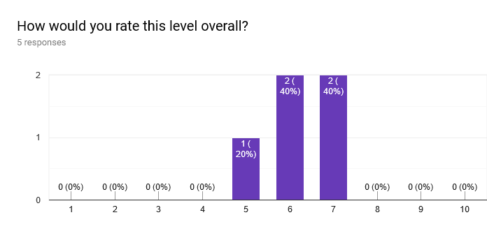

**CONCLUSIONS**

* As expected, the Flak Cannon feels out of place and the area needs improvement.
* A lot of issues regarding edge of world and getting stuck in geometry were found during this playtest. It impacted flow and the overall match quite a lot, as players were often left confused whether they should be able to access a certain area or got lost somewhere. This will be my number one priority for the next iteration.
* The scale of the level is fine, and I don’t need to add another area, which I thought I would have to do.
* The wall-dodging is still not used much. I will have to find new ways of applying it to my level.

___

# 1ST ITERATION WHITEBOX - V03

**PLAYTEST PLAN**

**REASON FOR TEST:**After swapping the Flak Cannon and Link Gun, and moving the Flak Cannon from inside the cave area to somewhere outside of it, I want to know whether these areas have improved as combat spaces. I also want to know whether the Rocket Launcher area benefits from having one more exit out of that space to decrease chaos. I’m also asking some questions about spawn point placement and the amount of health and armor pickups this time.

**HYPOTHESIS:**I think the Flak Cannon works better in the area it is right now. I am doubtful whether the Link Gun will work properly where the Flak Cannon was before. I think the Rocket Launcher area will now be less chaotic and liked more by testers. I suspect the spawn points and amount of pickups to be fine.

**TEST SETUP:**Two matches in total will be played. 6 players participate in a round of Deathmatch on the first iteration of the whitebox version of the level. The round is 10 minutes long. After the round is over, the players will fill in a survey about several topics, ending with a field where they can give additional feedback. Any feedback given during playtesting is written down.

**TEST METHOD:**Players are all roughly equal skill level. I was also participating in the matches as one of the players. Players playing this iteration twice don’t count as new testers and won’t fill in the survey twice.

**NO. OF INDIVIDUAL PARTICIPANTS:**8.

**OBSERVATIONS**

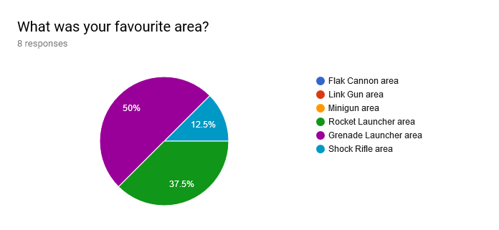

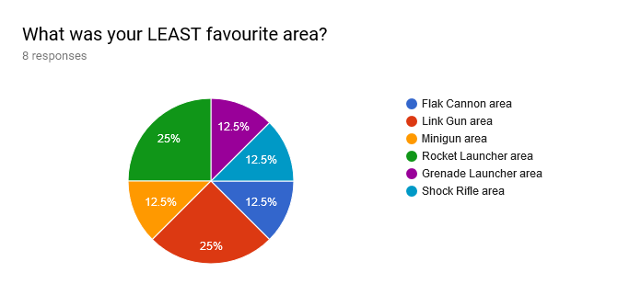

* The Rocket Launcher area is still too chaotic for some people, while others actually like that chaos.

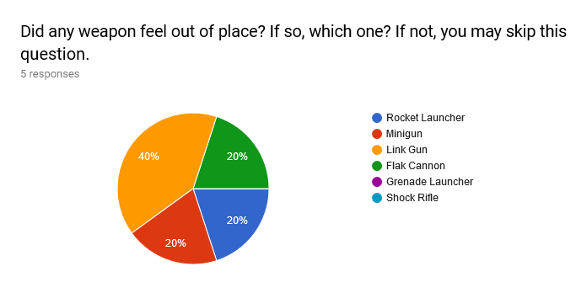

* The Link Gun area is not very popular. The area doesn’t suit the weapon well.

## Forms response chart. Question title: How would you rate the amount of health and armor pickups, with 1 being too few, 5 being too many, and 3 being exactly right?. Number of responses: 8 responses.

* Health and armor pickups seem to be alright, but could do with a little more.

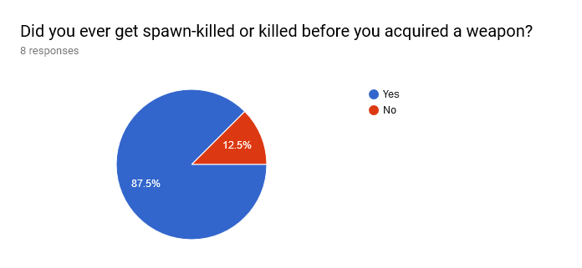

* Unexpectedly, the spawn points could do with a lot of improvement. Spawn-killing occurs too often.

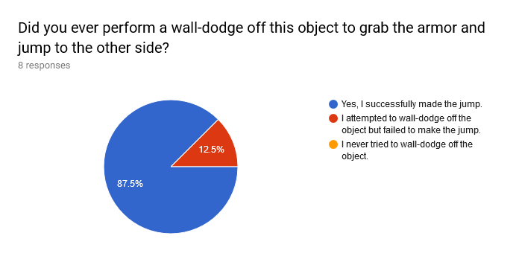

* It seems that the wall-dodge mechanic is being used more now. Using wall-dodge to cross a gap seems to be easier to understand than using it to get up to something, as 37.5% did not know how to reach the Jump Boots in the level, which required a different kind of wall-dodge jump.
* None of the testers knew how to reach the UDamage.

## Forms response chart. Question title: How would you rate this level overall?. Number of responses: 8 responses.

**CONCLUSIONS**

* The Link Gun area needs improvement; the Link Gun feels too out of place where it now is. The Rocket Launcher area might also benefit from some changes.
* Spawn points are worse than I thought. It’s critical that they get fixed.
* It should be easier and more obvious how to reach the UDamage and Jump Boots. Wall-dodging upwards is less obvious than wall-dodging over a gap.

___

# 2ND ITERATION WHITEBOX - V04

**PLAYTEST PLAN**

**REASON FOR TEST:**After almost completely redoing the Flak Cannon area and adding cover to the Link Gun area, I want to know if these areas are now better suited for those weapons and if they’re a good combat space. I also want to know if the spawn points have improved, and if the new UDamage position is better than where it was before. I replaced the Jump Pad near the Rocket Launcher area with a wall-dodge jump for armor, and want to know whether that jump is easy to make.

**HYPOTHESIS:**I’m pretty sure the Flak Cannon area has improved a lot now, but don’t know if adding cover to the Link Gun area solves all of its issues. I think spawn points are now safer, that it’s not more obvious how to reach the UDamage, and that the wall-dodge for armor is easy to do.

**TEST SETUP:**Two matches in total will be played. 6 players participate in a round of Deathmatch on the second iteration of the whitebox version of the level. The round is 10 minutes long. After the round is over, the players will fill in a survey about several topics, ending with a field where they can give additional feedback. Any feedback given during playtesting is written down.

**TEST METHOD:**Players are all roughly equal skill level. I was also participating in one of the matches as one of the players. Players playing this iteration twice don’t count as new testers and won’t fill in the survey twice.

**NO. OF INDIVIDUAL PARTICIPANTS:**11.

**OBSERVATIONS**

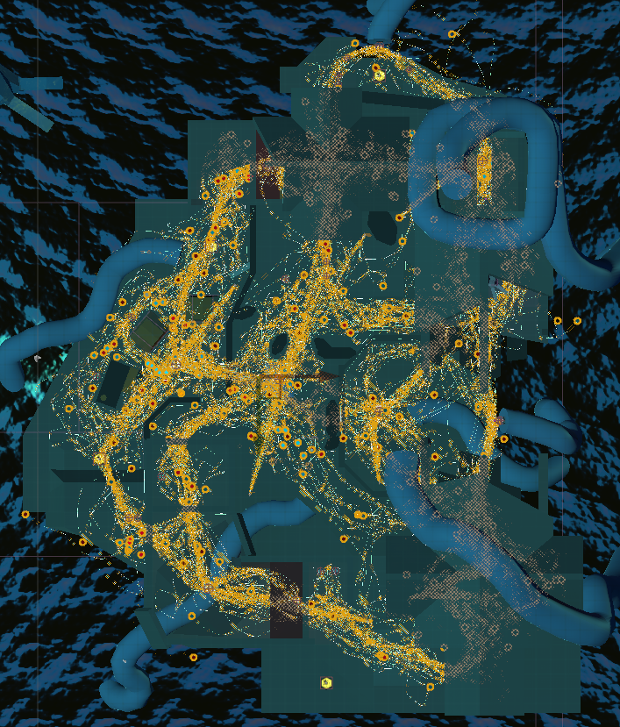

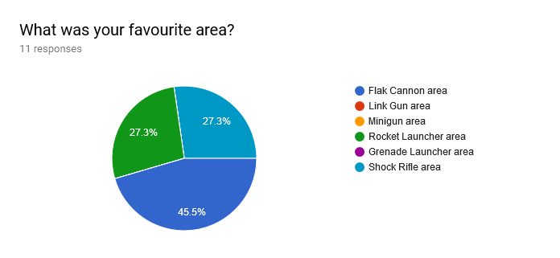

* As expected, the Flak Cannon area has improved. It was even considered the most popular area.

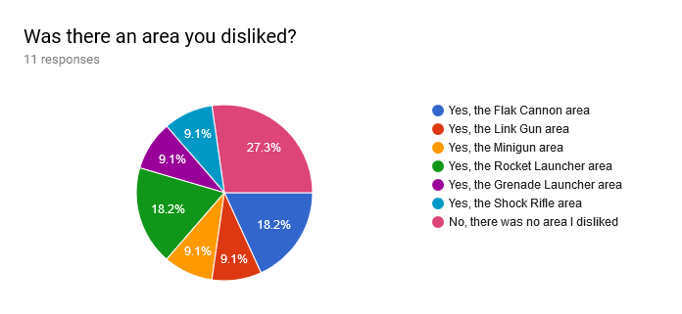

* The Link Gun area isn’t as disliked as I thought it would be, though testers still think the weapon itself feels out of place. The Rocket Launcher area is still an area that is getting mixed reactions. The Flak Cannon area can do with some improvements, like faster jump pads and less people flowing towards this area. Results of least favourite area is very scattered this time around.

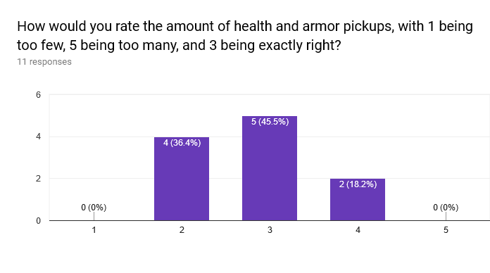

* Even with an additional armor pickup and a few more health pickups, the testers still thought there wasn’t enough. There is more than enough armor though; once you know how to get to them, it’s actually too powerful.

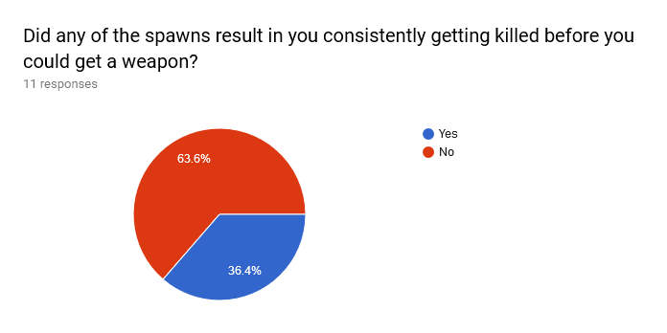

* While spawn points have definitely improved, they still aren’t perfect and still occasionally result in spawn-killing.

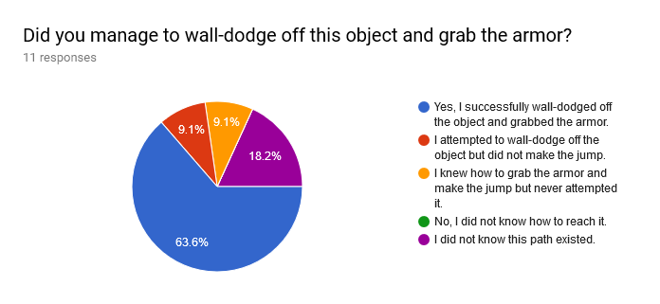

* The majority of players knew how to do the wall-dodge near the Rocket Launcher area.
* A lot of testers disliked falling off the level and having to swim back. They would rather instantly die than having to swim back, as this breaks flow.
* There are quite a few points where players got stuck in geometry which will have to be fixed in the next iteration.

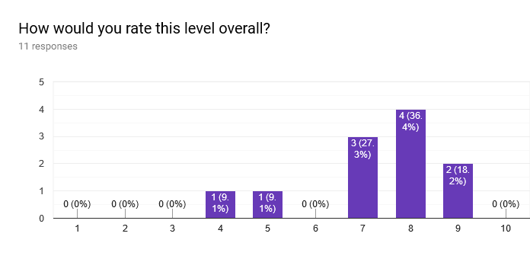

**CONCLUSIONS**

* The Link Gun area needs overhauling. It’s an alright combat space but doesn’t fit the weapon.
* The Rocket Launcher area needs to be more spacious to decrease the chaos.
* Flow needs to be redirected less towards the Flak Cannon area, but I don’t know how yet.
* The armor in the level is too strong once you know where it is. It’d be better if the armor was less powerful and was in easier to reach places (the armor above the Grenade Launcher area is too hard to reach).
* Spawn points still aren’t good enough and need improvement.
* Players dislike falling off the level and having to swim back; it might be better to have a kill volume there instead.

___

# 3RD ITERATION WHITEBOX - V05

**PLAYTEST PLAN**

**REASON FOR TEST:**This version was also playtested with the teachers. After making many changes to the Link Gun area and the Rocket Launcher area, I want to know if they have improved. I also want to know whether the amount of health and armor pickups have improved. I changed the spawn points too, and want to know if they work properly now.

**HYPOTHESIS:**I’m sure the Rocket Launcher area has benefited from the changes made to it. I also think the Link Gun area has improved and suits the weapon more now. The amount of armor should be fine now, and I also think the spawns have improved.

**TEST SETUP:**Two matches in total will be played, one of which with the teachers. 6 players participate in a round of Deathmatch on the third iteration of the whitebox version of the level. The round is 10 minutes long (5 for the round with the teachers). After the round is over, the players will fill in a survey about several topics, ending with a field where they can give additional feedback. Any feedback given during playtesting is written down.

**TEST METHOD:**Players are all roughly equal skill level. I was also participating in one of the matches as one of the players. Players playing this iteration twice don’t count as new testers and won’t fill in the survey twice.

**NO. OF INDIVIDUAL PARTICIPANTS:**9.

**OBSERVATIONS**

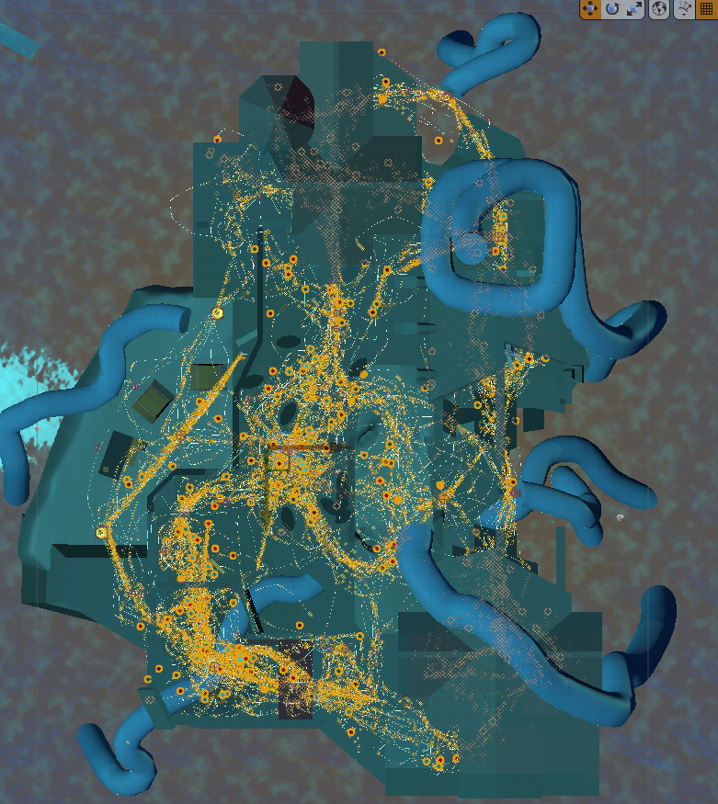

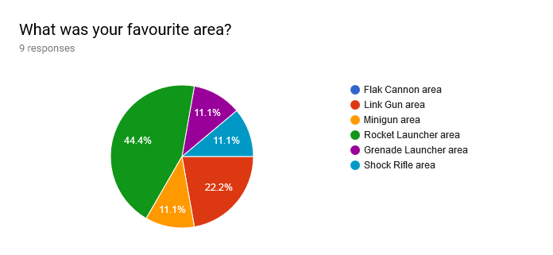

* The Rocket Launcher and Link Gun area are now the top two favourite areas.

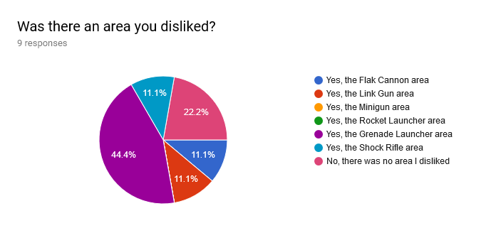

* The majority of testers disliked the Grenade Launcher area; people either didn’t even find it at all, or thought it was an obsolete weapon.

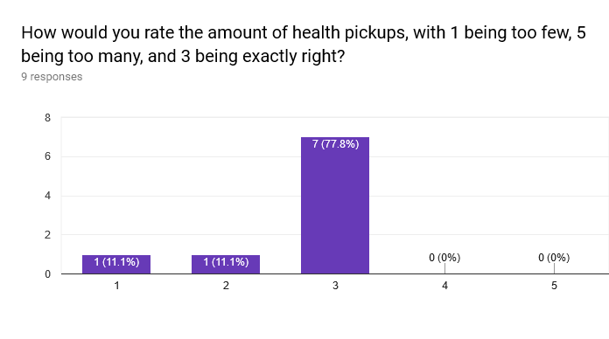

* The amount of health pickups seem to be fine, although some testers would still like more.

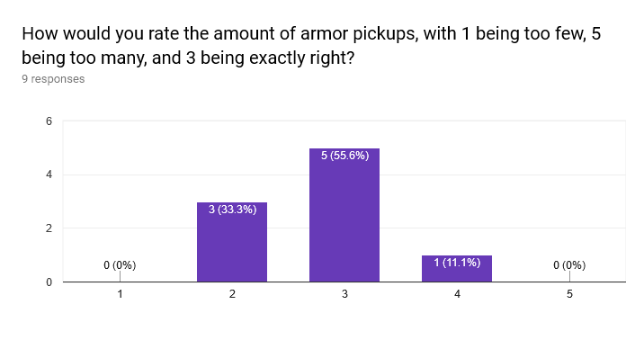

* Testers seem to want a little more armor pickups.

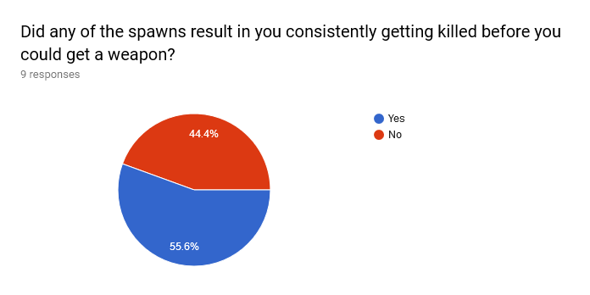

* Spawns actually seem to have gotten worse than last time.

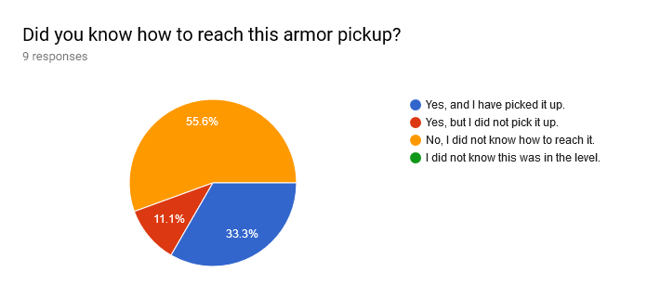

* This question was about the armor at the Grenade Launcher area. Testers did not seem to know how to reach it. This could tie in with them also thinking there wasn’t enough armor in the level.
* Some areas feel too big scale-wise.
* The flow through the level was quite bad; players avoided the lower areas heavily, except for the Flak Cannon area, which was overpopulated. Players also claimed a lot of backstabbing was happening and that that was frustrating.

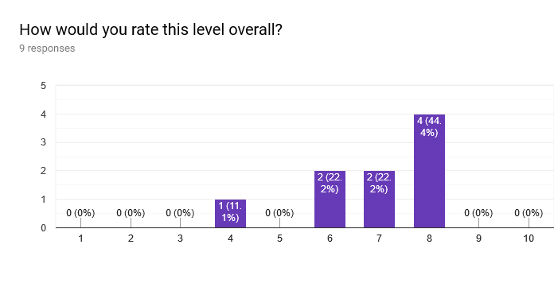

**CONCLUSIONS**

* The Rocket Launcher area and Link Gun area seem to have most of their issues fixed now.
* The Grenade Launcher area is the next area that needs improvement. It’s a bad combat space and the weapon is not enjoyable to use in it.
* There could be a few more health pickups. Armor pickups are fine, but they should be more easily accessible.
* Spawn points are not placed well. They don’t take the orientation of other spawn points in mind, resulting in the flow only circling in one direction, which causes a lot of backstabbing to happen. I will need to redo spawn points to make sure they’re placed correctly relative to each other.
* More bugs with geometry and collisions have been found that will need to be addressed before next iteration.

___

# 4TH ITERATION WHITEBOX - V06

**PLAYTEST PLAN**

**REASON FOR TEST:**I primarily want to know if the Grenade Launcher area has improved. I also really want to know whether the spawn points have improved.

**HYPOTHESIS:**I’m not really convinced the Grenade Launcher area has improved much. I do think spawn points are finally like they should be.

**TEST SETUP:**Two matches in total will be played. 6 players participate in a round of Deathmatch on the fourth iteration of the whitebox version of the level. The round is 10 minutes long. After the round is over, the players will fill in a survey about several topics, ending with a field where they can give additional feedback. Any feedback given during playtesting is written down.

**TEST METHOD:**Players are all roughly equal skill level. I was also participating in one of the matches as one of the players. Players playing this iteration twice don’t count as new testers and won’t fill in the survey twice.

**NO. OF INDIVIDUAL PARTICIPANTS:**8.

**OBSERVATIONS**

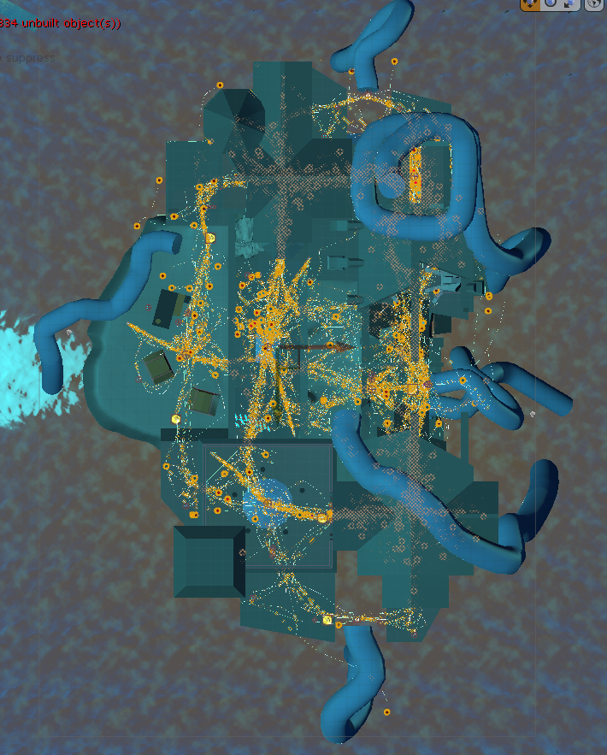

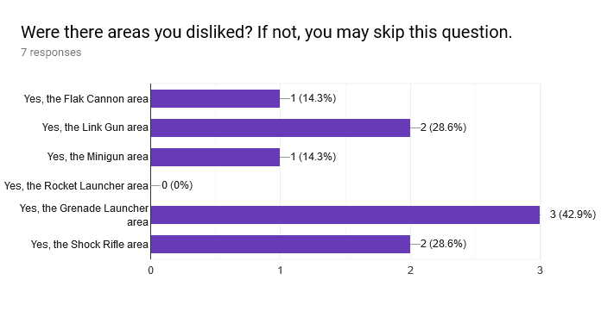

* The Grenade Launcher area is still not good enough. Players said it was too open and not a very interesting area in general. It also does not work well with the Minigun area next to it.

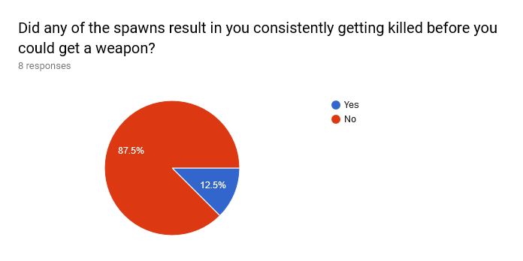

* Finally spawn points seem to be how they should be. Players who previously said they were getting attacked from behind a lot, now confirm that flow has improved.

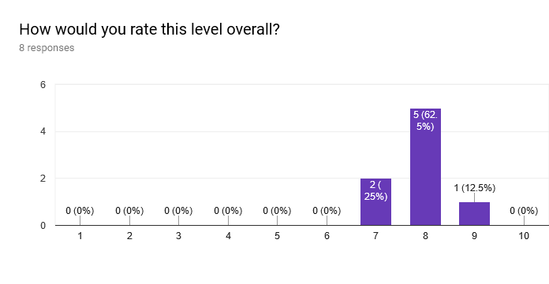

**CONCLUSIONS**

* The Grenade Launcher area still needs improvement; it is probably too open, and the cover doesn’t help the weapon that much. The Minigun area also has a too powerful line of sight into the area.
* The spawn points are finally fixed. I underestimated how much they would impact flow. The flow throughout the level is more balanced now.

___

# 5TH (FINAL) ITERATION WHITEBOX - V07

**PLAYTEST PLAN**

**REASON FOR TEST:**This version was playtested with (semi-)professional players. I primarily want to know if the Grenade Launcher area has improved, and if the level is also fun for players of higher skill levels. **Note: due to lack of time, I will not apply more changes to my level. This is purely information for a theoretical next iteration.**

**HYPOTHESIS:**I think the Grenade Launcher is finally as it should be. I also think the (semi-)pro players will enjoy the level, but perhaps request more room for advanced movement, or find that some weapons are easily exploitable in their surroundings.

**TEST SETUP:**Two matches in total will be played, one of which with active community members of a higher skill level. 6 players participate in a round of Deathmatch on the fifth iteration of the whitebox version of the level. The round is 7 minutes long. After the round is over, the players will fill in a survey about several topics, ending with a field where they can give additional feedback. Any feedback given during playtesting is written down.

**TEST METHOD:**Players in the same match are all roughly equal skill level. I was also participating in one of the matches as one of the players. Players playing this iteration twice don’t count as new testers and won’t fill in the survey twice.

**NO. OF INDIVIDUAL PARTICIPANTS:**11; only 7 filled in the survey however.

**OBSERVATIONS**

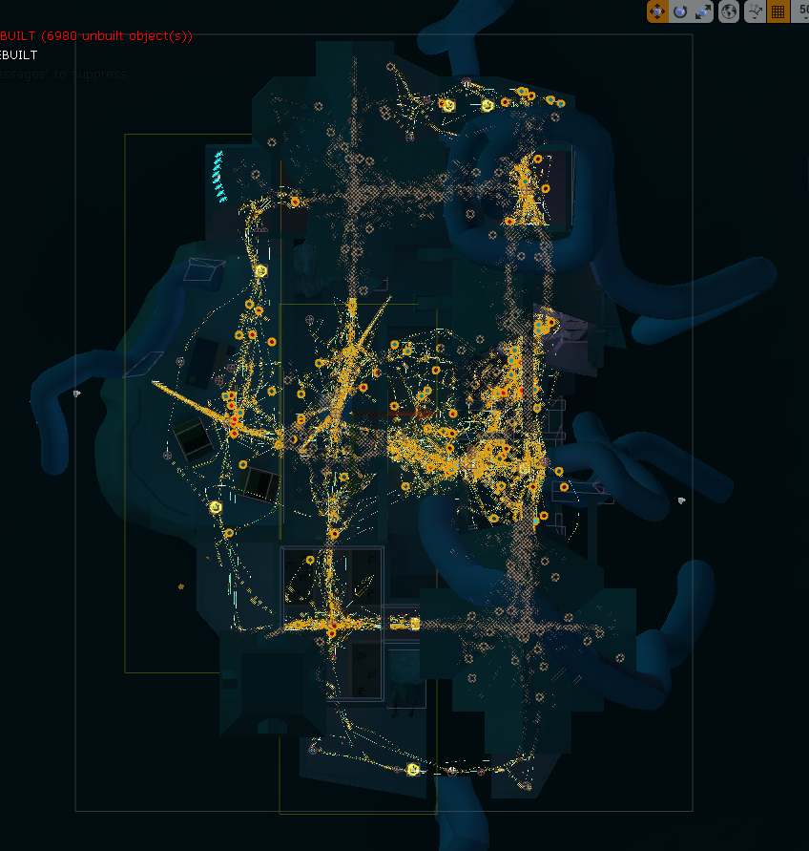

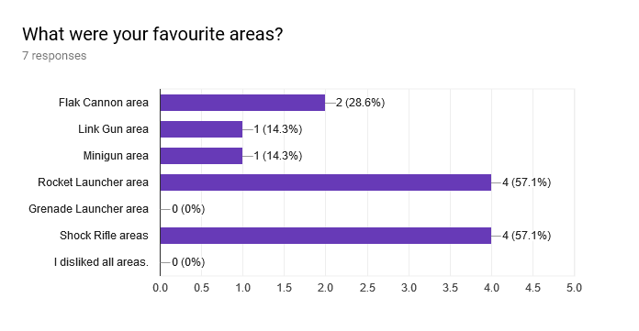

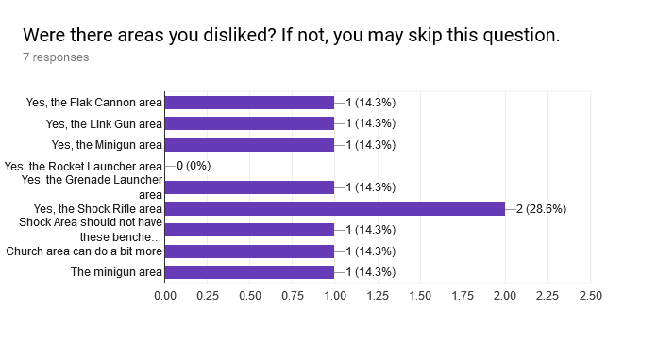

* Even though the Grenade Launcher is not one of the favourite areas, it will suffice for now. I think people mainly don’t like the area because the weapon itself isn’t that popular. When asked about the area, one of the pro players said that they think the area is fine. The one vote against this area stated this as the reason:  
  *“Got stuck sometimes on the fence or the doorway in the Grenade Launcher area. Beside that, not a big fan of open spaces, but that's mostly because I'm a projectile player.”*The pro players gave the same feedback about the fences. With some tweaking, this area will be sufficient enough and can be considered a good combat space.
* It appears the Shock Rifle area has issues. The church itself does not make good use of the space it provides, and if it gets crowded, it’s too dangerous to enter the area without hugging the wall or hiding behind cover. The area is too open to be safe to pass through.
* There are a few spots in the level where the player is not supposed to go or where they can get stuck; the fences in the Grenade Launcher room and some ledges behind fences on the edges of the level being the most prominent.
* Lighting is inconsistent in some places; the colours could lead you to the wrong places.
* One of the pro players said they want to go where they can think they can go; for example, stand on top of the Link Gun building, wall-ride across the walls around the Minigun area, or slide underneath the small building in the Flak Cannon area.

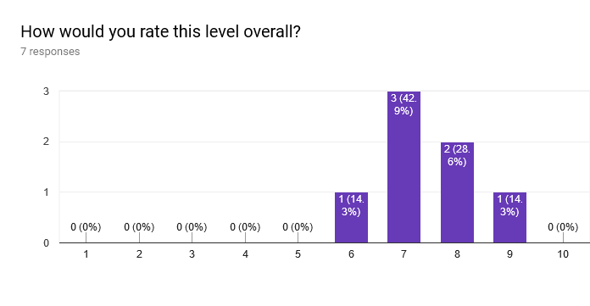

**CONCLUSIONS**

* The Grenade Launcher area’s fences need to be tweaked so people don’t get stuck anymore. I can add some openings in them so players can easily escape those corners.
* The Shock Rifle area needs more cover. I’m thinking of dividing the rooms in two, so there is a clear disconnect between the outside part where players can have Shock Rifle battles, and the inside part where it is safer to move through.
* I’ll remove some of the blocking volumes from the top of the Link Gun area to allow players to stand on it partially. I will also make wall-riding around the Minigun easier, and heighten the Flak Cannon building a tiny bit to allow sliding underneath it. However, I’ll have to see whether this causes more hiding spots to appear.