Emerging Environmental Impacts of Future Electricity Grid Infrastructure

Timo Diepersª, Philipp Daun^{b}, Menna Elsobki^{b}, Christian Zibunasª, Benedikt Nilgesª, Jan Hartmannª, Christina Kockel^{b}, Aaron Praktiknjo^{b},
Niklas von der Assen^{a,c,∗}
ª Institute of Technical Thermodynamics, RWTH Aachen University, 52062 Aachen, Germany
^{b} Institute for Future Energy Consumer Needs and Behavior, RWTH Aachen University, 52074 Aachen, Germany
^{c} JARA-ENERGY, 52425 Jülich, Germany
∗ Corresponding author. Email: niklas.vonderassen@ltt.rwth-aachen.de

Summary
Sustainable energy systems require major electricity grid expansion, yet the environmental impacts of future grid infrastructure are largely overlooked. We assess these impacts by combining a detailed model of Germany’s grid infrastructure with Integrated Assessment Model scenarios reflecting future supply chains. While more renewables help decarbonize grid component production, transmitting and distributing this renewable electricity requires additional grid expansion, raising emissions. We find that grid infrastructure becomes a major contributor to climate impacts of future electricity, with shares rising from 1% in 2023 to up to 21% by 2045. Main drivers of grid-related impacts, even under ambitious decarbonization, remain electricity and heat generation for aluminum production alongside emissions from steelmaking. Moreover, decarbonizing supply chains shift environmental impacts towards land use and mineral depletion. Our findings underscore the growing environmental relevance of grid infrastructure, reveal levers for reducing grid-related impacts, and call for their integration into global policy and energy planning.

Introduction
The transition towards renewable electricity is facing a critical bottleneck: globally, over 3,000 GW of renewable electricity projects – more than four times the solar photovoltaics and wind capacity installed in 2024 – are readily built, but awaiting grid connection^{1,2}. While renewable electricity has the potential to significantly reduce greenhouse gas emissions, these reductions cannot be realized without a corresponding expansion of electricity grid infrastructure³. Grid expansion, however, is not without environmental consequences: the construction of grid infrastructure and the production of required materials cause additional emissions. As the operational emissions of renewables decrease, grid-related emissions may gain importance, underscoring the need for an environmental assessment of future grid infrastructure. Given that an increasing deployment of renewable energy is known to shift environmental burdens from climate change to other impact categories such as ionizing radiation and ecotoxicity^{4–6}, an improved understanding of grid-related environmental impacts becomes increasingly relevant, raising the question: what are the climate and environmental implications of future grid systems?
An established tool for the holistic environmental assessment of products and processes along their entire life cycles is the standardized method of Life Cycle Assessment (LCA)^{7,8}. LCA has been used to assess the environmental impacts of electricity grid infrastructure, covering both individual components^{9–12} and entire electricity grids^{13–16}. Most studies find that emissions from constructing the grid infrastructure are overshadowed by power losses during the grid’s operation. However, a study of Norway's transmission grid¹³ marks a notable exception. As over 95% of the electricity in the Norwegian grid mix is generated by low-carbon hydropower¹⁷, power losses account for only half of the grid’s climate impact, with grid-related processes like material production and installation contributing the other half. While the aforementioned studies focus on existing grid infrastructure, to our knowledge only one study investigates the environmental impacts of future electricity grids: Jorge and Hertwich¹⁸ conduct an LCA of the planned European transmission grid expansion from 2012 to 2020. Because of the limited time span of the grid expansion, the authors assume that all processes and associated supply chains that supply material and energy for the grid expansion remain constant over time. However, Mendoza Beltran et al.¹⁹ demonstrate that this assumption can distort environmental impacts, particularly over long time periods in evolving systems.
For long-term grid expansion planning, it is important to include the evolution of processes and supply chains into the assessment. This is because future grid components might be produced with more sustainable technologies and materials, decreasing environmental impacts. Consequently, the relevance of grid-related emissions hinges on the development of future production systems. Accounting for the evolution of future technologies and supply chains in environmental assessments is central to the research field of prospective LCA (pLCA)²⁰. In pLCA, the underlying process datasets are adapted following scenarios for future technological, market and supply chain developments. While pLCA studies frequently address the electricity sector and transition scenarios^{4,19,21–24}, a holistic assessment under consideration of the environmental impacts of grid infrastructure expansion is currently missing.
In this study, we show how grid infrastructure will shape the environmental impacts of future power systems by integrating a detailed grid infrastructure and expansion model with scenario-based projections for process and supply chain development (Fig. 1). Using Germany as a case study of an industrialized country with ambitious decarbonization goals, we quantify the environmental impacts of electricity supply alongside required grid expansion via pLCA. To identify future mitigation opportunities, we conduct a time-resolved, multi-tier contribution analysis, revealing key material and process-level drivers of grid-related emissions. Finally, we show how evolving production systems may shift environmental burdens from climate change to other impact categories, underscoring the need for a broader sustainability perspective in grid planning.
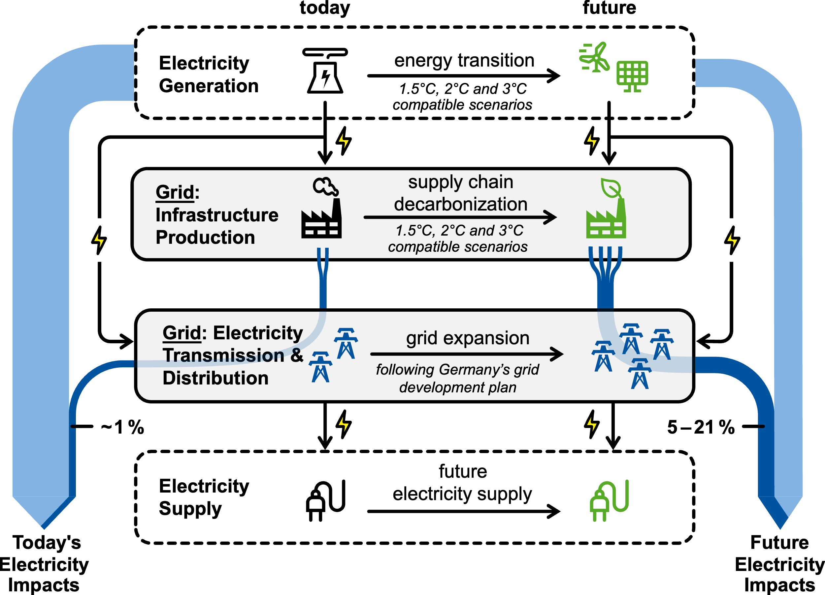
Fig. 1: Overview of current and future environmental impacts of electricity supply. The transition to renewable electricity sources simultaneously reduces climate impacts of electricity generation and helps decarbonize the production of grid infrastructure. However, the extensive grid expansion necessary to support increasing shares of renewables creates a trade-off, increasing the future relevance of grid-related impacts.

Results

Relevance of Grid-Related Climate Impacts in Future Power Systems
As electricity generation decarbonizes, grid infrastructure becomes a major contributor toward the climate change impact of electricity supply (Fig. 2). In 2023, grid infrastructure accounts for only 1 % of the impact per kilowatt hour supplied in Germany. Under a 1.5°C compatible decarbonization scenario, this share increases to 21 % by 2045, making grid infrastructure the third largest contributor to the climate change impact of electricity supply, behind electricity generation from wind (28 %) and solar (28 %). Considering that the grid’s impact share reaches 12 % in a 2°C scenario and 5 % in a 3°C compatible scenario, we conclude that the importance of grid-related climate impacts rises with increasingly decarbonized power systems.
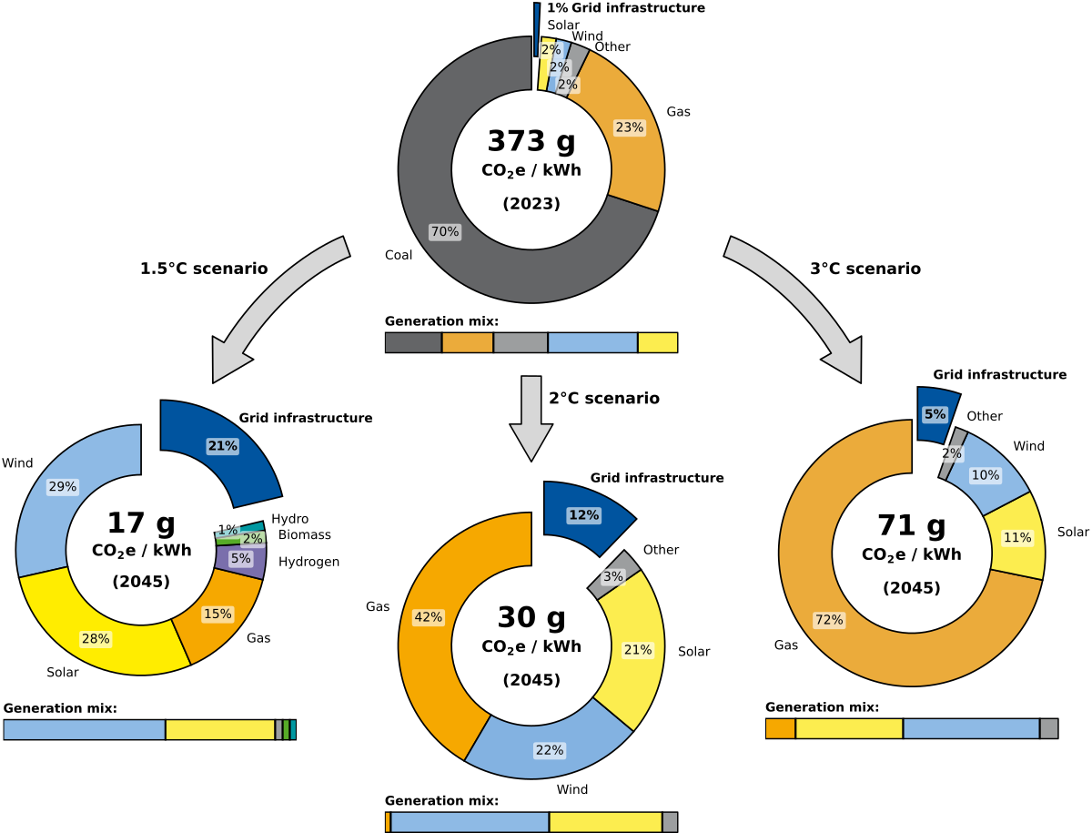
Fig. 2: Climate impact contributions of current and future electricity supply. As total climate impacts of electricity supply decrease, the share of grid-related impacts increases. In the fossil-dominated 2023 baseline electricity supply, electricity generation drives the total climate impact, with negligible contributions from grid infrastructure. By 2045, the transition toward renewables drastically lowers climate impacts per kWh of supplied electricity across scenarios. Because electricity generation decarbonizes faster and more extensively than grid infrastructure production, the grid-related share of the climate impact of electricity supply rises significantly.
The shift towards higher climate impacts from grid infrastructure in low-carbon power systems results from two opposing dynamics. On the one hand, decarbonization of electricity generation leads to less operational emissions, placing grid infrastructure more in focus. This shift is further reinforced by the required grid expansion to integrate rising shares of renewable electricity. On the other hand, the increase in grid-related impacts is partially offset by decreasing emission intensity of future grid infrastructure, driven by the decarbonization of their upstream supply chains.
While most decarbonization strategies to date have focused on electricity generation, the climate impacts of grid infrastructure, especially in the context of future system expansion, remain poorly understood. As these impacts grow in relative importance, understanding their origins and development trajectories becomes essential for more holistic mitigation strategies. To build this understanding, we first examine the climate impact of the current grid infrastructure and the underlying emission drivers, providing a basis for the following consideration of future grid expansion.

Climate Impacts of Current Grid Infrastructure
Based on installed grid component data reported by German transmission and distribution grid operators for 2023, we determine a total life-cycle climate change impact of current grid infrastructure of 61.7 Mt CO₂-equivalents (CO₂e). Fig. 3 visualizes the distribution of this impact on three different tiers throughout the supply chain: the grid components, the utilized materials, and the processes directly causing the emissions. For current grid infrastructure, over 90 % of the climate change impact results from the conducting equipment, i.e., overhead lines (53.7 %) and cables (37.0 %). For both overhead lines and cables, most of the impacts originate from their demand for aluminum as the conducting material. The contribution of copper to the impact of cables is small, particularly because aluminum is more commonly used as the conducting material in medium and low voltage cables. Moreover, copper has a higher conductivity than aluminum, which reduces the overall material required in the conductor. In addition, producing 1 kg of aluminum causes twice the climate change impact compared to producing 1 kg of copper. Transformers have the third largest impact after the conducting equipment, contributing 5.8 % to the overall impact, mostly due to their demand for steel, aluminum and copper. Substations and switchgears have relatively low impact shares, contributing only 1.9 % and 1.6 %, respectively.
The actual sources of these emissions largely do not lie within the immediate production processes of the materials themselves, but stem from upstream processes in their respective supply chains. When tracing impacts to these upstream processes, three main sectors emerge as dominant sources of direct emissions: electricity generation (35.3 %), process emissions from iron & steel production (13.5 %), and heat supply (11.1 %). These sectors are known to be emission-intensive in general, being responsible for over 38 % of global greenhouse gas emissions today²⁵. Consequently, all three sectors are prominent targets for mitigation^{26–28}. For our assessment of future grid expansion, we can consider decarbonization strategies for these sectors in future grid supply chains, reflecting the expected emission reductions associated with future grid infrastructure.
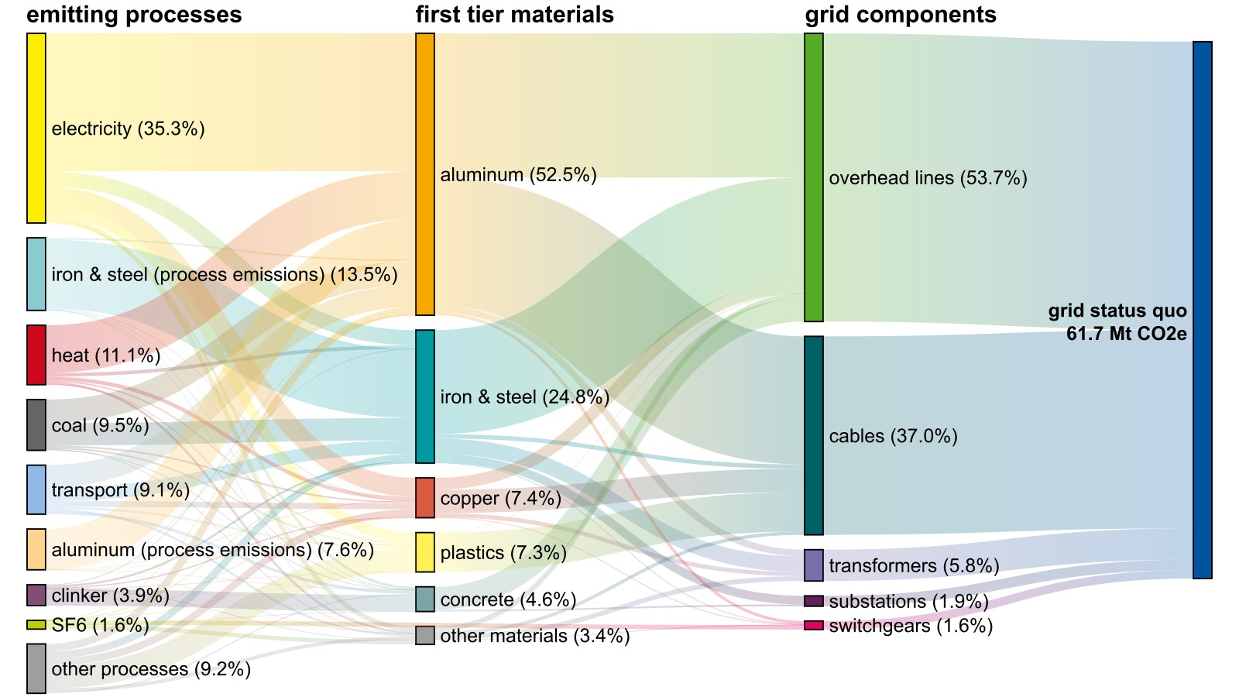
Fig. 3: Climate impact contributions of Germany’s current grid infrastructure on the component, material, and process level. “First tier materials” represent the aggregated impacts of direct material inputs to each grid component. “Emitting processes” denote the direct emission sources across the entire supply chain, grouped by their output product. Contributions under 1 % are aggregated as “other materials” or “other processes”.

Climate Impacts of Future Grid Expansion
To support rising shares of renewables and increasing electricity demands, Germany’s electricity grid needs to expand. To reflect this, we take the 2023 grid infrastructure as a baseline and add Germany’s planned grid infrastructure in multiple expansion periods according to the national grid development plan, finally yielding the projected grid infrastructure in 2045. Over these expansion periods, we account for projected process and supply chain developments, including the critical sectors electricity, iron & steel, and heat. Accounting for these developments alongside grid expansion, the total climate change impact of Germany’s grid infrastructure in 2045 reaches 83.6 Mt CO₂e in the 1.5°C scenario (+35 % compared to current grid) and 86.7 Mt CO₂e in the 3°C scenario (+40 % compared to current grid). The additional impact of grid infrastructure installed during expansion differs across scenarios due to varying projections for industrial decarbonization, as shown in Fig. 4a. In the 1.5°C scenario, faster and more extensive decarbonization of production processes and supply chains leads to lower-emission materials and energy inputs, reducing the overall climate change impact of grid components. In contrast, the 3°C scenario projects greater reliance on fossil fuels and conventional production processes, so grid components remain more emission-intensive. For comparison, the “Business as Usual” (BAU) case assumes processes and supply chains remain unchanged throughout the entire expansion until 2045.
Most of the climate change impact of future grid expansion occurs in the early expansion years (Fig. 4a). This is because the bulk of the grid expansion is scheduled for the earlier expansion periods between 2023 to 2035. Additionally, earlier expansion periods benefit less from the progressive supply chain decarbonization than later expansion periods, meaning that grid capacities installed later have lower specific impacts. The grid expansion through 2025 is modeled to use the 2023 processes and supply chains and does not yet benefit from decarbonization efforts, so impacts across scenarios match the BAU. For the impacts of the 2030-2035 expansion period, accounting for evolving production systems in the 1.5°C scenario yields 27 % lower impacts than the BAU. For the 2040-2045 expansion period, impacts in the 1.5°C scenario are less than half those of the BAU, as processes and supply chains have further decarbonized by then.
The projected changes in processes and supply chains affect components, materials, and emitting processes to different extents. Fig. 4 further illustrates the distribution of the climate change impact from grid expansion across grid components (Fig. 4b), their first-tier input materials (Fig. 4c), and the supply chain processes where direct emissions occur (Fig. 4c). Similar to the 2023 grid, conducting equipment accounts for the majority (>86 %) of emissions until 2045. Conducting equipment also drives the most emission reductions under progressively ambitious climate targets. Comparing BAU results, i.e., neglecting process and supply chain evolutions, to the 1.5°C scenario, advancements in cables and overhead line supply chains reduce the future climate impact by 26 %. This reduction stems from a lower climate change impact of aluminum, copper, and iron & steel, which in turn stems from a lower climate change impact of the materials’ electricity and heat inputs. Aluminum is produced via electrolysis, copper is refined electrolytically, and iron increasingly relies on electric arc furnaces. As a result, these materials’ impacts are highly sensitive to the electricity’s climate change impact. Fig. 4d highlights electricity generation as the directly emitting process group with the largest change, with its impact share decreasing from 33 % to 17 % with respect to the BAU impact
(-48 % relative change). Alongside electricity, heat is another key energy input to produce aluminum, copper, and iron & steel, contributing 9–10 % to the overall climate change impact. Unlike the emissions related to the electricity sector, emissions related to the heat sector only marginally decrease under progressively ambitious scenarios, as efficiency improvements and renewable fuels are offset by increasing heat demands in future supply chains, e.g., to support the adoption of Carbon Capture and Storage (CCS) processes. While CCS can reduce CO₂ emissions from iron & steel production, additional heat is required for sorbent regeneration. The contribution of direct emissions from iron & steel production reduces from 12% to 10% due do the implementation of CCS, but the iron & steel sector remains one of the largest direct emitters throughout the supply chain and across all scenarios. Since direct emissions from the heat and iron & steel sectors remain relatively constant while electricity progressively decarbonizes, their share to the climate impact increases. As a result, heat accounts for 12 % and iron & steel for 14 % of the remaining climate change impact in the 1.5°C scenario, whereas the electricity sector, despite its transformation, still contributes 24 %.
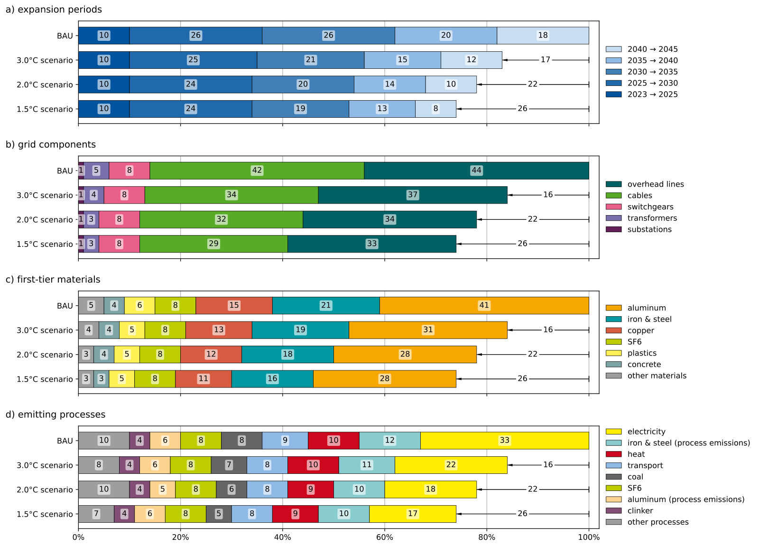
Fig. 4: Climate impact contributions of Germany's grid expansion from 2023 to 2045. Contributions are broken down on four levels: a) by expansion periods in 5-year steps, b) by grid components, c) by material impacts on the first tier of the supply chains, and d) by processes in the supply chains directly causing the emissions.

Future Shifts Towards Other Environmental Impact Categories
While reducing climate change impact remains a priority, transitions towards low-carbon systems can shift environmental burdens to other environmental impact categories.
Fig. 5 illustrates changes in environmental impact across all considered impact categories for the three future scenarios, using BAU as a baseline to assess potential shifts of environmental burdens due to process and supply chain evolution. For the absolute impacts in all categories and scenarios, see Supplementary Table 14. The largest shift in impacts is observed in the category climate change, which is also the main motivation behind current and projected transformation efforts. Through transformations towards renewable energy sources, environmental co-benefits also show for other impact categories. Predominantly, there are environmental benefits associated with the decreasing share of coal power plants in the electricity mix (cf. Fig. 2). Reduced coal consumption directly leads to up to 24 % less depletion of non-renewable energy resources. As phosphate emissions during treatment of spoil from hard coal and lignite mining are diminished, the eutrophication of freshwater decreases by up to 13 %. Furthermore, reduced reliance on coal lowers particulate matter formation, along with decreased eutrophication in both marine and terrestrial environments.
Climate-motivated transformation can, however, also cause an increase of environmental burdens in other impacts categories. We find such burden shifting to only two out of the sixteen considered impact categories. Most notably, the land use impact increases by up to 16 %, because more bio-based energy carriers are used in electricity generation. Moreover, we find a slightly increased impact on the depletion of material resources such as metals and minerals, predominantly introduced through increasing shares of renewable energy generation.
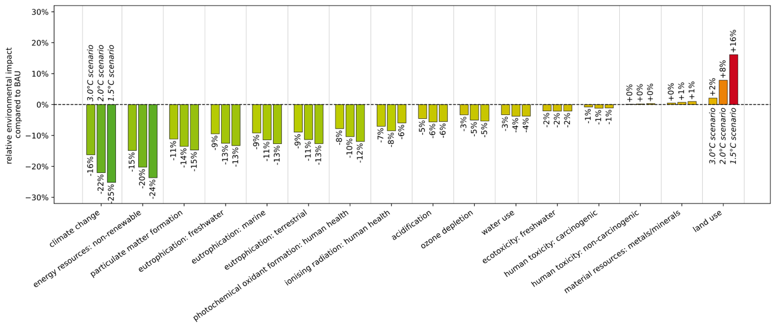
Fig. 5: Environmental burden shifting through future process and supply chain evolution. Relative changes across environmental impact categories are shown for the three decarbonization scenarios compared to the BAU baseline. Negative values indicate environmental co-benefits driven primarily by the phase-out of coal. Conversely, positive values highlight areas of burden shifting caused by climate-motivated transformation across supply chains, mainly originating from increased deployment of renewable electricity generation..

Discussion

The Growing Significance of Grid Infrastructure Impacts
Our results demonstrate that as power systems transition toward renewable electricity generation, the environmental footprint of grid infrastructure shifts from a marginal concern to a central pillar of systemic climate impact of electricity supply. In the German context, we show that the grid’s share of the climate change impact per kilowatt-hour of supplied electricity is projected to rise from 1% in 2023 to as much as 21% by 2045. This relative increase is driven by a fundamental "decarbonization gap": the direct emissions from electricity generation are being abated more rapidly than the embodied emissions in the aluminum, steel, and copper required for grid infrastructure expansion. Consequently, the grid infrastructure itself becomes an important lever for further emission reductions of future electricity supply.
Our findings also underscore the necessity of a holistic environmental perspective. While transitioning to low-carbon materials can mitigate impacts in categories such as eutrophication and particulate matter formation, it may simultaneously trigger environmental burden shifting towards land use and mineral depletion. Truly sustainable grid planning must therefore move beyond a carbon-centric view to account for these multi-dimensional environmental trade-offs.

Methodological Considerations and Robustness
To capture the developments of future grid component production systems, we use a stepwise prospective Life Cycle Assessment (pLCA) approach. This approach leverages Integrated Assessment Model (IAM) scenarios to create time-specific LCA databases for each considered grid expansion period. The cradle-to-grave impacts of installed grid components in the respective expansion periods are then calculated based on the state of the production system at the time of installation. A limitation of this stepwise approach is the temporal aggregation of life cycle stages, which assumes that all processes and respective impacts occur at the point of installation, thereby neglecting the real-world delay of the use phase and end-of-life processes. While time-explicit LCA approaches²⁹ could capture the potential benefits of further decarbonization up to the time at which the end-of-life processes actually occur, such additional complexity and associated uncertainty is deemed unnecessary for this study. As shown in Figure 4d, climate impacts of grid components are dominated by processes required for initial material production and component manufacturing (e.g., the generation of electricity and heat, transport, and the production of steel & iron, aluminium and clinker). These processes typically occur close to the time of component installation, making the production system conditions at that specific time representative. In comparison, use-phase and end-of-life impacts are comparatively small, so accounting for further decarbonization until their actual occurrence introduced negligible errors. Therefore, we conclude that the stepwise pLCA approach based on IAM scenarios provides a robust methodological basis for the present case.
While IAM scenarios can provide internally consistent projections for the evolution of future production systems, these scenarios cannot anticipate the full spectrum of market volatility or disruptive technological breakthroughs. However, by assessing three distinct climate scenarios, we effectively capture the sensitivity of future grid-related impacts to the broader evolution of global supply chains. This underscores that successful mitigation strategies must be collaborative, requiring both grid operators and component producers to proactively integrate supply chain decarbonization into their strategic roadmaps.

Integrating Environmental Metrics into Strategic Planning
Although this study focuses on Germany, the findings can be transferred to other national and multi-national contexts. Most current grid development planning approaches are governed by techno-economic criteria, often overlooking the environmental dimensions of grid expansion. By providing a compilation of high-resolution inventory data across grid voltage levels alongside prospective environmental impact indicators, this study establishes a basis for integrating environmental metrics into formal decision-making. Such metrics could be operationalized through environmental shadow pricing or multi-objective optimization within grid planning models.
The integration of environmental metrics becomes increasingly critical as future renewable energy systems face diverging supply and demand profiles and an urgent need for infrastructure resilience against rising climate hazards³⁰. Consequently, while greater grid redundancy is essential for security of supply, it inherently increases material inventories. Strategic grid planning must carefully balance these trade-offs to ensure that future grid infrastructure is both secure and environmentally sustainable.

Policy Implications and Global Perspectives
On a broader policy level, our findings suggest a need for more comprehensive carbon accounting. Current Nationally Determined Contributions (NDCs) focus primarily on emissions from electricity generation. Incorporating prospective grid-related impacts into these frameworks would improve accounting completeness and ensure consistency between long-term mitigation targets and the physical infrastructure required to achieve them. Overall, embedding grid-related impacts in regulatory frameworks and strategic energy planning is essential for more holistic, future-proof infrastructure decisions in line with global climate goals.

Methods

Goal and Scope Definition
The goal of the conducted Life Cycle Assessment (LCA) study is to investigate the environmental impacts of Germany’s existing and planned electricity transmission and distribution grid infrastructure as well as the current and future grid-related share of the overall climate change impact per kilowatt-hour of supplied electricity. To address this goal, we conduct a prospective LCA (pLCA) using different functional units.
For the assessment of current and future grid infrastructure, we define the functional unit as the overall grid infrastructure necessary to transmit and distribute electricity to meet the demand in a specific year. We evaluate this functional unit for two specific years, 2023 and 2045. For 2023, we use Germany’s existing grid infrastructure, including both transmission and distribution grids, as functional unit. For 2045, the 2023 infrastructure plus the planned grid expansion required to ensure future electricity supply is used as functional unit. Since processes and supply chains for grid components evolve over time, components added between 2023 and 2045 are modeled via pLCA, reflecting the production system’s state at the respective time of installation. We apply a cradle-to-grave system boundary, including the entire life cycles of the grid infrastructure. The electricity grid is assumed to be composed of overhead lines, cables and transformers, as well as substations and switchgears. For cables, we distinguish insulation materials (cross-linked polyethylene and oil) and conducting materials (aluminum and copper) based on the voltage level. Four voltage levels are considered for the electricity transmission and distribution grids: Extra-high voltage (EHV), high voltage (HV), medium voltage (MV) and low voltage (LV). The EHV transmission is subdivided into alternating current (AC) and direct current (DC) technology. Geographically, we consider the grid composition (line/cable lengths, numbers of units, etc.) of the German electricity grid with global supply chains for the grid component production and corresponding material inputs. For site-specific operations, e.g. excavation for cable ditches, as well as waste treatment processes, we use processes for Germany.
For the assessment of the grid-related share of the climate change impact per kilowatt-hour of supplied electricity, we define 1 kilowatt-hour of supplied electricity at the consumer as the functional unit. Thereby, we include both the electricity generation and the grid infrastructure necessary for transmission and distribution into the assessment. In this case, the system boundary is cradle-to-gate with respect to the supplied electricity.
Climate change impacts are assessed using premise_gwp³¹. This impact assessment method bases on characterization factors published by the Intergovernmental Panel on Climate Change³², with additional factors for hydrogen and biogenic carbon to better capture future impacts of increased hydrogen and bioenergy use. To assess environmental impacts besides climate change, we use the Environmental Footprint v3.1 impact assessment method, following the recommendation of the European Commission³³. LCA calculations and system modelling are performed using the Brightway LCA framework³⁴ and Activity Browser³⁵.

Grid Infrastructure Model
We assess the environmental impacts of Germany’s electricity grid based on data for installed components in 2023 and projected expansions until 2045. To ensure robustness, our modeling approach and underlying assumptions are validated in consultation with grid planning experts from Westnetz GmbH and the E.ON SE group.
Current Grid Infrastructure. The 2023 baseline data encompass AC and DC circuit lengths, substations, and offshore converter stations. Circuit lengths are derived from German grid monitoring reports, with the proportion of underground cables versus overhead lines extrapolated from public data provided by the ten largest German Distribution System Operators (DSOs)³⁶. Because comprehensive public inventories of individual substation components do not exist, we estimate the number of installed substations and auxiliary equipment using an apparent power approach. First, we calculate the national total transformer apparent power for each voltage level based on Transmission System Operator (TSO) and DSO reports. We then divide this total by the standard average apparent power of transformers at the respective voltage level to estimate the overall number of installed transformers. Finally, because the transformer dictates the technical design of a substation, we determine the number of auxiliary components, such as switchgears and housing, as a proportional multiple of these estimated transformers.
Future Grid Expansion. We model future grid expansion across two development periods (2023–2037 and 2037–2045), aligned with the support years of the German Grid Development Plan (GDP) ³⁷. At the EHV level, projected circuit lengths are taken directly from the GDP, distinguishing between onshore (predominantly AC overhead lines) and offshore (AC in the Baltic Sea, DC in the North Sea) expansions. For the underlying distribution networks (HV, MV, and LV), expansion projections are synthesized from Federal Network Agency data³⁸ and the DENA lead study³⁹ and accompanying expert report⁴⁰. These sources cover approximately 80% of the distribution grid, and we apply linear extrapolation to account for the remaining circuit lengths. We project the future deployment of substations and auxiliary equipment by assuming their growth scales proportionally with the expansion of circuit lengths, keeping average transformer sizes consistent with the 2023 baseline, following Oeding and Oswald⁴¹. Grid dismantling is excluded from this scope, assuming existing infrastructure is cyclically renewed to meet rising electricity demand. Complete data tables, including region-specific DSO assumptions, are detailed in Supplementary Tables 1 – 8.

LCA Datasets for Grid Components
The LCA datasets for grid components are compiled from different data sources which are summarized in Supplementary Table 9. In addition to the literature sources, we expand these datasets with further assumptions, e.g., for the land use of the masts, excavated volumes for cables, and leakage of SF₆ gas in switchgear. For material and energy inputs to grid component production, we use the ecoinvent 3.10 cut-off database⁴². Selected processes are detailed in Supplementary Table 10. For grid component production, we assume that the general material composition remains constant in the future. However, we do account for future process and supply chains development.

Process and Supply Chain Scenarios
To reflect the development of processes and supply chains in the grid component production system, we use prospective scenarios from the Integrated Assessment Model REMIND-EU⁴³. We assume that future socio-economic developments follow a “middle-of-the-road” development, where trends follow their historical patterns. We investigate a range of three scenarios, leading to different average temperature increases by 2100: A 3°C-scenario (no additional policies implemented, “SSP2-NPi”), a 2°C-scenario (carbon budget limitation to 1000 Gt CO₂e, “SSP2-PkBudg1000”) and a 1.5°C-scenario (carbon budget limitation to 650 Gt CO₂e, “SPP2-PkBudg650)⁴⁴. Additionally, we consider a BAU-case, where processes and supply chains remain unchanged, maintaining the 2023 configuration. Using premise⁴⁵ in version 2.3.0, we adjust processes and supply chains based on the ecoinvent 3.10 database according to the projected changes, covering the sectors electricity, steel, cement, fuels, transport, non-CO₂ emissions, and carbon capture and storage. Moreover, we consider the evolution of the aluminium sector through an additional scenario from the International Aluminium Institute⁴⁶, see Supplementary Methods 4.
For the prospective assessment of grid expansion, we use a stepwise pLCA approach based on Zimmermann et al.⁴⁷, as shown in Figure 6. First, we create a series of prospective databases for each scenario, representing the production system at specific points in time. These databases span from 2023 to 2045, covering 5-year intervals and including the start date of 2023 and the intermediate year 2037. Then, the grid expansion periods through 2037 and 2045 are uniformly distributed into sub-periods. Next, each sub-period is linked to the projected production system for that specific time. Consequently, the grid components built in that timespan use the production system that is projected for that point in time. As a conservative estimate, we use the 2025 production system for the 2025-2030 expansion period, the 2030 production system for the 2030-2035 expansion period, and so on. Finally, the overall environmental impacts of the German electricity grid in 2045 are determined by summing the impacts from the status quo and all grid expansion periods.
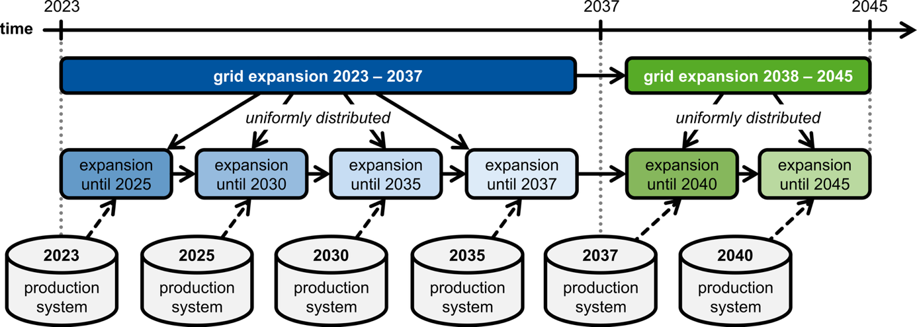
Figure 6: Stepwise prospective LCA approach linking grid expansion periods to time-specific databases. Grid expansion periods 2023-2037 and 2038-2045 are distributed into sub-periods and linked to prospective databases representing the production system at the corresponding points in time.

Attributing Grid Impacts to Electricity Supply
To assess the German grid infrastructure’s contribution to the environmental impacts per kilowatt-hour of supplied electricity, we first annualized the grid-related impacts for 2023 and 2045 (assuming a 30-year lifetime) and divided them by the respective gross electricity consumption in Germany (456.8 TWh in 2023⁴⁸; 801.4 TWh in 2045³⁷). For electricity generation impacts, we use ecoinvent-based datasets for 2023 and 2045, replacing the ecoinvent-native grid model with our model to avoid double counting. The grid-related share of total impacts was then determined by comparing grid and generation impacts. For further details, see Supplementary Methods 4.

Uncertainty and Sensitivity Analysis
We evaluate the robustness of the prospective grid expansion results using via uncertainty and sensitivity analysis. Uncertainty in the foreground system is modeled for grid component expansion numbers, the grid composition (including the share of overhead lines versus cables and the share of copper versus aluminium cables), as well as the grid component’s material demands. For each uncertain parameter, symmetric triangular distributions that widen linearly from 2023 to 2045 were assumed. A Monte Carlo simulation (N=5000) and a moment-independent Global Sensitivity Analysis (Borgonovo’s $δ$) are conducted to quantify the influence of these parameters on the total GWI of grid expansion. Additionally, a separate sensitivity analysis was performed to address the uncertainty regarding component lifetimes in the annualization of impacts. To address uncertainties related to the background system scenarios, we assess a range of three distinct scenarios (representing 1.5°C, 2.0°C, and 3.0°C pathways) rather than probabilistic simulation, following the recommendations from Langkau et al.²⁰ and Heijungs⁴⁹. Detailed assumptions and results of the uncertainty and sensitivity analysis are available in Supplementary Discussion 1.

CRediT Author Statement
Timo Diepers: Conceptualization, Data curation, Methodology, Software, Visualization, Writing – original draft. Philipp Daun: Data curation, Methodology, Writing – original draft. Menna Elsobki: Data curation, Methodology, Writing – original draft. Christian Zibunas: Conceptualization, Supervision, Writing – review & editing. Benedikt Nilges: Conceptualization, Supervision, Writing – review & editing. Jan Hartmann: Writing – review & editing. Christina Kockel: Supervision, Writing – review & editing. Aaron Praktiknjo: Funding acquisition, Supervision, Writing – review & editing. Niklas von der Assen: Conceptualization, Funding acquisition, Supervision, Writing – review & editing.

Data Availability Statement
All data are available on GitHub at https://github.com/TimoDiepers/plca-grid-expansion and archived on Zenodo at [link to be inserted after review].

Code Availability Statement
All code to reproduce the results of this study is available on GitHub at https://github.com/TimoDiepers/plca-grid-expansion and archived on Zenodo at [link to be inserted after review].

Declaration of Generative AI and AI-Assisted Technologies
During the preparation of this work, the authors used ChatGPT for proofreading. After using this tool or service, the authors reviewed and edited the content as needed and took full responsibility for the content of the publication.

Acknowledgements
Part of the LCA datasets used in this study was compiled and validated during a contract research project conducted in collaboration with Westnetz GmbH, Germany’s largest distribution grid operator, E.ON SE, a multinational electric utility company, and E.ON Group Innovation GmbH, which drives energy transition innovations within the E.ON Group. The authors especially thank Dominique Giavarra (Westnetz GmbH) and Dr. Jan Schiefelbein-Lach (E.ON Group Innovation GmbH) for their support. We also thank the anonymous reviewers for their constructive feedback.

References
1. International Energy Agency. Electricity Grids and Secure Energy Transitions. https://www.iea.org/reports/electricity-grids-and-secure-energy-transitions (2023).
2. International Energy Agency. Renewables 2024. https://www.iea.org/reports/renewables-2024 (2025).
3. Gorman, W. et al. Grid connection barriers to renewable energy deployment in the United States. Joule 9, 101791 (2025).
4. Reinert, C. et al. Environmental impacts of the future German energy system from integrated energy systems optimization and dynamic life cycle assessment. Comput. Chem. Eng. 153, 107406 (2021).
5. Algunaibet, I. M. & Guillén-Gosálbez, G. Life cycle burden-shifting in energy systems designed to minimize greenhouse gas emissions: Novel analytical method and application to the United States. J. Clean. Prod. 229, 886–901 (2019).
6. García-Gusano, D., Garraín, D. & Dufour, J. Prospective life cycle assessment of the Spanish electricity production. Renew. Sustain. Energy Rev. 75, 21–34 (2017).
7. ISO 14040, I. ISO 14040. (2006).
8. ISO 14044. ISO 14044. (2006).
9. Bumby, S. et al. Life Cycle Assessment of Overhead and Underground Primary Power Distribution. Environ. Sci. Technol. 44, 5587–5593 (2010).
10. Jones, C. I. & McManus, M. C. Life-cycle assessment of 11 kV electrical overhead lines and underground cables. J. Clean. Prod. 18, 1464–1477 (2010).
11. Jorge, R. S., Hawkins, T. R. & Hertwich, E. G. Life cycle assessment of electricity transmission and distribution—part 1: power lines and cables. Int. J. Life Cycle Assess. 17, 9–15 (2012).
12. Jorge, R. S., Hawkins, T. R. & Hertwich, E. G. Life cycle assessment of electricity transmission and distribution—part 2: transformers and substation equipment. Int. J. Life Cycle Assess. 17, 184–191 (2012).
13. Jorge, R. S. & Hertwich, E. G. Environmental evaluation of power transmission in Norway. Appl. Energy 101, 513–520 (2013).
14. Turconi, R. Environmental impacts of future low-carbon electricity systems: Detailed life cycle assessment of a Danish case study. Appl. Energy 132, 66–73 (2014).
15. Harrison, G. P., Maclean, E. J., Karamanlis, S. & Ochoa, L. F. Life cycle assessment of the transmission network in Great Britain. Energy Policy 38, 3622–3631 (2010).
16. Kockel, C. et al. A scalable life cycle assessment of alternating and direct current microgrids in office buildings. Appl. Energy 305, 117878 (2022).
17. International Energy Agency. Energy system of Norway. https://www.iea.org/countries/norway (2025).
18. Jorge, R. S. & Hertwich, E. G. Grid infrastructure for renewable power in Europe: The environmental cost. Energy 69, 760–768 (2014).
19. Mendoza Beltran, A. et al. When the Background Matters: Using Scenarios from Integrated Assessment Models in Prospective Life Cycle Assessment. J. Ind. Ecol. 24, 64–79 (2020).
20. Langkau, S. A stepwise approach for Scenario-based Inventory Modelling for Prospective LCA (SIMPL). Int. J. Life Cycle Assess. 28, 1169–1193 (2023).
21. Cox, B., Mutel, C. L., Bauer, C., Mendoza Beltran, A. & van Vuuren, D. P. Uncertain Environmental Footprint of Current and Future Battery Electric Vehicles. Environ. Sci. Technol. 52, 4989–4995 (2018).
22. Rüdisüli, M. et al. Prospective life-cycle assessment of greenhouse gas emissions of electricity-based mobility options. Appl. Energy 306, 118065 (2022).
23. Hertwich, E. G. et al. Integrated life-cycle assessment of electricity-supply scenarios confirms global environmental benefit of low-carbon technologies. Proc. Natl. Acad. Sci. 112, 6277–6282 (2015).
24. Gong, C. C. et al. Multilevel emission impacts of electrification and coal pathways in China’s net-zero transition. Joule 9, 101945 (2025).
25. Climate Change 2022: Impacts, Adaptation and Vulnerability. Contribution of Working Group III to the Sixth Assessment Report of the Intergovernmental Panel on Climate Change. (Cambridge University Press, Cambridge, 2022). doi:10.1017/9781009157926.
26. Davis, S. J. et al. Net-zero emissions energy systems. Science 360, eaas9793 (2018).
27. Crippa, M. et al. Fossil CO2 and GHG Emissions of All World Countries. (Publications Office of the European Union, Luxembourg, 2019). doi:10.2760/687800.
28. Zhang, X., Jiao, K., Zhang, J. & Guo, Z. A review on low carbon emissions projects of steel industry in the World. J. Clean. Prod. 306, 127259 (2021).
29. Müller, A. et al. Time-explicit life cycle assessment: a flexible framework for coherent consideration of temporal dynamics. Int. J. Life Cycle Assess. https://doi.org/10.1007/s11367-025-02539-3 (2025) doi:10.1007/s11367-025-02539-3.
30. Xu, L. et al. Resilience of renewable power systems under climate risks. Nat. Rev. Electr. Eng. 1, 53–66 (2024).
31. Sacchi, R. Premise_gwp. https://github.com/polca/premise_gwp.
32. Intergovernmental Panel On Climate Change. Climate Change 2021 – The Physical Science Basis: Working Group I Contribution to the Sixth Assessment Report of the Intergovernmental Panel on Climate Change. (Cambridge University Press, 2023). doi:10.1017/9781009157896.
33. Joint Research Centre (European Commission) et al. Updated Characterisation and Normalisation Factors for the Environmental Footprint 3.1 Method. (Publications Office of the European Union, 2023).
34. Mutel, C. Brightway: An open source framework for Life Cycle Assessment. J. Open Source Softw. 2, 236 (2017).
35. Steubing, B., de Koning, D., Haas, A. & Mutel, C. L. The Activity Browser — An open source LCA software building on top of the brightway framework. Softw. Impacts 3, 100012 (2020).
36. Bundesnetzagentur & Bundeskartellamt. Monitoringbericht 2023. (2024).
37. Übertragungsnetzbetreiber. Netzentwicklungsplan Strom 2037/2045, Zweiter Entwurf. (2023).
38. Bundesnetzagentur. Bericht zum Zustand und Ausbau der Verteilernetze 2022. (2023).
39. Deutsche Energie-Agentur GmbH. Dena-Leitstudie Aufbruch Klimaneutralität, Final Report. (2021).
40. Energiewirtschaftliches Institut an der Universität zu Köln. Dena-Leitstudie Aufbruch Klimaneutralität: Expert Report. (2021).
41. Oeding, D. & Oswald, B. R. Elektrische Kraftwerke und Netze. (Springer Berlin Heidelberg, Berlin, Heidelberg, 2016). doi:10.1007/978-3-662-52703-0.
42. Wernet, G. et al. The ecoinvent database version 3 (part I): overview and methodology. Int. J. Life Cycle Assess. 21, 1218–1230 (2016).
43. Luderer, G. et al. REMIND - REgional Model of INvestments and Development. (2025).
44. Riahi, K. et al. The Shared Socioeconomic Pathways and their energy, land use, and greenhouse gas emissions implications: An overview. Glob. Environ. Change 42, 153–168 (2017).
45. Sacchi, R. et al. PRospective EnvironMental Impact asSEment (premise): A streamlined approach to producing databases for prospective life cycle assessment using integrated assessment models. Renew. Sustain. Energy Rev. 160, 112311 (2022).
46. International Aluminium Institute. Aluminium Sector Greenhouse Gas Pathways to 2050. https://international-aluminium.org/resource/aluminium-sector-greenhouse-gas-pathways-to-2050-2021/ (2021).
47. Zimmermann, B. M., Dura, H., Baumann, M. J. & Weil, M. R. Prospective time‐resolved LCA of fully electric supercap vehicles in Germany. Integr. Environ. Assess. Manag. 11, 425–434 (2015).
48. Bundesnetzagentur. Strommarktdaten 2023. https://www.bundesnetzagentur.de/997252.
49. Heijungs, R. Probability, Statistics and Life Cycle Assessment: Guidance for Dealing with Uncertainty and Sensitivity. (Springer International Publishing, Cham, 2024). doi:10.1007/978-3-031-49317-1.

