* Repository: The codebase is maintained in <https://github.com/TimoJadu/DynamicUI-angular/tree/master> and publicly accessible. Sincere request is to fork/download the codebase from the mentioned github repository and **build** the solution using visual studio (2015), after restoring packages from the ‘**package.JSON’**.
* Language/platform used: Typescript, Angular2 & visual studio.
* DynamicUI- angular development:

The development work was completed keeping MVC model in mind. The ‘app.component.ts’ is acting as controller

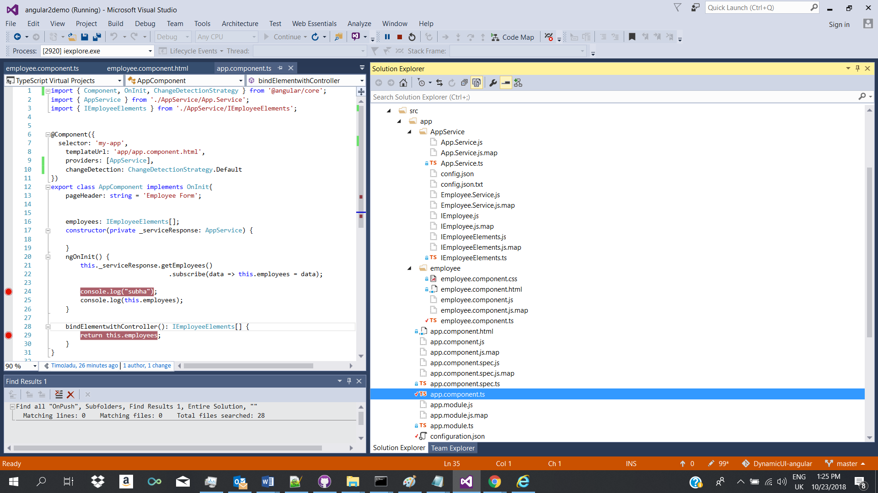

The ‘employee.component.html’ holds the view logic implementation.

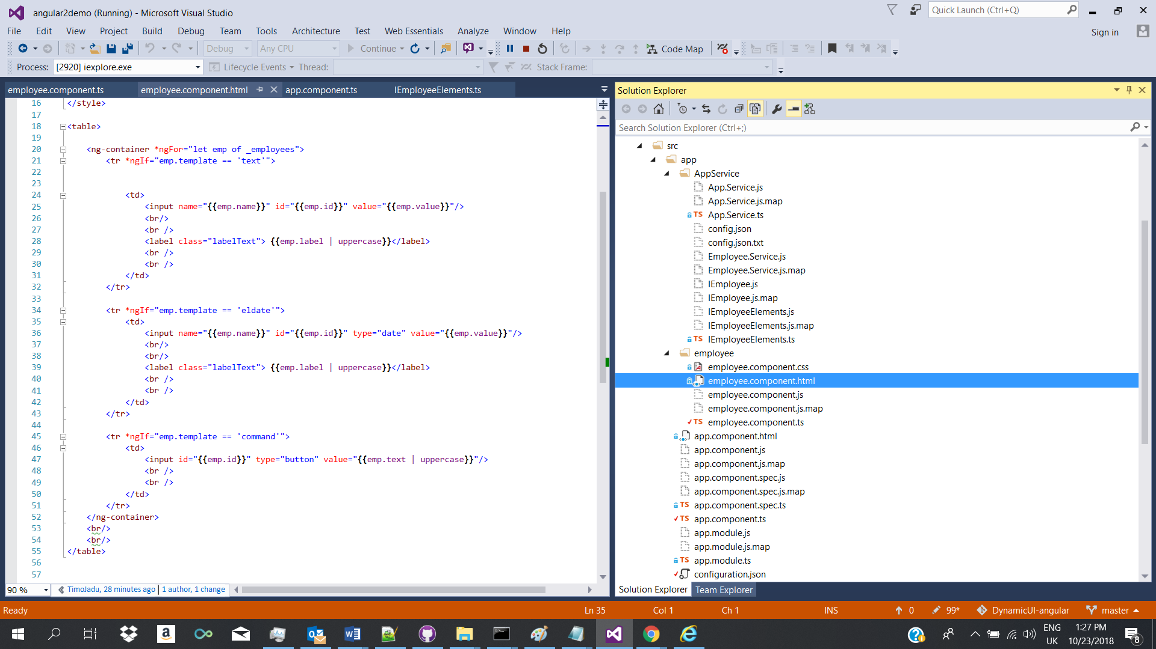

We created a service to pull the JSON data from ‘configuration.json’ file stored in ‘app’ folder. So it is working as DAC layer.

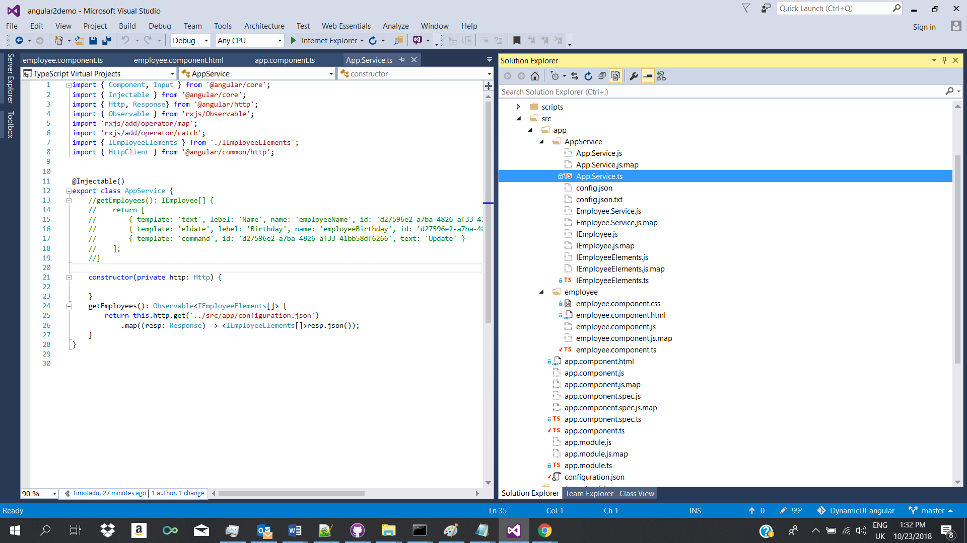

The configuration file: Needs to be in JSON format. The sample’s screenshot considered for development work is attached below.

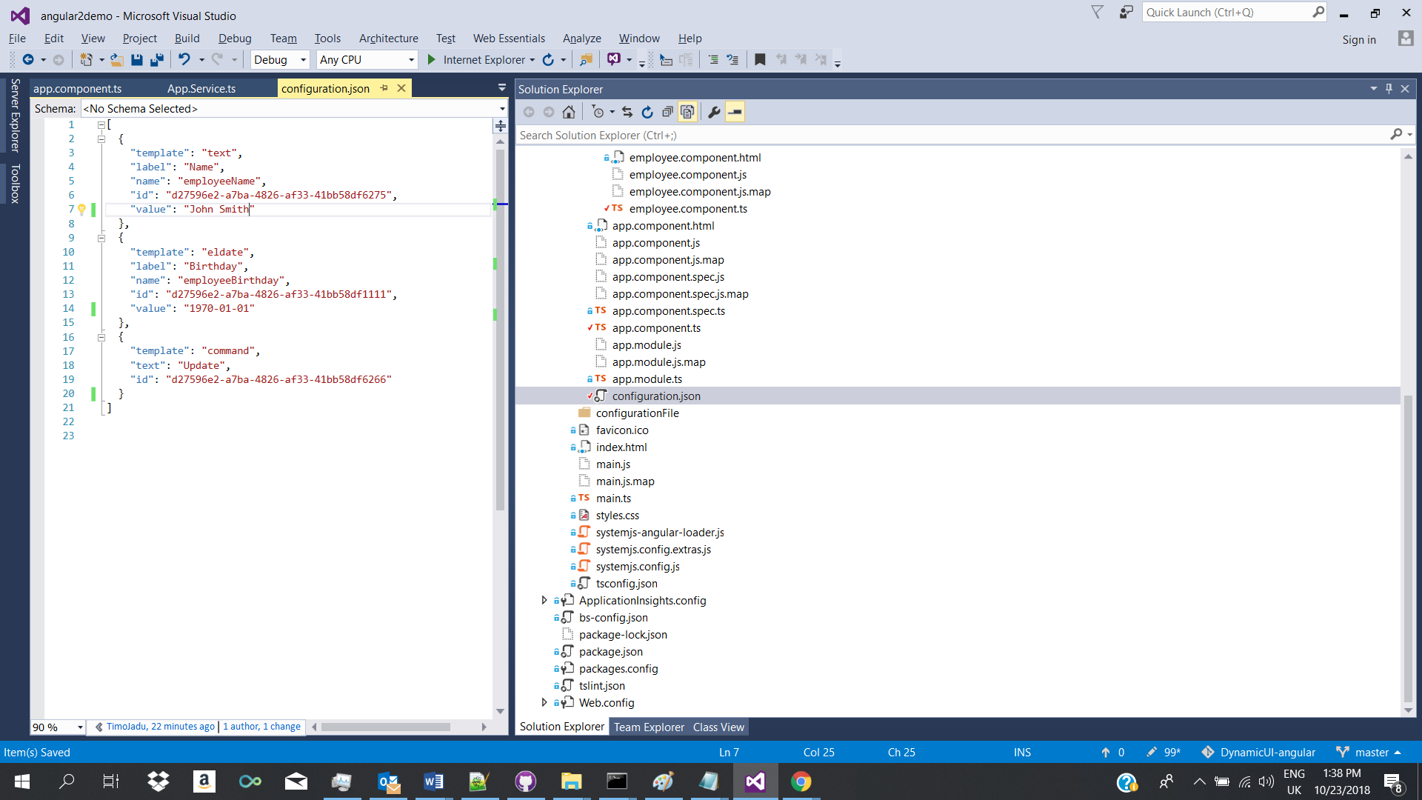

[N.B: For any schema change in the configuration file will require a parser logic implementation.]

Output Analysis or Test cases:

1. For the specified JSON file, we got dynamic UI layout like:

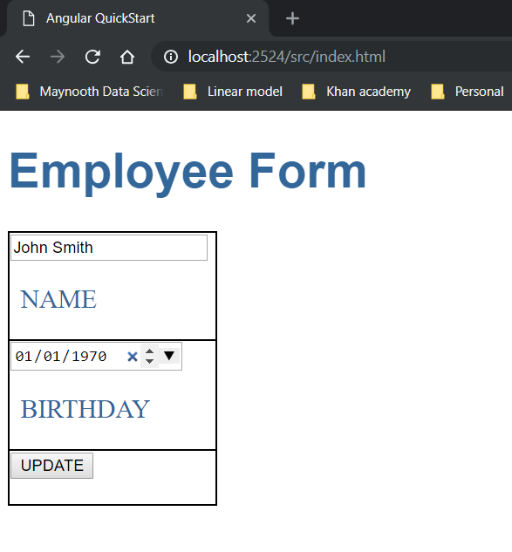

And

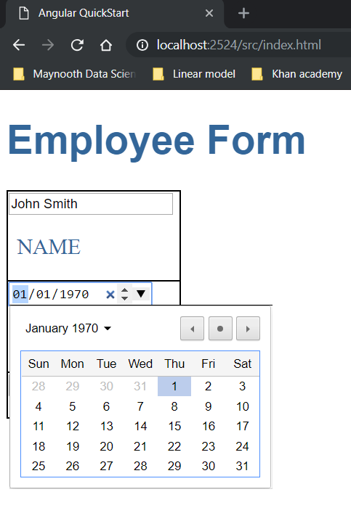

1. Test case 2: change the value field from ‘John Smith’ to ‘subhajit ghosh’.

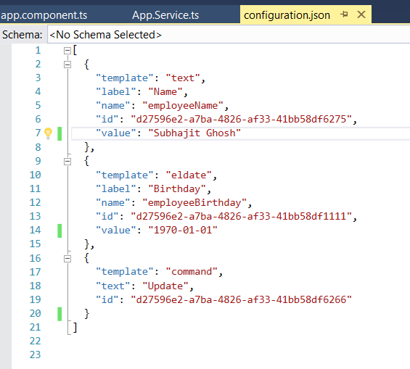

We received changed output in the UI as:

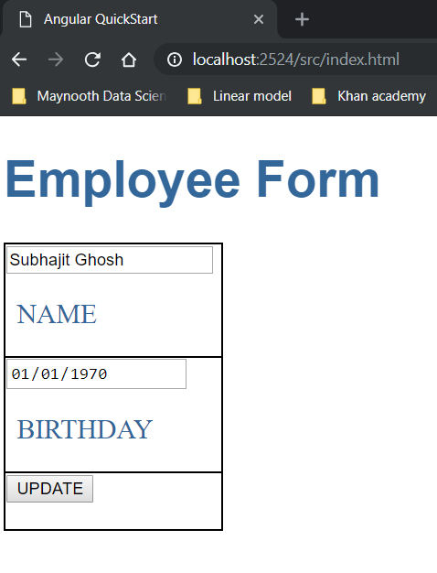

1. Test case 3: Let us add one more date field by repeating elements in the config file. (id should be unique) as:

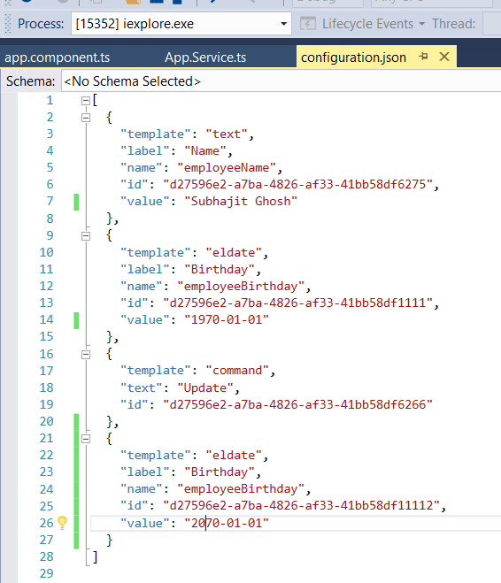

We get an excess date field as the las element in the user interface. Like:

