

Electronics Project 1: Cable-Monitor

in the third term of the Electrical Engineering studies

# Abstract

The Electronics Project 1 takes place in the third semester of the electrical engineering curriculum at the ZHAW School of Engineering. The concept is to use the skills acquired so far in a holistic way in building a prototype starting from an idea. The teaching method is similar to the concept of project-based learning. In contrast, however, the goal really is to build a working device. This year a Cable-Monitor will be built. By measuring the electric and the magnetic fields of a cable or wire connected to mains, it is possible to calculate distance, angle and current flow by means of analog signal processing and digital algorithms. The students will develop, implement, test and document hardware, firmware and user-interface of the Cable-Monitor.

(c) Hanspeter Hochreutener, [hhrt@zhaw.ch](mailto:hhrt@zhaw.ch), 04.03.2020

Table of content

Abstract 1

1. Module Description and Goals 3

1.1. Timeline with Subjects and Milestones 3

1.2. Grading 3

2. Cable-Monitor 4

2.1. Block Diagram and Function Description 4

2.2. Specification 5

2.3. Calibration and Test Equipment 6

3. How to Start and Where to Find What 7

3.1. Sensor Signals 7

3.2. Project Management 7

3.3. Sensor-Board 7

3.4. Writing the Hardware Report 7

3.5. Microcontroller STM32F429 8

3.6. Microcontroller Demo Code 8

3.7. Firmware Development, Documentation and Testing 8

3.8. Presentation and Demonstration 8

# Module Description and Goals

The main goal is to build a **Cable-Monitor**, which can indicate distance and direction of a mains cable by measuring the electric field radiated by the cable. Furthermore, it is desirable to indicate the current flow by additionally measuring the magnetic field.

Apart from the technical skills such as developing, building, testing and documenting HW and FW, this module also addresses communication and project management skills. The teams consist of two students. The working language is English.

A description of the module and the learning objectives can be found here: <https://eventoweb.zhaw.ch/Evt_Pages/Brn_ModulDetailAZ.aspx?node=c594e3e5-cd9a-4204-9a61-de1e43ccb7b0&IDAnlass=1560097&IdLanguage=133>

## Timeline with Subjects and Milestones

Public holydays change every year. See the document **Timeline.docx** in the same folder.

## Grading

Table 1: Tasks and grading

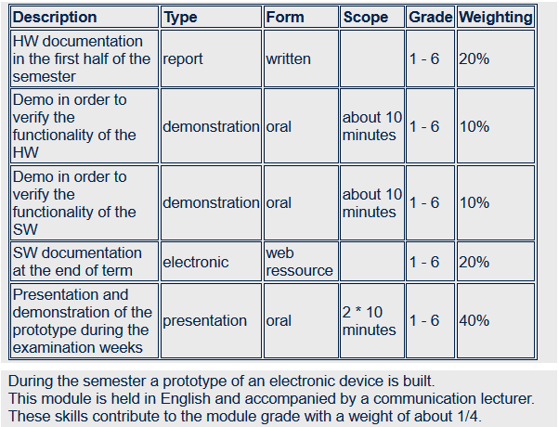

# Cable-Monitor

A wire connected to the mains electrical grid radiates an electric field. The strength of the field decreases with distance. The Cable-Monitor uses sensors to pick up the electric field, amplifies and filters the weak signals, converts them into the digital domain, calculates and displays the distance and angle to the cable.

When a current flows in a wire, it radiates a magnetic field. With a similar approach as described above, the Cable-Monitor estimates and displays the current.

## Block Diagram and Function Description

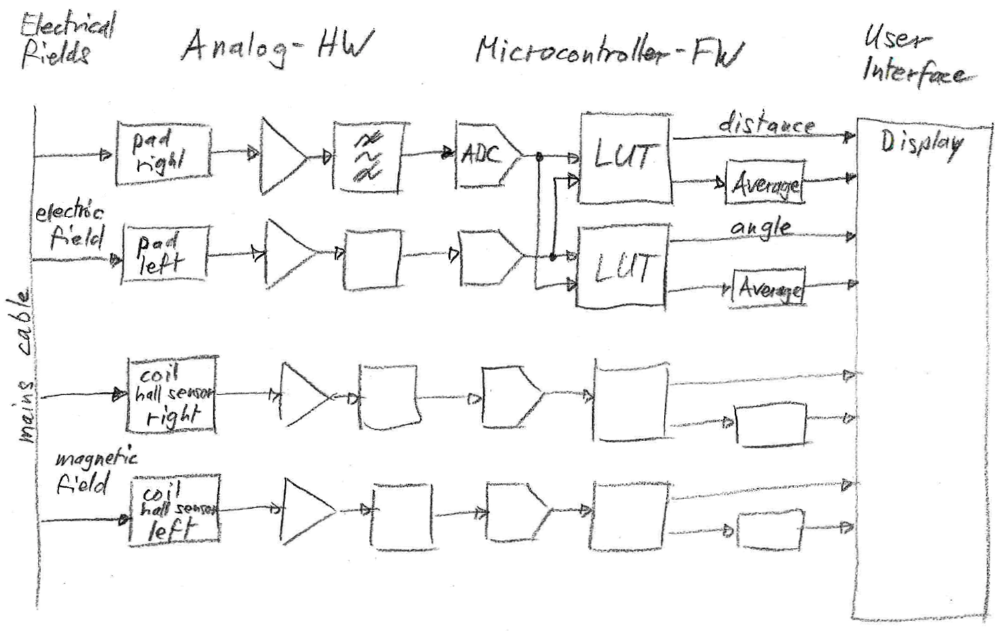

Figure 1: Block Diagram

Sensors, pads for the electric field and coils or hall sensors for the magnetic field, pick up the related field strengths and convert them into weak electrical voltages.

The weak signals are amplified and filtered before they are converted by the Analog-to-Digital-Converters.

The microcontroller processes the raw signals and calculates the signal strengths. These amplitudes are used as inputs to Look-Up-Tables followed by interpolation to calculate distance, angle and current of the mains cable.

The user interacts over a display with touch screen.

## Specification

The Cable-Monitor must fulfil these requirements:

* Detect a mains cable at a distance of up to 200mm
* Display the distance to the cable in the range 5mm to 100mm with a precision of ±30%
* Display the angle to the cable in the range of ±45° with a precision of ±15°
* Battery powered, preferably with auto shut down when no longer used
* Menu with these items
  + Start single measurement
  + Start accurate measurement (averaging: mean and standard deviation)

Optionally it is desirable to implement some additional features, like:

* Display current in the range of 1A to 10A with a precision of ±50%
  + for a single phase wire (at mains potential) up to a distance of 10mm
  + for a cable with phase, neutral and protecting earth up to a distance of 5mm
* Add menu items for current measurement
  + on a single phase wire
  + on a cable with phase, neutral and protecting earth
* Further menu items, like
  + turning the cable monitor off
  + calibration of distance (with look up table in non-volatile memory)
* Alarm
  + when cable distance is too big (= cable is disconnected)
  + with overcurrent
  + data logger functionality
* Other extensions of functionality are welcome and encouraged by the lecturers

## Calibration and Test Equipment

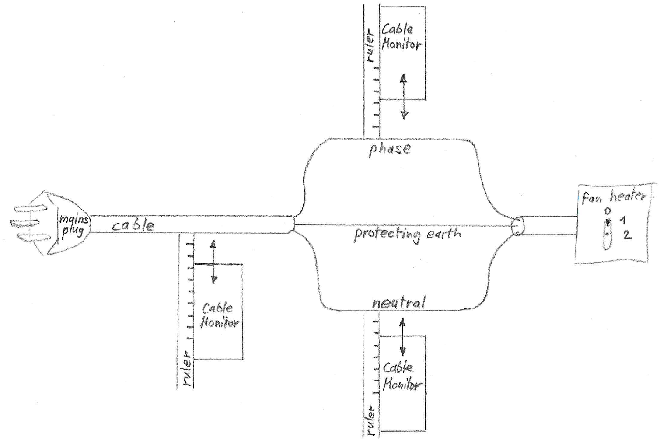

Figure 2: Calibration and Test Equipment

This is the equipment for calibrating and testing the Cable-Monitor.

It is possible to measure the fields of a cable or of the neutral resp. the phase wire individually.

Depending on the fan heater switch position the current is zero or has two defined values.

The distance of the Cable-Monitor is variable and indicated on the rulers.

# How to Start and Where to Find What

Fortunately, the project can be split into hardware (HW) and firmware (FW) development because the interface between the domains are just some analog input voltages.

Language and project management skills are used and improved in the whole project.

Tested and documented HW and FW templates facilitate a smooth start for the students.

## Sensor Signals

Understanding the physics is the basis for successfully developing a Cable-Monitor.

The weak sensor signals must be filtered and amplified to the input level of the ADCs.

The related documents are in the folder **Sensor_Signals**.

## Project Management

The team must be organised, and the tasks assigned to its members.

The related documents are in the folder **Project_Management**.

## Sensor-Board

The Sensor-Board is the piece of hardware that must be develop in this project.

The related documents are in the folder **SensorBoard**.

The PCB design is the next step once the amplifiers and filters have been designed and verified by simulation. For a smooth start, a template **HW_template*.zip** for the recommended PCB layout tool **KiCAD** is provided with the correct dimensions and socket positions. The schematic already includes the standard components.

**KiCad.docx** is a basic tutorial for Schematic Capture, Spice Simulation, PCB Layout and 3D Viewer. If you are very familiar with a different tool than KiCAD, feel free to use it.

The file **Microcontroller_STM32F429/Datasheets/Extension_Connectors.xlsx** lists the available peripherals of each pin.

Observe **PCB_Checklist.txt** before ordering the PCB.

After soldering **HW_Testing.docx** might be useful.

The sensor board is powered by a power bank connected to the USB plug on the microcontroller board. To power the device off, the USB cable must be disconnected.

## Writing the Hardware Report

Writing a technical report involves two main aspects:

* The rules: **Academic Writing_summary.docx** in the folder **Writing_HW Report**.
* Content and structure: **HW_Report.docx** in the same folder.

The hardware report must be updated continuously!

## Microcontroller STM32F429

For the Electronics Projects the microcontroller and the evaluation board have already been chosen. The folder **Microcontroller_STM32F429** contains an introduction **Microcontroller_STM32F429.docx** and the references needed for programming.

## Microcontroller Demo Code

The folder **Microcontroller_DemoCode** is the starting point for writing own code. The file **Install_IDE_and_Import_demo_code.pdf** is a step-by-step guide.

A fully functional **demo_code** includes demos for a menu system, ADCs, DMAs, timers, etc. The file **index.html** in the subfolder **html** opens a comprehensive documentation.

## Firmware Development, Documentation and Testing

The documents in the **Related Pages** tab of the **demo_code** documentation should be consulted before developing own FW, based on the provided **demo_code** mentioned above.

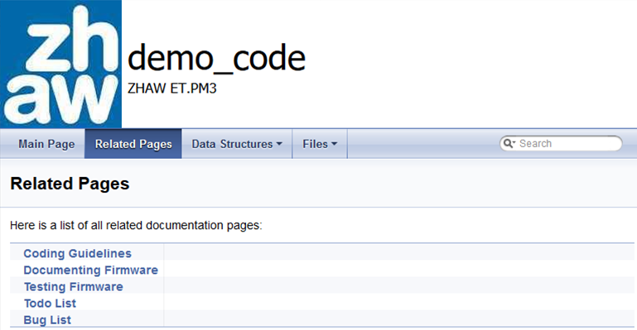

## Presentation and Demonstration

In the end, the device must find customers and be advertised (folder **Effective Presentations**).